Colour Vision Deficiency (CVD), also known as colour blindness
Colour vision deficiency (CVD) or colour blindness is when the eyes are unable to detect certain colours. People with colour vision deficiency find it difficult to tell differences between colours. How difficult this might be for someone depends on the severity of the colour vision deficiency.

How the eye works
We need light to see what’s around us and to see colour. Light bounces off the objects we look at and different objects reflect different amounts of light, which we see as different colours. The different parts of the eye work together to turn these light rays into images.

Light enters the eye through the clear dome at the front of the eye called the cornea, which along with the lens inside the eye, focusses the light onto the back of the eye.

The retina at the back of the eye consists of light sensitive cells called rods and cones. These cells collect the light signals and send them as electrical signals to the optic nerve at the back of our eye. The optic nerve takes these signals to the brain. The brain processes these signals so that we can ‘see’ the world around us.

Rod cells are concentrated around the edge of the retina. They help us to see things that are not directly in front of us, giving us a rough idea of what is around us. They help us with our mobility and getting around by allowing us to see at the sides of our vision so that we don’t bump into things. They also enable us to see things in dim light and to see movement.

Cone cells are concentrated in the centre of our retina, called the macula where the light is focused by the cornea and lens. The area with the highest concentration of cones is called the fovea. Cone cells give us our detailed vision which we use when reading, watching TV, sewing and looking at people's faces. They are also responsible for most of our colour vision.

What causes CVD?
CVD is caused when there is a problem with the cone cells. The visible spectrum is the range of colours and wavelengths that the eye can see. There are three types of cone cells which detect a range of different colours or wavelengths of light:
- Red cone cells detect long wavelengths of light
- Green cone cells detect medium wavelengths of light
- Blue cone cells detect short wavelengths of light

CVD is most commonly genetic or inherited (meaning you are born with it). Inherited CVD does not improve or get worse with age. Most forms of inherited CVD do not affect the eye’s ability to see fine detail.

CVD can develop (be acquired) as the result of:
- an underlying eye or health condition, such as optic neuritis from multiple sclerosis, or diabetes
- a side effect of a medication
- exposure to harmful chemicals
- the ageing process

Depending on the cause, acquired CVD can vary, improve or get worse with time. When the cause is known, you may be able to get a better understanding of how it might change with time.

Types of CVD
There are several types of CVD, depending on how many of the cone cells are working:

Anomalous trichromacy is where all three cone cells are working but one of them is not able to detect colour as sensitively. A person with anomalous trichromacy will see fewer colours compared to someone with normal colour vision. Some colours that appear different to someone with normal colour vision, will appear the same to an anomalous trichromat. Colours may be confused. Anomalous trichromacy can range from mild to severe forms.

Dichromacy is where only two cone cell types are working. A person with dichromacy will be unable to see certain colours and confuse more colours compared to a person with anomalous trichromacy. As most colours are made up of a mixture of wavelengths, when one of the cone types is missing, it will then affect all the colours in the spectrum that would normally be detected by that type of cone. Therefore, if the red cones are not working the person will confuse lots of colours, not just red. For example, they may confuse blue and purple because they can’t perceive the red element of the colour purple.

Cone monochromatism is where there is only one cone cell which is working.

Achromatopsia or rod monochromatism is where none of the cone cells are working or they are all reduced in function. This means you are unable to see any colours at all. A person with rod monochromatism has working rod cells but no working cone cells. This causes poor vision, sensitivity to bright lights and nystagmus (uncontrolled movements of the eyes). A person with this eye condition would only see different shades of grey. Achromatopsia doesn’t cause total vision loss and is generally stable over time rather than progressive.

Dichromacy and anomalous trichromacy are the most common types of CVD and the most commonly affected cone cells are the red and green cells.

Red – green CVD
The most common forms of CVD are red-green deficiencies. These can be a form of dichromacy (where either the red or green cone cells are not working at all) or anomalous trichromacy (where either the red or green cells are not working fully).

If the green cone cells are affected, it can cause:
- Deuteranopia – when the green cone cells are not working at all.
- Deuteranomaly – when the green cone cells are not fully working.

If the red cone cells are affected, it can cause:
- Protanopia – when the red cone cells are not working at all.
- Protanomaly – when the red cone cells are not fully working.

How do red-green types of CVD affect colour vision?
Regardless of whether it is the red or green cone cells that are not working, the way that colour vision is affected is very similar. This is because there is overlap in the colours that the red and green cells can detect, so all colours containing red and green will be affected. This causes difficulty in telling the difference between:
- reds, greens and browns
- oranges and yellows
- blues and purples
- greys and pastel colours

People may see these colours as much duller than they would appear to someone with normal colour vision. People with red deficiencies may also confuse reds with black. The exact way that someone experiences colour with this type of CVD will be very individual as it will depend on the level of function of the cone cells.

The images below show what a person with unaffected colour vision sees (top image) and a simulation of what a person with deuteranopia might see (bottom image).

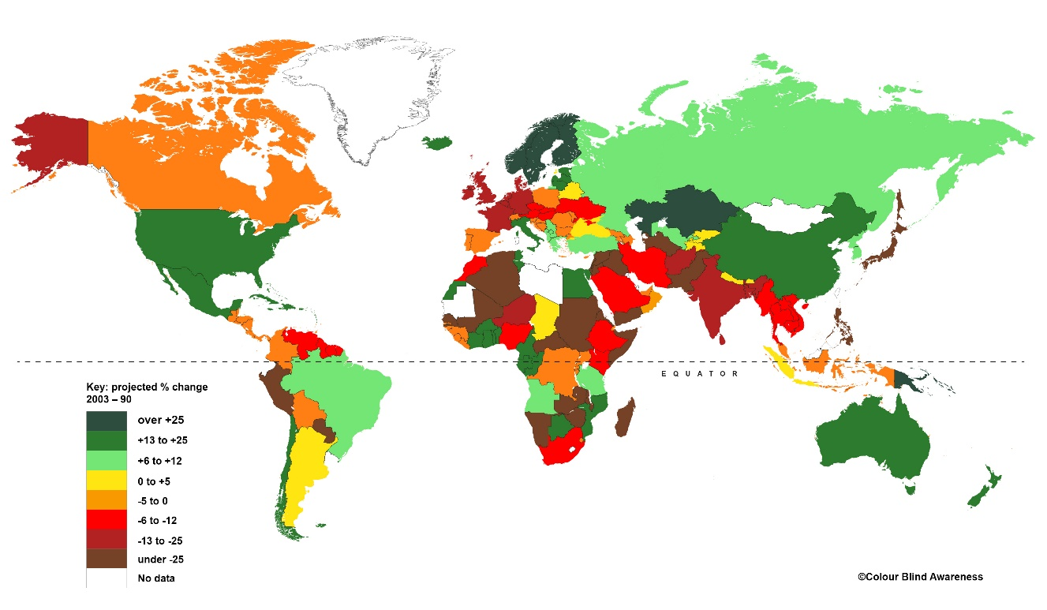
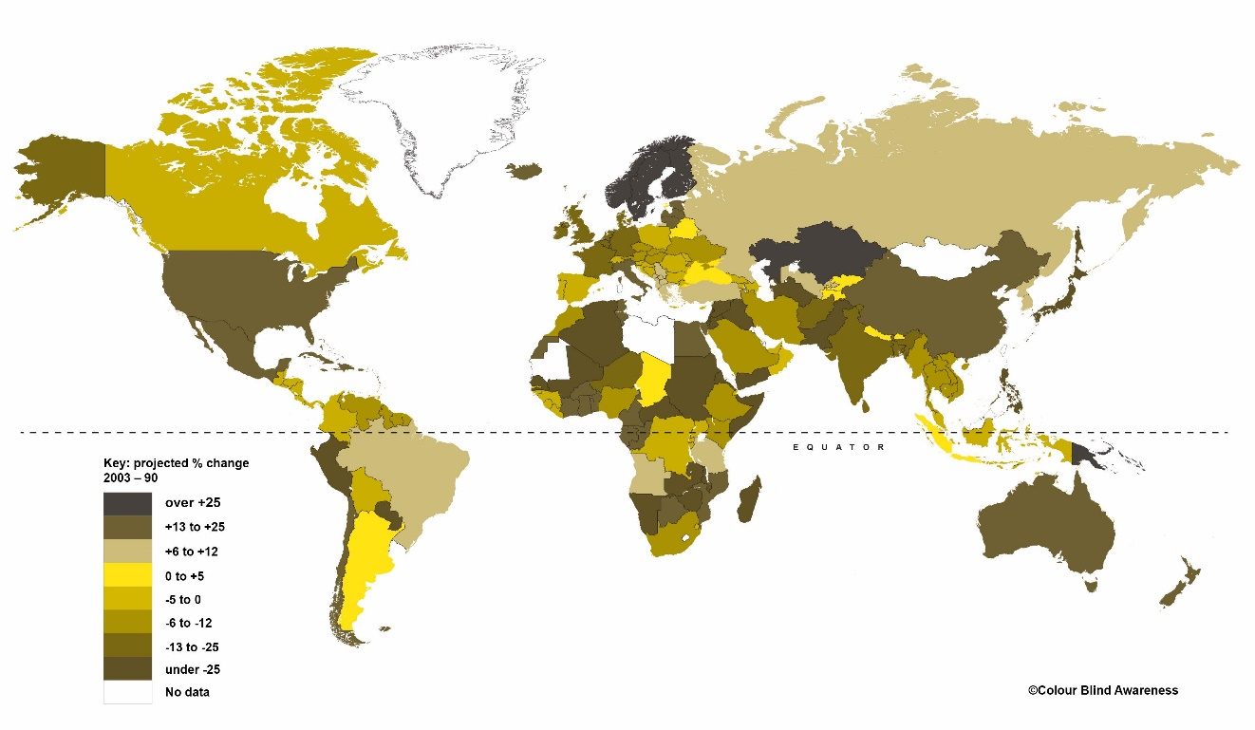

The images below show what a person with unaffected colour vision sees (top image). A simulation of what a person with protanopia might see is on the bottom image.

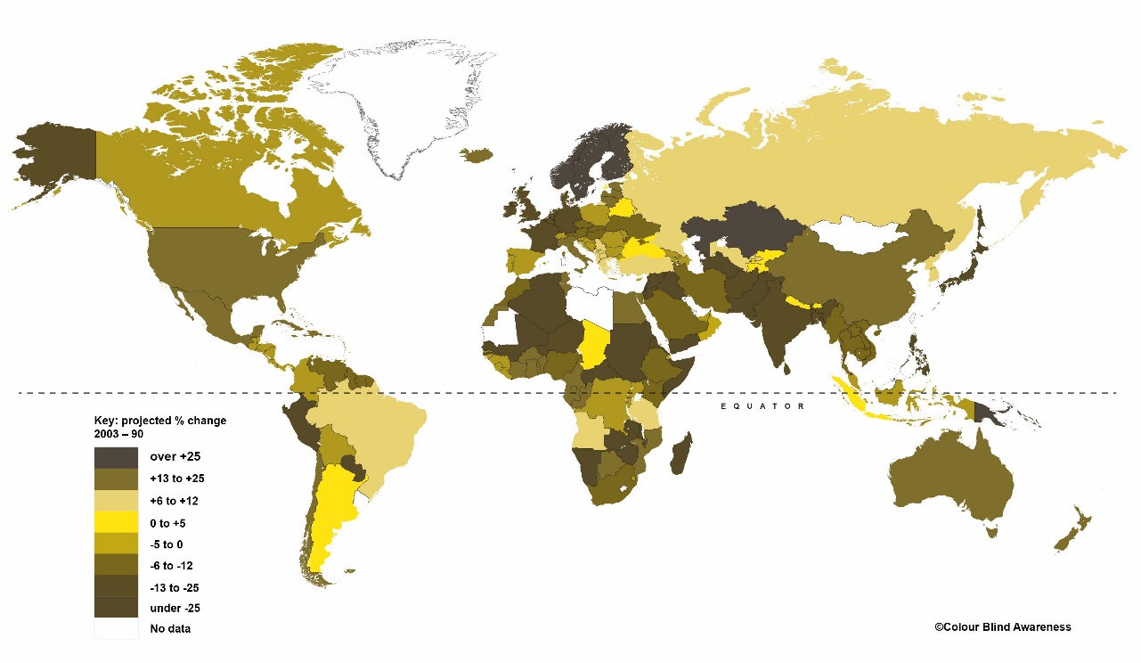

What causes red-green CVD?
Red-green CVD is an inherited condition and therefore runs in families. You inherit genes from your parents. Your genes give the cells in your body the instructions they need to work well and stay healthy. If a gene has a mutation, there is a fault in their instructions and the cells using those instructions don’t work as they should.

The genetic fault that causes red-green CVD is passed on in what’s known as an X-linked inheritance pattern meaning the faulty gene lies on the sex chromosomes.

Each person has two sex chromosomes which determines their genetic sex at birth:
- males have an X and Y chromosome and
- females have two X chromosomes.

In the case of CVD, the colour deficiency gene is found on the X chromosome. A male has only one X chromosome that they inherit from their biological mother. If this has the faulty gene, then they will have CVD.

A female inherits two X chromosomes, one from the biological mother and one from the biological father. If they have a faulty gene on one X chromosome but a normal copy of the gene on the other, they are a carrier of the condition. This means they do not have CVD but can pass the faulty gene onto their children. For a female to be affected by CVD, she will need to inherit the faulty gene from both parents, which happens less commonly.

Red-green CVD is a lifelong condition, which doesn’t improve or get worse throughout life. Whilst CVD does not affect your visual acuity (ability to see detail), it may limit your eligibility to join some professionals or specialist jobs within certain professions. It can also have an impact on education, sport and elements of everyday life where ability to distinguish between colours is essential, for example, accessing information on websites, presentations or documents, shopping, reading maps, and cooking.

Red-green CVD can be easily picked up using traditional colour vision tests such as Ishihara plates, which have been designed to detect the presence of red-green CVD and provide a pass or fail. More specialised occupational tests can be used to check whether someone with a CVD would be able to meet the colour vision standards for certain occupations, for example, where the work requires the ability to accurately read colours of light for safety reasons.

In the UK, school eye tests don’t include screening for CVD. It’s a good idea to ask the optometrist (optician) at your child’s regular eye test about whether your child has had their colour vision tested.

Blue-yellow CVD
Blue-yellow CVD is less common than red-green CVD and occurs when the blue cone cells are affected.
- Tritanopia is where the blue cones are not working at all.
- Tritanomaly is where the blue cones are not working fully.

Blue-yellow CVD affects the ability to see light in the short wavelength (blue) part of the spectrum. This causes confusion between blues, greens, yellows, oranges and violets. The appearance of these colours may also be duller or paler.

The images below show what a person with unaffected colour vision sees (top image). The bottom image is a simulation of what a person with tritanopia might see.

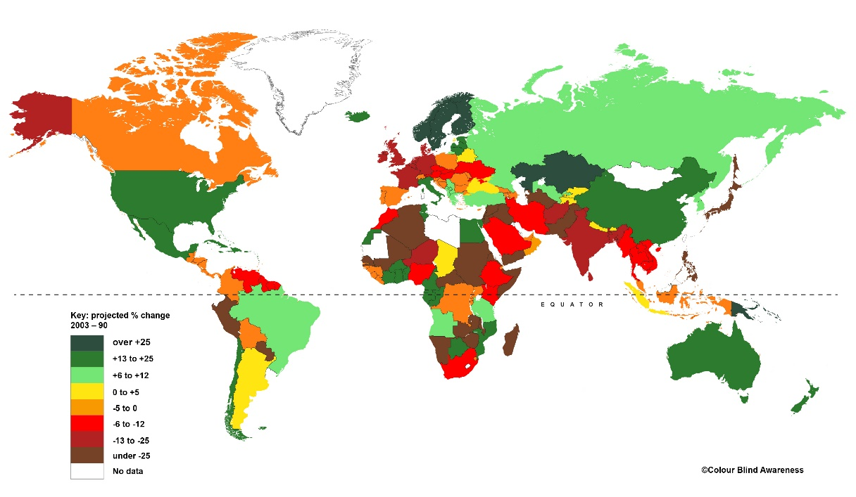

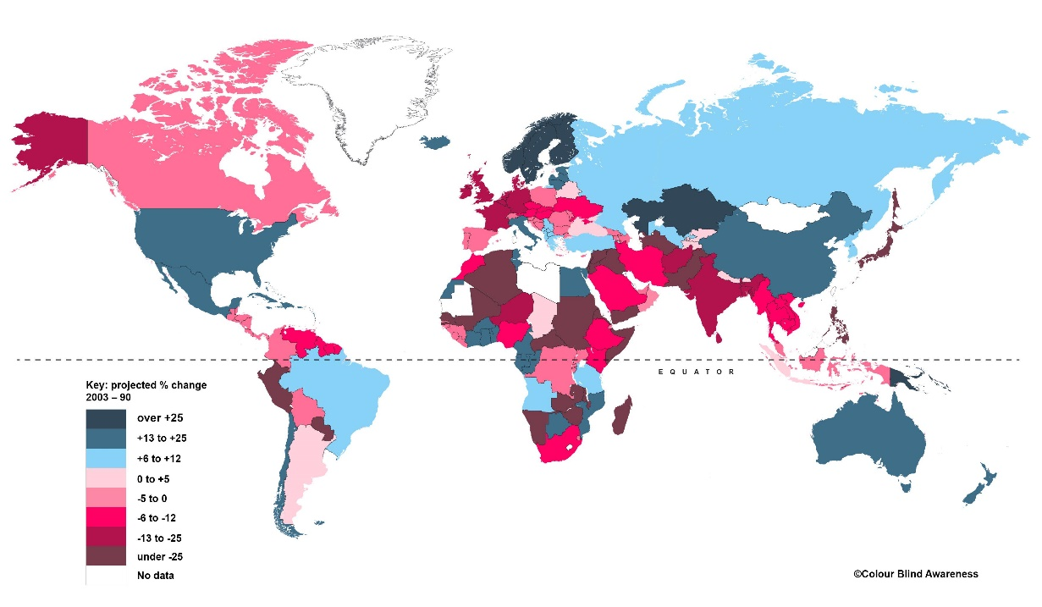

Blue-yellow CVD can either be inherited or caused by other underlying eye or health conditions.

It is not inherited in the same pattern as red-green CVD and is not inherited on one of the sex chromosomes. This means that is affects males and females equally. However, it is still quite rare, affecting less than one percent of people.

Monochromatism and achromatopsia
Monochromatism and achromatopsia are both inherited eye conditions that cause complete colour vision loss.

Achromatopsia
Achromatopsia is a rare inherited condition affecting 1 in 30,000 people. Faults in several genes have been identified to cause achromatopsia. These faults mean that the cone cells cannot work properly.

Cone cells are responsible for seeing detail and colour and therefore people with this condition have difficulty seeing any colour and will also have blurred vision. It can also cause sensitivity to bright light (photophobia), so seeing in daylight can be difficult. It can also cause nystagmus, where the eyes move or ‘wobble’ constantly, and this can also affect vision. How severe these symptoms are can vary between different people, but achromatopsia doesn’t cause total loss of vision and is generally stable over time.

Complete achromatopsia is when the cone cells don’t work at all causing colour blindness. Incomplete achromatopsia is where the cone cells still work to some extent so some colour vision may be present.

Rarely achromatopsia can develop later in life. For example, cerebral achromatopsia can develop due to brain damage caused by a stroke.

Achromatopsia is inherited in an autosomal recessive pattern. This means that to inherit this condition, both your biological parents would have to carry the faulty gene for the condition. If you inherit the faulty gene from one parent but not the other, then you are a carrier – this means you don’t have the condition but could pass on the faulty gene to your children. If two people carry the gene then their children have a 50% chance of being a carrier, 25% chance of inheriting the condition, and 25% chance of inheriting two completely normal copies of the gene.

Blue Cone monochromatism
Blue cone monochromatism is a rare inherited condition where only the blue cone cells are working. It affects less than 1 in 100,000 people.

It causes severely impaired colour vision, blurred vision, light sensitivity and nystagmus from birth. People with this condition are also short sighted (myopic).

It is caused by genetic changes on the X chromosome. This means that it affects males more frequently than females.

How are achromatopsia and cone monochromatism diagnosed?
Both conditions are diagnosed in the same way. An ophthalmologist (eye doctor) will use a range of tests including symptoms, examination of the inside of the eye and electro-diagnostic tests which can be used to check whether the cone cells are working correctly. This type of test is called an electroretinogram or ERG. A genetic test can also confirm the gene involved, which can be helpful in case of future developments in treatment. You or your family may also be able to have genetic counselling.

Is there any treatment for achromatopsia and cone monochromatism?
There is no cure for these conditions at present. Research is looking into potential gene therapy treatment to replace the faulty gene with a healthy copy.

Some adjustments can be made to help manage with these conditions including prescription glasses to correct any short or long sightedness. People may also benefit from wraparound sunglasses to reduce the light sensitivity and provide UV protection. Many people with achromatopsia find that red tinted sunglasses help with light sensitivity.

Low vision aids and assistive technology can help with daily activities. Assessment at a low vision clinic will also be beneficial. For more information call our Helpline or visit rnib.org.uk/low-vision-services.

Further help and support
Most forms of CVD do not affect your visual acuity (ability to see detail) or your visual field (the whole area of vision you have). Therefore, someone with CVD cannot be registered as sight impaired (partially sighted) or severely sight impaired (blind).

However, CVD can impact upon education, playing sport and careers if not properly supported. It’s important to let your child’s schoolteacher know about a diagnosis of CVD so that this can be managed.

The Colour Blind Awareness organisation provides further advice and support for children and families (their contact details can be found below).

Careful consideration of future careers is required as normal colour vision is essential for certain professions and trades. The Colour Research Lab at City, University of London provides accurate colour vision assessments for different occupational environments.

If your child is diagnosed with monochromatism or achromatopsia they will have a reduced level of vision which means they may meet the criteria to be registered as sight impaired or severely sight impaired. It’s completely natural to be concerned and normal to find yourself worrying about what it means now and in the future. We’re here to support you every step of the way, and to answer any questions you may have – just get in touch with our Sight Loss Advice Service.

Having the right support at an early age can make a big difference. Your local authority should have at least one qualified teacher of visually impaired children (QTVI) to work with you and your child both at home and at school. QTVIs are qualified teachers who can provide support with development, play, learning and education. At an early stage, ask your local authority to put you in contact with a QTVI. If you have difficulty getting help or need the details of the specialist teacher in your area, contact our Helpline.

Sources of support

RNIB Helpline
If you need someone who understands sight loss, call our Helpline on 0303 123 9999, say "Alexa, call RNIB Helpline" to an Alexa-enabled device, or email helpline@rnib.org.uk. Our opening hours are weekdays from 8am – 8pm and Saturdays from 9am – 1pm

You can also get in touch by post or by visiting our website:
RNIB
Grimaldi Building
154a Pentonville Rd
London N1 9JE
rnib.org.uk

Sight Advice FAQ
Ask the Sight Advice FAQ website your questions about sight loss and get helpful answers: sightadvicefaq.org.uk

Connect with others
You can meet or connect with others who are blind or partially sighted online, by phone or in your community to share interests, experiences and support for each other. From book clubs and social groups to sport and volunteering, our friendly, helpful and knowledgeable team can link you up with opportunities to suit you. Visit rnib.org.uk/connect or call our Helpline.

Other useful organisations
Colour Blind Awareness
Web: colourblindawareness.org

Look UK
Web: look-uk.org

Guide Dogs
Web: guidedogs.org.uk

Royal Society for Blind Children
Web: rsbc.org.uk

VICTA
Web: victa.org.uk

Special thanks
We would like to thank Colour Blind Awareness, who have supported RNIB by kindly supplying the images and simulations in this factsheet.

Colour Blind Awareness are an organisation advocating for people with colour vision deficiencies which provides support for families and individuals and consultancy to organisations such as schools and businesses. They have a lot of useful information about living with colour vision deficiency on their website.

We value your feedback
You can help us improve our information by letting us know what you think about it. Is this factsheet useful, easy to read and detailed enough – or could we improve it? We would also like your views on the pictures and diagrams, are they appropriate, helpful and are there places where a diagram might have helped?

Send your comments to us by emailing us at eyehealth@rnib.org.uk or by writing to the Eye Health Information Service, RNIB, Grimaldi Building,154a Pentonville Road, London N1 9JE.

Information sources
This factsheet has been written by the RNIB Eye Health Information service. Our factsheets have been produced with the assistance of patient and carer input and up-to-date reliable sources of evidence. The accuracy of medical information has been checked by medical specialists. If you would like a list of references for any of our factsheets, please contact us at eyehealth@rnib.org.uk.

Our factsheets are available in a range of formats including print, audio and braille.

RNIB is a member of the Patient Information Forum (PIF) and have been certified under the PIF TICK quality mark scheme.

Produced date: July 2023
Review date: July 2026

End of document.

