People’s experiences of accessing Eye Care services

Context

RNIB are working to innovate an Eye Care Support Pathway which will result in better support for people experiencing changes in their eye health or those with long-term eye health conditions and/or sight loss.

From the moment someone realises that ‘something isn’t quite right’ with their sight, through to diagnosis and being able to live confidently with their condition, we want it to be easy for anyone to get clear information, support and to better understand what happens next.

We know from previous research, including an Anglia Ruskin University report¹ and listening to customers via our helpline, that it is often difficult to access eye health and sight-loss information, services, and support. NHS England recognise the clinical pathway is complex and difficult to navigate and that currently there is no built-in pathway of support. It is a similar picture across the UK.

This report summarises the findings from speaking to approximately 400 people between September and December 2022. This was done with the support of UK wide organisations representing people with a range of eye health conditions including cataracts and glaucoma through to organisations supporting people with sight loss. The meetings were either in person, online or on the telephone. The purpose of the conversations was to hear people’s own stories first hand, to understand the main ‘pain points’ along the pathway and where future improvements should be focused.

Once we collected and collated people’s feedback we used this information, alongside our existing evidence base, to develop a detailed pathway. We also used several of the sessions to scope and test whether creating a digital pathway tool (for example an app) would be helpful and if so, what sort of information people would like to see within a digital tool.

People were generous and open about their experiences, and we would like to thank them for their time and insight. We would also like to thank the following organisations for their support with this work:

The table below has 3 columns and 7 rows.
Forth Valley Sensory Centre | RNIB Scotland | London Vision
Visionary | My Sight Notts | Vision Norfolk
Retina UK | Glaucoma UK | Vista (Leicestershire)
Support 4 Sight (Essex) | Vision North Somerset | My Sight York
MY Sight Notts | Sight Life Wales | My Vision Oxfordshire
4 Sight Vision Support, West Sussex | Vision and Hearing Support Gateshead | Henshaws (Greater Manchester)
Beacon Vision, Wolverhampton | RNIB | Blind Veterans UK

Pathway findings

Pain points
From our research, discussions with eye sector charities, the NHS, and many conversations with people with lived experience, we have identified a number of ‘pain points’ across the pathway. Pain points are where people experience a problem and may include a lack of information, a delay, a lack of clarity with what happens next and poor communication. We found challenges like these right across the pathway.

Through our UK wide engagement, we mapped pain points across the pathway and then collated them into 4 key stages. At every stage we found people experienced problems and challenges. These include waiting for appointments, inaccessible appointment letters etc.

The diagram below shows the key stages along the pathway and the three key themes that came out of the information collected from the sessions and from our insight work.

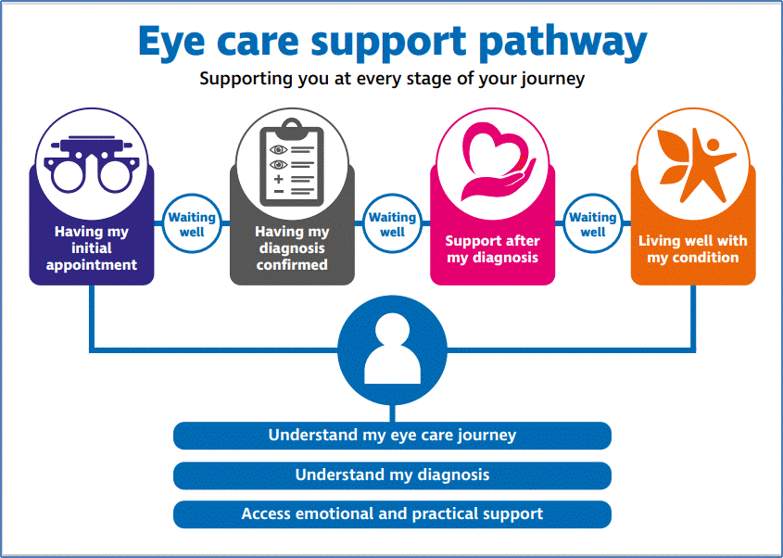
Diagram of the Pathway

The experiences people described in the conversations were their own and unique to them.

One participant commented:

“… it reminds us that many people have a very different experience of sight loss. It can be easy to forget that we all walk in different shoes.”

However, there were common themes found throughout the conversations with many examples of people facing similar challenges accessing services and information.

Having my initial appointment: pain points
People discussed their first port of call being the GP or more likely, a high street optician. Participants described a lack of information at the initial appointment stage and a feeling of 'not knowing what was next.’ Participants spoke of time pressures on opticians which resulted in a lack of information being provided. Other participants spoke of opticians not being able to offer advice which could be frustrating and that tests were sometimes carried out with little explanation of the purpose. People felt that clinicians should not assume ‘patients don’t want the detail’ as many of them do want to know the specifics of their condition, treatment etc.

Information is key. It needs to be accessible, digestible, tailored, available right at the start and always there when needed.

“Every person with sight loss shouldn't have to be the biggest detective of their life finding information, there should be something where they can just go, ‘a go to place’ and that's it.”

Waiting: pain points
Waiting happens at every stage of the pathway with participants speaking of the initial wait to see a specialist as being a significant issue. Waiting for a diagnosis is inevitability a time of stress and worry.

One participant spoke of waiting twelve weeks from the initial appointment for tests and a diagnosis. The person described being in a ‘’black hole” not knowing what was going to happen next.

Others spoke about letters being in a format that was inaccessible and that letters could and should give a clear picture of what tests would involve.

Participants talked about a fear of the unknown, from visiting the optician to receiving a hospital referral. People said at the point of referral information on wait times, process, possible tests etc. would have been extremely helpful.

Having my diagnosis confirmed: pain points
For many of the participants, the point of diagnosis was one of the most emotionally difficult experiences, with people recounting their personal stories during the conversations.

One participant spoke of tests being done with little explanation of the purpose and, with hindsight, they wished they had been better prepared and asked more questions. They felt they were not treated as a whole person as no-one asked about their general health or how they were feeling. They said the hospital could have put their “eyes in a dish for them to look at” as they felt there was little empathy around their feelings of anxiety. They felt as though the focus was solely on their eyes and not on them as a whole person.

Another person recounted that they were registered blind in 1999 but didn’t get a confirmed diagnosis until 2022. They were told it was incurable and untreatable “and that was it, bye-bye”. There was no follow up. They said, “there was nothing they could do” and they didn’t know where to turn to for support.

When diagnosed, people need information and support to help them prepare for a change in their sight. People need time to ask questions and feel listened to. Diagnosis is an emotional experience with emotions ranging from anger, despair, and depression. It is critical that people receive support at this stage.

“It does have a profound impact on your mental health and it's not knowing where to go. I think you just want information so you can find out what is going to happen to you.”

Support after my diagnosis: pain points
Finding support makes a huge difference to people, both at the point of diagnosis and after. This was one of the key topics of conversation in all the sessions.

One participant recalled after diagnosis that she felt she didn’t get any further information until she managed to see an Eye Care Liaison Officer (ECLO) and then it was

“like a whole block of concrete came off me”.

Another participant spoke about a friend mentioning a local support organisation and meeting an ECLO. They noted that everything changed for the better.

‘All she really wanted was someone to speak to about her condition and treatment; the ECLO offered her that support’.

Our evidence is that ECLOs have a key role in supporting people during and after a diagnosis as they offer an opportunity for people to speak about their condition, treatment and support available. However, not all people have access to an ECLO in their area.

Other participants spoke about their difficulty finding support services that could help them.

“People need to be put in the know about local provision, not knowing what is out there is the hardest thing.”

When services and support have been found it has made a huge difference to participants.

One participant was emotional while speaking about their experience after diagnosis of severe sight loss and commented that they never used to talk about their feelings and did not want to ‘worry’ those closest to them by sharing their thoughts. They sought support through speaking to friends; they in turn found a local support organisation where they could meet people in a similar situation.

The opportunity to talk to others was described as a ‘game-changer’ as they realised there were others experiencing the same sort of feelings. They became emotional when sharing their story as they said they know there will be people going through the same thing and had they found support earlier it would have “made living easier.”

Living well: pain points
Many of the 400 participants were living with significant and permanent eye heath conditions. They talked about how they had come to terms with their condition and adjusted their lifestyles. One participant reflected that whilst they didn’t have the support they needed at that time, they now feel well supported by local services. Another reflected that they took time to accept the diagnosis and with the support of family, friends and services were eventually able to get on with their life.

Participants recognised the importance of early access to support as this may have enhanced their quality of life living with changes in their eye health and/or sight loss.

Pathway: support requirements
Through the 400 conversations, RNIB’s research and ongoing discussion with external stakeholders such as the NHS, 3rd sector and Social Care, we have identified three key support themes which together can create an effective support pathway. These themes apply to every stage of the pathway they are:
- I understand my eye care journey.
- I understand my diagnosis
- I access practical and emotional support.

In themes ‘I understand my eye care journey’ and ‘I understand my diagnosis,’ the conversations highlighted that services need to be connected and fit for purpose. Accessible information is critical and needs to be available right at the start and there when people need it most. It is critical that the individual is at the centre of services, both treating the condition and supporting the person.

“I think there should be less focus on the medical aspect of it all and more on me as a whole person. I am more than a medical condition.”

Interacting with health and care professionals is really valued – whether that is face-to-face medical appointments, in-person support and care, or contact with others with lived experience.
Delivering potentially life changing information with empathy is essential.
Practical and emotional support should be offered right from the start and available as needed.

“You need help and support quickly – if not you can be in the wilderness for some time.”

Support should be an integral part of the pathway so that people can seek help at a time that is right for them and take away information to think about and access when they are ready. Existing channels such as accessible appointment letters could and should be a straightforward way to signpost available support, whether it is other Third Sector organisations, Local Councils etc.

“From the high street optician, to engaging with Local Authorities, accessible information should be given guiding people through available support even it’s just one phone number, that’s gold for someone with no information or support.”

Support should be available while people are waiting, not just during treatment or accessing services and for example, losing a driving licence and a result, independence.

As well as practical elements, such as technologies, support should cover the emotional and psychological aspects of eye health and sight loss. Counselling should be condition-specific rather than general. Peer support is also of huge value and should be built into the pathway. Speaking to people in a similar situation is life changing.

Development of the pathway: next steps
As a result of the insight from the conversations, our work with NHS sector partners and our own research we are now working on 5 key areas. These are:

- Eye Care Support pathway document co-produced with sector partners including the NHS, sight charities and people with eye health conditions and sight loss. This will be a model support pathway which can be integrated alongside any eye related clinical pathway.
- Eye Care Support Pathway Digital tool(s) development. During November to February, building from the conversation sessions, we worked with a small group of people with sight loss to explore what digital content and tools might support anyone going through the pathway. Work is progressing to take this forward.
- Eye Care Support Pathway insight report. We are pulling together a full report from all our research and insight work with key stakeholders.
- Pathway support improvements. We have a detailed plan of where we want to improve the support components of the pathway, with a focus on the beginning of people accessing services. This includes resources available in a variety of formats; people told us they would value information in paper format as well as digitally.

- We will continue to engage and consult on Pathway activity. This is a work in progress and its value comes from listening to people with lived experience.

Snapshot Report, May 23

References

- Sight loss pathway: Final report, Anglia Ruskin University, Vision and Eye Research Institute (2022) Report for RNIB

Document ends.

