# Smart Glasses Final Report

July 2016

**By:**

Tara Alexander: Senior Project Manager

Jo Arthur: User Experience Coordinator

Ranila Chandrakanthan: User Experience Coordinator

Sabine Croxford: User Experience Evaluator

Lori Di Bon Conyers: User Experience Evaluator

**Please note:**

**This report may only be reproduced in its entirety and not in part.**

RNIB Solutions, Design and Usability Team, Digital Accessibility, Bakewell Road, Orton Southgate, Peterborough, PE2 6XU

[nppd@rnib.org.uk](mailto:nppd@rnib.org.uk)

**Contents**

1.0 Executive summary 4

1.1 Background and information 4

1.2 Observed user testing 5

1.3 Take home testing 5

1.4 Overall conclusions 7

1.4.1 Indicators of benefit 7

1.4.2 Other factors impacting acceptability of the glasses 8

1.5 Recommendations 9

2.0 Observed user testing 11

2.1 Results from the observed user testing 11

2.2 Subjective feedback from participants 15

2.3 Preferred Mode 16

2.4 General comments on Smart Glasses from observed user testing 16

2.5 Conclusions following observed user testing 17

3.0 Take Home Trial 19

3.1 Results from the take home trials 19

3.2 Quotes from participants 24

3.3 Conclusions following take home trials 25

4.0 Comparison of results 25

4.1 Age range 26

4.2 Sight level 27

4.3 Field of Vision 28

4.4 Visual Acuity 29

4.5 Profile of Smart Glasses beneficiary 31

5.0: Appendix 1: Description of the Smart Glasses 33

6.0 Appendix 2: Observed testing – methodology 36

6.1 Familiarisation 37

6.2 Hand eye coordination test 39

6.3 Mobility test 41

6.4 Outside test 43

7.0 Appendix 3: Observed testing – demographics and charts 44

7.1 Visual Acuity 44

7.2 Visual Acuity versus subjective mode preference 49

7.3 Subjective sight level 51

7.4 Subjective sight level versus mode preference 55

7.5 Subjective field of vision 57

7.6 Sight loss conditions 61

7.7 Age range 65

8.0 Appendix 4: Take home trial – methodology 66

8.1 Selection for take home trial 66

8.2 Receiving feedback from participants 68

9.0 Appendix 5: Feedback from Take home trial 70

9.1 Subjective Feedback 70

9.2 Design Feedback 71

9.3 Technical Feedback 72

10.0 Appendix 6: Take home trial – demographics and charts 73

10.1 Visual Acuity 73

10.2 Visual Acuity versus subjective mode preference 74

10.3 Subjective sight level 76

10.4 Subjective sight level versus mode preference 78

10.5 Subjective field of vision 79

10.6 Sight loss conditions 80

10.7 Age range 83

10.8 Modes 84

11.0 Appendix 7: Lessons learnt 94

11.1 Logistics of the observed testing 94

11.2 Logistics of the Take home trial 94

11.3 Variables 95

11.4 Filter from Observed testing 97

11.5 Filter from Take home trial 97

11.6 Zoom and field of view from Observed testing 98

11.7 Zoom and field of view from Take home trial 98

## 1.0 Executive summary

### 1.1 Background and information

There are over 30 million blind people worldwide and up to 300,000 in the UK. Many face restricted social lives, reduced work prospects and lower independence due to difficulties in performing everyday tasks. Over 90% of these individuals have some useful remaining vision and our partners at the University of Oxford have been carrying out fundamental research into low-cost and non-invasive wearable technologies based on depth cameras and see-through displays to enhance sight for obstacle avoidance, face recognition and object recognition. Funding from the Google Impact Challenge in 2014 allowed us to build and test this technology, and taking it out of the lab and putting it into the hands of the public for the very first time.

The “Smart Glasses” used in this project are an augmented reality display system that assists people with severe sight loss to make sense of their surroundings. They were designed by the Nuffield Department of Clinical Neurosciences at Oxford University, and they work by using cameras and a computer processor to simplify the visual scene and increase its visibility through enhanced contrast and brightness.

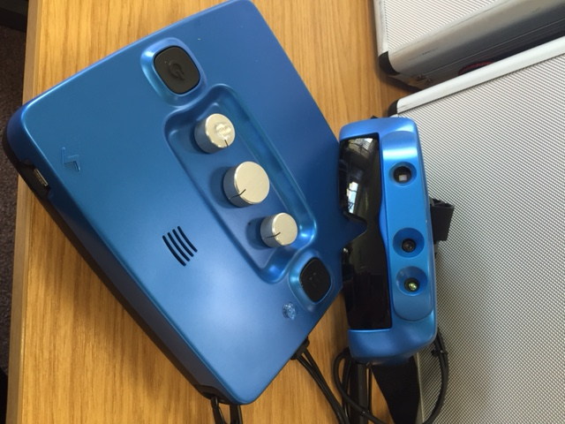The Smart Glasses unit is made up of a headset and a control box which are connected by a cable. The Smart Glasses allow the user to change between five ‘modes’: the first two modes use an infra-red camera and show the world in monochrome. These modes are most useful for low or indoor light. The last two modes use a regular (visible light, RGB) camera and can therefore be used outdoors. Mode 3 uses data from both cameras. Only mode 5 displays the visual scene in colour. Further details about the Smart Glasses can be found in Section 5.0, Appendix 1.

Initially our participants were invited to take part in ‘observed’ user testing in a lab setting. These sessions were led by a trained observer and included a familiarisation session of approximately 45 minutes followed by a series of tasks carried out both with and without the Smart Glasses to assess their benefits.

Following this, participants who had successfully utilised the Smart Glasses were invited to take part in the ‘take home’ user testing, where they would use the glasses in their own home for a period of 3 weeks.

### 1.2 Observed user testing

From June 2015 to January 2016, 221 people took part in the observed user testing. Following the familiarisation session, participants were asked to try the Smart Glasses in a controlled environment and use them for different tasks while researchers noted any problems that they faced and ensured the safety of the participant at all stages. We collected information about the visual status of participants to help us identify what factors determine whether the glasses will be beneficial for a particular participant or not (for example, sight loss condition, visual acuity and visual field).

Overall, of the 221 participants, 99 (45% of 221) people were shown to either have some measurable benefit, or have a similar experience when wearing and not wearing the glasses. Of these, 46 (21% of 221) were shown to have a measurable benefit from using the glasses and 53 (24% of 221) were shown to have a similar experience with and without the Smart Glasses.

We also asked the test participants whether they felt that they benefitted from the glasses, regardless of how well they completed the tasks. Of the 221 participants, 91 (44%) said that they felt that they benefitted.

Based on the findings from the observed user testing, we found that there was no single clear predictor (e.g. sight condition, visual field, visual acuity) of which of the participants would show benefit from the Smart Glasses.

### 1.3 Take home testing

Following the observed user testing, participants were asked if they would like to take part in the take home trials where they would be able to use the Smart Glasses at home for 2-4 weeks. This testing allowed us to collect more data regarding the benefit of day-to-day use of the glasses. In addition to self-reported benefit by the participants, this included data logged on the glasses regarding how often and for how long the glasses were used and which modes were favoured.

From the 46 people who had measurable benefit, 43 people were interested in trying the glasses at home. From the 53 people who had a similar experience with and without the Smart Glasses, 31 people were interested in taking part in the take home trial. One additional participant also joined the trial at this stage giving us a total of 75 participants who were suitable to take part in the home trial.

Of these 75 people who were invited to take part in the take home trials, 20 declined because they were either unavailable or no longer believed that they would benefit from the glasses.

Of the 55 people who took part in the take home trial, 35 participants reported that they definitely found the Smart Glasses beneficial following the completion of their take home trial. The other 20 participants had various issues with the Smart Glasses, not all of which were clinical issues. For example, the size, weight and bulk of the glasses were more of a factor when using the glasses over a longer period. 11 out of these 20 participants withdrew from the trial before completing the 3 weeks.

Looking at the usage logs of the glasses, participants who benefitted from the Smart Glasses used them for almost twice as long as those who were unsure following their trial. For participants that received benefit the time spent across their 3 week trial period varied widely. Even when participants reported benefit using the Smart Glasses, the time they spent using them was sometimes still quite limited.

Mode 5, which is the only full colour mode, was used over twice as much as any other mode. Participants also reported this as the most beneficial mode during the take home trial.

To summarise, shown below is a funnel chart with the number of participants at each stage of the testing. Each stage is represented in a different coloured level and the size of levels decrease as the number of participants becomes smaller.

**Chart 1.1 The number of people at each stage of testing**

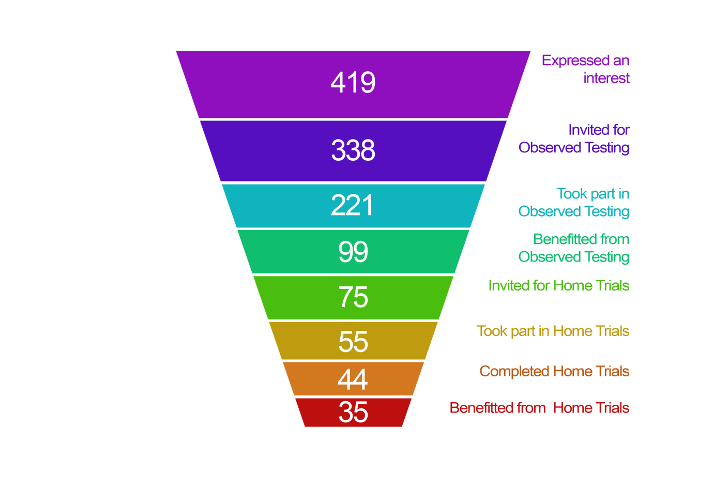

### 1.4 Overall conclusions

#### 1.4.1 Indicators of benefit

Due to the design of the Smart Glasses display being a small rectangle within the central point of the visual field, we expected people with some remaining central vision to get more benefit than those with only peripheral vision. We did find a marked difference between the number of people who benefitted with peripheral vision loss and those with central vision loss. However, as the visual field information was gathered through self-report it was not possible to determine more fine-tuned visual field properties that would predispose a participant to benefit from the glasses or not. The categories we used to determine field of vision (central vision loss, peripheral vision loss, loss in both and unknown) were far too broad to allow us to draw conclusions as to why some people with central vision did not benefit from the glasses.

The user testing showed that people with many different sight loss conditions could potentially benefit from using the glasses. Of the participants who did benefit, RP was the most represented sight loss condition. Across all sight loss conditions, those that tend to have some residual central vision (RP, Optic Nerve Damage and Cataracts) contained more participants that benefitted from the Smart Glasses than did not benefit.

During the testing, we ranked the severity of people’s sight loss with a rating from Low to Very High. We found that people from each group benefitted from using the Smart Glasses, although, as could be expected, people from the ‘Very High’ category, who therefore had more useful sight, benefitted slightly less from the glasses.

Many people do not know, or have accurate details of, their sight loss condition or visual field. It would have helped this study to have every participant take individual comprehensive clinical sight examination on the day of their observed testing session. This would have dramatically cut the number of people that could have completed testing, as there would be further restrictions on locations and the cost per participant would be higher.

Age was more of an indicator of benefit. A higher percentage of younger participants (aged 19-39) reported a subjective benefit when first using the glasses. However, more participants in the age range of 19-64 showed a measurable benefit. This could be as a result of the nature of the product. As it is a high technology device, younger people might be more inclined to both try and use the Smart Glasses.

The results also show that two people with similar characteristics, for example, age, gender, visual field, visual acuity or sight loss condition, may not have the same experience when using the Smart Glasses. However, considering the participants who showed measurable benefit from the glasses after the observed testing and the take home trial, there are some common trends and characteristics within these groups. The profile of the typical participant who is most likely to benefit from the glasses is between the ages of 40 and 64, with RP, with any visual field profile except central sight loss, and a sight severity level of medium.

#### 1.4.2 Other factors impacting acceptability of the glasses

As we know that people with the same sight loss condition, sight loss, visual field or visual acuity might not experience the same benefit from the Smart Glasses, we cannot give clear guidance to narrow down those who are interested in using the glasses. When introducing the glasses to test participants, the glasses could not be used without a familiarisation session, conducted by a trained assessor, where the controls and usage of the glasses were explained. This version of the glasses should be seen more as a prescriptive solution for some people, rather than an off-the-shelf solution, and could be an addition to the Low Vision Assessment that is currently used to find the most suitable low vision aids.

Following the take home trials, many participants reported that being given the opportunity to take the glasses home with them and use them independently was very beneficial. Using the glasses gave participants an improvement in their quality of life and general confidence. For example, some reported that they felt more socially involved after wearing the Smart Glasses. One participant stated:

“The last few weeks have changed my social life completely. I have been out more than I have in the last few years. I can actually see people’s faces, in this way it is easier to talk to them and is definitely a rewarding experience.”

A number of participants felt that the glasses provided them with a feeling of safety, as they were aware of their surroundings and nearby dangers. Another participant stated that the glasses made him feel safe:

“I know there's a threat, and I know there's something there. Feels like I can control my own space.”

Some participants reported that even if they had a benefit using the Smart Glasses, this does not ensure that the glasses would always be useful to them in a real life environment. For example, within a familiar environment, participants reported having coping strategies in place already which nullify the benefit that using the Smart Glasses may have. Conversely, using the glasses in an unfamiliar environment brings other issues, such as safety, and a potential requirement for extra mobility training.

Similarly, the weight and bulk of the glasses were not too intrusive in the lab environment, but they were reported to be far less acceptable when used for longer periods of time, or when out and about.

As the benefit of using the glasses might not necessarily translate to usefulness outside of the testing environment, a loan period equalling or more than the period used in the take-home trials (three weeks) is recommended to show if the glasses are actually helpful and useful to a person in their daily life.

### 1.5 Recommendations

As the Smart Glasses gave demonstrable benefit to people across all eye conditions, it is recommended that more work be carried out to bring these to market.

**Methodology for further research:**

* When measuring benefit, there should be a sliding scale, rather than only allowing answers of yes or no. For example, benefit could be measured on a scale of 1 to 5 to allow a better indication of the life changing benefit for the users. In this way it would be possible to better determine when the benefit does not outweigh the disadvantages of setting up, wearing and adjusting the glasses.
* A more detailed visual field assessment should be carried out for each participant so that more reliable indicators of sight loss are available.
* More useful feedback could be obtained from participants who are prepared to use the glasses over a longer period of time, to gauge how often the glasses are used after the initial “honeymoon” period.
* More accurate conclusions could be drawn by reducing the number of variables in the testing, for example focussing on just one mode or one sight loss condition.

**Glasses physical design**

* Both the glasses headset and control box should be made smaller and lighter if possible.
* The design of the dials on the control box should be reconsidered. A tactile pointer and a number of tactile marks around the dial could be introduced to assist people in identifying the dial’s current setting.
* There should be a clear indication on the control box showing which mode is selected.
* The design of the filter should prevent it falling out accidentally and the filter should be easy to fit.
* There should be clear audible and visual indications when the battery is running low.
* Any power switches (including the master power switch) need to be easy to use in order to conserve battery.
* A zoom function of better quality (for example if a HD camera is used) would be beneficial for clarity and magnification purpose.
* A larger screen size (currently only 23 degrees, in the centre of the field of view) would be able to be used by people with more eye conditions. People with a good level of acuity in their peripheral vision would be able to see the screen.
* A larger screen size would also mean that those who can currently see the screen would have a larger field of view. The small field of view affects mobility and carrying out other tasks. Displaying an equivalent image to natural sight would be beneficial.

## 2.0 Observed user testing

The initial recruitment of participants resulted in 419 people expressing an interest in taking part in the Smart Glasses trials. All these people were contacted to obtain more information on their sight condition and location. If they had no residual vision, or had too much (for example, they could still drive a car), we excluded them from the trail.

20 locations for testing were identified throughout the UK, based on the largest number of potential testers living in the vicinity. This information led us to offer 338 people a chance to take part in the trials. 95 people could not take part in the testing for a number of reasons, including eyesight that had deteriorated below our criteria for inclusion in the trial.

A total of 243 people took part in our observed testing sessions. 221 of these carried out a user trial of the Smart Glasses in a controlled environment supervised by RNIB members of staff. 22 people were invited to take part in a slightly different set of tests supervised by Oxford University (See “Familiarisation with Residual Vision Glasses has the Potential to Improve Mobility in Visually Impaired People” by Merit Bruckmaier, available on request from Oxford University, 13 April 2016). This report will focus on the 221 people taking part in the RNIB trials.

### 2.1 Results from the observed user testing

**Familiarisation**

Before beginning the tasks, participants were given a 45 minute ‘familiarisation’ session. Participants were guided through each mode by the observer and they gave their initial thoughts on the glasses. 101 (46%) participants reported that found benefit from the Smart Glasses and 92 (42%) reported that they could see better without the glasses at this stage. 14 (6%) participants were unsure if they received benefit or not and 14 (6%) participants did not answer the question as it was added after testing had begun. Following the familiarisation session, 49 (22%) participants decided not to continue with the tasks.

**Hand Eye Coordination Test**

During the testing, a task was devised where participants were asked to count and identify objects on two sets of tables with and without the Smart Glasses. Of the 221 participants, 172 carried out this test, while 49 people could not, as they were not able to use the smart glasses for this purpose.

We scored participants on how many objects they could identify on the tables.

Of the 172 participants who carried out the tasks, 45 (26%) participants performed the tasks better with the Smart Glasses and 98 (57%) performed the tasks better without the glasses. A further 29 (17%) performed the same with both their natural sight and the Smart Glasses.

These tasks were carried out using Modes 3 and 5 as these were deemed to be the most useful modes for hand eye coordination tasks. This is because Mode 3 gives the most detail while still providing information on depth and Mode 5 allows participants to use any remaining colour vision. The majority of people who benefitted from the glasses found Mode 5, colour Mode, most useful (30 out of 45 = 67%) and 4 people found both Mode 3 and Mode 5 useful (9%).

**Mobility Test**

For the mobility tasks, an indoor obstacle course was put together. Participants were asked to compare identifying and avoiding the obstacles in a room with and without the Smart Glasses. We scored participants on the number of objects they could identify.

Of the 221 participants, 164 people carried out this test and 57 people could not, as they were unable to use the glasses for this purpose. This is slightly fewer people than successfully completed the hand eye coordination test, as more people struggled with mobility in general.

Participants were asked to choose from Mode 1 or 2 and completed the tasks using this Mode and then carried out the tasks with Modes 3 and 5. Of the 164 people who carried out the tasks, 51 (31%) participants performed the tasks better with the Smart Glasses and 101 (62%) performed worse with the Smart Glasses. A further 12 (7%) people performed the same using natural sight as with the Smart Glasses. People who benefitted from the glasses found Mode 5, colour Mode, most useful (34 out of 51 = 67%), followed by Mode 3 which was preferred next (10 out of 51 people = 20%).

**Outside Test**

For the outside tasks, participants were given the opportunity to try the Smart Glasses outside using Modes 4 and 5. Participants were asked to compare identifying and avoiding the obstacles in the street with and without the Smart Glasses. Of the 221 participants, only 75 people carried out this test and 146 people could not, as they were either unable to use the Smart Glasses for this purpose, or as a result of the weather, restrictions of the testing locations or non-visual problems with mobility.

Participants carried out the tasks with Modes 4 and 5 as these are most suitable for outside conditions. Of the 75 people who carried out the tasks, 24 (32%) participants performed the tasks better with the Smart Glasses and 42 (56%) performed worse with the Smart Glasses. A further 9 (12%) people performed the same using natural sight as with the Smart Glasses. People who benefitted from the glasses found Mode 5 most useful and this was preferred by 15 participants (63%) and Mode 4 which was preferred by 10 participants (42%).

**Overall Results**

The Smart Glasses were subjectively liked by 91 of the 221 test participants (41%) and could potentially be beneficial to this group. 46 participants displayed an increase in observer-rated task performance (21%). To be considered to benefit from the glasses, participants needed to show an improvement in performance with the Smart Glasses during more than one of the tasks.

**Table 2.1 The number of participants who experienced measurable benefit during each task and overall, out the total test participants (221).**

|  |  |  |  |  |  |
| --- | --- | --- | --- | --- | --- |
| **Question** | **Yes** | **No** | **Same** | **Inconclusive** | **Did not complete task** |
| Did the participant show measurable benefit during the hand eye coordination task? | 45 (20%) | 98 (44%) | 29 (13%) | 0% | 49 (22%) |
| Did the participant show measurable benefit during the mobility tasks? | 51 (23%) | 101 (46%) | 12 (5%) | 0% | 57 (26%) |
| Did the participant show measurable benefit during the outside task? | 24 (10%) | 42 (19%) | 9 (4%) | 0% | 146 (66%) |
| Did the participant show measurable benefit in more than one task during observed testing? | 46 (21%) | 118 (53%) | 53 (24%) | 4  (2%) | 0% |

**Sight loss condition**

As shown in the table below, the sub-group of participants with RP (18 participants) showed the highest percentage of participants who benefitted from the glasses. In the group of people who performed better in tasks when not using the glasses, participants with MD were the most represented, with 35 participants not showing benefit. However, it is true for all conditions that more people performed better without the glasses than with them.

**Table 2.2 The results of the observed testing by sight loss condition in numbers and percentages**

|  |  |  |  |  |  |
| --- | --- | --- | --- | --- | --- |
| **Objective benefit vs condition** | **Better with glasses** | **Better without glasses** | **Same with and without** | **Unknown** | **Total number of participants** |
| **RP** | 18 (32%) | 26 (46%) | 10  (18%) | 2  (4%) | 56  (100%) |
| **MD** | 4  (9%) | 35 (76%) | 6  (13%) | 1  (2%) | 47  (100%) |
| **Glaucoma** | 3  (7%) | 22 (54%) | 16  (39%) | 0% | 41  (100%) |
| **Cataract** | 8  (24%) | 17 (50%) | 9  (26%) | 0% | 35  (100%) |
| **Optic nerve damage** | 3  (25%) | 5  (42%) | 4  (33%) | 0% | 11  (100%) |

**Age**

Participants under the age of 65 were more likely to perform better when using the glasses than those above that age, although the numbers in the lower age groups are smaller. We had more participants take part in the study between the ages of 40 and 84.

**Table 2.3 The results of the observed testing by age range in numbers and percentages**

|  |  |  |
| --- | --- | --- |
| **Age range** | **No of participants who the researchers felt objectively could benefit** | **Percentage** |
| Under 18 | 1 out of 2 | 50% |
| 19 – 39 | 16 out of 24 | 67% |
| 40 – 64 | 52 out of 99 | 53% |
| 65 – 84 | 24 out of 84 | 31% |
| Over 85 | 4 out of 12 | 33% |
| **Total** | **99 out of 221** |  |

**Filter**

The majority (68% out of 69 people who were asked if they felt the filter was beneficial) preferred to use the glasses with the filter. They felt it was easier to focus on the image projected in the glasses and that the filter reduced glare for those people who are sensitive to bright light.

### 2.2 Subjective feedback from participants

Subjectively when asked at the end of the testing if they thought they would benefit from the Smart Glasses, out of the 221 in testing, 91 participants (41% of the 221) said that they did benefit, 102 (46% of the 221) participants did not benefit from using the glasses and 28 (13% of the 221) were not sure or did not answer this question.

**Table 2.4 the number of participants the received benefit from the Smart Glasses**

|  |  |  |  |  |
| --- | --- | --- | --- | --- |
| **Question** | **Yes** | **No** | **Same** | **Unknown** |
| Did the participant feel that the glasses were beneficial? | 91 (41%) | 102 (46%) | 0 | 28 (13%) |

28 people decided not to continue with the Observed testing so were not asked about their overall experience with the Smart Glasses. However, for the majority of these it was clear to researchers that they did not receive benefit from the Smart Glasses and were objectively classified as no.

### 2.3 Preferred Mode

When looking at the modes that the participants found beneficial the table below shows the breakdown.

It can be observed from the table below that some of the people who reported a preferred mode, actually used a different mode more successfully during the observed testing tasks. However, Mode 5 was both the most preferred and most successful mode. In some cases more than one mode was found to be preferred or successful.

**Table 2.5 Comparison between mode preference and most successful mode**

|  |  |  |  |  |  |
| --- | --- | --- | --- | --- | --- |
|  | **Mode 1** | **Mode 2** | **Mode 3** | **Mode 4** | **Mode 5** |
| **Mode Preference**  91 people | 3 (3%) | 10 (11%) | 10 (11%) | 3 (3%) | 71 (79%) |
| **Most successful Mode**  46 people | 4 (9%) | 8 (17%) | 10 (22%) | 3 (7%) | 28 (61%) |

### 2.4 General comments on Smart Glasses from observed user testing

At the end of the observed testing sessions, 39 of the 91 participants that felt that they subjectively benefitted from the glasses believed that they would wear the glasses and the control box in its current design and 33 participants wouldn’t. 19 people did not answer this question as it was added after the first month of testing. The main reasons for not wanting to wear the Smart Glasses in their current form were:

* The Smart Glasses are too heavy and large
* The Smart Glasses are uncomfortable to wear
* The control box is too bulky

As the testing went on we started to see repeat comments and started to record the issues in more detail. These focused on the technical limitations of the Smart Glasses:

* 52 people specifically mentioned that the image was flickering (10 for Mode 1, 28 for Mode 2 and 37 for Mode 3).
* 105 people specifically mentioned that they would benefit from a wider view, with a less cropped image.
* 73 people specifically mentioned that they would benefit from a larger display screen.

The view when looking through the glasses is cropped from that which can be seen with the naked eye, even when using the minimum zoom. This was found to be a negative point for participants who needed to scan more and move their head more to get an overview of what is around them. In addition the area to where the image is displayed is quite small and some people struggled with this.

Mode 5 was often used in combination with the zoom and this provided the most benefit to people. The power of the magnification is currently limited due to the technology used in the Smart Glasses and it did not allow for an image to be zoomed in further than a 1:1 ratio. Participants would have liked to zoom further into objects so that they may be able to see more detail.

### 2.5 Conclusions following observed user testing

It is important to make sure that people get enough time to get familiar with the glasses and make sure that they understand what the glasses are showing them. During the observed testing participants were given up to 45 minutes to become familiar with the glasses and this time was needed in order to understand the controls and the images displayed by the Smart Glasses.

We have found that there was a slight difference in subjective and objective results in that objectively (researcher’s opinion based on observation) participants seem to benefit less than they subjectively (participant’s view) reported. Some people could complete the tasks better without the glasses but still reported that they could see better with the glasses.

There is no single predictor as to why the Smart Glasses may or may not be suitable and beneficial for an individual. There are so many variables (age, sight loss condition, sight level, visual field, light levels of the environment and different modes of the Smart Glasses) that it is difficult to define the possible profile of a potential beneficiary of the glasses. In each of the groups mentioned there are people who do and people who do not benefit from the glasses.

With regards to sight loss conditions when looking at the 5 main sight loss conditions (sight loss conditions reported by participants) as expected people with Macular degeneration found the Smart Glasses the least beneficial. This is understandable as the centre of the eye is affected making it more difficult to make use of the image displayed in the centre of the Smart Glasses. It was found that participants with RP received more benefit objectively. In all groups there are people who could potentially benefit from the glasses and people who wouldn’t.

As expected for a device which requires some technical confidence, participants in younger age groups appeared to benefit the most from the glasses.

In conclusion, based on the findings from the observed user testing, the data tells us that people with the same sight loss condition, sight loss, visual field or visual acuity might not experience the same benefit from the Smart Glasses. As expected people with central vision loss benefit the least from the glasses and people who have RP could potentially benefit slightly more, as do younger age groups. However, for every person in the same group that finds benefit from the glasses there is a person that does not benefit and therefore the glasses cannot be recommended for a specific user group without the person trying on the glasses first for a significant amount of time. A ‘training or familiarisation’ session of at least 45 minutes by a trained person is required. The glasses should be seen more as a prescriptive solution for some people, rather than an off-the-shelf solution, similar as people will go for a low vision assessment to find the most suitable magnifier or low vision aids.

## 3.0 Take Home Trial

Following the observed user testing, participants were asked if they would like to take part in the ‘take home trials’ where they would be able to use the Smart Glasses at home for 2-4 weeks. Participants were said to be suitable for the take home trial if they experienced some benefit during the observed testing sessions – this included people who definitely had measurable benefit and some of those that had a similar experience with an without the Smart Glasses. However some participants were not interested in using the Smart Glasses at home so were not included in the take home trial.

From the 46 people who had measurable benefit, 43 people were suitable to use the glasses at home. From the 53 people who had a similar experience with and without the Smart Glasses 31 people were suitable for taking part in the take home trial. This gave us a total of 74 participants who were suitable to take part. We had one additional participant who showed interest, making it a total of 75 participants who would be taking part in the take home trial.

**Table 3.1 Suitability for home trials after the Observed Testing**

|  |  |  |  |
| --- | --- | --- | --- |
|  | **Answer** | | |
| **Question** | **Yes** | **Maybe** | **No** |
| **Would the participant like to try the glasses at home?** | 103 (47%) | 17 (8%) | 101 (46%) |
| **Is the participant suitable for take home trials?** | 43 (19%) | 31 (13%) | 147 (67%) |

Between January 2015 and June 2016, a total of 55 people took part in the Take Home Trials. 35 people reported they had definitely benefitted from the glasses following home trials. 11 people who did not benefit from the glasses withdrew before the end of the full 3 weeks of the take home trial.

### 3.1 Results from the take home trials

Detailed feedback from the take home trials can be found in Section 10.0 (Appendix 6).

#### 3.1.1 Overall results

From the 35 ‘yes’ participants included in the trial, 22 (63%) benefitted from using the glasses. From the 20 ‘maybe’ participants who took part in the take home trial 13 (65%) benefitted from using the glasses.

**Table 3.2 Breakdown of results following home trials**

|  |  |  |
| --- | --- | --- |
| **Did the participant feel they benefitted from the Smart Glasses after the home trials?** | **Participant classified as ‘yes’** | **Participant classified as ‘maybe’** |
| Yes | 22 (63%) | 13 (65%) |
| No | 7 (20%) | 5 (25%) |
| Not Sure | 6 (17%) | 2 (10%) |

The take home trials were affected by more issues than just clinical benefits. The size, weight and bulk of the glasses were more of a factor when using the glasses over a longer period. Below is a list of reasons given by participants for why they struggled with the glasses. These participants either did not benefit from the Smart Glasses or were unsure if they benefitted or not.

Participants that did not benefit from the Smart Glasses following the Take Home said the following:

* Glasses hinder sight
* Design flaw – surrounding light is very distracting
* Only useful in certain conditions
* I am not able to make use of them during the day
* I only made use of them when I was within a couple of inches from a face
* Gap at bottom - could see underneath
* Need a wider angle and high definition display
* More improvement needed
* Size of the device was an issue
* Control box is in the way for activities
* Difficult to position
* Too bulky and the wires get in my way!

Participants who were unsure if they received benefit from the Smart Glasses or not following the Take Home said the following:

* Only useful in certain conditions
* I could see things but not identify what they are
* It was quite cumbersome with the control box
* Hard to know which mode I am on
* Control box is okay, but the glasses are far too heavy
* Needs to be more compatible
* Not enough benefit - a little disorientating
* Couldn't get the depth perception right, this then led to difficulty in judging distances.
* I was hesitant to navigate using them
* Depth perception was weird
* Hard to know which mode you are on and the device is far too heavy
* I won't use them every day
* It’s giving detail, but it’s not real detail. Not realistic enough an image

For many participants it had been a number of months since they had come to the initial sessions with evaluators observing and helping with set up and they were not used to setting up the Smart Glasses independently. Some of these participants might have benefitted from some additional training or assistance when they received the glasses.

Individual log files from the Smart Glasses have been provided for 36 of the 55 participants who took part in the take home trial, using these files we can establish how long each participant used the Smart Glasses for. The table below shows that participants who benefitted from the Smart Glasses used them for almost twice as long as those who were unsure following their trial. For participants that received benefit the time spent varied from 12 minutes to 10 hours, across their 3 week trial period.

**Table 3.3 Average usage of the glasses following take home trials**

|  |  |
| --- | --- |
| **Did the participant subjectively benefit?** | **Average time using the Smart Glasses** |
| Yes (23 participants) | 03:09:03 |
| No (10 participants) | 02:29:04 |
| Not sure (3 participants) | 01:36:50 |

24 participants of the 35 participants who received benefit during their Take Home Trial felt that they received benefit from Mode 5 with Mode 2 being liked by 11 people. As participants are able to select multiple modes, this will not add up to 35.

**Table 3.4 Overall mode preferences following the take home trial**

|  |  |  |  |  |  |
| --- | --- | --- | --- | --- | --- |
|  | **Mode 1** | **Mode 2** | **Mode 3** | **Mode 4** | **Mode 5** |
| **Number of participants** | 7 (20%) | 11 (31%) | 7 (20%) | 9 (26%) | 24 (68%) |

This is also shown in the table below with objective data from the Smart Glasses logs (section 10.8), this shows that Mode 5 was used 53% of time throughout the entire take home trial. The table shows the mode usage of the 23 participants who benefitted that we have individual log files for.

**Table 3.5 Average time and percentage each mode was used over the entire take home trial**

|  |  |  |  |  |  |
| --- | --- | --- | --- | --- | --- |
| **Smart Glasses Mode usage** | **Mode 1** | **Mode 2** | **Mode 3** | **Mode 4** | **Mode 5** |
| **Average time (hours)** | 00:17:36 | 00:20:42 | 00:33:08 | 00:36:25 | 01:37:24 |
| **Average time (percentage)** | 9% | 9% | 13% | 15% | 55% |

#### 3.1.2 Subjective Feedback

Following the take home trials, some participants felt more socially involved after wearing the Smart Glasses, this included being able to take part in activities such as playing pool and being able to spot balls, taking part in family/friends gathering and actually being able to see facial expressions, going to the cinema and being able to find an empty seat.

One participant stated: “When having a one-to-one conversation with my partner across the dining room, I was able to see facial features, glasses and earrings for the first time in years. ... It provided vision I have not seen in years, actually recognizing facial features”.

A number of participants felt that the glasses provided them with a feeling of safety, as they were aware of their surroundings and nearby dangers. One participant was able to use Mode 4 to organise her pill box, she was able to successfully see the very small pills and assign the correct dosage to the correct day. This is something she would have been unable to do without the Smart Glasses. Another participant stated that the glasses made him feel safe, “I know there's a threat, and I know there's something there. Feels like I can control my own space.”

A label which reads "electronic visual aid for sight-impared person" was added to the Smart Glassed by a participant

However, other participants have stated that the glasses made them feel isolated from their natural surroundings, or that they were uncomfortable using the Smart Glasses in public. One participant was so concerned about the appearance of the glasses that he attached a label to let people know that he was using a visual aid. The Smart Glasses beep a number of times when setting up, which he felt made him look like a bomber in central London – something he was keen to avoid. Another participant was unwilling to wear the glasses in public when he was unaccompanied as he was concerned he would get mugged due to the high value appearance of the Smart Glasses. Some participants struggled when judging distances, depth and tracking moving objects. For many participants a common issue was depth, participants felt that as they move closer to an object it disappeared, making it a little uncomfortable for them.

The following is a specific quote from a participant who was using Modes 4 and 5 to cross a car park: “even with a sighted guide, I did not feel safe in trying to judge the distance of vehicles and kerbs.”

On some occasions, some participants were able to navigate both in daylight and in the dark, identify people and objects, and feel more confident in their surroundings.

But at the same time, some participants struggled with the limitations of the zoom function; double vision and not feeling safe to walk outside.

**3.1.3 Design Feedback**

* The Smart Glasses are too heavy and large
* The Smart Glasses are uncomfortable to wear
* The control box is too bulky
* The screen/image is quite small which makes the image difficult to see and strain eyes
* The Smart Glasses shrink the field of view into a smaller space. This was preferred by people with restricted tunnel vision as more of the field of view was then visible to them. However, for people with better peripheral vision, this limits their field of view and people need to do more scanning by moving their head.
* The screen flickers quite a bit which is a little annoying
* Difficult to judge depth

13 of the 55 participants that took part in the take home trials stated that the glasses and control box were an okay weight and size. Nine of these participants found benefit from the Smart Glasses during their take home trial.

42 participants felt that either the headset or control box was heavy or bulky. Participants disliked the size and weight of both the headset and control box and this is something that needs to be considered when moving forwards. Participants also struggled with the amount of light which comes through and around the dark filter, and the filters coming loose during use.

Four participants struggled to remember which mode they were on, one in particular suggested having some sort of display which flashes up a large number to overcome this issue. It would be recommended to add a tactile pointer on the zoom and contrast dials with some corresponding tactile markings on the body of the control box to allow users to know an approximate level for these controls.

One participant was deaf-blind and struggled a lot with the controls and design of the Smart Glasses. “There is no indication as to which way to turn the knobs. Also as I am blind deaf I am never sure whether I have successfully switched on the device. You need some sort of stronger visual indication.” Other participants mentioned that it is not clear what mode is selected on the control box and this could be made clearer. The filter which can be attached to the glasses is difficult to fit into place and does not always stay in place well which is also an issue.

### 3.2 Quotes from participants

For most participants during the take home trials, the experience of using the Smart Glasses had both positive and negative aspects.

**Positive experiences of the Smart Glasses:**

Participant 22 - “Gives me a lot of confidence. I can recognise faces which I couldn't before. I am able to recognise numbers, so this helps me with getting on the correct bus. Pedestrian crossings - I can see the lights change brilliant.”

Participant 26 - “The last few weeks have changed my social life completely. I have been out more than I have in the last few years. I can actually see people’s faces, in this way it is easier to talk to them and is definitely a rewarding experience.”

Participant 33 - “In a familiar environment, moving with the glasses is very easy. With colour and texture filtered out, the form of the furniture has never been clearer.”

Participant 66 - “I was able to identify items in the garden, without glasses I would have stumbled over things like I normally do. I normally see everything 'out-of-shape' but with the glasses I was able to see true shapes.”

**Suggestions for improvement of the Smart Glasses:**

Participant 13 - “You can only zoom in on the central part of the image - would be useful if the user can pan around the whole image as opposed to just the central part.”

Participant 21 - “I struggled with double vision and couldn't bring the image into focus. I would benefit from a brighter screen image and possibly a larger screen image (not zoom but larger final image)”

Participant 45 – “The filters were very beneficial, but often fell out and were difficult to fit.”

Participant 62 – “Zoom loses clarity when fully zoomed in, so better camera quality would be perfect. A few things need to be further developed.”

### 3.3 Conclusions following take home trials

When looking at the Visual Acuity (VA) and whether people felt that they could see better or worse with the Smart Glasses, it shows that there is no direct link to VA level. Across the VA range, there are people that benefitted from using the Smart Glasses and people that did not.

Similarly to the Observed Testing, Mode 5 was thought to be the most beneficial to the most number of participants following the take home trial.

There is no direct link between subjective sight level and whether people benefitted from the glasses. People from each group of subjective sight level range found that they benefitted from using the Smart Glasses. However the majority of participants who benefitted from the Smart Glasses are in the ‘Low’, ‘Medium’ and ‘High’ category. Participants in the ‘No’ and ‘Extra High’ categories benefitted less.

Following the take home trial, it was found that people with anything but predominantly central vision loss could potentially benefit from the Smart Glasses.

The results of the take home trial show that people with many different sight loss conditions could potentially benefit from using the glasses. It can also been seen that two people who are similar in terms of any of the following: age, gender, visual field, visual acuity or sight loss condition, may not have the same experience when using the Smart Glasses.

Following observed user testing, it was noted that participants below the age of 40 received more benefit. This has resulted in a higher number of younger participants joining the take home trial. However following the take home trials it seems that age does not play such an important role. Participants between the ages of 19 and 39 years old still have slightly better results, with 75% of people feeling that they benefitted from the Smart Glasses. Older people also had an over 50% success rate which shows that, as expected, given the chance to become familiar with the technology they are able to find benefit from the Smart Glasses.

## 4.0 Comparison of results

As the sample of participants who carried out take home-home trials is strongly biased towards experiencing benefit from the glasses, we carried out some further analysis across all user test activities to examine any notable characteristics of these participants.

### 4.1 Age range

Following observed user testing, it was noted that participants below the age of 65 received more benefit. This has resulted in a higher number of those participants joining the take home trial. Although the age range of 40 – 84 was well represented in the observed trials, the age range of 19 – 39 had the best chance of benefitting from the Smart Glasses.

**Table 4.1 Participants that benefitted from the trials, by age range**

|  |  |  |  |  |
| --- | --- | --- | --- | --- |
| **Age category** | **Participants that objectively benefit during observed testing** | **Objective observed testing benefit %** | **Participants that subjectively benefit during take home trial** | **Home trials benefit %** |
| Under 18 | 1 of 2 | 50% | 0 | 0 |
| 19 – 39 | 16 of 24 | 67% | 9 of 12 | 75% |
| 40 – 64 | 52 of 99 | 53% | 20 of 32 | 63% |
| 65 – 84 | 26 of 84 | 31% | 5 of 9 | 56% |
| Over 85 | 4 of 12 | 33% | 1 of 2 | 50% |
| **Total** | **99 of 221** | **45%** | **35 of 55** | **64%** |

**Chart 4.1 The percentage of participants that received benefit within each age range during observed testing and take home trials**

### 4.2 Sight level

Following the observed testing, participants who were classed as having Medium sight level received the most benefit. However, following the take-home trails, higher percentages in every category received benefit.

**Table 4.2 Participants that benefitted from the trials, by sight level**

|  |  |  |  |  |
| --- | --- | --- | --- | --- |
| **Subjective sight levels** | **Participants that objectively benefit during observed testing** | **Objective observed testing benefit %** | **Participants that subjectively benefit during take home trial** | **Home trials benefit %** |
| No | 5 of 20 | 25% | 1 of 2 | 50% |
| Low | 23 of 59 | 44% | 9 of 14 | 64% |
| Medium | 48 of 88 | 55% | 15 of 23 | 65% |
| High | 11 of 30 | 37% | 5 of 7 | 71% |
| Extra high | 12 of 24 | 50% | 5 of 8 | 63% |
| **Total** | **99 of 221** | **45%** | **35 of 55** | **64%** |

**Chart 4.2 The percentage of participants that received benefit during observed testing and take home trial, by sight levels**

### 4.3 Visual field

Following the observed testing, participants with either peripheral vision loss, or vision loss in both their peripheral and central vision received the most benefit from the Smart Glasses. However following the take home trial, participants with central vision loss also had a high success rate. It should be noted that there were only two participants with central vision loss who took part in the home trial and it was likely that not all of their central vision was obscured.

It should be noted that participants were required to self report if they had central or peripheral vision loss which is not a very accurate measure.

**Table 4.3 Participants that benefitted from the trials, by field of vision**

|  |  |  |  |  |
| --- | --- | --- | --- | --- |
| **Field of vision** | **Participants that objectively benefit during observed testing** | **Objective observed testing benefit %** | **Participants that subjectively benefit during take home trial** | **Home trials benefit %** |
| Peripheral vision loss | 37 of 67 | 55% | 14 of 20 | 70% |
| Central vision loss | 6 of 25 | 24% | 2 of 2 | 100% |
| Both | 45 of 92 | 49% | 16 of 25 | 64% |
| Not Sure | 11 of 37 | 30% | 3 of 8 | 38% |
| **Total:** | **99 of 221** | **45%** | **35 of 55** | **64%** |

**Chart 4.3 The percentage of participants that received benefit during observed testing and take home trial, by field of vision**

### 4.4 Visual Acuity

The results of the observed testing showed that participants with a visual acuity (VA) between 0.5 and 0.69 seemed to benefit more than other groups. However, when comparing this to the results of the home trial, it is clear that the majority of participants who experienced benefit had a VA between 0.02 and 0.059. It is worth noting that the numbers of participants within each range are very small.

In general it can be said that in all different visual acuity groups there will be people who could potentially benefit.

**Table 4.4 People who benefitted from the trials, by visual acuity**

|  |  |  |  |  |
| --- | --- | --- | --- | --- |
| **Visual Acuity** | **Participants that objectively benefit during observed testing** | **Observed testing benefit %** | **Participants that subjectively benefit during take home trial** | **Home trials benefit %** |
| Less than 0.019 | 18 of 45 | 40% | 6 of 11 | 55% |
| Between 0.02 and 0.039 | 12 of 23 | 52% | 4 of 5 | 80% |
| Between 0.04 and 0.059 | 16 of 25 | 64% | 6 of 7 | 86% |
| Between 0.06 and 0.079 | 4 of 11 | 36% | 2 of 2 | 100% |
| Between 0.08 and 0.099 | 4 of 7 | 57% | 1 of 2 | 50% |
| Between 0.1 and 0.29 | 21 of 58 | 36% | 8 of 13 | 62% |
| Between 0.3 and 0.49 | 12 of 20 | 60% | 3 of 6 | 50% |
| Between 0.5 and 0.69 | 3 of 4 | 75% | 1 of 1 | 100% |
| Between 0.7 and 0.89 | 1 of 5 | 20% | 0 of 1 | 0 |
| Between 0.9 and 1 | 2 of 3 | 66% | 2 of 3 | 66% |
| Not known | 6 of 22 | 28% | 2 of 4 | 50% |
| **Total** | **99 of 221** | **45%** | **35 of 55** | **64%** |

**Chart 4.4 The percentage of participants that received benefit within each visual acuity range during observed testing and take home trials**

### 4.5 Profile of Smart Glasses beneficiary

If we look at the people who showed measurable benefit from the glasses after the observed testing and the take home trial, and look at common trends and characteristics within these groups, we can draw up the profile of who could potentially benefit from the glasses.

**Table 4.5 Profile of Smart Glasses beneficiary following observed testing and take home trials**

|  |  |  |  |  |  |
| --- | --- | --- | --- | --- | --- |
|  | **Factor** | | | | |
| **Test** | **Age** | **Subjective sight** | **Visual Field** | **Visual Acuity** | **Sight loss condition** |
| **Observed**  99 participants | 40 – 64 (53%) | Medium (48%) | Both peripheral and central vision loss (45%) | Less than 0.019 (18%) | RP (28%) |
| **Home trial**  35 participants | 40 – 64 (57%) | Medium (43%) | Both central and peripheral vision loss (46%) | Between 0.1 and 0.29 (22%) | RP (23%) |

The profile is a participant between the ages of 40 and 64, with RP, with both peripheral and central vision loss and a subjective sight level of medium.

As far as visual acuity is concerned the two ranges that benefit most in both observed user testing and during the take home trial are visual acuity of less than 0.019 and between 0.1 and 0.29.

## 5.0: Appendix 1: Description of the Smart Glasses

The Smart Glasses are designed to help blind and partially sighted people by enhancing the image to make the most of the residual vision they have.

The smart glasses, designed by the team at the Nuffield Department of Clinical Neurosciences at Oxford University, allow the user to change between 5 settings: the first 3 modes use an infra-red camera and show the world in black and white. These modes do not work well in a bright environment and cannot be used outside in sun light.

1. Mode 1, aka “brightness” – objects are shown as bright silhouettes. Objects that are close are brighter and when they are further away from the wearer of the Smart Glasses they become fainter and fainter till they fade in the dark background the further away they are.

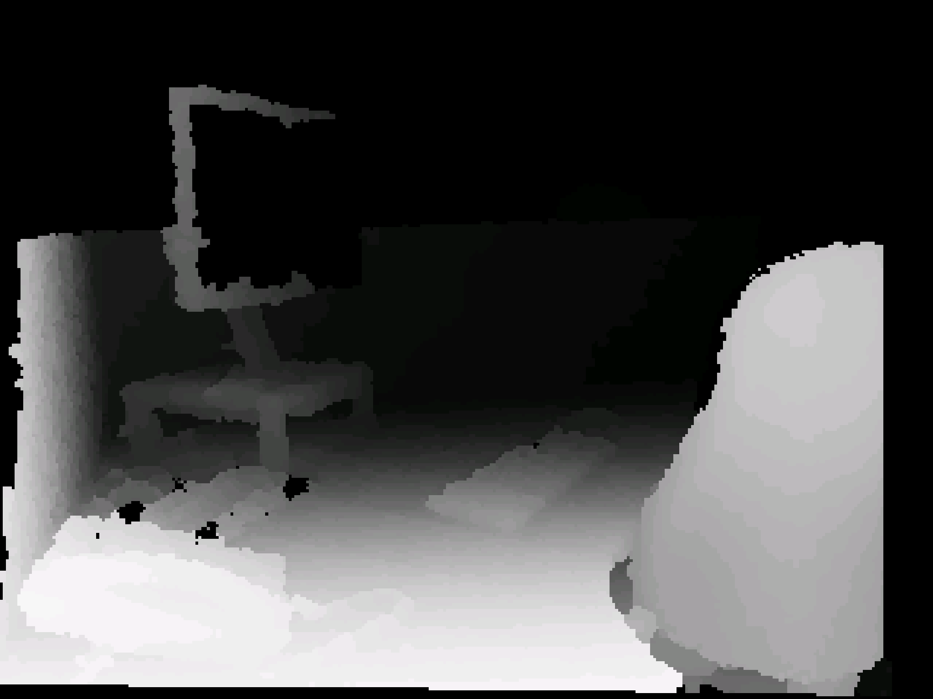

1. Mode 2, aka “edges” – works as the first mode but in this case objects and people have white outlines

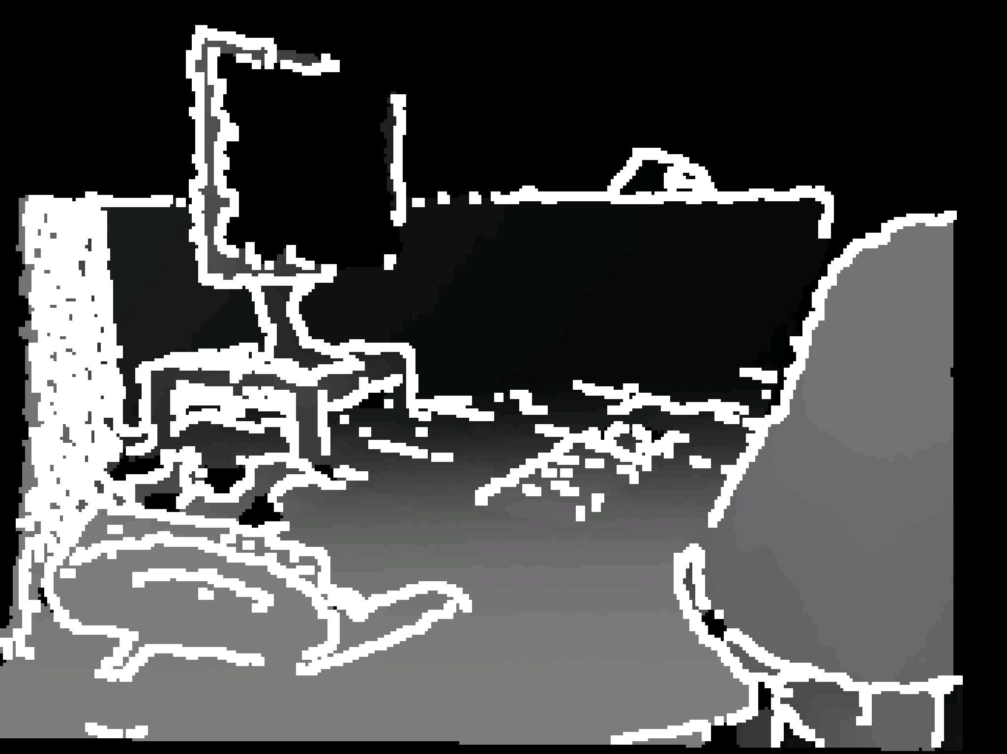

1. Mode 3, aka “details” – more information about the objects and people is added in this mode as details such as facial features or patterns on clothes might be seen

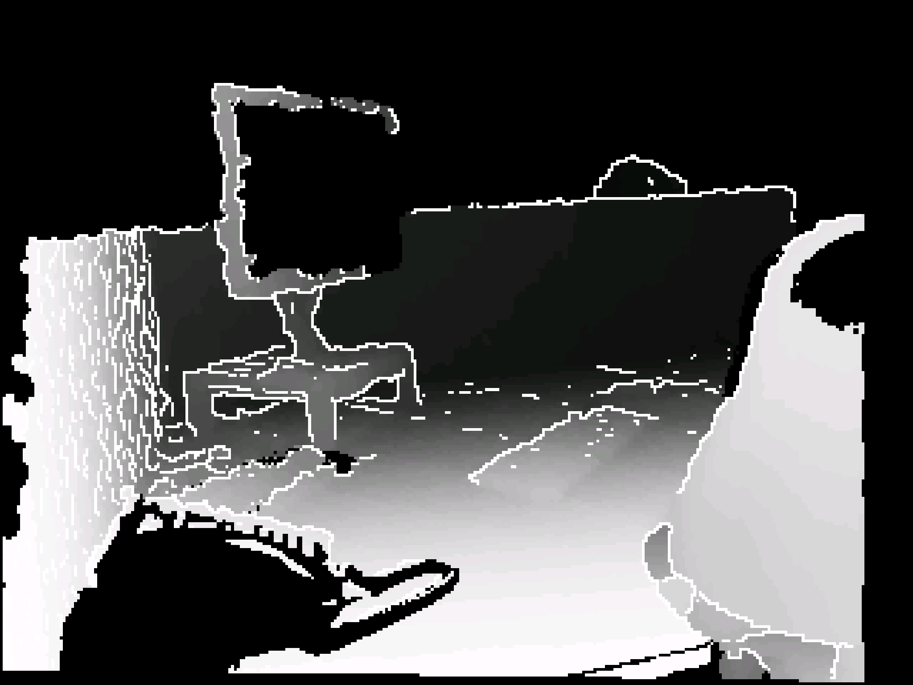

1. Mode 4, aka “high contrast” – there is no depth filter in this mode and all objects around can be seen in high contrast black and white. This mode can be used in bright daylight.

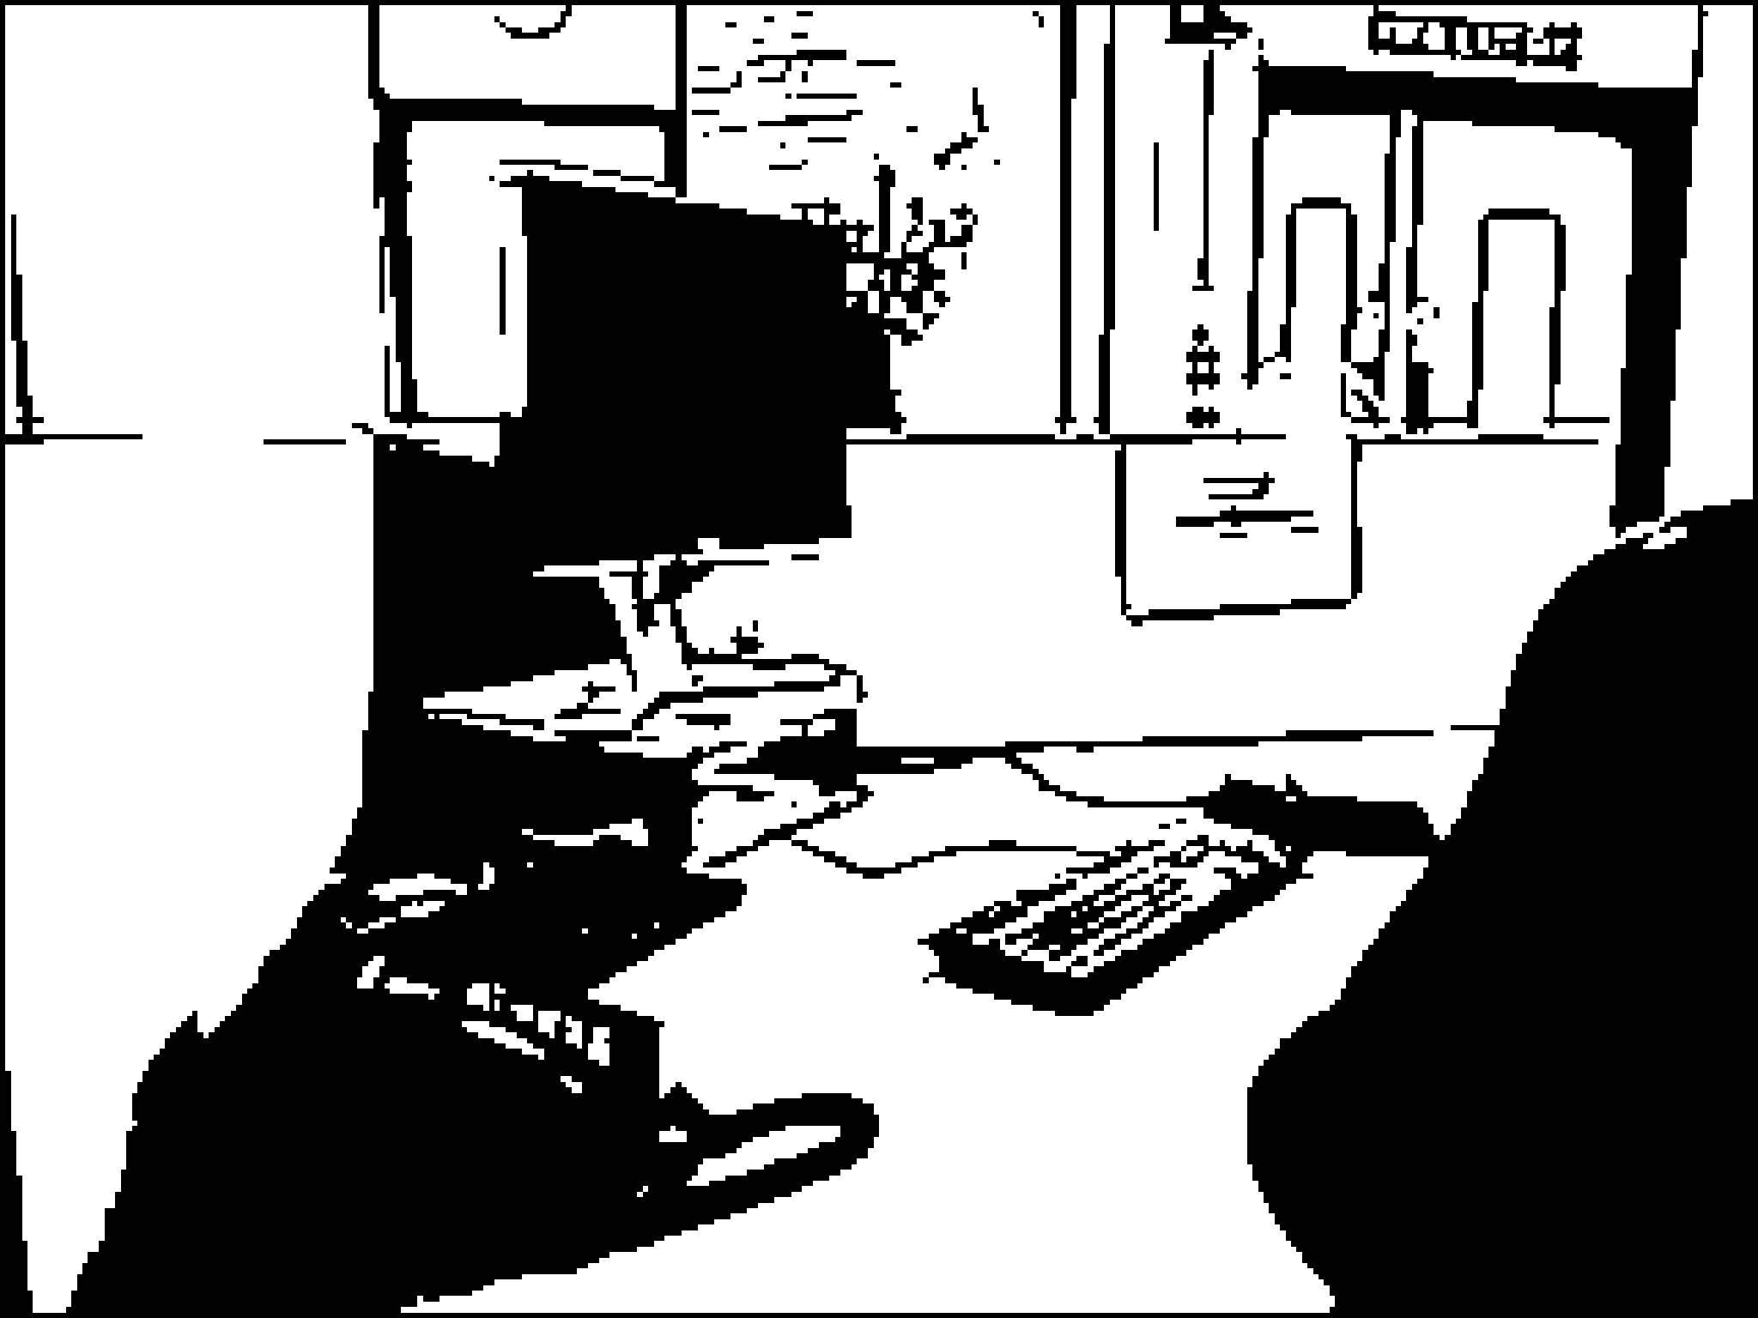

1. Mode 5, aka “colour” – shows the world in colour as an unenhanced video camera does.

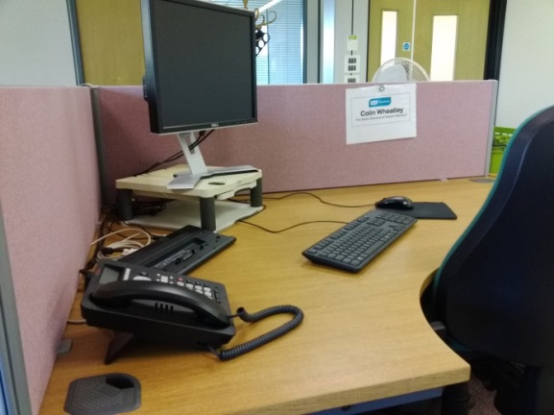

The Smart Glasses control box has two buttons; one is the power on and off button and the other a pause button which allows the user to pause an image, as if talking a photograph. This allows them to then have this image shown on the display in the glasses even if they are moving their head around. They can then zoom into it and magnify it.

There are also three dials on the control box, one allows the user to change between the different modes, and the other two dials control the zoom and the contrast.

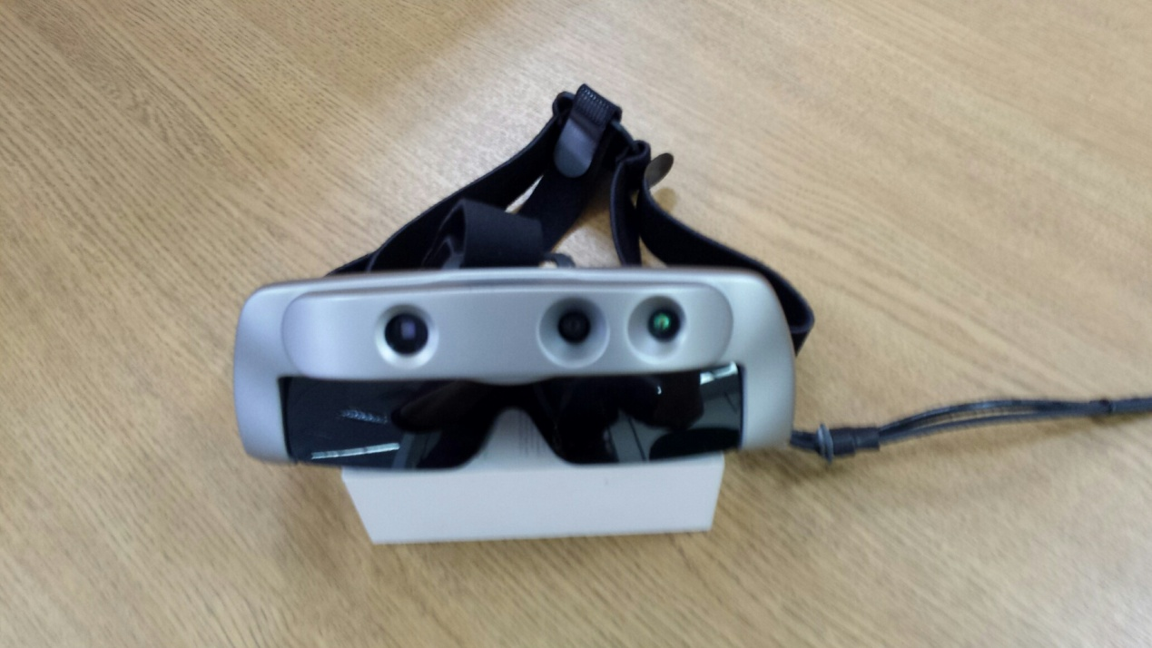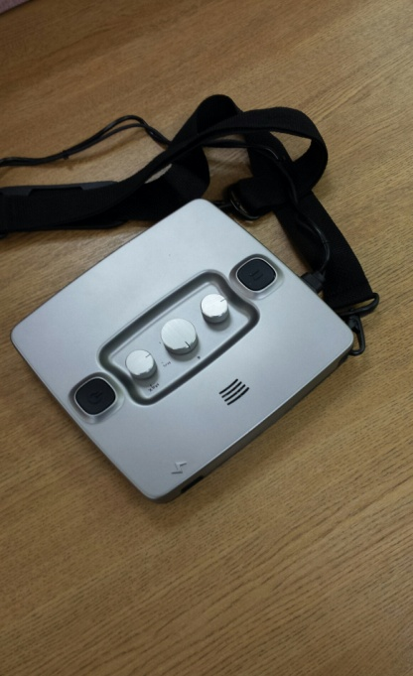

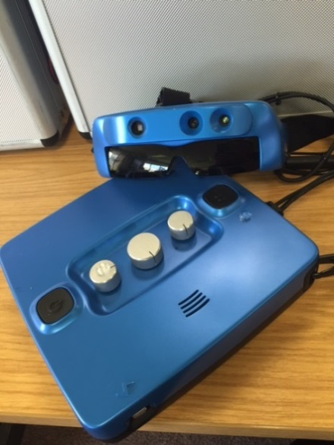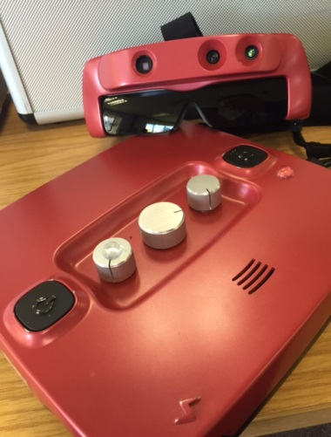

## 6.0 Appendix 2: Observed testing – methodology

The initial recruitment of participants resulted in 419 people expressing an interest in taking part in the Smart Glasses trials. All these people were contacted to obtain more information on their sight condition, leading us to offer 338 people a chance to take part in the trials.

20 locations for testing were identified throughout the UK, based on the largest number of potential testers living in the vicinity. 95 people could not take part in the testing for a number of reasons, including deteriorating eye sight.

A total of 243 people took part in our observed testing sessions. 221 of these carried out a user trial of the Smart Glasses in a controlled environment supervised by RNIB members of staff. 22 people were invited to take part in a slightly different set of tests supervised by Oxford University (See “Familiarisation with Residual Vision Glasses has the Potential to Improve Mobility in Visually Impaired People” by Merit Bruckmaier, available on request from Oxford University, 13 April 2016).

The observed user testing contained set tasks in a controlled environment to understand the usefulness of the Smart Glasses.

The tasks for the observed testing were designed to look at areas that the Smart Glasses should help with in everyday life, such as obstacle detection for mobility and hand eye coordination.

Participants were asked to carry out the tasks both with and without the Smart Glasses. Participants and researchers were then able to compare the two experiences and come to a subjective (participant comments) and an objective (measurable benefit) assessment of the Smart Glasses.

To determine how much detail the Smart Glasses can add to someone’s vision, a task was devised where participants were asked to count and identify objects on two sets of tables. The objects and the contrast that they provided to the tablecloth for each table were slightly different so that the Smart Glasses were compared to normal sight with different contrast levels. These tasks were referred to as the hand eye coordination tasks.

For the mobility tasks, an indoor obstacle course was put together. This course included obstacles on the ground and at head height that a person with sight loss would have to avoid when walking. The inflatable and soft nature of the course provided the benefit of not being hazardous to the participants and also the possibility of recreating, as far as possible, an identical course in different locations throughout the country.

During the testing period some alterations were made to the testing script. These changes were a result of the realisation, as the testing progressed, of how many variables came into play when considering whether the Smart Glasses were beneficial. One of the major changes that was introduced was asking participants for their first impressions straight after the familiarisation process. Another was to add some questions about carrying out the obstacle course in dim conditions when possible.

A cut down (shorter version) of the protocol was also produced after about 50 tests were carried out. This was used in cases where the preliminary information we had on the participants made us think that they either had too much sight or too little sight to benefit from the Smart Glasses. This meant that the observed test could be carried out in about 1 hour as opposed to 2 hours.

The findings in this section will be reported as ‘objective’ or ‘subjective’ results.

**Subjective results**:

Participants at the trial were asked if the Smart Glasses were beneficial and how they found them for each task they carried out. Their subjective opinions and feedback were reported.

**Objective results**:

The objective reporting is based on the observation of how participants carried out the tasks and the measurable benefit they experienced from the Smart Glasses.

### 6.1 Familiarisation

Participants were shown the Smart Glasses and all the modes were explained at the beginning of the trial. They were given time to familiarise themselves with the modes and to look at the researcher and their surroundings to understand how each mode represented reality and how they differ from each other.

During the familiarisation, of the 221 participants, 101 felt that they subjectively could see better in general or in certain situations with the Smart Glasses on, 92 could see better without and 28 were unsure.

Participants who felt they could see better with the Smart Glasses during familiarisation were asked if there were any modes that they found most useful. This question was also asked to participants who were unsure if they benefitted from the Smart Glasses or not. Below the split per mode is shown, some participants liked more than one mode so the numbers do not always add up to the number of participants who took part. The vast majority (77%) found that Mode 5 (colour mode) benefitted them most.

**Table 6.1 the number of participants that preferred each mode following the familiarisation**

|  |  |  |  |  |  |
| --- | --- | --- | --- | --- | --- |
|  | **Mode 1** | **Mode 2** | **Mode 3** | **Mode 4** | **Mode 5** |
| Out of the 101 participants that benefitted | 13 (13%) | 14  (14%) | 15 (15%) | 16 (14%) | 77 (75%) |
| Out of the 28 participants that were unsure | 3  (11%) | 5  (18%) | 3  (11%) | 4  (14%) | 14  (50%) |

Some of the comments that people who liked the Smart Glasses made on the Smart Glasses are as follows:

* Modes 1 and 2 will be helpful when moving around, detecting movement and judging distance. This mode would also be useful in the dark or dusk.
* Mode 3 gave more detail in faces, the mode gives more detail without visual overload
* Mode 4 gave more detail in the distance
* Mode 5 was useful because it is in colour and this is more what people are used to, the image is bright, and the zoom is very beneficial particularly in this mode.

### 6.2 Hand eye coordination test

Participants were asked to look at two different tables with 7 objects each, and asked if they could see anything. If they could, they were asked to say how many items they could see and then asked to identify what object or type of object each one was and then pick it up. This order ensured participants were seeing items and not identifying them by touch.

One table had a blue tablecloth that provided a better contrast with some of the objects displayed on it and the other was a pink table which provided a different contrast level. The participants were asked to look at the pink table without the Smart Glasses on and carry out the tasks. Then the researcher moved the items around. The participants were then asked to put the Smart Glasses on and see if this made it easier or harder to see and identify the objects. Participants were also asked to look at the blue table with the Smart Glasses on and then asked to take them off and see if this made it easier or harder to see the objects. This was to make sure that different contrasts were included and that participants could not remember the different objects and therefore perform better. At the end of the tasks participants were asked to compare the task with and without the Smart Glasses.

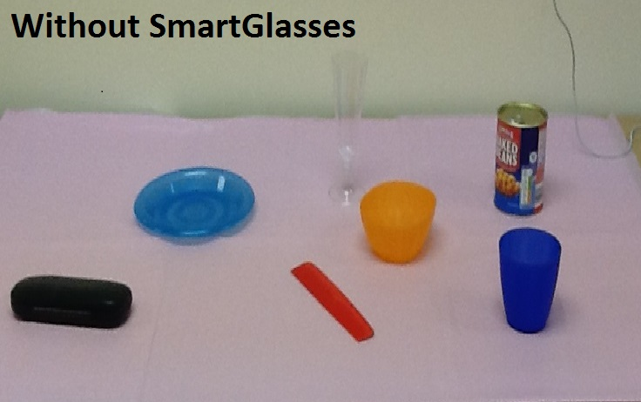

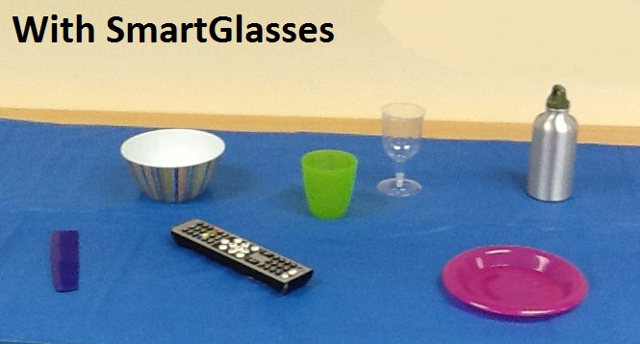

172 people carried out the task and 45 (26%) participants performed better with the Smart Glasses, 98 (57%) performed better without the Smart Glasses and the glasses did not make any difference for 29 people (17%). See table below.

**Table 6.2 the objective results following the hand eye coordination tasks**

|  |  |  |  |
| --- | --- | --- | --- |
|  | **Better with the Smart Glasses** | **The same** | **Better without the Smart Glasses** |
| Of the 172 participants who carried out the table task | 45 (26%) | 29 (17%) | 98 (57%) |

49 people did not carry out or complete this task as the Smart Glasses were of no benefit and they could not make use of the Smart Glasses.

The recognition of objects on a table task was generally carried out in Mode 3 and Mode 5 as these are the modes that we expected the users to find most helpful in this kind of close up, detailed task. At times participants who had not found one of these two modes particularly helpful wanted to try the Smart Glasses in a mode that they had liked during the familiarisation. In general, Mode 5 was found to be most beneficial by the majority of people (34 = 76% ), as is shown in the table below. In some cases more than one mode was found to be helpful so the numbers do not always add up to the number of participants.

|  |  |  |  |  |  |
| --- | --- | --- | --- | --- | --- |
|  | **Mode**  **2** | **Mode 3** | **Mode 4** | **Mode 5** | **Neither** |
| Out of the 45 participants that benefitted from the Smart Glasses for the table top test | 2  (4%) | 11 (24%) | 1 (2%) | 34 (76%) | 1  (2%) |

**Table 6.3 the number of participants that preferred each mode following the hand eye coordination tasks**

Participants who could see better with the Smart Glasses said that:

* The Smart Glasses helped them spot more objects
* The Smart Glasses helped them see more details and it was therefore easier to identify the different objects
* The Smart Glasses provided them with a sharper/clearer image
* The zoom helped them identify the different objects.

### 6.3 Mobility test

Participants were asked to walk through an obstacle course in a variety of modes and to say when they could see that there was an obstacle in their path.

Obstacles were soft (such as blow up chairs, scarves and balloons) and the participants were asked if they were happy to walk around the course independently or with assistance. The image below shows a typical obstacle course set up.

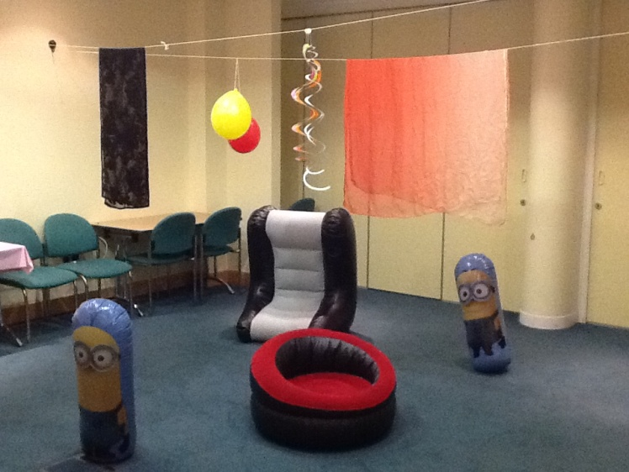

Once again the participants were asked to compare between the modes and provide feedback on which they found most useful and then compare the experience of carrying out the task with and without Smart Glasses and to examine if the Smart Glasses were beneficial in this task.

164 People carried out the obstacle course task and (objectively) 51 (31%) participants performed better with the Smart Glasses, 101 (62%) performed better without the Smart Glasses and the glasses did not make any difference for 12 people (7%), as is shown in the table below.

**Table 6.4 the objective results following the mobility tasks**

|  |  |  |  |
| --- | --- | --- | --- |
|  | **Better with the Smart Glasses** | **The same** | **Better without the Smart Glasses** |
| Of the 164 participants who carried out the obstacle task | 51 (31%) | 12 (7%) | 101 (62%) |

57 people did not complete this task as the Smart Glasses were of no benefit, they could not make use of the Smart Glasses or it was clear that they could see better without the Smart Glasses and they did not want to continue.

The table below shows which mode the participants thought provided most benefit to carry out this mobility task. Once again some participants expressed a preference for more than one mode. In general Mode 5 (66%) was found to be most beneficial, followed by Mode 3 (20%).

**Table 6.5 the number of participants that preferred each mode following the mobility tasks**

|  |  |  |  |  |  |
| --- | --- | --- | --- | --- | --- |
|  | **Mode 1** | **Mode 2** | **Mode 3** | **Mode 4** | **Mode 5** |
| Out of the 51 participants that benefitted from the Smart Glasses for the obstacle task | 3  (6%) | 5  (10%) | 10  (20%) | 2  (4%) | 34  (67%) |

Participants that like Modes 1, 2 and 3 could see more objects that they could without the Smart Glasses and felt more confident walking in an unfamiliar environment. Those who found Mode 5 most beneficial in general could see more detail because they reported their surroundings were brighter but often also relied on the zoom and found this useful.

### 6.4 Outside test

Participants were asked to carry out a short walk outside, using Modes 4 and 5 as these modes are suitable for use in bright daylight. Participants were asked to compare the experience with and without Smart Glasses and below are their answers. Objectively, more people could see better without the Smart Glasses (56%) than with the Smart Glasses (32%), however only 75 people carried out the outside task, as is shown in the table below.

**Table 6.6 the objective results following the hand eye coordination tasks**

|  |  |  |  |
| --- | --- | --- | --- |
|  | **Better with the Smart Glasses** | **The same** | **Better without the Smart Glasses** |
| Of the 75 participants who carried out the outside task | 24 (32%) | 9 (12%) | 42 (56%) |

146 participants did not complete this test for a number of different reasons. These reasons include: the location not being suitable, the weather not being appropriate, the participant was reluctant to go outside wearing the glasses or it was clear that the participant could see better without the Smart Glasses and did not find them beneficial so did not want to continue.

Of the people who did find the Smart Glasses beneficial for the outside task, nine found Mode 4 most useful, 14 found Mode 5 most beneficial and one person liked both Mode 4 and 5. The zoom was found to be useful and both modes provided the participant with more details when looking at things in the distance.

**Table 6.7 the number of participants that preferred each mode following the outside tasks**

|  |  |  |
| --- | --- | --- |
|  | **Mode 4** | **Mode 5** |
| Out of the 24 participants that benefitted from the Smart Glasses outside | 10  (42%) | 15  (63%%) |

## 7.0 Appendix 3: Observed testing – demographics and charts

The following findings are based on the 221 people who had taken part in the observed user testing.

The number and percentage of participants in each age category is shown in the table below.

**Table 7.1 the number of participants in each age range and the percentage within the trial**

|  |  |  |
| --- | --- | --- |
| **Age category** | **No of participants** | **%** |
| Under 18 | 2 | 1 % |
| 19 – 39 | 24 | 11 % |
| 40 – 64 | 99 | 45% |
| 65 – 84 | 84 | 38 % |
| Over 85 | 12 | 5 % |
| **Total** | **221** | **100 %** |

### 7.1 Visual Acuity

To determine a slightly more accurate and objective visual acuity the FrACT test was carried out. FrACT is a widely used visual test in the form of a free computer programme carried out at 1 or 2 metres with a letter C or E that becomes smaller and smaller until the participant is no longer able to see it accurately. If participants were unable to see the FrACT test at 1 metre, the Berkeley Tumbling E assessment was used instead. This is a white board with four different sizes of the letter ‘E’ on it which is rotated and made larger and smaller until the observer was satisfied that the participant was able to see it reliably. This test was carried out either 1 meter or 25 centimetres from the participant, depending upon their sight level. It is recognised that the conditions in which the test was carried out were not identical and consistent for all participants (due to different lighting conditions in the different test locations), but some idea of visual acuity was recorded as follows. For some participants the visual acuity was not tested due to restrictions in participant’s sight level. The visual acuity of all participants included in the observed testing is shown below in the table and graph.

**Table 7.2 the number of participants in Visual Acuity range and the percentage within the trial**

|  |  |  |
| --- | --- | --- |
| **Visual Acuity** | **No of participants** | **%** |
| Less than 0.019 | 45 | 20% |
| Between 0.02 and 0.039 | 23 | 10% |
| Between 0.04 and 0.059 | 23 | 10% |
| Between 0.06 and 0.079 | 11 | 5% |
| Between 0.08 and 0.099 | 7 | 3% |
| Between 0.1 and 0.29 | 58 | 26% |
| Between 0.3 and 0.49 | 20 | 9% |
| Between 0.5 and 0.69 | 4 | 2% |
| Between 0.7 and 0.89 | 5 | 2% |
| Between 0.9 and 1 | 3 | 1% |
| Not known | 22 | 10% |
| **Total** | **221** | **100%** |

**Chart 7.1 the number of participants in Visual Acuity range included in the trial**

When looking at the visual acuity, and whether people could subjectively and objectively see better or worse with the Smart Glasses, there is not a clear cut sight level that received benefit from the Smart Glasses.

There are visual acuity ranges where the subjective results are that slightly more people felt that they would benefit from the Smart Glasses, but this is not backed up by the objective data. In general it can be said that in all different visual acuity groups there will be people who could potentially benefit but objectively there are more people who do not benefit.

The following four charts and tables show the number of participants that subjectively and objectively felt that they would benefit from the glasses, both in number of people and percentages.

**Chart 7.2 the number of participants that felt they were better with the glasses, better without the glasses, the same within each Visual Acuity range**

**Table 7.3 the number of participants that felt they were better with the glasses, better without the glasses, the same within each Visual Acuity range**

|  |  |  |  |  |
| --- | --- | --- | --- | --- |
|  | **Better with glasses** | **Better without glasses** | **Same with and without** | **Unknown** |
| Less than 0.019 | 18 | 24 | 2 | 1 |
| Between 0.02 and 0.039 | 12 | 9 | 0 | 2 |
| Between 0.04 and 0.059 | 12 | 9 | 1 | 1 |
| Between 0.06 and 0.079 | 3 | 7 | 1 | 0 |
| Between 0.08 and 0.099 | 4 | 3 | 0 | 0 |
| Between 0.1 and 0.29 | 23 | 33 | 2 | 0 |
| Between 0.3 and 0.49 | 8 | 7 | 5 | 0 |
| Between 0.5 and 0.69 | 1 | 1 | 2 | 0 |
| Between 0.7 and 0.89 | 1 | 4 | 0 | 0 |
| Between 0.9 and 1.09 | 3 | 0 | 0 | 0 |
| Not known | 4 | 15 | 0 | 3 |

**Chart 7.3 the percentage of participants that felt they were better with the glasses, better without the glasses, the same within each Visual Acuity range**

**Table 7.4 the percentage of participants that felt they were better with the glasses, better without the glasses, the same within each Visual Acuity range**

|  |  |  |  |  |
| --- | --- | --- | --- | --- |
|  | **Better with glasses** | **Better without glasses** | **Same with and without** | **Unknown** |
| Less than 0.019 | 40% | 53% | 4% | 2% |
| Between 0.02 and 0.039 | 52% | 39% | 0 | 9% |
| Between 0.04 and 0.059 | 52% | 39% | 4% | 4% |
| Between 0.06 and 0.079 | 27% | 64% | 9% | 0 |
| Between 0.08 and 0.099 | 57% | 43% | 0 | 0 |
| Between 0.1 and 0.29 | 40% | 57% | 3% | 0 |
| Between 0.3 and 0.49 | 40% | 35% | 25% | 0 |
| Between 0.5 and 0.69 | 25% | 25% | 50% | 0 |
| Between 0.7 and 0.89 | 20% | 80% | 0 | 0 |
| Between 0.9 and 1.09 | 100% | 0 | 0 | 0 |
| Not known | 18% | 68% | 0 | 14% |

The following two charts and tables show the number of participants that the researchers found objectively would benefit from the glasses, both in number or people and percentages.

**Chart 7.4 the number of participants that experienced objective benefit within each Visual Acuity range**

**Table 7.5 the number of participants that experienced measurable objective benefit within each Visual Acuity range**

|  |  |  |  |  |
| --- | --- | --- | --- | --- |
|  | **Better with glasses** | **Better without glasses** | **Same with and without** | **Unknown** |
| Less than 0.019 | 13 | 27 | 5 | 0 |
| Between 0.02 and 0.039 | 3 | 11 | 9 | 0 |
| Between 0.04 and 0.059 | 5 | 7 | 11 | 0 |
| Between 0.06 and 0.079 | 2 | 7 | 2 | 0 |
| Between 0.08 and 0.099 | 2 | 3 | 2 | 0 |
| Between 0.1 and 0.29 | 11 | 37 | 10 | 0 |
| Between 0.3 and 0.49 | 3 | 8 | 9 | 0 |
| Between 0.5 and 0.69 | 0 | 1 | 3 | 0 |
| Between 0.7 and 0.89 | 1 | 4 | 0 | 0 |
| Between 0.9 and 1.09 | 2 | 1 | 0 | 0 |
| Not known | 4 | 13 | 2 | 3 |

**Chart 7.5 the percentage of participants that experienced measurable objective benefit within each Visual Acuity range**

**Chart 7.6 the percentage of participants that experienced measurable objective benefit within each Visual Acuity range**

|  |  |  |  |  |
| --- | --- | --- | --- | --- |
|  | **Better with glasses** | **Better without glasses** | **Same with and without** | **Unknown** |
| Less than 0.019 | 29% | 60% | 11% | 0 |
| Between 0.02 and 0.039 | 13% | 48% | 39% | 0 |
| Between 0.04 and 0.059 | 22% | 30% | 48% | 0 |
| Between 0.06 and 0.079 | 18% | 64% | 18% | 0 |
| Between 0.08 and 0.099 | 29% | 42% | 29% | 0 |
| Between 0.1 and 0.29 | 19% | 64% | 17% | 0 |
| Between 0.3 and 0.49 | 15% | 40% | 45% | 0 |
| Between 0.5 and 0.69 | 0 | 25% | 75% | 0 |
| Between 0.7 and 0.89 | 20% | 80% | 0 | 0 |
| Between 0.9 and 1.09 | 66% | 33% | 0 | 0 |
| Not known | 18% | 59% | 9% | 14% |

### 7.2 Visual Acuity versus subjective mode preference

When looking at which mode people preferred (of the 99 people who objectively showed benefit and had a similar experience with and without the Smart Glasses) in relation to people’s Visual Acuity, it shows that Mode 5 is preferred across the VA range (28 people in total). Modes 1, 2 and 3 are more preferred towards the lower VA ranges (less than 0.1). It is important to keep in mind that the numbers of people who preferred Mode 1, 2, 3 and 4 are relatively low (4, 10, 10 and 5 people respectively).

**Chart 7.8 the number of participants who preferred each mode within each Visual Acuity range**

**Table 7.9 the number of participants who preferred each mode within each Visual Acuity range**

|  |  |  |  |  |  |
| --- | --- | --- | --- | --- | --- |
|  | **Mode 1** | **Mode 2** | **Mode 3** | **Mode 4** | **Mode 5** |
| Less than 0.019 | 0 | 3 | 5 | 2 | 8 |
| Between 0.02 and 0.039 | 1 | 2 | 1 | 1 | 9 |
| Between 0.04 and 0.059 | 1 | 0 | 1 | 0 | 12 |
| Between 0.06 and 0.079 | 0 | 0 | 0 | 0 | 4 |
| Between 0.08 and 0.099 | 0 | 2 | 2 | 0 | 2 |
| Between 0.1 and 0.29 | 0 | 1 | 1 | 0 | 20 |
| Between 0.3 and 0.49 | 0 | 1 | 0 | 1 | 10 |
| Between 0.5 and 0.69 | 0 | 0 | 0 | 0 | 3 |
| Between 0.7 and 0.89 | 0 | 0 | 0 | 0 | 1 |
| Between 0.9 and 1.09 | 0 | 0 | 0 | 0 | 2 |
| Not known | 2 | 1 | 0 | 1 | 5 |

**Chart 7.9 the percentage of participants who preferred each mode within each Visual Acuity range**

**Table 7.10 the percentage of participants who preferred each mode within each Visual Acuity range**

|  |  |  |  |  |  |
| --- | --- | --- | --- | --- | --- |
|  | **Mode 1** | **Mode 2** | **Mode 3** | **Mode 4** | **Mode 5** |
| Less than 0.019 | 0% | 17% | 28% | 11% | 44% |
| Between 0.02 and 0.039 | 8% | 16% | 8% | 8% | 75% |
| Between 0.04 and 0.059 | 6% | 0% | 6% | 0% | 75% |
| Between 0.06 and 0.079 | 0% | 0% | 0% | 0% | 100% |
| Between 0.08 and 0.099 | 0% | 50% | 50% | 0% | 0% |
| Between 0.1 and 0.29 | 0% | 5% | 5% | 0% | 95% |
| Between 0.3 and 0.49 | 0% | 0% | 0% | 800% | 83% |
| Between 0.5 and 0.69 | 0% | 0% | 0% | 0% | 100% |
| Between 0.7 and 0.89 | 0% | 0% | 0% | 0% | 100% |
| Between 0.9 and 1.09 | 0% | 0% | 0% | 0% | 100% |
| Not known | 33% | 16% | 0% | 16% | 83% |

### 7.3 Subjective sight level

Prior to testing, a process to understand the subjective sight level of each participant was carried out. An online questionnaire was produced and a set of questions were used to determine the sight level of participants. Participants were then categorised according to the answers they provided for the following questions (see table below):

**Table 7.11 the definitions of the subjective sight levels**

|  |  |
| --- | --- |
| **Category of sight** | **Question** |
| No | Can only see where the windows are |
| Low | Can see the shape of the furniture around |
| Low plus | Can see the shape of the furniture around  Can see facial expressions at arm's length |
| Medium | Can recognise a friend at arm's length |
| Medium plus | Can recognise a friend at arm's length  Can see facial expressions at arm's length minimum |
| High | Can recognise a friend at the other side of the room |
| High plus | Can recognise a friend at the other side of the room  Can see facial expressions across table minimum |
| Extra high | Can recognise a friend on the other side of road |

Initially it was decided that people who were in the ‘No’ group would not have enough sight to make use of the image displayed in the Smart Glasses. But due to the fact that we were testing in their area we gave everybody the opportunity to try out the Smart Glasses, however we tried to manage their expectations. It was explained to them how the Smart Glasses worked and what to expect from the testing in order not to raise expectations for those people with very limited vision.

**Chart 7.10 the percentage of participants included in the trial within each sight level**

**Table 7.12 the percentage and number of participants included in the trial within each sight level**

|  |  |  |
| --- | --- | --- |
| **Subjective sight level** | **Number of participants** | **Percentage** |
| No | 20 | 9% |
| Low | 55 | 25% |
| Low plus | 4 | 2% |
| Medium | 28 | 13% |
| Med plus | 60 | 27% |
| High | 5 | 2% |
| High plus | 25 | 11% |
| Extra high | 24 | 11% |

When looking at subjective sight levels it looks that across the board (apart from the group with very limited sight, the ‘no’ category), the percentage per category in the sight levels of people who benefit from the glasses and those who do not are very close and within about 15% from each other when looking at whether people felt that they subjectively benefitted from the glasses.

Although as expected people in the ‘no’ category with just light perception on the whole do not benefit from the Smart Glasses (apart from 3 people).

The table and chart below show the subjective results when comparing benefit to the subjective sight level of participants, this is shown by number and by percentage.

**Table 7.13 the subjective results of the observed testing by sight level in numbers and percentages**

|  |  |  |  |  |  |
| --- | --- | --- | --- | --- | --- |
|  | **Overall** | **Better with glasses** | **Better without glasses** | **Same with and without** | **Unknown** |
| **No** | 20 | 3  (15%) | 11  (55%) | 3  (15%) | 3  (15%) |
| **Low** | 59 | 24  (41%) | 33  (56%) | 2  (3%) | 0  (0%) |
| **Medium** | 88 | 41  (47%) | 37  (42%) | 7  (8%) | 3  (3%) |
| **High** | 30 | 12  (40%) | 16  (53%) | 2  (7%) | 0  (0%) |
| **Extra high** | 24 | 9  (38%) | 11  (46%) | 3  (13%) | 1  (4%) |

**Chart 7.11 the subjective results of the observed testing by sight level in percentages**

Objectively however it shows that people who fall in the ‘high’ category benefit less than they subjectively reported as their sight is often too good to benefit from the glasses. Again it shows that in each category there will be people who could potentially benefit from the glasses and people who could not. This is shown in the table and charts below.

**Table 7.14 the objective results of the observed testing by sight level in numbers and percentages**

|  |  |  |  |  |  |
| --- | --- | --- | --- | --- | --- |
|  | **Overall** | **Better with glasses** | **Better without glasses** | **Same with and without** | **Unknown** |
| **No** | 20 | 1  (5%) | 12  (60%) | 4  (20%) | 3  (15%) |
| **Low** | 59 | 16  (27%) | 36  (61%) | 7  (12%) | - |
| **Medium** | 88 | 20  (23%) | 40  (45%) | 28  (32%) | - |
| **High** | 30 | 4  (13%) | 19  (63%) | 7  (23%) | - |
| **Extra high** | 24 | 5  (21%) | 11  (46%) | 7  (29%) | 1  (4%) |

**Chart 7.12 the objective results of the observed testing by sight level in numbers**

**Chart 7.13 the objective results of the observed testing by sight percentages**

### 7.4 Subjective sight level versus mode preference

When looking at which mode people preferred (of the 99 people who objectively showed benefit and had a similar experience with and without the Smart Glasses) in relation to people’s subjective sight level, it shows that Mode 5 is preferred across the range (72 people in total). Mode 1 was preferred by more people with low levels of sight, Mode 2 was liked more towards the lower and the higher levels of sight, Mode 3 across the range and Mode 4 was preferred by people with medium sight levels. It is however important to keep in mind that the numbers of people who preferred Modes 1, 2,3 and 4 are relatively low (4, 10, 10 and 5 people respectively) and no real conclusions can be drawn. Some participants chose multiple modes, and some participants did not prefer any of the modes.

**Chart 7.14 the number of participants who preferred each mode within the sight levels**

**Chart 7.15 the percentage of participants who preferred each mode within the sight levels**

**Table 7.15 the number and percentage of participants who preferred each mode within the sight levels**

|  |  |  |  |  |  |
| --- | --- | --- | --- | --- | --- |
|  | **Mode 1** | **Mode 2** | **Mode 3** | **Mode 4** | **Mode 5** |
| No | 0 | 1 (20%) | 0 | 0 | 2 (40%) |
| Low | 3 (13%) | 3 (13%) | 5 (22%) | 0 | 12 (52%) |
| Medium | 1 (2%) | 2 (4%) | 3(6%) | 5 (10%) | 39 (81%) |
| High | 0 | 2 (18%) | 1 (9%) | 0 | 9 (82%) |
| Extra High | 0 | 2 (17%) | 1 (8%) | 0 | 10 (83%) |

### 7.5 Subjective field of vision

Before the observed testing, participants were asked to bring a visual field test if they were able to. Only 52 visual fields out of 221 participants were received. Some participants have not had one for years, others had trouble getting them from their hospitals or their eyesight was not good enough to do a visual field test.

Therefore the following is based on subjective feedback from participants whether their central vision, peripheral vision or both were affected. Not all participants were able to answer this question. The table below shows the number and percentage of participants with central loss, peripheral loss or both.

**Table 7.16 the number and percentage of participants in the trial by the field of vision loss they reported**

|  |  |  |
| --- | --- | --- |
| **Sight Loss** | **No of Participants** | **%** |
| Central vision loss | 25 | 11% |
| Peripheral vision loss | 67 | 30% |
| Loss of both | 92 | 42% |
| Not known | 37 | 17% |
| **Total** | **221** | **100%** |

The number of people with central vision loss is quite low (11%), although they are also included in the ‘both’ (central and peripheral vision loss, 42%) group. When recruiting for participants it was mentioned that due to the ‘technical design of the glasses it means that some central vision is required’. This might be why this number is quite low. However, we also made it clear that we would like to test with people with all sight loss conditions.

When looking at the subjectively reported sight loss and whether people could subjectively and objectively see better or worse with the Smart Glasses. It shows that subjectively both people with central vision loss and people with peripheral vision loss and both conditions together could potentially benefit from the Smart Glasses, however if people just have central vision loss then people are less likely to benefit from the glasses.

It must be noted that this self-reporting on whether people have central or peripheral vision loss is not a very accurate measure and not everybody knows whether they have got central or peripheral vision loss. If somebody has for example cataracts then their visual field might not be affected but they might report that they have central vision loss as they struggle with reading as everything is blurry (not just the centre). This is not the same as somebody with macular degeneration where there is central vision loss but their peripheral vision is not affected.

The charts and tables below show the results when looking at subjectively reported sight loss in relation to subjective benefit, this is shown in numbers and percentages.

**Table 7.17 the subjective results of the observed testing by field of vision in numbers and percentages**

|  |  |  |  |  |  |
| --- | --- | --- | --- | --- | --- |
|  | **Better with glasses** | **Better without glasses** | **Same with and without** | **Unknown** | **Total** |
| Central vision loss | 6  (24%) | 16  (64%) | 3  (12%) | 0 | 25  (100%) |
| Peripheral vision loss | 28  (42%) | 27  (40%) | 7  (10%) | 5  (7%) | 67  (100%) |
| Loss of both | 44  (48%) | 44  (48%) | 4  (4%) | 0 | 92 (100%) |
| Not known | 11  (30%) | 21  (57%) | 3  (9%) | 2  (6%) | 37 (100%) |

**Chart 7.16 the subjective results of the observed testing by field of vision in numbers**

**Chart 7.17 the subjective results of the observed testing by field of vision in percentages**

Objective findings show slightly clearer that people with just central vision loss would not benefit from the glasses, and this was as expected. The charts and tables below show the results when looking at subjectively reported sight loss in relation to measurable benefit.

**Table 7.18 the objective results of the observed testing by field of vision in numbers and percentages**

|  |  |  |  |  |  |
| --- | --- | --- | --- | --- | --- |
|  | **Better with glasses** | **Better without glasses** | **Same with and without** | **Unknown** | **Total** |
| Central vision loss | 1  (4%) | 19 (27%) | 5  (20%) | 0 | 25  (100%) |
| Peripheral vision loss | 15 (22%) | 28 (42%) | 22  (33%) | 2  (3%) | 67  (100%) |
| Loss of Both | 26  (92%) | 47 (28%) | 19  (51%) | 0 | 92 (100%) |
| Not known | 4 (11%) | 24 (65%) | 7  (19%) | 2  (5%) | 37 (100%) |

**Chart 7.18 the objective results of the observed testing by field of vision in numbers**

**Chart 7.19 the objective results of the observed testing by field of vision in numbers**

### 7.6 Sight loss conditions

The table below shows the sight loss conditions that the participants reported having. The main ones are listed separately and some are grouped under ‘other’ if there were only one or two participants with that particular sight loss condition. These, amongst some others included: acute myopia, hemianopia, cornea oedema, macular oedema or retinoschisis.

We checked the findings of the sight loss conditions people reported against the prevalence figures in the UK (MyVoice 2015) to account for sampling bias. The findings show that the Smart Glasses study includes more people with Retinitis Pigmentosa (RP) and less people with Macular Degeneration (MD). This was expected a little as when recruiting for participants it was mentioned that due to the ‘technical design of the glasses it means that some central vision is required’. This might be why the number of people with MD is quite low (21%) in comparison with the prevalence figures (48%) although in the recruitment stage we tried to manage expectations and pointed out that while some central vision is needed we were happy for anybody who wanted to try the glasses to take part.

In addition, the Smart Glasses had already received publicity before the trials started showing that they could potentially benefit people who had problems with night vision and those who were able to use some of their central vision. This might be why in our testing the percentage for people with RP is higher (25% instead of 10%).

Please note that in the following table some people reported having more than one sight loss condition, but the percentage is calculated against the total number of participants (221).

**Table 7.19 the percentage and number of participants with each sight loss condition included in the trial and from the MyVoice Research**

|  |  |  |  |
| --- | --- | --- | --- |
| **Sight loss condition** | **No of participants** | **%** | **MyVoice research (2015)** |
| Retinitis Pigmentosa (RP) | 56 | 25% | 10% |
| Macular Degeneration (MD) | 47 | 21% | 48% |
| Glaucoma | 41 | 19% | 16% |
| Cataracts | 35 | 16% | 12% |
| Nystagmus | 19 | 9% |  |
| Retinal detachment | 14 | 6% | 4% |
| Optic Nerve damage | 11 | 5% |  |
| Rod cone dystrophy | 9 | 4% |  |
| Diabetic retinopathy | 9 | 4% | 8% |
| Leber optic neuropathy | 7 | 3% |  |
| Choroideremia | 6 | 3% |  |
| Albinism | 6 | 3% |  |
| Stargards syndrome | 5 | 2% |  |
| Microphalmia | 4 | 2% |  |
| Uveitis | 3 | 1% |  |
| Aniridia | 3 | 1% |  |
| Ushers syndrome | 2 | 1% |  |
| Injury | - | - | 3% |
| Other | 29 | 14% | 26% |

When looking at the 5 main sight loss conditions (sight loss conditions most reported by participants) then as expected people with Macular degeneration found the Smart Glasses the least beneficial. This is understandable as the centre of the eye is affected making it more difficult to make use of the image displayed in the centre of the Smart Glasses.

**Table 7.20 the subjective results of the observed testing by sight loss condition in numbers and percentages**

|  |  |  |  |  |  |
| --- | --- | --- | --- | --- | --- |
|  | **Better with glasses** | **Better without glasses** | **Same with and without** | **Unknown** | **Total number of participants** |
| **RP** | 30  54% | 19  34% | 3  5% | 4  7% | 56  (100%) |
| **MD** | 14  30% | 27  57% | 1  2% | 5  11% | 47  (100%) |
| **Glaucoma** | 17  41% | 19  46% | 1  2% | 4  10% | 41  (100%) |
| **Cataract** | 16  46% | 13  37% | 3  9% | 3  9% | 35  (100%) |
| **Optic nerve damage** | 6  55% | 4  36% | 1  9% | 0 | 11  (100%) |

**Chart 7.20** **the subjective results of the observed testing by sight loss condition in percentages**

**Chart 7.21 the subjective results of the observed testing by sight loss condition in numbers**

During the observed testing it was found that people with Glaucoma in general benefitted less from the glasses (7% who found the glasses beneficial versus 54% who would not benefit objectively).

People with Cataract and Optic Nerve damage found slightly more benefit, although in these two groups only around 20-25% would benefit, while in the RP group 32% would benefit objectively. Again, in all groups there are people who could potentially benefit from the glasses and people who would not.

**Table 7.21 the objective results of the observed testing by sight loss condition in numbers and percentages**

|  |  |  |  |  |  |
| --- | --- | --- | --- | --- | --- |
|  | **Better with glasses** | **Better without glasses** | **Same with and without** | **Unknown** | **Total number of participants** |
| **RP** | 18 (32%) | 26 (46%) | 10  (18%) | 2  (4%) | 56  (100%) |
| **MD** | 4  (9%) | 35 (76%) | 6  (13%) | 1  (2%) | 47  (100%) |
| **Glaucoma** | 3  (7%) | 22 (54%) | 16  (39%) | 0% | 41  (100%) |
| **Cataract** | 8  (24%) | 17 (50%) | 9  (26%) | 0% | 35  (100%) |
| **Optic nerve damage** | 3  (25%) | 5  (42%) | 4  (33%) | 0% | 11  (100%) |

**Chart 7.22 the objective results of the observed testing by sight loss condition in percentages**

**Chart 7.23 the objective results of the observed testing by sight loss condition in numbers**

### 7.7 Age range

Below is a breakdown of the 91 people who subjectively found benefit from the Smart Glasses and 99 people who either showed measurable objective benefit, or had a similar experience with and without the Smart Glasses per age category.

It seems that subjectively younger, working age participants (up to 64 years of age) seemed to have fared slightly better with the Smart Glasses, see table below.

**Table 7.22 the number and percentage of participants who felt they subjectively benefitted from the Smart Glasses**

|  |  |  |
| --- | --- | --- |
| **Age range** | **No of participants who subjectively felt they could benefit** | **Percentage** |
| Under 18 | 1 out of 2 | 50% |
| 19 – 39 | 15 out of 24 | 63% |
| 40 – 64 | 47 out of 99 | 47% |
| 65 – 84 | 24 out of 84 | 29% |
| Over 85 | 4 out of 12 | 17% |
| **Total** | **91 out of 221** | **41%** |

Objectively more benefits were shown with slightly younger working age participants (up to 40 years of age), see table below.

**Table 7.23 the number and percentage of participants who showed measurable benefit from the Smart Glasses**

|  |  |  |
| --- | --- | --- |
| **Age range** | **No of participants who the researchers felt objectively could benefit** | **Percentage** |
| Under 18 | 1 out of 2 | 50% |
| 19 – 39 | 16 out of 24 | 67% |
| 40 – 64 | 52 out of 99 | 53% |
| 65 – 84 | 26 out of 84 | 31% |
| Over 85 | 4 out of 12 | 33% |
| **Total** | **99 out of 221** | **45%** |

In fact both objectively and subjectively the group that benefited most from the glasses was that of those belonging to the 19 to 39 years of age as it is more that 13% ahead of the other groups if the under 18 are disregarded for the lack of numbers in that specific category.

## 8.0 Appendix 4: Take home trial – methodology

### 8.1 Selection for take home trial

Following the observed user testing participants were asked if they would like to take part in the ‘take home trials’ where they would be able to use the Smart Glasses at home for 2-4 weeks. Participants were said to be suitable for the take home trial if they experienced some benefit during the observed testing sessions – this included people who definitely had measurable objective benefit and some of those that had a similar experience with and without the Smart Glasses. However some participants who experienced measurable objective benefit were not interested in using the Smart Glasses at home so were not included in the take home trial.

From the 46 people who had measurable objective benefit, 43 people were interested in trying the glasses at home. From the 53 people who had a similar experience with and without the Smart Glasses 31people were interested in taking part in the take home trial. This gave us a total of 74 participants who were suitable to take part. We had one additional participant who showed interest, making it a total of 75 participants who took part in the take home trial.

**Table 8.1 the number of participants who wanted to take part in the take home trial and the number of participants who were suitable**

|  |  |  |  |
| --- | --- | --- | --- |
|  | **Answer** | | |
| **Question** | **Yes** | **No** | **Maybe** |
| **Would the participant like to try the glasses at home?** | 103 (47%) | 101 (46%) | 17 (8%) |
| **Is the participant suitable for take home trials?** | 43 (19%) | 147 (67%) | 31 (13%) |

### 8.2 Receiving feedback from participants

The purpose of the take home trial was to allow participants to use the Smart Glasses on a daily basis for everyday tasks and become more familiar with them. The results from both the observed testing and take home trials would highlight benefits and possible issues and areas for improvement.

An instruction guide was sent out to participants in their preferred format as well as a feedback form to gather as much information as possible. This contained suggestions of tasks to carry out with the Smart Glasses; however it was up to individuals how they used the Smart Glasses.

Participants were asked to fill out a survey for each task they carried out with the Smart Glasses. If they were unable to submit it online, participants were able to email feedback or call a member of the team. It was made clear to participants that everybody would have a different experience, but it was important for us to receive all feedback (positive and negative) so we could better understand who may benefit from the Smart Glasses.

We found that when participants were emailing feedback they did not always follow the format of the survey monkey. This occasionally meant we were missing some of the details about a particular experience, such as the light levels during a specific task.

When participants were providing feedback over the telephone we followed the online questionnaire which had been sent to participants and submitted their feedback for them. However, on a few occasions there was a gap between participants completing a task and providing feedback to the Smart Glasses team, this often led to details missing from their feedback.

Close to the end of the trial, a member of the team would call the participant to arrange a suitable time for the Smart Glasses to be collected and to go through final questions regarding their overall experience and view on the glasses. A shipping label was sent with the Smart Glasses and participants were asked to attach it to the cardboard box for the courier to collect them.

## 9.0 Appendix 5: Feedback from Take home trial

The feedback from the take home trial is purely subjective, as participants carried varying tasks in uncontrolled environments. Although we had suggested tasks to carry out with the Smart Glasses, it was up to individuals how they used the Smart Glasses. Below are a few common tasks that were carried out by participants during the take home trials:

* Navigating around the house using the different modes, locating and avoiding obstacles, making coffee, filling the kettle, cutting vegetables etc
* Shopping – being able to identify and select items
* Taking part in social activities - bowling, family/friends gathering, boating, visiting the theatre, watching television (being able to zoom in and see small details) etc
* Going to the cinema – being able to navigate themselves around to find an empty seat
* Gardening - being able to carry out small tasks independently and seeing details of brick work, bushes, cracks on the wood etc
* Seeing facial expressions - being able to see features on people’s faces as they were highlighted.

### 9.1 Subjective Feedback

Following the take home trials, some participants felt more socially involved after wearing the Smart Glasses, this includes being able to take part in activities such as playing pool and being able to spot balls, taking part in family/friends gathering and actually being able to see facial expressions, going to the cinema and being able to find an empty seat.

One participant stated: “When having a 1-2-1 conversation with my partner across the dining room, I was able to see facial features, glasses and earrings for the first time in years. Brilliant, down side is my partner now knows I can see her. It provided vision I have not seen in years, actually recognising facial features”. Another participant stated that “A smile was discernible from a frown!”

One participant was able to use Mode 4 to organise her pill box, she was able to successfully see the very small pills and assign the correct dosage to the correct day. This is something she would have been unable to do without the Smart Glasses.

A number of participants felt that the glasses provided them with a feeling of safety, as they were more aware of their surroundings and nearby dangers. A participant stated that the glasses made him feel safe, “I know there's a threat, and I know there's something there. Feels like can control my own space.”

However, other participants have stated that the glasses made them feel isolated from their natural surroundings. Some struggled when judging distances, depth and tracking moving objects. For many participants a common issue was depth, participants felt that as they move closer to an object it disappeared, making it a little uncomfortable for them.

The following is a specific quote from a participant: “I found Mode 2 best for being on the move. The white line it gave round objects was extremely useful in helping me locate and avoid obstacles. When I needed detail and could stop and look at objects Mode 3 was best. On the move though Mode 3 gave too much information for me to be able to process it and be able to carry on walking. However when I stopped and needed to identify things like house numbers, keyholes and even a car number plate Mode 3 was brilliant.”

There have been a number of participants who have been unable to replicate the experience they had during the observed testing sessions. This could have been as a result of the change in surroundings or a change in sight level, but it is also possible that participants struggled to correctly position the headset so that they were able to view the display.

### 9.2 Design Feedback

The gap around the glasses was a problem for some participants due to the amount of light coming through. As a result of this, some participants have struggled to focus on the display.

38 of the 55 participants that took part in the take home trials have complained about the glasses and control box stating that they are far too cumbersome and heavy. One participant said she would never walk out with them and it “would be much better if they actually look like sunglasses, but these are far too bulky!” Another participant said “after an hour I get a headache because of the weight of the glasses, it’s very painful”. Participants disliked the size and weight of both the headset and control box and this is something that needs to be considered when moving forward.

Four participants struggled to remember which mode they were on, one in particular suggested having some sort of display which flashes up a large number to overcome this issue.

One participant was deaf-blind and struggled with the controls and design of the Smart Glasses. “There is no indication as to which way to turn the knobs. Also as I am blind deaf I am never sure whether I have successfully switched on the device. You need some sort of stronger visual indication.” Other participants mentioned that it is not clear what mode is selected on the control box and this could be made clearer. The filter which can be attached to the glasses is difficult to fit into place and does not always stay in place well which is also an issue.

### 9.3 Technical Feedback

On the rear of the control box is a small recessed switch which is a secondary power switch. This allowed us to courier the Smart Glasses to participants fully charged, which would mean that people could use the glasses straight out of the box. Unfortunately, this design did not take into account how difficult it would be for the participants to locate or access the switch as it was not intended for use by participants.

However, if participants were able to use this secondary power switch they were able to charge the glasses less often and this helped participants avoid situations where the glasses would have no power after being unplugged for a number of hours.

During the take home trial there were a few instances of damage which included scratches on the lenses of the Smart Glasses, control box and headset, as well as the supporting parts which kept the wires in place coming loose. This needs to be considered for future designs of the Smart Glasses and their packaging.

## 10.0 Appendix 6: Take home trial – demographics and charts

### 10.1 Visual Acuity

When looking at the visual acuity and whether people felt that they could see better or worse with the Smart Glasses, it shows that there is no direct link to VA level. Across pretty much the whole VA range, there are people that benefitted from using the Smart Glasses.

The following chart shows the number of participants that subjectively felt that they would benefit from the glasses following the take home trials.

Due to the varying number of people in each VA group we have included the percentage in the table below as not to rely just on numbers as this might show the results differently.

It can be observed that the percentages are slightly higher when you look at participants who have less sight especially levels of sight between 0.02 and 0.79 show percentages in the 80%. The number of participants in some sight ranges is very small so it is difficult to draw solid conclusions but we can just point out a trend.

**Table 10.1 comparing visual acuity with how participants felt they benefitted by number and percentage**

|  |  |  |  |  |
| --- | --- | --- | --- | --- |
| **Visual Acuity and subjective benefit** | **Better with glasses** | **Better without glasses** | **Not sure** | **Total** |
| **Less than 0.019** | 6 (55%) | 2 (18%) | 3 (27%) | 11 |
| **Between 0.02 and 0.039** | 4 (80%) | 0 | 1 (20%) | 5 |
| **Between 0.06 and 0.079** | 2 (100%) | 0 | 0 | 2 |
| **Between 0.08 and 0.099** | 1 (50%) | 0 | 1 (50%) | 2 |
| **Between 0.1 and 0.29** | 8 (62%) | 3 (23%) | 2 (15%) | 13 |
| **Between 0.3 and 0.49** | 3 (50%) | 3 (50%) | 0 | 6 |
| **Between 0.5 and 0.69** | 1 (100%) | 0 | 0 | 1 |
| **Between 0.7 and 0.89** | 0 | 1 (100%) | 0 | 1 |
| **Between 0.9 and 1** | 2 (67%) | 0 | 1 (33%) | 3 |
| **Not known** | 2 (50%) | 2 (50%) | 0 | 4 |

**Chart 10.1 comparing visual acuity with how participants felt they benefitted by number of participants**

**Chart 10.2 comparing visual acuity with how participants felt they benefitted by percentage**

### 10.2 Visual Acuity versus subjective mode preference

When looking at which mode people preferred (of the 35 people who subjectively felt that they would benefit from the glasses following the take home trials) in relation to people’s visual acuity (VA), it shows that Mode 5 is preferred across the VA range (24 people in total), and Modes 1, 2, 3 and 4 were also liked across the range. Mode 5 was by far the preferred mode with a total of 24 people mentioning it as their preferred mode and the only other mode that was liked by more than 10 people was Mode 2 with 11 people liking it. In some cases more than one mode was found to be helpful so the numbers do not always add up to the number of participants.

**Table 10.2 the number and percentage of participants who preferred each mode within each Visual Acuity range**

|  |  |  |  |  |  |  |
| --- | --- | --- | --- | --- | --- | --- |
| **Visual Acuity and subjective Mode** | **Mode 1** | **Mode 2** | **Mode 3** | **Mode 4** | **Mode 5** | **Total** |
| **Less than 0.019** | 0 | 1 (11%) | 0 | 2 (22%) | 6 (67%) | **9** |
| **Between 0.02 and 0.039** | 1 (20%) | 2 (40%) | 0 | 0 | 2 (40%) | **5** |
| **Between 0.04 and 0.059** | 1 (9%) | 2 (18%) | 1 (9%) | 3 (27%) | 4 (36%) | **11** |
| **Between 0.06 and 0.079** | 1 (50%) | 0 | 0 | 0 | 1 (50%) | **2** |
| **Between 0.08 and 0.099** | 1 (50%) | 1 (50%) | 0 | 0 | 0 | **2** |
| **Between 0.1 and 0.29** | 1 (7%) | 2 (15%) | 4 (31%) | 1 (7%) | 5 (38%) | **13** |
| **Between 0.3 and 0.49** | 1 (14%) | 1 (14%) | 1 (14%) | 1 (14%) | 3 (43%) | **7** |
| **Between 0.5 and 0.69** | 0 | 0 | 1 (50%) | 1 (50%) | 0 | **2** |
| **Between 0.7 and 0.89** | 0 | 0 | 0 | 0 | 0 | **0** |
| **Between 0.9 and 1** | 0 | 1 (33%) | 0 | 0 | 2 (66%) | **3** |
| **Not known** | 1 (33%) | 1 (33%) | 0 | 0 | 1 (33%) | **3** |
| **Total** | **7** | **11** | **7** | **8** | **24** | **57** |

**Chart 10.3 the number of participants who preferred each mode within each Visual Acuity range** an we make any conclusions at this stage?

**Chart 10.4 the percentage of participants who preferred each mode within each Visual Acuity range** an we make any conclusions at this stage?

### 10.3 Subjective sight level

When looking at the subjective sight level and whether people felt that they could see better or worse with the Smart Glasses, it shows that there is no direct link. Across pretty much the whole subjective sight level range there are people that benefitted from using the Smart Glasses.

The table and graph below shows that the majority of participants who benefitted from the Smart Glasses are in the ‘Low’, ‘Medium’ and ‘High’’ category (29 out of 44). Overall following the take home trials there are more people that benefitted than those that did not. It is important to realise that a strong selection already took place during the objective testing and that some people already withdrew from the take home testing before this even started.

**Table 10.3 comparing sight level with how participants felt they benefitted by number and percentage**

|  |  |  |  |  |
| --- | --- | --- | --- | --- |
|  | **Better with glasses** | **Better without glasses** | **Not sure** | **Total** |
| **No** | 1 (50%) | 1 (50%) | 0 | 2 |
| **Low** | 9 (64%) | 2 (14%) | 3 (21%) | 14 |
| **Medium** | 15 (65%) | 6 (26%) | 2 (9%) | 23 |
| **High** | 5 (71%) | 1 (14%) | 1 (14%) | 7 |
| **Extra high** | 5(56%) | 2 (22%) | 2 (22%) | 9 |

**Chart 10.5 comparing sight level with how participants felt they benefitted by number of participants**

**Chart 10.6 comparing sight level with how participants felt they benefitted by percentage**

### 10.4 Subjective sight level versus mode preference

When looking at which mode people preferred (of the 35 people who felt that they would benefit from the glasses following the take home trials) in relation to people’s subjective sight level, it shows again that Mode 5 is preferred across the range (24 people in total), Mode 1 more for people with low levels of sight, Mode 1 towards the lower and the higher levels of sight, Mode 3, 2 and 4 across the range. In some cases more than one mode was found to be helpful so the numbers do not always add up to the number of participants.

**Table 10.4 the number and percentage of participants who preferred each mode within each sight level**

|  |  |  |  |  |  |
| --- | --- | --- | --- | --- | --- |
|  | **Mode 1** | **Mode 2** | **Mode 3** | **Mode 4** | **Mode 5** |
| **No** | 0 | 0 | 1 (100%) | 0 | 0 |
| **Low** | 3 (21%) | 3 (21%) | 1 (7%) | 2 (14%) | 5 (36%) |
| **Medium** | 0 | 3 (15%) | 2 (10%) | 3 (15%) | 12 (60%) |
| **High** | 3 (27%) | 2 (18%) | 1 (9%) | 1 (9%) | 4 (36%) |
| **Extra high** | 1 (8%) | 3 (25%) | 3 (25%) | 2 (17%) | 3 (25%) |
| **Total** | **7** | **11** | **8** | **8** | **24** |

**Chart 10.7 the number of participants who preferred each mode within each sight level**

**Chart 10.8 the percentage of participants who preferred each mode within each sight level**

### 10.5 Subjective field of vision

It must be noted that people were required to self report if they had central or peripheral vision loss. This is very subjective and is not a very accurate measure as not everybody knows whether they have got central or peripheral vision loss.

It was assumed at the start of the project that due to the design of the Smart Glasses, those with residual central vision would find more benefit than those with only remaining peripheral vision.

The chart below shows our results when looking at subjectively reported sight loss in relation to visual field and it shows that through the process of the observed testing sessions we had already deselected a large percentage of people with central vision loss as it was felt by researchers that they received less benefit from the Smart Glasses. It appears that as initially hypothesised; participants require some central vision to receive benefit from the Smart Glasses.

**Table 10.5 comparing visual field with how participants felt they benefitted by number and percentage**

|  |  |  |  |  |
| --- | --- | --- | --- | --- |
| **Sight Loss** | **Better with glasses** | **Better without glasses** | **Not sure** | **Total** |
| **Central vision loss** | 2 (100%) | 0 | 0 | 2 |
| **Peripheral vision loss** | 14 (70%) | 3 (15%) | 3 (15%) | 20 |
| **Loss of both** | 16 (62%) | 6 (23%) | 4 (15%) | 26 |
| **Not known** | 3 (43%) | 3 (43%) | 1 (14%) | 7 |

**Chart 10.9 comparing visual field with how participants felt they benefitted by number of participants**

**Chart 10.10 comparing visual field with how participants felt they benefitted by percentage**

### 10.6 Sight loss conditions

The main sight loss conditions that were reported by the participants can be found in the table below. The ‘other’ category consists of the following:

* Septo optic dysplasia
* Night Blindness
* Bilateral Aniridia Nystagmus
* Retinal Detachment
* Stargards Distrophy
* Retinal Thrombosis
* Lebers congenital amaurosis syndrome E18
* Leber Optic Neuropathy

The table below shows that, following the take home trials, people with all the different recorded sight loss conditions could potentially benefit from using the glasses.

**Table 10.6 comparing condition with how participants felt they benefitted by number and percentage**

|  |  |  |  |  |
| --- | --- | --- | --- | --- |
| **Sight loss condition** | **Better with** | **Better without** | **Not sure** | **Number of home trial participants** |
| Retinitis Pigmentosa | 8 (47%) | 3 (18%) | 6 (35%) | 17 |
| Glaucoma | 6 (75%) | 2 (25%) | 0 | 8 |
| Optic Nerve damage | 2 (29%) | 3 (42%) | 2 (29%) | 7 |
| Macular Degeneration | 2 (40%) | 3 (60%) | 0 | 5 |
| Cataracts | 4 (100%) | 0 | 0 | 4 |
| Nystagmus | 3 (75%) | 0 | 1 (25%) | 4 |
| Albinism | 3 (75%) | 0 | 1 (25%) | 4 |
| Choroideremia | 3 (100%) | 0 | 0 | 3 |
| Ushers Syndrome | 2 (100%) | 0 | 0 | 2 |
| Rod-Cone Dystrophy | 1 (50%) | 1 (50%) | 0 | 2 |
| Diabetic Retinopathy | 2 (100%) | 0 | 0 | 2 |
| Other | 9 (90%) | 1 (10%) | 0 | 10 |

**Chart 10.11 comparing condition with how participants felt they benefitted by number of participants**

**Chart 10.12 comparing condition with how participants felt they benefitted by percentage**

### 10.7 Age range

Below is a breakdown of the 35 participants who have benefitted from the Smart Glasses during the take home trial.

Following observed user testing, it was noted that participants below the age of 40 received more benefit. This has resulted in a higher number of younger participants joining the take home trial. However following the take home trials it seems that age does not play such an important role. Participants between the ages of 19 and 39 years old still have slightly better results, with 75% of people feeling that they benefitted from the Smart Glasses. This is in line with the results of the Observed testing, however during the home trials older people also had an over 50% success rate.

**Table 10.7 how many participants within each age range felt they benefitted during the take home trial and the observed testing by number and percentage**

|  |  |  |  |  |
| --- | --- | --- | --- | --- |
| **Age range** | **No of participants who felt they could benefit following the take home trials** | **Percentage** | **No of participants who felt they could benefit following the observed testing** | **Percentage** |
| Under 18 |  |  | 1 out of 2 | 50% |
| 19 – 39 | 9 out of 12 | 75% | 12 out of 24 | 50% |
| 40 – 64 | 20 out of 32 | 63% | 21 out of 99 | 21% |
| 65 – 84 | 5 out of 9 | 56% | 10 out of 84 | 12% |
| Over 85 | 1 out of 2 | 50% | 2 out of 12 | 17% |
| **Total** | **35 out of 55** | **64%** | **46 out of 221** | **21%** |

### 10.8 Modes

Subjectively, 24 out of the 35 people that benefitted from the Smart Glasses following the home trials felt that they received benefit from Mode 5 when using the Smart Glasses in the take home trial. This is followed by 11 participants who felt that Mode 2 was beneficial. As participants could like more than one mode, the results will not add up to 35. The full numbers are shown in the table and chart below.

|  |  |  |  |  |  |
| --- | --- | --- | --- | --- | --- |
|  | **Mode 1** | **Mode 2** | **Mode 3** | **Mode 4** | **Mode 5** |
| Number of participants | 7 (20%) | 11 (31%) | 7 (20%) | 9 (26%) | 24 (68%) |

**Table 10.8 how many participants benefitting from each mode during the take home trial, by number and percentage**

**Chart 10.13 how many participants benefitting from each mode during the take home trial**

The Smart Glasses recorded duration of use, mode use and some accelerometer data, which allowed the team at Oxford to establish if the glasses were being used or not. Due to unforeseen issues with how the data was being recorded and downloaded from the Smart Glasses, of the 55 home trials, there are 36 individual records and a further eight records which include data from two take home trials. Three log files had no data recorded in them, so cannot be included in the analysis. We are able to use all 44 of the records to evaluate the average time spent using the Smart Glasses and different modes, but have excluded these eight records from analysis regarding the length of time each participant used the glasses for or the amount of time each mode was used for.

Two elements need to be remembered, first of all Modes 5 and 4 are the only modes that can be used regardless of light conditions as Modes 1, 2 and 3 work better in dim/dark conditions outside and in dim or artificial lighting inside and secondly that the majority of the testing was carried out from March 2016 to May 2016 when days were getting lighter and longer. Both these factors need to be considered when looking at how long participants have used each mode.

As can be seen in the table and chart below, out of 52 participants, Mode 5 was used the most by quite a long way (55% of all recorded data) followed by Mode 4 (15%), Mode 3 (13%), Mode 1 (9%) and Mode 2 (9%). This is in line with the subjective feedback from participants where Mode 5 was often preferred. The chart below shows this as a length of time, in hours, which is also included in the table.

**Chart 10.14 the average time each mode was used during the entire take home trial, shown in hours**

**Table 10.9** **the average time and percentage each mode was used during the entire take home trial**

|  |  |  |  |  |  |
| --- | --- | --- | --- | --- | --- |
| **Smart Glasses**  **mode usage** | **Mode 1** | **Mode 2** | **Mode 3** | **Mode 4** | **Mode 5** |
| **Average time (percentage)** | 10% | 9% | 11% | 16% | 53% |
| **Average time (hours)** | 00:15:41 | 00:18:23 | 00:23:31 | 00:34:54 | 01:27:18 |

The chart and table below show the average length of time that the Smart Glasses were used for during the take home trial. This has been divided into participants who received benefit from the Smart Glasses, participants who did not receive benefit and participants who were not sure. It can be seen that on average, participants who found the glasses to be beneficial used the glasses for an additional 40 minutes than those that did not, and 90 minutes more than those that were unsure.

**Table 10.10 the average amount of time participants spent using the glasses by if they benefitted or not**

|  |  |
| --- | --- |
| **Did the participant subjectively benefit?** | **Average time using the Smart Glasses** |
| Yes (23 participants) | 03:09:03 |
| No (10 participants) | 02:29:04 |
| Not sure (3 participants) | 01:36:50 |

**Chart 10.15 the average amount of time participants spent using the glasses by if they benefitted or not**

However, when we look at the length of time the Smart Glasses were used over the duration of their three week trial by each participant. We can see that the 23 participants who benefitted from the glasses used them for between 12 minutes and 10 hours. Five participants spent less than an hour during the three week trial and five participants used the glasses for more than six hours over the three week period.

The 10 participants who did not benefit from the Smart Glasses used the glasses for between eight minutes and 10 hours. The three participants who were unsure if they were beneficial used the Smart Glasses for between 45 minutes and 2 hours and 50 minutes.

It is not clear if the participants who did not benefit spent less time because of the lack of benefit or if they did not benefit due to spending less time using the Smart Glasses.

The table below shows the total length of time each participant used the Smart Glasses for. Participants have been grouped by those that benefitted from the Smart Glasses, those that did not find the Smart Glasses beneficial and those that were unsure.

**Table 10.11 the amount of time each participant spent using the glasses during their trial and the length of their trial in weeks**

| **Did participant benefit from the glasses?** | **Participant number** | **Total time (h)** | **Length of trial (weeks)** |
| --- | --- | --- | --- |
| Yes | 4 | 00:12:09 | 3 |
| Yes | 29 | 00:23:16 | 3 |
| Yes | 39 | 00:25:20 | 3 |
| Yes | 66 | 00:33:44 | 3 |
| Yes | 57 | 00:58:23 | 3 |
| Yes | 15 | 01:00:57 | 3 |
| Yes | 1 | 01:05:10 | 3 |
| Yes | 34 | 01:14:02 | 3 |
| Yes | 11 | 01:33:35 | 3 |
| Yes | 62 | 01:47:38 | 3 |
| Yes | 47 | 02:01:18 | 3 |
| Yes | 45 | 02:28:19 | 2 |
| Yes | 22 | 02:48:30 | 3 |
| Yes | 26 | 02:54:01 | 3 |
| Yes | 13 | 02:59:06 | 3 |
| Yes | 73 | 03:07:11 | 3 |
| Yes | 3 | 04:01:48 | 3 |
| Yes | 33 | 04:52:24 | 3 |
| Yes | 60 | 06:21:43 | 3 |
| Yes | 28 | 06:37:31 | 3 |
| Yes | 51 | 07:04:06 | 3 |
| Yes | 32 | 07:45:16 | 3 |
| Yes | 43 | 10:12:46 | 3 |
| No | 23 | 00:08:40 | 2 |
| No | 67 | 00:11:37 | 2 |
| No | 6 | 00:49:56 | 3 |
| No | 5 | 01:07:13 | 1 |
| No | 44 | 01:10:15 | 3 |
| No | 50 | 01:27:35 | 2 |
| No | 49 | 02:03:36 | 2 |
| No | 21 | 02:36:33 | 1 |
| No | 36 | 05:01:00 | 1 |
| No | 27 | 10:14:15 | 3 |
| Not Sure | 2 | 00:44:58 | 3 |
| Not Sure | 52 | 01:16:35 | 1 |
| Not Sure | 30 | 02:48:58 | 3 |
|  |

The table below shows how many participants from each group (those who found the Smart Glasses beneficial, those who did not and those who were unsure) used the glasses for less than an hour, 1 – 3 hours, 3- 6 hours and more than 6 hours.

**Table 10.12 the number of participants who used the glasses for less than an hour, 1 – 3 hours, 3 – 6 hours and more than 6 hours**

|  |  |  |  |  |
| --- | --- | --- | --- | --- |
| **Did participant benefit from the glasses following the home trial?** | **less than 1 hour** | **1 - 3 hours** | **3 - 6 hours** | **more than 6 hours** |
| **Yes (23 participants)** | 5 | 10 | 3 | 5 |
| **No (10 participants)** | 3 | 5 | 1 | 1 |
| **Not sure (3 participants)** | 1 | 2 | 0 | 0 |

Using the extracted data it has also been possible to evaluate how participants that found the glasses beneficial used the glasses in comparison to those that did not. It can be seen that participants who found benefit from the Smart Glasses following the take home trial spent longer using the different modes than those who did not feel they benefitted or were not sure. It can be seen that participants all used Mode 5 more than any of the other modes. This is shown in the charts and tables below using length of time and then percentage of time as references.

**Chart 10.16** **the average amount of time participants spent using each mode by if they benefitted or not**

**Table 10.13 the average amount of time participants spent using the glasses by if they benefitted or not**

|  |  |  |  |  |  |
| --- | --- | --- | --- | --- | --- |
| **Did the participant subjectively benefit?** | **Mode 1** | **Mode 2** | **Mode 3** | **Mode 4** | **Mode 5** |
| **Yes (23 participants)** | 00:17:36 | 00:20:42 | 00:33:08 | 00:36:25 | 01:37:24 |
| **No (10 participants)** | 00:12:28 | 00:14:21 | 00:09:45 | 00:15:24 | 01:32:14 |
| **Not sure (3 participants)** | 00:06:11 | 00:18:46 | 00:12:28 | 00:15:56 | 00:58:00 |

**Chart 10.17 the average percentage of time participants spent using**

**the glasses by if they benefitted or not**

**Table 10.14 the average percentage of time participants spent using the glasses by if they benefitted or not**

|  |  |  |  |  |  |
| --- | --- | --- | --- | --- | --- |
| **Did the participant subjectively benefit?** | **Mode 1** | **Mode 2** | **Mode 3** | **Mode 4** | **Mode 5** |
| **Yes (23 participants)** | 9% | 9% | 13% | 15% | 55% |
| **No (10 participants)** | 14% | 8% | 5% | 13% | 60% |
| **Not sure (3 participants)** | 5% | 13% | 17% | 12% | 53% |

The table below shows the percentage of time that each participant spent using each mode. This has been compared with the mode which participants told us they preferred at the end of the take home trial. Overall, Mode 5 is the most preferred and the most used.

For some participants the data below shows that they used their preferred mode more often than any of the others. Whereas other participants, such as Participant 15, can be seen to have spent longer using modes they did not prefer at the end of the trial, this may be participants attempting to become familiar with them or using the modes to complete tasks.

**Table 10.15 the percentage of time each participant used the Smart Glasses compared to their preferred mode at the end of the take home trial**

| **No** | **Benefit** | **Mode 1** | **Mode 2** | **Mode 3** | **Mode 4** | **Mode 5** | **Participant preference** |
| --- | --- | --- | --- | --- | --- | --- | --- |
| 1 | Yes | 11% | 15% | 33% | 5% | 36% | 1, 2, 3, 4, 5 |
| 11 | Yes | 10% | 10% | 19% | 7% | 53% | 5 |
| 13 | Yes | 4% | 1% | 9% | 3% | 82% | 5 |
| 15 | Yes | 7% | 24% | 24% | 33% | 14% | 1, 2 |
| 22 | Yes | 3% | 1% | 2% | 1% | 94% | 5 |
| 26 | Yes | 3% | 2% | 1% | 2% | 92% | 5 |
| 28 | Yes | 12% | 36% | 12% | 28% | 11% | 2 |
| 29 | Yes | 14% | 5% | 10% | 8% | 63% | 4, 5 |
| 3 | Yes | 14% | 19% | 18% | 15% | 34% | 2, 3, 4 |
| 32 | Yes | 9% | 4% | 23% | 9% | 54% | 3, 5 |
| 33 | Yes | 14% | 10% | 29% | 14% | 33% | 1, 2, 5 |
| 34 | Yes | 0 | 0 | 0 | 0 | 99% | 5 |
| 39 | Yes | 7% | 10% | 17% | 7% | 59% | 5 |
| 4 | Yes | 39% | 2% | 5% | 28% | 27% | 1 |
| 43 | Yes | 9% | 8% | 36% | 7% | 40% | 3 |
| 45 | Yes | 2% | 1% | 1% | 1% | 94% | 5 |
| 47 | Yes | 2% | 3% | 3% | 2% | 90% | 5 |
| 51 | Yes | 1% | 7% | 6% | 81% | 4% | 5 |
| 57 | Yes | 9% | 16% | 25% | 10% | 39% | 2, 5 |
| 60 | Yes | 12% | 10% | 15% | 9% | 55% | 5, 2 |
| 62 | Yes | 12% | 2% | 8% | 26% | 52% | 5 |
| 66 | Yes | 2% | 1% | 1% | 4% | 91% | 3 |
| 73 | Yes | 9% | 12% | 2% | 33% | 43% | 2, 4, 5 |
| 5 | No | 21% | 10% | 1% | 56% | 12% | 2 |
| 21 | No | 8% | 14% | 10% | 16% | 52% | None |
| 23 | No | 44% | 4% | 9% | 2% | 40% | None |
| 27 | No | 3% | 2% | 2% | 5% | 88% | None |
| 36 | No | 0 | 1% | 1% | 4% | 94% | 5 |
| 44 | No | 11% | 26% | 12% | 8% | 43% | 5 |
| 49 | No | 1% | 0 | 0 | 1% | 97% | None |
| 50 | No | 8% | 12% | 6% | 13% | 58% | 2 |
| 6 | No | 37% | 14% | 6% | 25% | 17% | 4 |
| 67 | No | 2% | 1% | 0 | 2% | 95% | None |
| 2 | Not sure | 1% | 1% | 1% | 2% | 95% | 5 |
| 30 | Not sure | 4% | 24% | 17% | 18% | 35% | 5 |
| 52 | Not sure | 10% | 14% | 32% | 16% | 28% | 5 |

**Table 10.15 the amount of time each participant used the Smart Glasses**

| **No** | **Benefit** | **Mode 1 time (h)** | **Mode 2 time (h)** | **Mode 3 time (h)** | **Mode 4 time (h)** | **Mode 5 time (h)** |
| --- | --- | --- | --- | --- | --- | --- |
| 1 | Yes | 00:07:18 | 00:09:29 | 00:21:20 | 00:03:12 | 00:23:37 |
| 11 | Yes | 00:09:30 | 00:09:26 | 00:17:52 | 00:06:20 | 00:49:41 |
| 13 | Yes | 00:06:52 | 00:02:21 | 00:16:54 | 00:05:53 | 02:27:00 |
| 15 | Yes | 00:04:26 | 00:14:22 | 00:14:25 | 00:20:13 | 00:08:46 |
| 22 | Yes | 00:05:06 | 00:01:06 | 00:02:37 | 00:01:43 | 02:37:55 |
| 26 | Yes | 00:05:39 | 00:03:04 | 00:01:33 | 00:03:47 | 02:39:30 |
| 28 | Yes | 00:49:09 | 02:24:11 | 00:48:26 | 01:51:34 | 00:43:47 |
| 29 | Yes | 00:03:12 | 00:01:04 | 00:02:21 | 00:01:53 | 00:14:45 |
| 3 | Yes | 00:33:19 | 00:46:57 | 00:44:16 | 00:35:46 | 01:22:21 |
| 32 | Yes | 00:42:16 | 00:19:49 | 01:49:17 | 00:42:58 | 04:10:26 |
| 33 | Yes | 00:40:50 | 00:28:16 | 01:25:46 | 00:40:48 | 01:36:32 |
| 34 | Yes | 00:00:04 | 00:00:05 | 00:00:06 | 00:00:14 | 01:13:32 |
| 39 | Yes | 00:01:49 | 00:02:25 | 00:04:15 | 00:01:49 | 00:14:59 |
| 4 | Yes | 00:04:46 | 00:00:14 | 00:00:36 | 00:03:24 | 00:03:17 |
| 43 | Yes | 00:52:25 | 00:51:14 | 03:42:22 | 00:43:43 | 04:02:57 |
| 45 | Yes | 00:03:03 | 00:01:14 | 00:01:40 | 00:02:06 | 02:19:39 |
| 47 | Yes | 00:02:08 | 00:03:44 | 00:03:49 | 00:02:56 | 01:48:36 |
| 51 | Yes | 00:04:49 | 00:28:33 | 00:27:02 | 05:44:10 | 00:15:29 |
| 57 | Yes | 00:05:32 | 00:09:36 | 00:14:20 | 00:06:02 | 00:22:44 |
| 60 | Yes | 01:31:37 | 01:12:35 | 01:50:43 | 01:08:18 | 06:56:45 |
| 62 | Yes | 00:12:40 | 00:02:32 | 00:08:23 | 00:28:20 | 00:55:40 |
| 66 | Yes | 00:00:45 | 00:00:23 | 00:00:28 | 00:01:17 | 00:30:49 |
| 73 | Yes | 00:17:26 | 00:23:19 | 00:03:43 | 01:01:13 | 01:21:16 |
| 5 | No | 00:13:03 | 00:21:59 | 00:15:58 | 00:24:22 | 01:20:59 |
| 21 | No | 00:03:49 | 00:00:20 | 00:00:49 | 00:00:12 | 00:03:30 |
| 23 | No | 00:19:36 | 00:11:15 | 00:14:35 | 00:30:20 | 08:57:53 |
| 27 | No | 00:00:02 | 00:00:04 | 00:00:09 | 00:00:26 | 00:10:56 |
| 36 | No | 00:32:22 | 01:19:45 | 00:35:11 | 00:24:21 | 02:09:14 |
| 44 | No | 00:00:31 | 00:00:07 | 00:00:17 | 00:00:58 | 01:07:58 |
| 49 | No | 00:14:11 | 00:06:49 | 00:00:52 | 00:37:27 | 00:07:52 |
| 50 | No | 00:07:24 | 00:10:44 | 00:24:14 | 00:12:37 | 00:21:23 |
| 6 | No | 00:32:35 | 00:12:04 | 00:05:17 | 00:22:19 | 00:15:17 |
| 67 | No | 00:01:09 | 00:00:22 | 00:00:09 | 00:00:54 | 00:47:21 |
| 2 | Not Sure | 00:00:28 | 00:00:24 | 00:00:32 | 00:00:54 | 00:42:38 |
| 30 | Not Sure | 00:07:36 | 00:41:17 | 00:29:05 | 00:30:38 | 00:59:53 |
| 52 | Not Sure | 00:10:29 | 00:14:36 | 00:07:48 | 00:16:16 | 01:11:28 |

## 11.0 Appendix 7: Lessons learnt

The complexity of the project and all the variables that would come into play were aspects of the project that were underestimated at the start. We had not envisaged the impact that some of these would have on the project.

### 11.1 Logistics of the observed testing

The logistics of trying to recreate the same testing scenario all over the country was something that we underestimated at the start. We had not taken into account the organisational demand of trying to test in several locations across the UK and taking with us the equipment necessary to carry out the testing.

Some of the issues had been thought out at the beginning so we had planned to use light weight objects for the object recognition task on the table and inflatable, safe and easy to store obstacles for the obstacle course. However, the logistic of several team members carrying out testing at different locations one after the other had not been envisaged, particularly because the number of pairs of Smart Glasses available for testing was limited.

As the project proceeded we put into place an organised system by which we are able to take with us the equipment for the testing even with tight turnarounds.

### 11.2 Logistics of the Take home trial

The glasses were being manufactured when we began the home trials, this resulted in limitations on how many pairs of glasses we could send to participants and the amount of notice we could give to people when organising delivery of the Smart Glasses. This resulted in slightly fewer people being given the opportunity to take part in the home trial than we had originally planned.

The logistics of trying to mail out and receive back several pairs of glasses each week was something that we underestimated at the start of the project. We had not taken into account the organisational demand shipping to locations across the UK and the risks that were associated with this.

As the trials proceeded we put into place an organised system by which we were able to track the status of Smart Glasses, schedule collection and drop off, log any issues and record received feedback.

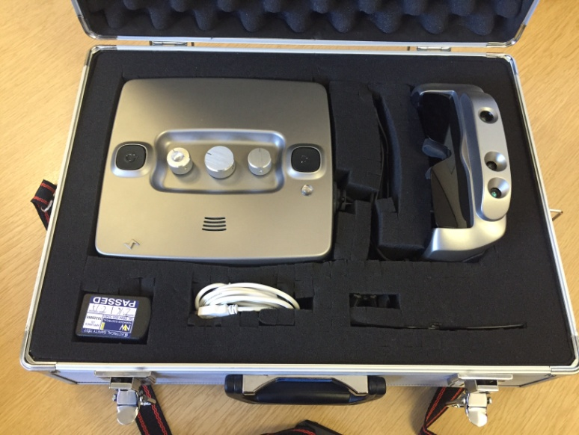For the purposes of shipping the Smart Glasses safely to participants we began to use protective packing cases with custom cut foam inserts. The foam inserts ensure the glasses and wires were securely held in place during transport and allowed the participants to safely store the glasses when not in use.

Even with the glasses packed in a protective padded case, we were not entirely in control of the safe transportation of the glasses. It was possible that the glasses could arrive with the participant having been damaged during transit or could be damaged during the time with each participant.

Due to the nature of couriering products, there was also a possibility of the Smart Glasses being lost between us sending them out and the participants safely receiving them or vice versa. This was a risk that we undertook, as it would not have been practical to distribute the Smart Glasses by any other means.

It had been hoped that we would be able to provide all participants who required prescription lenses a pair of Smart Glasses with their prescription fitted. This was not possible due to delays in receiving accurate prescription details. This was caused by a) participants not sending original copies of prescriptions, b) not having an up-to-date prescription which was 2-years old or below, or c) having to obtain additional information such as PDs (pupillary distance). As a result of these delays, 5 participants took part in the trial and had to wear their prescription lenses underneath the Smart Glasses.

### 11.3 Variables

One aspect of the testing that we had foreseen as a problem area was the number of variables that would come to have an effect on the testing, however as the testing went on this issue was more noticeable.

**Visual Acuity and visual field:**

Two big variables, identified early on in the process were finding out a participant’s field of vision and their visual acuity.

We tried to minimise the effect of the visual acuity variable by carrying out a basic portable visual acuity test on the day of the testing with each participant. We carried out either a FrACT test on a portable tablet or a Berkeley test with each participant.

However, the accuracy of the results achieved with these visual acuity tests is difficult to assess. Light levels make a big difference to what a person with sight problems is able to see. The right level of light might help them see much more and as we had to carry out the test in different location with different light levels this was not consistent. In some cases we might have obtained better results and some other worse because of the light level. It would have been more accurate if the light level would have been the same at all the testing venues.

While the accuracy might not be rigorous we have at least an indication of participants’ visual acuity in addition to their recorded subjective sight level (e.g. able to recognise a friend across the room).

As there is no portable way to assess the visual field of a participant we had to ask participants to provide us with a copy of their latest test. This was not as successful as we had hoped as we only had 52 visual fields out of 221participants. Some participants have not had one for years and others have had trouble getting them from their hospitals or their eyesight was not good enough to do a visual field test.

We underestimated the issue of getting visual fields and the lesson learned in this case might be to try and gather this information as much in advance of the testing as possible or to provide a venue where participants can have a visual acuity and visual field test done professionally prior to testing.

**Different Modes:**

Another variable that has to be taken into consideration in this testing is the fact that we have not been testing just a set of Smart Glasses with one mode, but there are five modes and there are two added variables that are the zoom and contrast (on top of lighting levels, sight loss conditions and level of sight).

We tried to reduce as much as possible the influence of these various variables by allowing an extended time for participants to make sure the glasses are fitted properly, familiarise themselves with the different modes and the different settings. Allowing participants to have as much time as they needed to understand what they might be able to see with the Smart Glasses and play around with the contrast and zoom has produced some “eureka” moments when suddenly things fell into place and the participant understood what they were meant to look for and they could use the contrast and zoom to better effect. This is quite time consuming, but very important and needed.

The ability of the individual to interpret what they see is another variable that comes into play. We had not taken into consideration that, as four of the modes show the world in black and white (but not as a colour blind person might see it), participants would not be familiar with what they saw in the Smart Glasses and would miss the information that colour provided them (for those people able to make use of colour in their daily life).

Using the Smart Glasses is not only a matter of deciphering the shape of something but also thinking what that could possibly match in one’s experience of the world. Therefore a lot of interpreting of what is displayed in the Smart Glasses needs to take place and this is a learning process (hence the long time given for familiarisation with the Smart Glasses). For example, the white lines they see in Mode 2 do not mean much if they do not recognise them as the edges of a table or chair.

### 11.4 Filter from Observed testing

The glasses can be fitted with a dark filter (like sun glasses). This filter blocks out some of the light making the glasses easier and more comfortable to use for people who are sensitive to light and also make it easier for some people to focus on the image projected on the glasses rather than seeing the images of the real world at the same time as the projected image. After the familiarisation exercise participants were asked if there was a difference between having the filter on and off. We have had 69 responses. 47 said that the glasses are better with the filter (68%), 15 said that the glasses are better without the filter (22%) and 7 said that it was the same (10%).

Not all participants were asked this question. Sometimes it was clear that the participant did not benefit from the glasses as they had too much sight and other times the short survey was carried out and this question was not asked.

Overall it shows that the majority of people who were asked prefer to have the filter fitted to the glasses.

During the observed testing it was clear that the current fitting of the filter is not secure and the filter often came loose and fell off and this needs to be reviewed for future developments.

### 11.5 Filter from Take home trial

For the purposes of the take – home trial, participants were provided with the dark plastic filter and also a lighter plastic filter which is more transparent. This will block out some light, but not all of it. It will also not block out all of the real world information that participants may be able to see.

Through the feedback we have received of the take home trial, it is clear that the use of the filter depends heavily on the participant, the task they were attempting and the environment that they are in, along with their sight level and visual field.

Some participants prefer to block out all background information and focus solely on the image presented by the Smart Glasses, whereas others prefer to use the Smart Glasses alongside a real world image.

Participants who struggle with light sensitivity found that due to the size and shape of the filters, light is able to come in from the sides and below the filter. This interfered with the experience of some participants as they found it difficult to focus on the screen when this happened. Those affected by this have suggested they would prefer a completely enclosed experience so that they would be able to use the Smart Glasses in all light conditions.

It has also been fed back that the filters are not fitted securely and often come loose, with one participant going so far as to tape it into place.

### 11.6 Zoom and field of view from Observed testing

It is clear from the findings that Mode 5 is preferred by the majority of participants. Mode 5 was often used in combination with the zoom and this provided the most benefit to people. The zoom is currently quite limited due to the quality of the camera, which is not good enough to provide a detailed image to zoom into. Some people commented that their own monocular or other low vision device provided a better quality image than the Smart Glasses in their current state and this should be considered for future developments.

The field of view when looking through the glasses is also quite limited and this was found to be a negative point particularly for mobility. Also the area to look at (where the image is displayed) is quite small and some people struggled with this. After these two issues were initially highlighted by participants a question was added and consequently 105 people commented that they would benefit from a wider field of view and 73 people commented that they would benefit from a larger screen. Again this should be considered for future developments.

### 11.7 Zoom and field of view from Take home trial

Some participants have reported finding that the quality of the image deteriorates when they use the zoom function at its maximum level. This is consistent with what was found during the observed testing part of the trial. One participant suggested that he would prefer an optical zoom to be used in the Smart Glasses, as it would allow him to zoom in further.

One participant has mentioned that he would like to be able to zoom in to areas other than the centre of a paused image.

A number of participants have mentioned during their feedback that they would benefit from a larger screen. It has also been mentioned that some participants would prefer viewing the screen without having to focus on the centre of the display. This can be done by using one eye or by having the screen positioned in such a way that they would be able to use their peripheral vision. One participant mentioned that he would prefer a portrait display as that would be better suited to his visual field. He felt this would help him to navigate more successfully, and would make him feel safer.

### About RNIB’s research

RNIB is a leading source of information on sight loss and the issues affecting blind and partially sighted people. Our Research and Knowledge Hub contains key information and statistics about blind and partially sighted people including our Sight Loss Data Tool, which provides information about sight loss at a local level throughout the UK. You’ll also find research reports on a range of topics including employment, education, technology, accessibility and more. Visit our Knowledge and Research Hub at: **rnib.org.uk/research**