# RNIB Smart Glasses Project

**Data analysis report**

Prepared by Dr Keziah Latham Prof Cert LV FCOptom

25 July 2016

Contents

Introduction 4

Visual field through Smart Glasses 4

Observer testing 5

Type of loss: self-reported as central, peripheral or both 6

Self-reported tunnel vision 6

Visual fields 7

Visual field loss as determined objectively by field plots 11

Objective tunnel vision 12

Comparison of objective visual field plots and self-reported visual field loss 13

Spectacle prescription 15

Visual acuity (VA) 16

Contrast sensitivity 16

Self-reported sight level 17

Age 18

Duration of visual loss 19

Diagnosis 19

Specific tasks in observer testing 23

Table top testing 23

Obstacle course 24

Outside walk 25

Comparison of tasks 26

Home trial 26

Diagnosis 27

Age 28

Duration of visual loss 29

Visual acuity 30

Visual field 31

Type of loss 31

Self-reported tunnel vision 31

Objective tunnel vision 32

Useful mode(s) 33

Use of filter 35

Conclusions 36

References 37

## Introduction

The purpose of this report is to further analyse the findings of the RNIB Smart Glasses project in order to comment on the characteristics of people who are more likely to gain benefit from the device. Particular emphasis is given to analysis of the visual field data provided by a subset of participants.

## Visual field through Smart Glasses

The Smart Glasses (Glasses) have a restricted field of view compared to the normal extent of visual field. It might therefore be considered that people with a visual field that extends beyond that of the Glasses will be losing visual extent by using the Glasses, so the appearance of the image within the screen would have to be significantly better to outweigh the restricted field of view. For those with visual field restricted to within the limits of the Glasses, vision is not being ‘lost’ by wearing them, and so the Glasses may need to provide less improvement in vision to be of benefit overall. To understand this further, visual field whilst wearing the Glasses was assessed.

Binocular visual field was assessed kinetically on the Octopus 900 with the Glasses in mode 5 (with filter in place, maximum contrast, and minimum zoom). As shown in Figure 1, the vertical extent of the field was approx. 35 deg, and horizontal extent approx. 55 deg. In addition, a 50 cm horizontal object fills the Glass screen from a distance of 40cm, indicating a field of 51 deg, consistent with the perimetric findings. Thus the Smart Glasses in mode 5 will be potentially of most use to patients who have vision retained within the central 35 deg vertically (approx. 15 deg above and below fixation) and 55 deg horizontally (approx. 25 deg either side of fixation).



Figure 1. Binocular visual field of the Glasses in mode 5.

In use, modes 1-3 have the same apparent magnification and field of view. Assessing the field of view perimetrically was more problematic as it was difficult to distinguish between the single target being seen through the Glasses and through the periphery of the filter. However, a 50cm horizontal object fills the Glasses screen from a distance of 50cm, which implies a horizontal field of 45 deg, slightly smaller than in mode 5.

## Observer testing

221 people tried the glasses and underwent observed testing. In this section, the main outcome measure that has been used is whether the participant benefitted sufficiently from the Glasses to be deemed suitable for take home testing on the basis of objective testing, with yes and maybe considered as a positive response to the Glasses, and no being a negative response. To try to identify those most likely to benefit from the Glasses, this response has been compared to several markers of visual loss, as outlined in the following sections.

### Type of loss: self-reported as central, peripheral or both

Participants were asked to report whether their visual impairment affected their central vision, peripheral vision, or both. People with what basic type of self-reported visual loss benefitted sufficiently from the glasses to warrant recommendation for a home trial?

|  |  |  |  |  |  |
| --- | --- | --- | --- | --- | --- |
|  | | Suitable for Take Home Testing (Objective) | | | Total |
| No | Maybe | Yes |
| Central, peripheral or has both been affected? | central | 23 | 1 | 1 | 25 |
| peripheral | 38 | 16 | 12 | 66 |
| both | 57 | 17 | 19 | 93 |
| no response | 29 | 7 | 1 | 37 |
| Total | | 147 | 41 | 33 | 221 |

Table 1. Suitability for home trial as a function of self-reported type of visual loss.

As shown in Table 1, it tends to be people with peripheral loss that benefit from the glasses. Of 25 people with central vision loss only, 8% found the Glasses helpful (maybe or yes). Of those with only peripheral loss, 28 of 66 people (42%) found the Glasses helpful. If both central and peripheral vision were affected, 36 out of 93 people (39%) found the Glasses helpful. Thus, perceived peripheral vision loss seems to drive potential utility of the glasses to some extent. However, what type or extent of field loss relate to successful use of the Glasses can be considered in more detail.

### Self-reported tunnel vision

Since peripheral visual field loss (either with or without additional central loss) seems to indicate a greater likelihood of the Glasses being helpful, self-reported presence of ‘tunnel vision’ was also related to suitability for home testing.

|  |  |  |  |  |  |
| --- | --- | --- | --- | --- | --- |
|  | | Suitable for Take Home Testing (Objective) | | | Total |
| No | Maybe | Yes |
| Has tunnel vision? | No | 110 | 27 | 20 | 157 |
| Yes | 35 | 14 | 13 | 62 |
| Not sure | 2 | 0 | 0 | 2 |
| Total | | 147 | 41 | 33 | 221 |

Table 2. Suitability for home trial as a function of self-reported tunnel vision.

As shown in Table 2, of the 62 people reporting that they had tunnel vision, 44% were or might be suitable for home testing, as opposed to 30% of the 157 people who did not report tunnel vision. Considered from an alternative perspective, 36% of those who might or would benefit from home trial reported tunnel vision, despite making up only 28% of the total sample. However, the association between reported tunnel vision and likelihood of being suitable for home testing was not quite statistically significant (χ2(1)=3.7, p=.055).

### Visual fields

In addition to relying on self-reported visual field status, some objective data on visual field was available, as 48 subjects provided some form of visual field plot and a further 4 provided written description of field status. The full nature of the visual field can be appreciated by the concept of the ‘hill of vision’ (Figure 2). The vertical axis of the plot represents sensitivity, with peak sensitivity at the fovea or point of fixation in normal vision. Further away from fixation, sensitivity decreases, and light stimuli need to be brighter to be detected. The horizontal axes of the plot represent eccentricity away from fixation, in both horizontal (nasal / temporal) and vertical (superior / inferior) directions. The visual field can assess the hill of vision in different ways, which can be broken down into ‘static’ paradigms which assess sensitivity at specified locations in the visual field, and ‘kinetic’ paradigms which assess the extent of visual field to a stimulus of specific brightness.

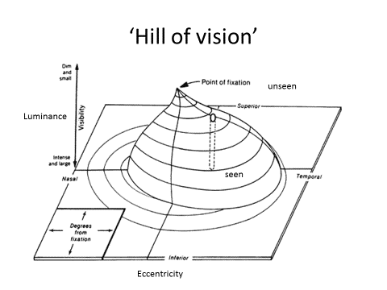

Figure 2. The Hill of Vision.

The majority of field plots that were provided were static plots of sensitivity (Total n= 40: central 30 deg threshold, n=15; central 10 deg threshold, n=1; central 30 deg suprathreshold, n=20; full field suprathreshold, n=2; Estermann binocular suprathreshold full field, n=2), consistent with the visual field equipment predominantly used in primary care settings. Threshold perimetric paradigms (Figure 3) determine the brightness of the stimulus that can be seen at different locations within the visual field. The values obtained are compared to age-related normative values, and an output created which compares the stimuli seen relative to expected norms. Suprathreshold paradigms (Figure 4) present a single stimulus of a luminance that should be seen by an eye with normal vision, and reports the stimuli seen and not seen.

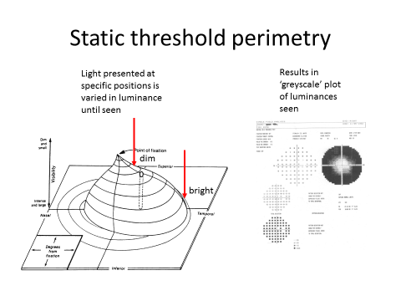

Figure 3. Static threshold perimetry.

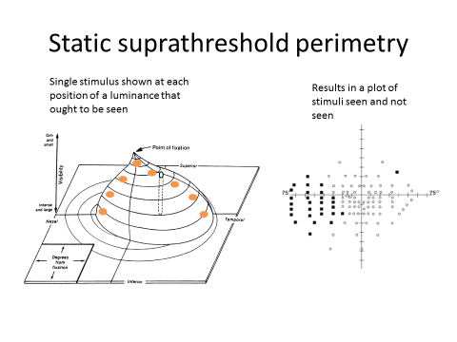

Figure 4. Static suprathreshold perimetry.

A handful of kinetic plots were provided (Total n= 9; confrontation, n=5; Amsler, n=1; manual kinetic (Goldmann), n=3; note figures don’t add to 48 as some presented more than 1 field). In kinetic perimetry (Figure 5), a stimulus of known luminance is moved from an unseen position in peripheral field towards fixation until it is seen. Kinetic perimetry therefore determines the extent of the visual field to a stimulus of constant sensitivity, rather than determining sensitivity within the field.

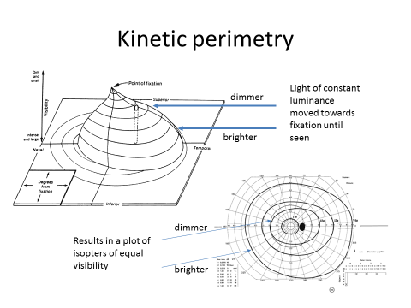

Figure 5. Kinetic perimetry.

In future studies, where it is possible to measure visual fields as part of the assessment, the following points might be considered. Static fields have limited utility in assessing advanced tunnel vision as the points are generally spaced 6 deg apart which is not sufficient to map small residual fields. Some participants providing a static field plot may have seen no points on the visual field test, but there may have been a small area of residual field operating between the points on the test grid. However, a static field can be a useful tool as when using a predetermined test pattern limited operator skill is needed to obtain a valid result. If static fields were to be used, a full field suprathreshold design utilising a 10dB stimulus could be used to determine a rough idea of area of field remaining through the parameter of ‘proportion of points seen’. Current standards for Paralympic visual impairment classification (International Paralympic Committee, 2013) suggest a full field suprathreshold static assessment (FF120) plus a more detailed central static threshold field of a nature appropriate to the capture the individual’s field loss (30, 24 or 10 deg extent as appropriate).

Kinetic visual field plots (see e.g. those provided for subject 197 and 273) would be better for determining the extent of residual field that is compatible with the Glasses proving potentially useful in the cases of those with severely restricted peripheral field or ‘tunnel vision’. However, these plots require more operator skill to obtain, and they are of less benefit for patients with less severe visual loss.

#### Visual field loss as determined objectively by field plots

Of the 52 people providing a field plot or written description of field status, 4 were deemed objectively suitable for home testing and 6 were maybe suitable. Note that this is a small proportion of the 74 people potentially suitable for home trial, so the following analysis should be considered as case study examples. The participants who were suitable for home trial and provided field plots were:

Suitable for home trial:

23: R absolute peripheral loss, relative defect within 10 deg of fixation. L very small amount of residual central field. Classic ‘tunnel vision’. Retinitis Pigmentosa (RP). Poor VA (0.01 decimal).

140 R absolute loss. L sparing centrally and extending to at least 25 deg in upper left half of field, absolute defect lower right half. Not classic tunnel vision, but certainly restricted peripherally. Diabetic retinopathy. Fair VA (0.4 decimal).

197 R&L very small residual central fields (<5deg). Also in each eye an inferior peripheral slither of residual vision at about 40 deg eccentricity. Classic ‘tunnel vision’. Choroideraemia. Fair VA (0.3 decimal).

273 R temp island of residual vision from 20-50 deg temporally, no central function; L residual island from just at the macula to 50 deg temporally. Constitutes ‘tunnel vision’ but less restricted than subjects 23/197. Leber’s optic neuropathy. No VA result.

Maybe suitable for home trial:

7 RE no plot provided, LE sparing of vision in temporal field to about 25 deg. Unsure of condition. Poor VA (0.05 decimal).

12 RE no plot provided, LE island of residual vision from just above fixation to 10 deg inferior field. Classic ‘tunnel vision’. Glaucoma and cataract. Fair VA (0.2 decimal).

73 RE residual vision to at least 30 deg in upper left quadrant of field, LE crescent of residual vision from 25 deg temporally. Optic atrophy. Poor VA (0.05 decimal).

108 RE no vision, LE vision retained in central 5 deg. Classic ‘tunnel vision’. Glaucoma. Fair VA (0.4 decimal).

160 R&L vision retained in central 10 deg. Classic ‘tunnel vision’. Glaucoma, retinal detachment, cataract and corneal oedema. Poor VA (0.02 decimal).

165 R&L loss of superior visual field, with inferior field intact to at least 25 deg. Glaucoma, cataract and nystagmus. Fair VA (0.2 decimal).

If there is a pattern here, it is that the field plots of those who could benefit from the Glasses are tending to be the ones with ‘classic’ RP type tunnel vision and very small residual central fields. Most have visual fields that are restricted to be within the field of view of the Glasses.

#### Objective tunnel vision

Given the varied nature of the visual field plots provided, it was not possible to derive a continuous variable expressing the level of field loss either in terms of loss of sensitivity (dB) or extent of remaining visual field to a specific stimulus (extent in degrees). Fields provided were therefore divided into categories of ‘tunnel vision’ or ‘not tunnel vision’. ‘Tunnel vision’ was defined as a residual field of radius less than 10 deg from fixation. Fields that were not considered to constitute tunnel vision were those with greater residual field than the definition, and also visual fields that were not measurable (no points seen). As described above, this definition might miss some examples of tunnel vision where some residual visual function remains which is not captured by the field plot used. Future studies could usefully measure visual field as part of the protocol to determine a fine graded numerical value for a specific aspect of the visual field.

|  |  |  |  |  |  |
| --- | --- | --- | --- | --- | --- |
|  | | Suitable for Take Home Testing (Objective) | | | Total |
| No | Maybe | Yes |
| Tunnel vision (<10deg residual) from field plot | No | 26 | 2 | 1 | 29 |
| Yes | 16 | 4 | 3 | 23 |
| Don't know | 105 | 35 | 29 | 169 |
| Total | | 147 | 41 | 33 | 221 |

Table 3. Relationship between objectively defined ‘tunnel vision’ and suitability for a home trial with the Glasses.

As shown in Table 3, of the 52 participants providing objective evidence of their visual field, 23 participants could be defined as having ‘tunnel vision’. Considering this subgroup of 52 people, the presence of ‘tunnel vision’ was significantly associated with being suitable for a home trial with the Glasses (χ2(1)=6.9, p<.01).

#### Comparison of objective visual field plots and self-reported visual field loss

Since both objective assessment of field loss and subjective perception of field loss are available for some participants, it is worth considering to what extent each measure tells the same story.

As shown in Table 4, 52 participants provided a field plot or clinical description of their field loss, of which 23 fitted the description of ‘tunnel vision’ (residual field extending no more than 10 deg radius from fixation). Those who did not provide a visual field are defined as ‘don’t know’ (n=169). Comparing the objective report of tunnel vision to participants’ self-report of central or peripheral loss, the vast majority of those with ‘tunnel vision’ (91%) describe themselves as having peripheral visual loss. 55% of those who did not have objective tunnel vision also describe themselves as having peripheral visual loss, which is potentially reasonable since objective categorisation of tunnel vision was given quite a tight definition of severe peripheral loss.

|  |  |  |  |  |  |  |
| --- | --- | --- | --- | --- | --- | --- |
|  | | Central, peripheral or has both been affected? | | | | Total |
| central | peripheral | both | no response |
| Tunnel vision (<10deg residual) from field plot | No | 6 | 7 | 9 | 7 | 29 |
| Yes | 1 | 10 | 11 | 1 | 23 |
| Don't know | 18 | 49 | 73 | 29 | 169 |
| Total | | 25 | 66 | 93 | 37 | 221 |

Table 4. Relationship between objectively defined ‘tunnel vision’ and self-reported type of visual loss.

The relationship between objective and perceived ‘tunnel vision’ (Table 5) is not quite so clear, with about half of those with objective tunnel vision describing their field loss in this way, but the other half not reporting their field loss as ‘tunnel vision’. The association between the two parameters is just about significant (χ2(1)=5.6, p<.05).

|  |  |  |  |  |
| --- | --- | --- | --- | --- |
|  | | Has tunnel vision? | | Total |
| Yes | No |
| Tunnel vision (<10deg residual) from field plot | No | 6 | 23 | 29 |
| Yes | 12 | 11 | 23 |
| Don't know | 44 | 125 | 169 |
| Total | | 62 | 159 | 221 |

Table 5. Relationship between objectively defined ‘tunnel vision’ and self-reported ‘tunnel vision’.

Thus, self-reported type of field loss is not completely consistent with categorisations based on examination of the objective data. Some of the discrepancy is likely because of the varied and non-optimal field assessments presented affecting the objective classification, but some is also likely due to variations in the perceptions of what constitutes tunnel vision, or central or peripheral visual loss. It is known that self-report often differs from objective assessment (Latham & Usherwood, 2010; van Nispen, Hoeijmakers, De Boer, Ringens, & van Rens, 2008), and that self-reported difficulty is driven not only by vision loss but also by psychosocial factors such as depression and adjustment to visual loss (Tabrett & Latham, 2011). The evidence examined thus far suggests that standardised assessment of the extent of residual visual field for those with peripheral visual loss might be useful in giving greater clarity in identifying those most likely to benefit from the Glasses.

### Spectacle prescription

53 subjects provided a spectacle prescription. These were rather variable in terms of whether visual acuities with the glasses were given, and also in terms of whether the prescription had actually been prescribed to be worn as spectacles or did not improve vision and had been provided for information only. The spectacle prescriptions have therefore not been evaluated further.

### Visual acuity (VA)

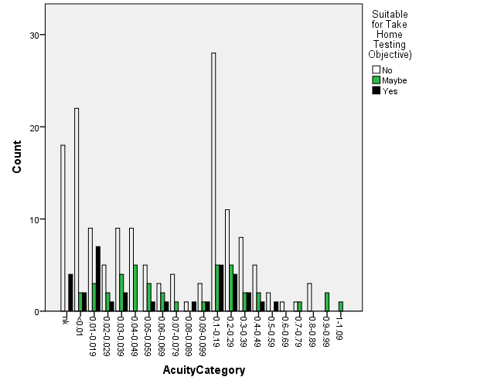

Figure 6. Relationship between being suitable for a home trial with the Glasses and visual acuity.

There is no obvious relationship between visual acuity and being objectively suitable for home testing of the Glasses (Figure 6), with those either suitable or maybe suitable for home testing having acuities covering pretty much the full range of acuities (given in decimal acuity: bigger numbers are better acuities with 1.0 equivalent to 6/6, 0.0 logMAR, and 0.01 equivalent to 6/600, 2.0logMAR).

### Contrast sensitivity

Contrast sensitivity was not assessed as part of observer testing. Since the effect of the Glasses in modes 1-4 is to increase contrast and optimise edge detection, it would be expected that those with reduced contrast sensitivity might preferentially benefit from the Glasses. Loss of contrast sensitivity cannot be predicted from loss of visual acuity, and relates more strongly to ‘real-world’ visual difficulties than loss of acuity (Owsley & Sloane, 1987). In future assessment, measurement of contrast sensitivity using the gold-standard approach of the Pelli-Robson chart (Pelli, Robson, & Wilkins, 1988) would be recommended.

### Self-reported sight level

Reported sight level from ‘none’ to ‘extra high’ is collected, and may well capture some aspects of contrast sensitivity as well as visual acuity, since reporting is based on ability to see furniture and faces, which are not necessarily high contrast tasks. Interestingly, reported sight level bears little relationship to measured visual acuity, as shown in Figure 7.

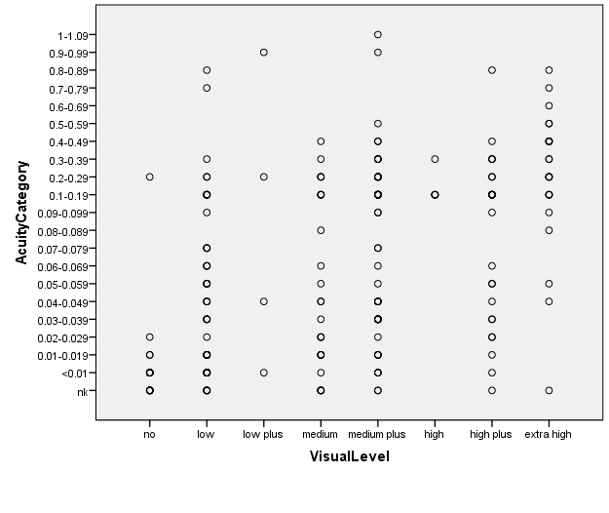

Figure 7. Relationship between objectively assessed visual acuity (Acuity category) and reported level of vision (Visual level).

The proportion of people suitable for a home trial (yes or maybe) was (as for visual acuity) similar across the range of reported visual abilities (Table 6). Only those with ‘no’ vision (‘unable to see the shape of furniture’) were considerably less likely to benefit sufficiently to warrant a home trial.

|  |  |  |  |  |  |  |
| --- | --- | --- | --- | --- | --- | --- |
|  | | Suitable for Take Home Testing (Objective) | | | Total | % suitable |
| No | Maybe | Yes |  |
| Visual Level | no | 17 | 2 | 1 | 20 | 15 |
| low | 37 | 8 | 10 | 55 | 33 |
| low plus | 2 | 2 | 0 | 4 | 50 |
| medium | 18 | 3 | 7 | 28 | 36 |
| medium plus | 36 | 17 | 7 | 60 | 38 |
| high | 3 | 1 | 1 | 5 | 40 |
| high plus | 19 | 3 | 3 | 25 | 24 |
| extra high | 15 | 5 | 4 | 24 | 38 |
| Total | | 147 | 41 | 33 | 221 | 33 |

Table 6. Relationship between suitability for home trial and self-reported level of vision.

Visual impairment registration status might be another useful parameter to include to capture level of sight loss in future studies.

### Age

The majority of participants (83%) were in the age range 40-84 years. There was a trend for younger participants (<65 years, and particularly <40 years) to be more likely to benefit from a home trial than older participants (Table 7). If a cut-off were to be suggested, it would be at 64 years or younger. An age of <65 years was strongly associated with being suitable for a home trial (χ2(1)=16.0, p<.001). Possible factors influencing this finding might be thatyounger people are more comfortable with technology, or perhaps because the Glasses are more suited to tasks undertaken by younger people (e.g. working environment).

|  |  |  |  |  |  |  |
| --- | --- | --- | --- | --- | --- | --- |
|  | | Suitable for Take Home Testing (Objective) | | | Total | % suitable |
| No | Maybe | Yes |  |
| AgeGroup | <18 | 1 | 1 | 0 | 2 | 50 |
| 19-39 | 10 | 4 | 9 | 23 | 57 |
| 40-64 | 56 | 25 | 16 | 97 | 42 |
| 65-84 | 68 | 10 | 6 | 84 | 19 |
| >85 | 9 | 0 | 2 | 11 | 18 |
| Total | | 144 | 40 | 33 | 217 |  |

Table 7. Relationship between age group and suitability for a home trial with the Glasses.

### Duration of visual loss

While younger age does seem to be associated with potential usefulness of the Glasses, there is no obvious relationship between the duration of visual loss and the likelihood of being suitable for a home trial of the Glasses (Table 8).

|  |  |  |  |  |  |  |
| --- | --- | --- | --- | --- | --- | --- |
|  | | Suitable for Take Home Testing (Objective) | | | Total | % suitable |
| No | Maybe | Yes |  |
| Duration | Not known | 1 | 0 | 0 | 1 |  |
| Congenital | 36 | 15 | 9 | 60 | 40 |
| <1985 | 30 | 2 | 9 | 41 | 27 |
| 1985-89 | 7 | 2 | 2 | 11 | 36 |
| 1990-94 | 9 | 4 | 1 | 14 | 36 |
| 1995-99 | 7 | 5 | 3 | 15 | 53 |
| 2000-04 | 14 | 4 | 3 | 21 | 33 |
| 2005-09 | 28 | 4 | 5 | 37 | 24 |
| 2010-15 | 15 | 5 | 1 | 21 | 29 |
| Total | | 147 | 41 | 33 | 221 |  |

Table 8. Relationship between duration of visual loss and likelihood of suitability for a home trial with the Glasses.

### Diagnosis

The principal cause of visual loss was re-categorised based on the tick boxes used and additional information given. In the event of more than one condition being specified, the one with generally greater impact on visual function was selected as the principal cause. Inherited retinal dystrophies covers conditions usually initially or preferentially affecting peripheral vision including Retinitis Pigmentosa (RP), choroidaemia, retinoschisis, Usher’s syndrome, rod-cone dystrophy, Bardet-Biedl syndrome, and Leber’s congenital amaurosis. Macular degeneration covers conditions generally affecting central vision including AMD and Stargardt’s disease. Cerebro-vascular accident (CVA) covers stroke and brain haemorrhage. Diabetic retinopathy also includes CMV Retinitis. Optic nerve damage includes optic atrophy, giant cell arteritis, non-arteritic anterior ischaemic optic neuropathy (AION), and Leber’s optic neuropathy. Although several participants did report having cataract, this was usually in combination with another condition (e.g. macular condition, or inherited retinal disorder) that usually has a greater impact on visual function, so it was not considered the primary diagnosis. Only a few participants remained who only gave cataract as a cause of their visual loss, and these individuals are considered in the ‘other’ category.

|  |  |  |  |  |  |  |
| --- | --- | --- | --- | --- | --- | --- |
|  | | Suitable for Take Home Testing (Objective) | | | Total | % suitable |
| No | Maybe | Yes |  |
| Diagnosis | Inherited retinal dystrophy | 44 | 10 | 20 | 74 | 41 |
| Macular condition | 41 | 3 | 3 | 47 | 13 |
| Glaucoma | 15 | 9 | 2 | 26 | 42 |
| Optic nerve damage | 10 | 6 | 5 | 21 | 52 |
| CVA | 4 | 0 | 0 | 4 | 0 |
| Diabetic retinopathy | 5 | 2 | 1 | 8 | 38 |
| Retinal detachment | 7 | 1 | 0 | 8 | 13 |
| Albinism / aniridia | 3 | 6 | 0 | 9 | 67 |
| Unknown or not specified | 5 | 1 | 0 | 6 |  |
| Other | 13 | 3 | 2 | 18 |  |
| Total | | 147 | 41 | 33 | 221 |  |

Table 9. Relationship between principal ocular diagnosis and suitability for a home trial with the Glasses.

The benefit of the Glasses appears to be more pronounced for those with inherited retinal dystrophies or glaucoma, which affect peripheral vision in the first instance (Table 9). This fits with the previous suggestion that the Glasses will be of most benefit for those whose residual vision lies within the limited field of view of the Glasses. Those with optic nerve damage often have problems with reduced contrast sensitivity and also seem to benefit from the Glasses. In this instance it may be that the benefits of contrast enhancement in modes 1-4 outweigh the restricted field of view. Those with albinism / aniridia also seem to benefit, but in the ‘maybe’ rather than ‘yes’ category. This might relate to an advantageous effect of the filter?

The overall preferred mode with the Glasses during observer testing (if specified, regardless of whether vision was better with or without the Glasses) is compared to the participants’ diagnosis in Table 10. Mode 5 was by far the most popular mode in general. Modes 1-4 were only preferred by a proportion of those with retinal dystrophies. Despite the hypothesis above, those with optic nerve damage did not tend to prefer modes 1-4.

|  |  |  |  |  |  |  |  |
| --- | --- | --- | --- | --- | --- | --- | --- |
|  | | Preferred Mode of Glasses | | | | | Total |
| 1 | 2 | 3 | 4 | 5 |
| Diagnosis | Inherited retinal dystrophy | 5 | 8 | 6 | 3 | 34 | 56 |
| Macular condition | 1 | 1 | 0 | 1 | 28 | 31 |
| Glaucoma | 2 | 0 | 0 | 1 | 20 | 23 |
| Optic nerve damage | 0 | 1 | 2 | 0 | 12 | 15 |
| CVA | 0 | 0 | 0 | 0 | 1 | 1 |
| Diabetic retinopathy | 0 | 1 | 0 | 1 | 4 | 6 |
| Retinal detachment | 0 | 0 | 0 | 0 | 3 | 3 |
| Albinism / aniridia | 0 | 0 | 0 | 0 | 8 | 8 |
| Unknown or not specified | 0 | 1 | 0 | 0 | 3 | 4 |
| Other | 0 | 1 | 0 | 3 | 13 | 17 |
| Total | | 8 | 13 | 8 | 9 | 126 | 164 |

Table 10. Preferred mode of the Glasses for people with different ocular diagnoses.

### Specific tasks in observer testing

#### Table top testing

Only 69 of the 221 participants showed a benefit of the Glasses (either reported that vision was better with than without the glasses, or reported that vision was the same in each condition but the observer noted some benefit of the Glasses) in the table top test, most of whom had inherited retinal dystrophy (42%, as compared to 33% in the original sample). The preferred mode for table top testing of those who showed benefit is considered in Table 11. Mode 5 was the preference of most people (78%). Mode 2 or 3 was the preference of 14 people, 10 of whom (71%) had inherited retinal dystrophy. Mode 1 was no one’s preference.

|  |  |  |  |  |  |  |
| --- | --- | --- | --- | --- | --- | --- |
|  | | Preferred Mode of Glasses | | | | Total |
| 2 | 3 | 4 | 5 |
| Diagnosis | Inherited retinal dystrophy | 3 | 7 | 0 | 19 | 29 |
| Macular condition | 0 | 0 | 0 | 9 | 9 |
| Glaucoma | 0 | 1 | 0 | 8 | 9 |
| Optic nerve damage | 0 | 1 | 0 | 5 | 6 |
| Diabetic retinopathy | 0 | 1 | 0 | 2 | 3 |
| Retinal detachment | 0 | 0 | 0 | 2 | 2 |
| Albinism / aniridia | 0 | 0 | 0 | 6 | 6 |
| Unknown or not specified | 0 | 1 | 0 | 1 | 2 |
| Other | 0 | 0 | 1 | 2 | 3 |
| Total | | 3 | 11 | 1 | 54 | 69 |

Table 11. Mode preference for table top testing for participants who benefitted from the Glasses for this task.

Of the 69 people benefitting from the Glasses on the table top task, three quarters were aged between 19 and 64 years, they had a wide range of acuities, a quarter had congenital visual loss and the remainder had durations of visual loss spread across the range of options. Three people reported central vision loss, the remainder reporting either peripheral loss (n=24) or central and peripheral loss (n=34), with 8 having no response. Twenty six people reported subjective tunnel vision. In this group of 69, 15 people had provided visual field plots: 6 were rated as having tunnel vision.

#### Obstacle course

Only 47 people were seen to find the Glasses helpful for the obstacle course, most of whom had inherited retinal dystrophy (49%; Table 12). The majority of people who found the Glasses of benefit here found mode 5 most useful (60%). Modes 1-4 were found useful by a total of 19 people, most of whom (63%) had inherited retinal dystrophy.

|  |  |  |  |  |  |  |  |
| --- | --- | --- | --- | --- | --- | --- | --- |
|  | | Preferred Mode of Glasses | | | | | Total |
| 1 | 2 | 3 | 4 | 5 |
| Diagnosis | Inherited retinal dystrophy | 3 | 4 | 5 | 0 | 11 | 23 |
| Macular condition | 0 | 0 | 0 | 1 | 4 | 5 |
| Glaucoma | 0 | 0 | 1 | 0 | 4 | 5 |
| Optic nerve damage | 0 | 0 | 2 | 0 | 2 | 4 |
| Diabetic retinopathy | 0 | 1 | 1 | 0 | 1 | 3 |
| Albinism / aniridia | 0 | 0 | 0 | 0 | 2 | 2 |
| Other | 0 | 0 | 0 | 1 | 4 | 5 |
| Total | | 3 | 5 | 9 | 2 | 28 | 47 |

Table 12. Mode preference for the obstacle course for participants who benefitted from the Glasses for this task.

Of the 47 people benefitting from the Glasses on the obstacle course, three quarters were aged between 19 and 64 years, they had a wide range of acuities, a third had congenital visual loss and the remainder had durations of visual loss spread across the range of options. Only 1 person reported central vision loss, the remainder reporting either peripheral loss (n=16) or central and peripheral loss (n=26). Seventeen people reported subjective tunnel vision. In this group of 47, 9 people had provided visual field plots: 6 were rated as having tunnel vision.

#### Outside walk

The outside walk was not attempted with a number of participants for various reasons including location, poor mobility, or lack of improvement of the Glasses in previous tasks. 25 people did benefit from the Glasses on an outside walk, and these were people with a range of different diagnoses (Table 13). Mode 5 was preferred more often than mode 4.

|  |  |  |  |  |
| --- | --- | --- | --- | --- |
|  | | Preferred Mode of Glasses | | Total |
| 4 | 5 |
| Diagnosis | Inherited retinal dystrophy | 1 | 7 | 8 |
| Macular condition | 2 | 1 | 3 |
| Glaucoma | 1 | 1 | 2 |
| Optic nerve damage | 1 | 2 | 3 |
| Diabetic retinopathy | 2 | 1 | 3 |
| Albinism / aniridia | 1 | 3 | 4 |
| Other | 1 | 1 | 2 |
| Total | | 9 | 16 | 25 |

Table 13. Mode preference for the outside walk for participants who benefitted from the Glasses for this task.

Of the 25 people benefitting from the Glasses on an outside walk, 19 were aged between 19 and 64 years. They had a wide range of acuities, 11 had congenital visual loss and the remainder had durations of visual loss spread across the range of options. Only 1 person reported central vision loss, the remainder reporting either peripheral loss (n=8) or central and peripheral loss (n=13). Only 4 reported subjective tunnel vision. In this group of 25, 4 people had provided visual field plots and all 4 were rated as having tunnel vision.

#### Comparison of tasks

Comparing the tasks, the characteristics of those benefitting from the Glasses appears broadly similar. The age range, duration of visual loss and acuity of people gaining benefit was wide ranging. There was a tendency for people with peripheral visual loss, and with inherited retinal dystrophies to feature in the group benefitting from the Glasses, and mode 5 was found useful most frequently. Fewer people found the mobile tasks beneficial (obstacle course n=47, outside walk n=25) than the sedentary task (n=69) in this initial familiarisation. Older people (>65 years) formed a smaller proportion of the group benefitting from the Glasses in the mobile tasks (outside walk 25%; obstacle course 25%) than in the sedentary table top task (33%).

## Home trial

The Glasses were tried by 221 people, of whom 103 volunteered for a home trial. Of these 103, 33 showed objective benefit of Glasses and 41 got some benefit, so were deemed suitable for home trial. One additional participant joined the home trial who had not taken part in observer testing. Of these 75, 55 eventually took part in a home trial of the Glasses, and 44 completed the trial.

Thirty three people (60% of those starting a home trial, 15% of those who tried the Glasses in total) both completed the home trial and responded that they had benefitted from the Glasses. In the analysis that follows, these 33 people are analysed to consider what characteristics of successful users of the Glasses can be identified.

### Diagnosis

Nearly half of those successful with the Glasses at home had an inherited retinal dystrophy (Table 14), although people with this diagnosis constituted only a third of the original sample. Although the numbers are small, there are also a greater proportion of people with aniridia / albinism who gained benefit from the Glasses than were in the original sample. The representation of other diagnoses in this successful group of Glasses users reflects the proportions in the initial sample, although there was a lower proportion of successful users with macular conditions, and no successful users with a CVA or an ‘unknown’ diagnosis. The Glasses appear to be of greater benefit to those with inherited retinal disorders and possibly to those with albinism / aniridia, but are of less benefit to those with macular conditions.

|  |  |  |  |  |
| --- | --- | --- | --- | --- |
|  | | Frequency | Percent | % in original sample |
| Diagnosis | Inherited retinal dystrophy | 15 | 45.5 | 33.5 |
| Macular condition | 3 | 9.1 | 21.3 |
| Glaucoma | 3 | 9.1 | 11.8 |
| Optic nerve damage | 4 | 12.1 | 9.5 |
| Diabetic retinopathy | 1 | 3.0 | 3.6 |
| Retinal detachment | 1 | 3.0 | 3.6 |
| Albinism / aniridia | 3 | 9.1 | 4.1 |
| Other | 3 | 9.1 | 8.1 |
| Total | 33 | 100.0 |  |

Table 14. Diagnoses of home trial participants who completed the trial and found the Glasses beneficial. For comparison, the proportion of people with this diagnosis in the full sample undergoing observer testing (n=221) is also given.

### Age

Successful participants tended to be adults of working age (Table 15): there were a greater proportion of successful users of the Glasses in the 19-64 age group than in the original sample. There were too few users under 18 to make a judgement as to whether the Glasses were helpful to this age group. People over 65 were less likely to be successful users of the Glasses. These findings are consistent with those seen in the observer testing.

|  |  |  |  |  |
| --- | --- | --- | --- | --- |
|  | | Frequency | Percent | % in original sample |
| Age group | <18 | 1 | 3.0 | 0.01 |
| 19-39 | 8 | 24.2 | 10.4 |
| 40-64 | 17 | 51.5 | 43.9 |
| 65-84 | 4 | 12.1 | 38.0 |
| >85 | 1 | 3.0 | 5.0 |
| Total | 31 | 93.9 |  |
| Missing | System | 2 | 6.1 |  |
| Total | | 33 | 100.0 |  |

Table 15. Age group of home trial participants who completed the trial and found the Glasses beneficial. For comparison, the proportion of people in each age group in the full sample undergoing observer testing (n=221) is also given.

### Duration of visual loss

As with the initial observer testing, there was little relationship between duration of visual loss and likelihood of successful use of the Glasses following home trial (Table 16). The proportions of successful users of the Glasses roughly reflects the proportions seen in the original sample of testers.

|  |  |  |  |  |
| --- | --- | --- | --- | --- |
|  | | Frequency | Percent | % in original sample |
| Duration of loss | Congenital | 11 | 33.3 | 27.1 |
| <1985 | 2 | 6.1 | 18.6 |
| 1985-89 | 2 | 6.1 | 5.0 |
| 1990-94 | 1 | 3.0 | 6.3 |
| 1995-99 | 5 | 15.2 | 6.8 |
| 2000-04 | 3 | 9.1 | 9.5 |
| 2005-09 | 4 | 12.1 | 16.7 |
| 2010-15 | 4 | 12.1 | 9.5 |
| Total | 32 | 97.0 |  |
| Missing | System | 1 | 3.0 |  |
| Total | | 33 | 100.0 |  |

Table 16. Duration of visual loss of home trial participants who completed the trial and found the Glasses beneficial. For comparison, the proportion of people in each duration category in the full sample undergoing observer testing (n=221) is also given.

### Visual acuity

Any level of visual acuity could be associated with a successful home trial of the Glasses, either from an objective measure of visual acuity (Figure 8) or a subjective report of what can be seen (Figure 9). This is consistent with the findings of the observer testing.

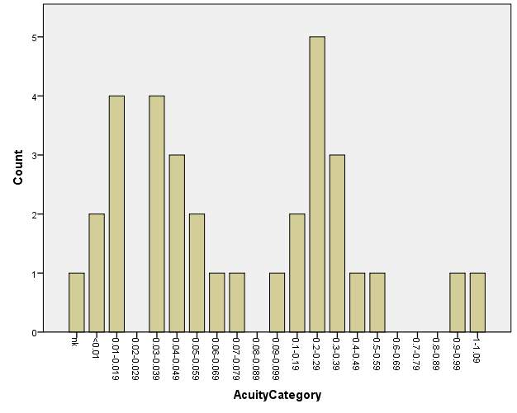

Figure 8. Objectively measured visual acuity category of those who completed the home trial and found the Glasses of benefit.

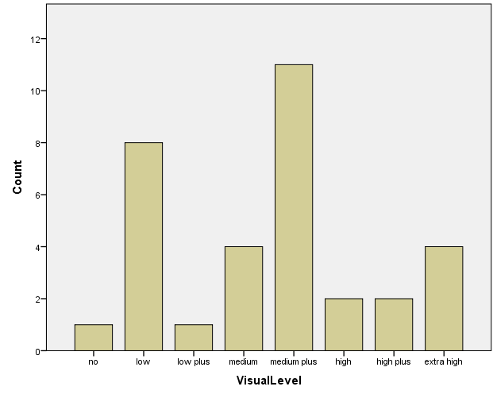

Figure 9. Subjectively reported visual level of those who completed the home trial and found the Glasses of benefit.

### Visual field

#### Type of loss

Successful Glasses users were slightly more likely to have peripheral loss only (39%) compared to the original sample (30%) (Table 17). As previously seen, people with central visual loss only were not likely to benefit from the Glasses.

|  |  |  |  |  |
| --- | --- | --- | --- | --- |
|  | | Frequency | Percent | % of original sample |
| Type of loss | central | 1 | 3.0 | 11.3 |
| peripheral | 13 | 39.4 | 29.9 |
| both | 14 | 42.4 | 42.1 |
| no response | 4 | 12.1 | 16.7 |
| Total | 32 | 97.0 |  |
| Missing | System | 1 | 3.0 |  |
| Total | | 33 | 100.0 |  |

Table 17. Reported type of visual loss of home trial participants who completed the trial and found the Glasses beneficial. For comparison, the proportion of people in each category in the full sample undergoing observer testing (n=221) is also given.

#### Self-reported tunnel vision

People with perceived tunnel vision made up 28% of the original 221 participants in observer testing, but make up 42% of those benefitting from the Glasses after a home trial (Table 18). As with the observer testing, this suggests that people with restricted visual fields are more likely to benefit from the Glasses.

|  |  |  |  |  |
| --- | --- | --- | --- | --- |
|  | | Frequency | Percent | % of original sample |
| Subjective: Has tunnel vision? | Yes | 14 | 42.4 | 28.0 |
| No | 18 | 54.5 | 71.0 |
| Total | 32 | 97.0 |  |
| Missing | System | 1 | 3.0 |  |
| Total | | 33 | 100.0 |  |

Table 18. Reported tunnel vision status of home trial participants who completed the trial and found the Glasses beneficial. For comparison, the proportion of people in each category in the full sample undergoing observer testing (n=221) is also given.

#### Objective tunnel vision

As described in observer testing, from the visual field plots and written descriptions of visual field status provided, participants were defined as having objective tunnel vision (n=23), or as not having tunnel vision (n=29). Participants not providing a visual field were defined as ‘don’t know’ (n=169).

Of the 33 people who completed the home trial and found the Glasses of benefit, 6 people had provided a field plot. All were categorised as having tunnel vision (Table 19). There was no participant providing a field plot that was not categorised as having tunnel vision who benefitted from the Glasses in home trial, or indeed even completed the home trial. This data suggests that objectively measured ‘tunnel vision’ (as defined as a residual central field of <10deg radius in this instance) is a potential predictor of success with the Glasses. However, for reasons described above, the visual field analysis has been quite coarse in this instance, and visual fields could be assessed in more detail in future studies to give a better idea of what extent of residual field best relates to successful use of the Glasses.

|  |  |  |  |  |  |
| --- | --- | --- | --- | --- | --- |
|  | | Glasses Of Benefit | | | Total |
| No | Yes | Not sure |
| Tunnel vision (<10deg residual) from field plot | Yes | 0 | 6 | 0 | 6 |
| Don't know | 4 | 27 | 6 | 37 |
| Total | | 4 | 33 | 6 | 43 |

Table 19. Relationship between the benefit of the Glasses to those completing the home trial, and objective visual field status.

### Useful mode(s)

Participants were asked to specify all the modes of the Glasses that they found useful. Considering the responses of those who completed the home trial and found the Glasses of benefit (Table 20), it can be seen that the colour mode 5 was the most popular, with mode 2 the most popular of the black and white options. The non-colour modes tended to be found to be more useful by people with inherited retinal dystrophies, optic nerve damage or glaucoma. As noted previously, this may relate to reduced contrast sensitivity, which is common in these conditions. It would be interesting in future studies to relate contrast sensitivity to preferred mode with the Glasses.

It was also noted in participants’ comments that different modes were useful for day and night tasks. Future testing to determine the people most likely to benefit from the Glasses should consider asking for self-reported difficulty in night vision, and / or measured visual function in dark conditions such as mesopic / scotopic visual acuity or dark adaptation.

|  |  |  |  |  |  |  |
| --- | --- | --- | --- | --- | --- | --- |
|  | Useful mode | | | | |  |
|  | 1 | 2 | 3 | 4 | 5 | No of observers |
| Inherited retinal dystrophy | 5 | 9 | 4 | 4 | 9 | 15 |
| Macular condition |  |  | 1 |  | 3 | 3 |
| Glaucoma |  |  | 2 | 1 | 1 | 3 |
| Optic nerve damage | 2 | 2 |  | 1 | 3 | 4 |
| Diabetic retinopathy |  |  |  |  | 1 | 1 |
| Retinal detachment |  |  |  | 1 | 1 | 1 |
| Albinism / aniridia |  |  |  | 1 | 2 | 3 |
| Other |  |  |  |  | 3 | 3 |
| Total | 7 | 11 | 7 | 8 | 23 |  |

Table 20. Mode of Glasses found useful by those who found benefit from the Glasses following home trial. More than one mode could be selected, so numbers do not add up to the number of individuals (n=33).

### Use of filter

It was earlier hypothesised that some participants, particularly those with albinism / aniridia, might find the dark filter of the Glasses beneficial. The preferred filter of those who found the Glasses of benefit following completion of a home trial are shown in Table 21. The missing data makes it difficult to draw judgements from this data, with similar numbers preferring the Glasses with and without filters.

|  |  |  |  |  |  |  |  |
| --- | --- | --- | --- | --- | --- | --- | --- |
|  | | filter | | | | | Total |
| Not specified | Both | Dark | With | Without |  |
| Diagnosis | Inherited retinal dystrophy | 3 | 1 | 2 | 4 | 5 | 15 |
| Macular condition | 2 | 0 | 1 | 0 | 0 | 3 |
| Glaucoma | 2 | 0 | 0 | 1 | 0 | 3 |
| Optic nerve damage | 1 | 0 | 0 | 1 | 2 | 4 |
| Diabetic retinopathy | 0 | 0 | 0 | 1 | 0 | 1 |
| Retinal detachment | 1 | 0 | 0 | 0 | 0 | 1 |
| Albinism / aniridia | 2 | 0 | 0 | 1 | 0 | 3 |
| Other | 1 | 0 | 1 | 0 | 1 | 3 |
| Total | | 12 | 1 | 4 | 8 | 8 | 33 |

Table 21. The filter condition found useful by those who found benefit from the Glasses following home trial.

## Conclusions

The principal findings of the present analysis are:

* The observer testing and the home trial tell similar stories as to who is most likely to benefit from the Glasses.
* People benefitting from the Glasses are more likely to:
  + Be aged under 65 years
  + Have restricted peripheral visual fields. There is some evidence that ‘tunnel vision’ (as defined here as an objective residual visual field of <10 deg radius) may be more predictive of likely benefit than self-reported visual field status.
  + Have a diagnosis of an inherited retinal disorder. People with albinism / aniridia also seemed to be more likely to benefit from the Glasses, although the sample size was small.
* Duration of visual loss and acuity do not appear to influence the likelihood of gaining benefit from the Glasses.
* The colour mode 5 was the most popular, with mode 2 the most popular of the black and white options. The non-colour modes tended to be found to be more useful by people with inherited retinal dystrophies, optic nerve damage or glaucoma.

In future testing of the Glasses it would be recommended to incorporate:

* An objective assessment of visual field capable of assessing the residual visual field of those with ‘tunnel vision’, in order to more accurately predict the visual field parameters of people likely to benefit from the Glasses.
* Assessment of contrast sensitivity. The hypothesis would be that those with more impaired contrast sensitivity would be more likely to benefit from the Glasses.
* Consideration of night vision status, by objective or subjective means. A potential subjective question might be ‘do you consider that your visual impairment is more severe under night time conditions than under daytime conditions?’ The hypothesis would be that those with more impaired scotopic (night time) vision would be more likely to benefit from the Glasses.

## References

International Paralympic Committee (2013). Medical Diagnostics Form for athletes with visual impairment.

Latham, K., & Usherwood, C. (2010). Assessing visual activities of daily living in the visually impaired. *Ophthal Physiol Opt, 30*, 55-65.

Owsley, C., & Sloane, M. E. (1987). Contrast sensitivity, acuity, and the perception of 'real-world' targets. *Br J Ophthalmol, 71*, 791-796.

Pelli, D., Robson, J., & Wilkins, A. (1988). The design of a new letter chart for measuring contrast sensitivity. *Clinical Vision Science, 2*, 187-199.

Tabrett, D., & Latham, K. (2011). Factors influencing self-reported vision-related activity limitation in the visually impaired. *Investigative Ophthalmology and Visual Science, 52*, 5293-5302. doi: doi:10.1167/iovs.10-7055

van Nispen, R. M. A., Hoeijmakers, J. G. J., De Boer, M. R., Ringens, P. J., & van Rens, G. H. M. B. (2008). Agreement between self-reported co-morbidity of visually impaired older patients and reports from their General Practitioners. *Visual Impairment Research, 10*, 49-56.