Aniridia

What is aniridia?
Aniridia is a rare condition where the iris (the coloured part of your eye) has not formed properly, so it may be missing or underdeveloped. The word “aniridia” means “no iris”, but the amount of iris tissue missing will vary from person to person. People with aniridia will often have very large pupils; the pupil is the hole in the middle of each iris. The pupil may also have an irregular shape because so much of the iris tissue is missing. Sometimes, the iris will have a more regular shape and only an eye specialist will be able to tell aniridia is present.

Most people with aniridia have a central part of their retina that is not fully developed, and many have nystagmus, a constant and involuntary movement of the eyes.

Aniridia affects both eyes and is a condition that you’re born with.

Following eye trauma or surgery, it is possible for an eye to have damage to the iris tissue where some of it is missing. This is called acquired aniridia. For the purpose of this factsheet, we will only be discussing aniridia that is present from birth.

How do we see?
Light enters our eyes by passing through our cornea (the clear window at the front of the eye), pupil, and lens so that it’s sharply focused onto our retina at the back of our eye. The retina is a delicate tissue that lines the inside of the back of your eye and is made up of light-sensitive nerve cells. Your retina converts light into electrical impulses which travel along the optic nerve to our brain. Our brain processes these signals so that we can “see” the world around us.

Light is focused onto the central part of the retina called the macula. This highly specialised part of your retina is vital because it enables you to see the fine detail and colour of things you look at directly, such as words, photos or the television. The macula also gives you much of your ability to see colours. The rest of your retina gives you side vision (peripheral vision).

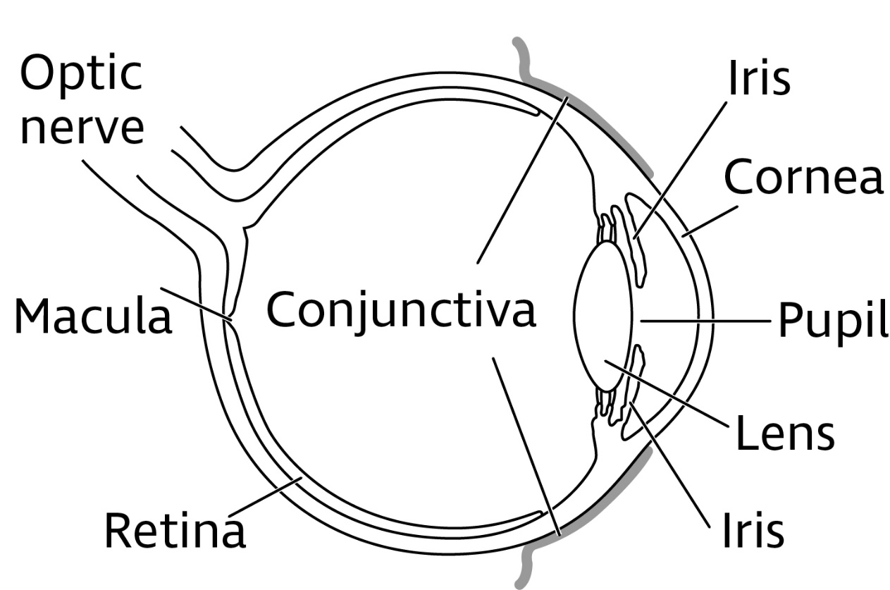

Image description: Diagram showing the cross section of an eye including the labels cornea, iris, pupil, conjunctiva, lens, retina, macula, optic nerve.

What causes aniridia?
Aniridia is a genetic condition, which means it is caused by a mutation, or fault, in a gene. In most cases, aniridia is caused by a fault in the PAX6 gene, although in a small number of cases another gene might be responsible.

What are the genetics of aniridia?
All genes come in pairs. You inherit one copy of the gene from each of your parents to make a pair. Your genes give the cells in your body the instructions they need to work well and stay healthy. When a gene is faulty, the genes do not give their instructions correctly to the cells and the cells then don’t develop or work as they should.

As a baby grows during pregnancy, the PAX6 genes provide instructions for making a particular protein that is important for the early development of different tissues, including those of the eyes and the brain. The PAX6 gene is thought to control other genes that can affect the development of different eye structures, including some that continue to develop even after birth.

How is aniridia inherited?
There are two ways in which aniridia can be inherited from a parent:
- A parent can pass on the faulty gene when he or she also has aniridia. This is known as familial aniridia
- A fault in the gene can arise randomly when neither parent has the condition. This is known as sporadic aniridia.

Familial
This is the most common type of aniridia, accounting for about two-thirds of those with the condition. There is a family history of aniridia, and the faulty gene (in most cases PAX6) is inherited from one parent who also has the condition. This pattern of inheritance is called autosomal dominant (AD) because only one of the genes in the gene pair needs to be faulty to dominate over the healthy one to cause aniridia. This means that, if a person has one faulty copy and one healthy copy of the gene, they will have aniridia themselves and will have a 50 per cent (1 in 2) chance of passing the faulty gene on to each child that they have. If a child doesn’t inherit the aniridia gene, they cannot pass it on to their children.

Sporadic
This is when there is no family history of aniridia and accounts for about a third of people with the condition. The fault in the gene happens by chance within the egg or sperm cell or during the very early stages of development in pregnancy (embryonic stages). Again, only one faulty gene in the gene pair is required to cause sporadic aniridia. People with sporadic aniridia then have the same 50 per cent (1 in 2) chance of passing the condition on to their children as familial aniridia.

Genetic testing and counselling
If there is aniridia in your family, you may find it helpful to speak with a genetic counsellor, a consultant geneticist, or an ophthalmologist (hospital eye doctor) with a specialist interest in genetics. Genetic counselling can help you understand how aniridia has been passed through your family and the chances of passing it on to future children.

Genetic specialist professionals can arrange for genetic testing to confirm whether your own or your child’s aniridia is inherited or sporadic and to confirm the gene responsible. They can explain the results and the likelihood of passing on aniridia.

Genetic counselling is a free NHS service. You can ask your GP or your ophthalmologist to refer you to your local genetic service.

Pre-implantation genetic diagnosis (PGD)
If you have aniridia and are planning on starting a family, your genetic counsellor may also be able to talk to you about pre-implantation genetic diagnosis (PGD). PGD is a medical procedure carried out before pregnancy to prevent the aniridia gene from being passed on from a parent who has it. It involves the use of in vitro fertilisation (IVF) and selection of embryo(s) that do not have the faulty gene. Selected embryos are then placed back into the womb to continue to develop. More information about PGD can be found on the Aniridia Network, Gene Vision and Genetic Alliance UK websites; their details are listed at the end of this information.

How can aniridia affect vision?
The iris has muscle cells which control the amount of light coming into our eyes by changing the size of the pupil. In bright light conditions, the iris muscles automatically make our pupils smaller to reduce glare and discomfort and to give us better quality of vision.

People with aniridia can’t control the amount of light entering their eyes because their iris tissue is missing, their pupils remain large, and their eyes do not adjust to differing lighting levels. People with aniridia can therefore experience dazzle, particularly in bright conditions, or difficulty adjusting as light levels change, reducing vision. As well as having an impact on sight, the light sensitivity (photophobia) they experience can cause discomfort and can, for some people, cause headaches.

Aniridia nearly always causes other parts of the eye to be underdeveloped, such as the optic nerve and fovea (the very centre of the macula) and can also cause nystagmus. These conditions can also affect vision in addition to the lack of iris. People with aniridia may also develop other eye conditions, such as glaucoma, cataract and corneal problems. These other effects on the eye can have a larger impact on sight than the large pupil or lack of iris itself.

Aniridia and these associated conditions affect everyone differently. So, while some people with aniridia have quite a lot of sight loss, others may have only mild blurred vision.

What other eye conditions can be linked with aniridia?
Other eye conditions can be linked with aniridia, some of which can be present from birth and some which may develop later in life. Not everyone with aniridia will experience all these eye conditions.

The following eye conditions can be linked to aniridia:

Nystagmus
Many people with aniridia have nystagmus, a constant and involuntary movement of the eyes. The movement can be side to side, up and down, in a circular motion or a combination of these. This uncontrolled movement can affect how clearly a person can see and is likely to reduce their vision. Nystagmus is usually present from birth or very soon after birth. There is currently no treatment for nystagmus.

You can find out more about nystagmus from our website rnib.org.uk/eyehealth or by calling our Helpline on 0303 123 9999.

Foveal or optic nerve hypoplasia
People with aniridia often have foveal or optic nerve hypoplasia. “Hypoplasia” is a term that refers to underdevelopment of tissue and is a condition someone is born with. The degree of underdevelopment can vary between people, so how much it affects someone’s sight can vary.

Foveal hypoplasia is underdevelopment of the fovea, the central part of the macula. It can cause problems with central detailed vision tasks such as reading, writing, or recognising faces. Foveal hypoplasia is very common in people with aniridia.

Optic nerve hypoplasia is underdevelopment of the optic nerve. The optic nerve is a bundle of nerve fibres which carries information from your eyes to your brain. Optic nerve hypoplasia can affect central and peripheral (side) vision.

Cataract
Aniridia may also cause cataracts to develop at an earlier age, often in late childhood, adolescence, or early adulthood. The lens sits just behind the iris and needs to be clear to allow light into the eye to focus it on the retina. A cataract is a clouding of the lens which causes sight to become cloudy and misty. Cataract may only affect a small part of the lens but if it starts to affect vision a lot, it may require treatment. Cataracts can be safely left untreated for many years if the vision is not badly affected.

Cataracts can be treated using surgery to remove the cloudy lens, replacing it with a clear artificial one (intraocular lens implant). This procedure is usually more complicated for people with aniridia, so the ophthalmologist will weigh up and discuss all the risks with you before considering surgery.

You can find more information about cataracts from our website rnib.org.uk/eyehealth or by calling our Helpline on 0303 123 9999.

Glaucoma
Glaucoma is an eye condition where your optic nerve is damaged by the pressure of fluid inside your eye. Glaucoma in people with aniridia can develop in late childhood, adolescence or early adulthood. Treatment for glaucoma can be given to lower eye pressure and to prevent damage to the optic nerve and to protect sight.

You can find out more about glaucoma from our website rnib.org.uk/eyehealth or by calling our Helpline on 0303 123 9999.

Aniridic keratopathy
Keratopathy simply means an unhealthy cornea. The cornea is the clear window at the front of the eye which allows light in. Around the edge of the cornea are limbal stem cells which constantly multiply to produce new cells on the corneal surface to keep it healthy. They also prevent less transparent cells from the conjunctiva (the membrane covering of the white of the eye) growing across into the cornea.

In aniridia, there is an abnormality of these limbal cells, known as limbal stem cell deficiency. As a result, the surface of the cornea can become dry and unhealthy, the conjunctiva and its blood vessels can grow over the cornea, and the cornea cannot heal easily from injuries or scratches. Ultimately, the cornea can become scarred and opaque (not clear) so that light cannot enter the eye.

Signs of keratopathy can start anytime from childhood onwards but tends to occur more as people move into adulthood and middle age. Keratopathy usually starts as a ring of clouding around the edge of the cornea, but if it progresses into the centre of the cornea then vision can become hazy or blurry. Keratopathy can make the eye feel dry and uncomfortable, and lubricating eye drops may help with this.

If the keratopathy progresses to a point where a lot of your sight is affected, a transplant may be suggested to replace the cornea or stem cells from a healthy donor. However, this can carry significant risks for people with aniridia and your ophthalmologist would discuss this very carefully with you to decide if this could help.

Is there any treatment for aniridia?
Unfortunately, there is no treatment to cure aniridia at the moment.

There are treatments available for some of the eye conditions associated with aniridia, such as cataracts, glaucoma or keratopathy.

Children and adults with aniridia will usually be monitored by an ophthalmologist regularly throughout life. This is to ensure that their eye health is monitored for other eye conditions associated with aniridia.

How can light sensitivity be helped?
People who are light sensitive find that bright light causes discomfort. The level of discomfort can vary from person to person.

Although there is no one solution for light sensitivity, many people with aniridia find that shielding their eyes with sun hats and sunglasses or tinted glasses can help.

Some people with aniridia may have a special-coloured contact lens fitted. This can act as an artificial iris and reduce light sensitivity. However, these may not be suitable for everyone with aniridia due to the risk they can have to the cornea and keratopathy.

Similarly, for some people who need cataract surgery, a special-coloured artificial implant can be placed inside the eye during cataract surgery to reduce glare. This may be part of your intraocular lens implant or an additional implant. However, this is only carried out very rarely because it can make cataract surgery more risky. Your ophthalmologist will be able to discuss these options with you further.

For babies and small children, you may wish to consider how to protect your child from lights in different circumstances, for example:
- Use sunlight diffusers on the back windows in a car
- Do not suddenly put on bright overhead light in a dark room, especially when a baby is small and sleeps on their back
- You may notice your child turning away from certain light sources if it’s making them uncomfortable; this can help you know how to adjust things
- You may notice your child positioning their head at a certain angle to maximise their vision or minimise light sensitivity. This can help you to know where to hold toys or place yourself when you’re playing with your child
- Wherever possible, it may help to use matt surfaces, such as for paper, books, walls, floors etc. Shiny surfaces, including snow and water, can reflect light and cause glare.

You can find more information about Light Sensitivity on our website rnib.org.uk/eyehealth or by calling our Helpline on 0303 123 9999.

What other health problems can affect some people with aniridia?
The PAX6 gene also plays a role in the development of the brain, spinal cord, nose and pancreas, as well as the eye. Therefore, if the PAX6 gene does not function properly, other parts of the body can be affected as well as the eye. However, for most people the main effects are on the eyes.

Aniridia can form part of a syndrome where other parts of the body are also affected:

WAGR syndrome
This is a sporadic condition where there is no family history of aniridia, but certain genes are missing (deleted) at random. WAGR syndrome is also known as 11p13 deletion syndrome.

WAGR describes the four most common effects associated with the condition:
- Wilms’ Tumour – a form of kidney cancer affecting children. If detected early, Wilms’ tumour can be treated successfully. It does not affect all WAGR patients but there is a strong risk
- Aniridia
- Genitourinary problems – in boys, this can cause undescended testicles. It can also cause the opening for urination to be in a different place than usual. In girls, it can cause urinary problems and can affect the genitals. In both boys and girls, it can affect fertility
- Range of developmental delays – more commonly described as learning disability.

A person only has to have two of the above effects to have WAGR syndrome, so it may or may not include aniridia.

Children with sporadic aniridia are assumed to potentially have WAGR until proven otherwise by genetic testing. There are well-established genetic tests to determine the presence of a WAGR deletion. Children, who may be at risk of developing a Wilms’ tumour, usually have an abdominal ultrasound on a regular basis to show if there is a tumour developing on the kidney. If detected early, Wilms’ tumour can be treated successfully.

Gillespie syndrome
In most cases the PAX6 gene is not involved in this syndrome but aniridia is present along with other developmental issues.

This is a very rare, genetic condition which can cause aniridia and cerebellar ataxia. Cerebellar ataxia affects the parts of the brain responsible for co-ordination, balance and muscle tone. Cerebellar ataxia can cause problems with walking unaided, writing and clear speech.

Help to see better
How much aniridia can affect vision can vary from person to person. For a baby or young child, it may be hard to tell what effect aniridia will have on their sight until they’re older and are able to say more accurately how well they can see.

Some people with aniridia may have focusing problems that aren’t caused by the aniridia itself, such as being short-sighted or long-sighted, so their optometrist (optician) may advise that they need to wear glasses. Although glasses and contact lenses cannot improve any sight problems that are caused by aniridia, it’s important for children to have any focusing problems corrected to allow their sight to develop as fully as possible.

Low vision aids, such as magnifiers can help with reading. Tinted glasses may be useful to control glare. A low vision assessment will look at using these types of aids and explore which ones may help.

A low vision assessment looks at ways to help people make the most of their vision. This may mean making things bigger, using brighter lighting or using colour and contrast to make things easier to see. The assessment gives people a chance to discuss any practical problems they are having with their vision with a low vision specialist. The specialist can explore things like magnifiers, lighting, colour contrast and other adaptations that may help. You can ask for a referral to a low vision clinic from an ophthalmologist, optometrist, GP or Eye Care Liaison Officer (ECLO). If your child has reduced vision due to aniridia, it’s helpful to visit a low vision service regularly, as their needs change as they grow up.

Coping
It’s completely natural to be concerned if you or your child has aniridia and normal to find yourself worrying about what it means now and in the future.

It can sometimes be helpful to talk about how you are feeling with someone outside of your circle of friends or family. At RNIB, we can help with our telephone Helpline and our Sight Loss Counselling team. Your GP or social worker may also find a counsellor for you if you feel this might help.

Your eye clinic may also have an Eye Care Liaison Officer (ECLO), who can be on hand to provide you with further practical and emotional support about your child’s or your own eye condition.

Further help and support
For children who have sight loss as a result of aniridia, having the right support at an early age can make a big difference. Your local authority (LA) should have at least one qualified teacher of children and young people with vision impairment (QTVI) to work with you and your child both at home and at school. A QTVI is a qualified teacher who can provide support with development, play, learning and education. At an early stage, ask your local authority to put you in contact with a QTVI. They will support you and your child as soon as a visual impairment is suspected or diagnosed. If you have difficulty getting help or need the details of the specialist teacher in your area, contact RNIB Helpline on 0303 123 9999.

Local social services can help people of all ages who have sight loss to get out and about safely and can offer practical adaptations around the home.

Depending on how much of a person’s sight is affected by aniridia they may be eligible to be registered as sight impaired (partially sighted) or severely sight impaired (blind). An ophthalmologist would be able to tell you whether you or your child is eligible. Registration can act as a passport to help and sometimes to financial concessions, but a lot of this support is still available to people who aren’t registered.

You can find more information about all the support available to children and adults with sight problems on our website rnib.org.uk or by calling our Helpline on 0303 123 9999.

Sources of support
If you have questions about anything you’ve read in this factsheet, or just want to speak to someone about this eye condition, please get in touch with us. We’re here to support you at every step.

Our Helpline is your direct line to the support, advice and services you need. Whether you want to know more about your eye condition, buy a product from our shop, join our library, find out about possible benefit entitlements, or be put in touch with a trained counsellor, we’re only a call away.

Call our Helpline on 0303 123 9999, we’re ready to answer your call Monday to Friday 8am – 8pm and Saturday 9am – 1pm. You can also email us at helpline@rnib.org.uk. You can also say, “Alexa, call RNIB Helpline” to an Alexa-enabled device.

You can also get in touch by post or by visiting our website:

RNIB
105 Judd Street
London WC1H 9NE
rnib.org.uk

Other useful organisations
Aniridia Network
The Aniridia Network is a support group and charity for people with aniridia and their families.
Web: aniridia.org.uk
Email: info@aniridia.org.uk
Phone: 07792 867 949

Genetic Alliance UK
Genetic Alliance UK is a charity working to improve the lives of patients and families affected by all types of genetic conditions.
Web: geneticalliance.org.uk
Email: contactus@geneticalliance.org.uk
Phone: 0300 124 0441

Gene Vision
A resource on rare genetic eye disorders for everyone.
Web: gene.vision

Nystagmus Network
Nystagmus UK is a UK based charity providing help, information and support to anyone affected by nystagmus.
Phone: 01427 718 093
Email: info@nystagmusnet.org
Website: nystagmusnetwork.org

International WAGR Syndrome Association
Website: wagr.org

MACS (Microphthalmia, Anophthalmia and Coloboma Support)
MACS is an organisation supporting children born without eyes or with underdeveloped eyes.
Helpline: 0800 169 8088
Email: enquiries@macs.org.uk
Web: macs.org.uk

LOOK UK
Looks UK supports young people (up to age 29) and families of children living with a visual impairment
Phone: 01432 376 314
Email: info@look-uk.org
Web: look-uk.org

Children and Young People’s Services within Guide Dogs (formally Blind Children UK)
Helpline: 0800 781 1444
Email: cypservices@guidedogs.org.uk
Web: guidedogs.org.uk

We value your feedback
You can help us improve our information by letting us know what you think about it. Is this factsheet useful, easy to read and detailed enough – or could we improve it?

Send your comments to us by emailing us at eyehealth@rnib.org.uk or by writing to the Eye Health Information Service, RNIB, 105 Judd Street, London WC1H 9NE.

This factsheet has been written by the RNIB Eye Health Information service. Our factsheets have been produced with the assistance of patient and carer input and up-to-date reliable sources of evidence. The accuracy of medical information has been checked by medical specialists. If you would like a list of references for any of our factsheets, please contact us at eyehealth@rnib.org.uk.

All of our factsheets are available in a range of formats including print, audio and braille.

Last Review September 2022
Next Review September 2025

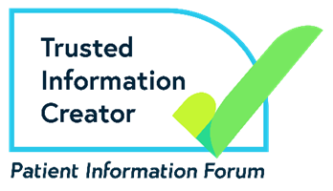

RNIB is a member of the Patient Information Forum (PIF) and have been certified under the PIF TICK quality mark scheme.

End of document.

