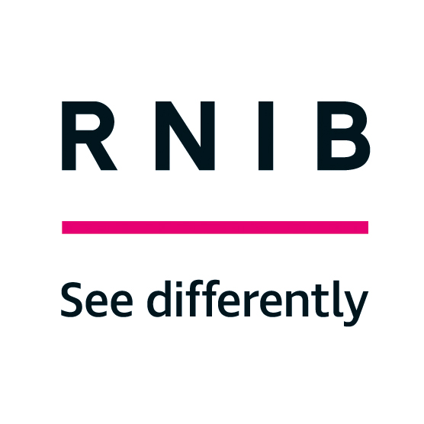

RNIB’s Technology Grants Form

Guidance notes
Please read these notes before completing the Application Form.

Who can apply for a grant from us?
You must meet all the following criteria to apply for a grant from RNIB:
- Be resident in the UK.
- Be registered with your local authority as blind (“severely sight impaired”) or partially sighted (“sight impaired”) unless you are applying on behalf of a child who has not yet had their sight loss certified or registered.
- Receive a means-tested benefit and one that is not a Tax Credit.
- Have been refused funding from your local authority for the items you need.
- Have savings of less than £6,000.
- Not have had a grant from us in the last three years.
- Be supported by a professional

Which benefits are means tested?
The following is a list of means tested benefits we consider:
Council Tax Support, Housing Benefit, Income Support, Income-related Employment and Support Allowance, Income-based Jobseeker’s Allowance, Pension Credit and Universal Credit.

Which benefits will we not consider?
The following is a list of benefits we cannot consider:
Disability Living Allowance (DLA), Personal Independence Payment (PIP) and Attendance Allowance (AA) are not means-tested benefits. Neither are the forms of Employment and Support Allowance and Jobseeker’s Allowance that are contribution based.

We need a professional to support your application.
We need a professional to support your application and they do this by writing a letter of support for you. The letter must be on their official letterhead, must be signed by them and should include:

- Confirmation that you are registered blind or partially sighted.
- Confirmation of the make, model and price of each item being supported and that you need the item or items you are applying for and that, if the items are replacements, your existing items are beyond repair or unsuitable for your needs.
- What difference the item or items would make to your life and the benefits you will derive from receiving them.
- That you have been unable to get the item, or help with the cost, from your local authority.
- If you are applying for access technology (such as software, video magnifiers and mobile phones), that you have tried out the items and that they are suitable for your needs.
- If you are applying for a mobile phone, that you are able to meet the ongoing cost of using it.

The person who supports your application must be a professional who knows your circumstances at home, such as a social worker, occupational therapist, health care visitor, a worker from another charity or local society that is helping you, or a representative from your housing association. It cannot be your GP, a friend, family member or carer.

The person who is supporting your application can also make an application on your behalf using either the online form or the paper-based application process. They can also email the supporting statement, and other evidence if creating the application on your behalf.

What must be included with my application form?
- A copy of a recent official letter or statement that proves you receive one means-tested benefit listed above.
- A letter of support covering the required information listed above from the professional supporting your application.
- A copy of the letter or email with the supporting statement from other organisations that may have pledged money toward the cost of an item over and above our maximum grant amount (if applicable).
If completing an online application, you will receive an email asking for the supporting evidence. Please reply to this email attaching your evidence. Evidence can also be emailed to tfl@rnib.org.uk or sent by post to RNIB Technology Grants Team, Grimaldi Building, 154A Pentonville Road, London, N1 9JE.

Items we consider grant applications for
- Talking phones, accessible smartphones, accessible tablets and e-readers (£400 maximum)
- Big button or talking landline telephones and accessibility accessories (£100 maximum)
- Computer accessibility software (£500 maximum)
- Electronic Braille Displays and note takers (£500 maximum)
- Portable handheld video magnifiers (£500 maximum)
- DAISY players and USB players (£300 maximum)
- Smart home devices and accessories (£150 maximum)
- Wearable technology including health and fitness devices (£200 maximum)
- Voice recorders and Dictaphones (£150 maximum)
- Accessible kitchen equipment including talking microwaves, talking scales and talking measuring jug.
- Talking watches and clocks (£80 maximum)
- RNIB’s Penfriend 3 labelling device plus any spare labels and Talking Colour Detectors

If you are applying for access technology (such as software, portable video magnifiers, mobile phones and tablets), you must have tried the items before applying to make sure that they are suitable for your needs. Your local sight loss charity or an RNIB Products for Life Store may be able to help you with this.

We also suggest that you contact our Technology for Life Team who can give specialist advice around accessible technology and what items may suit you. Please contact RNIB Helpline on 0303 123 9999 and arrange to speak to the Technology for Life Team.

You may be eligible to receive some of the above items for free from your local authority. Please check with them before applying to us. If they cannot fund an item this must be confirmed in the supporting letter.

You can apply for help with more than one item, but we can only give a maximum of £500 in total, as our grant fund is limited, so if the total amount you ask for is more than this you must find the rest of the funding elsewhere before you apply to us for the remainder. This can include other charities offering you the money or a contribution from you or your family.

If you apply to us for a grant and have yet to secure the remaining funding from elsewhere, we might award you a grant on a conditional basis, which will expire after 6 months.

What we don’t accept applications for
We do not consider applications for:
- Anything not mentioned in the list in section 6.
- Items you have already purchased.
- Items you need for your job (please talk to your employer about the Government’s Access to Work scheme which can provide practical support).
- Items you need for educational purposes (please speak to your school, college, or university about specialist items you need for your studies).

If you would like a grant for an item, we do not cover, please call our Helpline on 0303 123 9999 and ask for either a copy of our “other sources of grant’s” factsheet, which lists other grant providers who might be able to help you. Or you can ask to speak to one of our Sight Loss Advisors, who can provide information and guidance on alternative options.

How often can I apply for a grant and when?
- We welcome grant applications at any time of the year.
- If we award you a grant, you must wait three years before applying again.
- If you are unsuccessful, you must wait six months before applying again.
- Sorry, we do not give emergency grants.

When will I hear from you?
- We’ll let you know that we’ve received your form within 3 working days of getting it.
- If there is any missing information, we will let you know within 2 weeks. Please Note: We cannot make a decision on a grant application until we receive any and all missing information.
- If you have sent us all the information we need, we can usually decide on your application within 1 month of receiving all required information.
- If your application is successful, and RNIB sells the product, and the item or items, are within the maximum permissible amount, we’ll send you the item or items within 2 weeks of our decision.
- If you’ve requested the funds for an item RNIB do not sell then we’ll pay you the grant amount awarded, usually within 2 weeks from the decision date. You will be contacted to provide your bank account details when and only if we approve your grant.

Why we refuse applications.
We reserve the right to refuse an application for any reason and we can’t guarantee that your application will be successful. Usually, we refuse an application for one of the following reasons:
- You don’t meet our criteria for who can apply.
- You asked for help with an item we do not fund.
- We only have limited funds.
- You can contribute enough money to fund a reasonably priced item yourself.
- You have already purchased the item.
- You do not provide all the information required to make a decision on your application.

