Corneal transplant

The cornea
Your cornea is the clear part of the front of the eye. It is made up of five layers and is normally smooth and transparent. For the purpose of this fact sheet, we’ll be discussing four of the five layers of the cornea that are involved in corneal transplant surgery.

The cornea is very strong and acts as a barrier between your eye and the outside world, helping to protect it from injury and infection. The surface of the cornea is very sensitive. It contains many nerve endings and can detect even the smallest piece of dirt or fluff.

Your cornea is important for sight. It bends and focuses light into the eye. This light is then focused by the eye’s lens onto the retina, at the back of the eye. Your retina converts light into electrical signals. These are then sent to the brain where they are interpreted to “see” the world around you.

The layers of the cornea from the outer part of the eye inwards or front to back, and their function are:
- The corneal epithelium: blocks the passage of foreign bodies, such as dust, water, and bacteria, into the eye and other layers of the cornea
- Bowman's layer: helps in maintaining the shape of the cornea
- The corneal stroma: this is the thickest corneal layer, giving mechanical strength to the cornea and the cornea its transparency. Also, the main surface which bends the light entering the eye through the cornea
- Descemet’s membrane: resting layer for endothelial cells
- The corneal endothelium: the endothelial layer acts as a pump, removing fluid from the stroma to keep it clear. This is vital in keeping the cornea transparent.

The layers relevant to this fact sheet are the corneal epithelium, stroma, Descemet’s membrane and the endothelium.

Diagram of cross section of eye (ciliary body, iris, cornea, anterior chamber, lens, vitreous) showing the different layers of the cornea as detailed above.
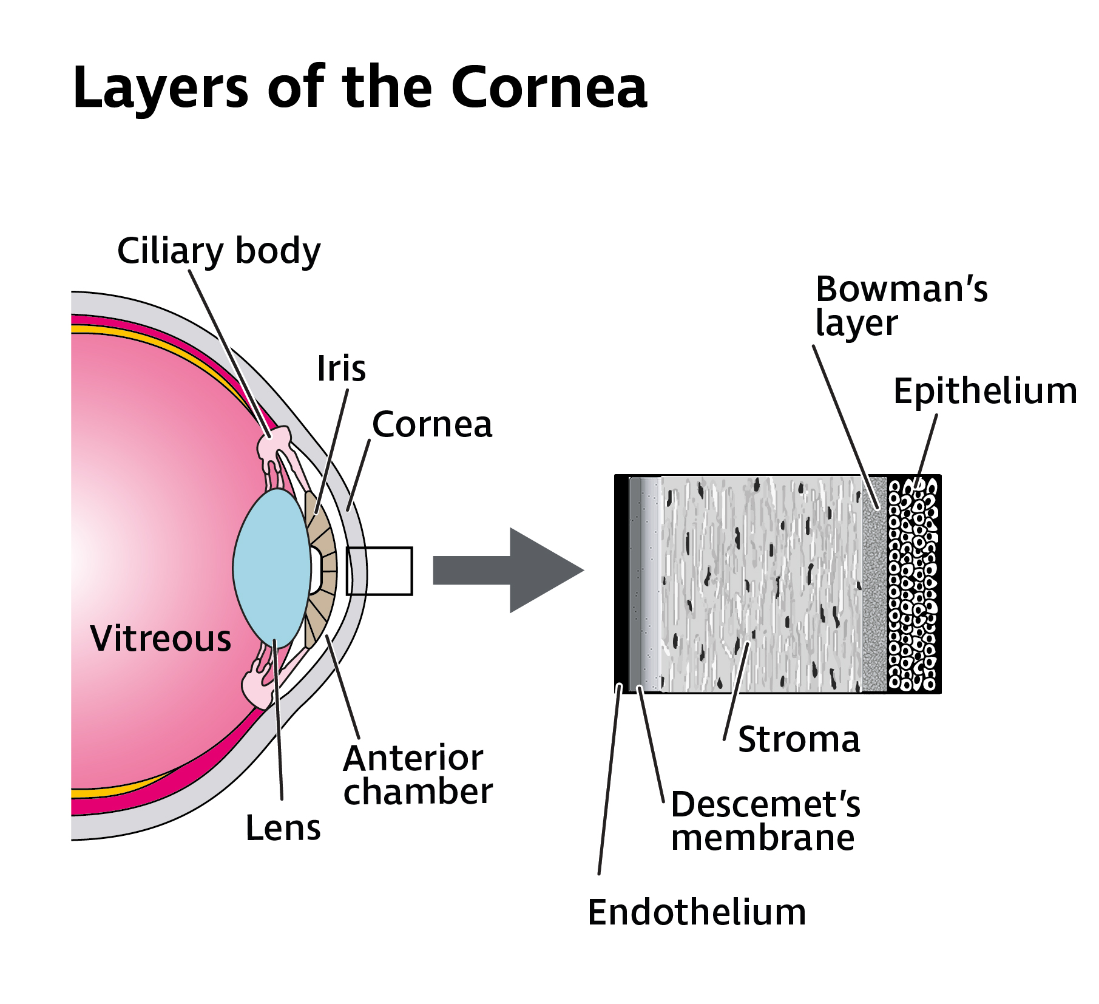

What is a corneal transplant?
A corneal transplant is surgery to remove all or part of a damaged cornea and replace it with healthy, clear corneal tissue from the eye of a donor who has died. A corneal transplant is often referred to as a keratoplasty or a corneal graft.

When is a corneal transplant needed?
If your cornea is scarred, damaged or distorted to a point where the vision can no longer be improved with glasses or contact lenses, you may need a corneal transplant to provide clear vision once more. A corneal transplant can also be used to relieve any pain or discomfort caused by severe infection or injury that is no longer being managed effectively with treatment.

Your ophthalmologist (hospital eye doctor) will discuss with you how a corneal transplant will help, and they should help you make the decision on whether and when to have a transplant.

Types of corneal transplant
There are three types of corneal transplant:
- EK – Endothelial Keratoplasty which removes and replaces the innermost layers of the cornea
- DALK – Deep Anterior Lamellar Keratoplasty – which removes and replaces part of the front layers of the cornea
- PK – Penetrating Keratoplasty which removes and replaces all the layers of your cornea.

The type of transplant you will be offered depends on the layers of your cornea that are affected.

What happens during a corneal transplant?
Surgery for a corneal transplant usually takes around an hour, although depending on the type of transplant surgery you are having, it may take up to two hours to complete. Transplant surgery can be done either under local anaesthetic, where you are awake, or general anaesthetic, where you are unconscious and unaware.

If you have a local anaesthetic, you will usually have an injection into the soft tissue around your eye, not into your eye itself. You will also be given anaesthetic eye drops to numb the front of the eye. The injection stops you feeling pain from your eye, reduces what you can see and stops your eye from moving around. You will need to be able to lie still for the whole operation to be suitable for a local anaesthetic.

If you have a local anaesthetic, you might be offered sedation, medication which makes you feel sleepy and relaxed during the surgery. Sedation can make the surgery less stressful and more comfortable for you. Your doctor would be able to explore whether sedation would be right for you.

Endothelial keratoplasty (EK)
EK replaces only the innermost layers of the cornea, making it suitable for corneal dystrophies and conditions solely affecting the endothelial layer of the cornea, such as Fuchs endothelial dystrophy. EK surgery is usually carried out under both local and general anaesthesia and takes about an hour.

There are two main types of EK transplants, which require different preparation:
- Descemet's stripping endothelial keratoplasty (DSEK), also known as a 'DSAEK' where the 'A' stands for automated
In DSEK you receive a replacement endothelium and Descemet's membrane, as well as some of the stroma from a donor cornea.
- Descemet's membrane endothelial keratoplasty (DMEK)
In DMEK you receive only the endothelium and Descemet's membrane from a donor cornea.

Descemet stripping automated endothelial keratoplasty (DSAEK) is most widely used.

The visual outcomes may be slightly better with DMEK but the comparative long-term survival is not known.

During EK surgery
The ophthalmologist makes a small incision (cut) at the side of the cornea and removes the back layers of your cornea through this.
The surgeon inserts a small disc of donor endothelium as well as the other layers being replaced. This is followed by an air bubble being inserted into the front of the eye to press the new endothelium onto the inside of your cornea. A suture (stitch) may or may not be needed to close the incision.

Cataract formation is a common complication of EK surgery, so your ophthalmologist may carry out cataract surgery at the same time, if you haven’t already undergone cataract surgery (see ‘other complications of corneal transplant’ section below).

After surgery
Following the surgery, you will need to ‘posture’ (to lie flat on your back) to help the air bubble inserted during the surgery to push the new corneal layers against your cornea, allowing the graft to attach to the inside of your cornea.

Following posturing you will usually be able to go home, but you may need to continue positioning face-up, as much as is practical to do so, for the first two days post-surgery.

What will my sight be like following EK surgery?
Following surgery, the air bubble will remain in your eye for roughly the first week, helping the new layer attach to the inside of your cornea.

Your vision will be blurred following surgery. As the air bubble absorbs and gets smaller, your vision is likely to improve. Most people notice their vision getting better within the first week or two, although it may take 3 months to get the full improvement following DMEK, while DSAEK usually requires a longer recovery period.

Your corneal transplant will only help with your corneal eye condition, so if you have another eye condition which affects your sight, this will not be improved by your operation.

You will probably still need to wear glasses or contact lenses to get the best possible level of vision following transplant surgery. If you’ve had cataract surgery at the same time as your transplant or shortly before, you will need a new glasses prescription. Your ophthalmologist will advise you when your eye has healed enough for an optometrist (optician) to carry out an eye examination.

EK transplants cannot be used to treat stromal dystrophies or conditions where the front layers of the cornea are scarred or damaged. The corneal transplant, known as DALK, needs to be used in these cases.

Deep anterior lamellar keratoplasty (DALK)
In DALK surgery, the surgeon removes the corneal epithelium, Bowman’s membrane and stromal layers of the cornea from the centre of your cornea, leaving in place Descemet’s membrane and the innermost endothelial layer.

Your ophthalmologist then places a specially prepared donor cornea (‘button’) containing stroma and epithelium onto your cornea. The donor button is cut so that it fits precisely into the area of your cornea which was removed. The donor cornea position is secured by tiny sutures until it heals in place.

DALK usually takes about a year to heal. Some sutures may be removed before this, but usually not before the first six months.

DALK is used for keratoconus and inherited stromal conditions such as macular corneal dystrophy or granular dystrophy. DALK may be less suitable than PK for certain conditions.

What will my sight be like following DALK surgery?
Your vision will probably be blurred for the first few months after surgery as the layers of your cornea slowly heal together, although you may notice a faster improvement in your vision even in the first few weeks after your operation - particularly if your sight was very poor before the surgery. Usually, vision improves during the first six to nine months after surgery.

Sutures are removed from six months onwards although it may be two years or more before you have the full improvement in your sight.
Your corneal transplant will only help with your corneal eye condition, so if you have another eye condition which affects your sight, this will not be improved by your operation.

Many people make a good recovery of their vision in the long term. Further interventions or surgeries may be required. Most people need to wear glasses or contact lenses to get the best possible level of vision.

Penetrating keratoplasty (PK)
PK is a ‘full thickness’ transplant. PK is more likely to be offered if the stroma and endothelium of your cornea are damaged, for example in keratoconus. During PK your whole cornea is replaced by a donor cornea which is held in place with sutures. Corneal transplant sutures are made of nylon which is non-absorbable and provides long lasting good tensile strength in tissues. Sutures are usually left in place for a year or more following surgery.

What will my sight be like following PK surgery?
Your vision will probably be blurred for the first few weeks and months after surgery as the layers of your cornea slowly heal together, although you may notice an immediate improvement in your vision even in the first few days or weeks, particularly if your sight was very poor before the surgery.

Sutures are not normally removed until a year or more after surgery. Your vision can improve while the transplant is healing but it takes 12 or more months for a PK transplant to fully heal and for you to see the full improvement in your vision.

Your corneal transplant will only help with your corneal eye condition, so if you have another eye condition which affects your sight, this will not be improved by your operation.

Many people make a good recovery of their vision in the long term; however, you will still need to wear glasses or contact lenses to get the best possible level of vision.

Some people may also need further treatment to get the best possible level of sight. This can include your ophthalmologist correcting any unevenness in your cornea which might be affecting how well it is focusing light, known as astigmatism, by adjusting some of the sutures to even out the shape of your cornea as it heals. (see ‘other complications of corneal transplant’ section below).

You may also need to undergo further surgery to even out the shape of the cornea to improve focusing. Your ophthalmologist will let you know if and what treatment is needed to improve the shape of your cornea.

What can I expect after all types of surgery?
Your eye should not be too painful following surgery, but if there is any discomfort you may be given painkillers, such as paracetamol. The sutures in your eye may make your eye feel gritty, but these should not be painful. If they are, it would be important to contact the hospital about this (see ‘other complications of corneal transplant’ section below).

Following surgery your eye will be patched. You can usually go home either the same or next day but will have to go back within the first week to have your eye checked by your ophthalmologist. During this time, you may need to wear a plastic shield at night to protect your eye while you are asleep.

You will need to use steroid eye drops for at least one year and in some cases, life-long to prevent your immune system from rejecting the new donor corneal layers. You might need to take other medicines to suppress your immune system if your ophthalmologist feels that there is a high risk of rejection. Rejection is covered in more detail under ‘corneal transplant rejection’ later in this fact sheet.

After surgery you’ll be given antimicrobial eye drops for a few weeks to prevent infection. You ophthalmologist will advise you how often you will need to use all these medicines and for how long.

After the first week’s check-up, you would typically be seen again within a month and then every few months for the first year. Depending on the type of transplant you have, after the first one to two years, further appointments may not be needed. Some people who have had a corneal transplant will need life-long check-ups.

You will normally be advised to have two weeks off work following surgery, although this may be longer. Your ophthalmologist will advise you about your individual circumstance and length of time needed off work.

Do I need to avoid any activities following surgery?
Your ophthalmologist should give you specific information about taking care of your eye following the transplant surgery. Generally, after your surgery:
- You can have a bath and shower as normal, but it’s important to take care not to get any water in your eye for a week
- If your eye becomes sticky, you can wipe your eyelids but do not wash your eye with water
- You shouldn’t wear any make-up, including eye shadow, eye liner and mascara for a month after surgery
- You must not rub your eye. Wearing an eye shield at night can prevent you rubbing your eye by accident when you are asleep. Eye shields are normally worn at night for the first one to two weeks after surgery
- You cannot go swimming until your ophthalmologist confirms it is okay to do so
- You must avoid playing contact sports until your ophthalmologist says you can start playing again. For some types of corneal transplant, they will advise that you always wear eye protection when playing
- You should avoid lifting heavy objects until your ophthalmologist confirms it is okay to do so. This is particularly important if you are in a job that requires heavy lifting
- You might want to protect your eye when its windy outdoors, so that nothing blows into your eye. Wearing glasses or sunglasses can help protect your eye
- You may find you are more sensitive to bright light. Wearing sunglasses can help minimise any discomfort while your eye is healing
- You will not be able to wear contact lenses until your ophthalmologist says it’s safe to wear them.

How well does EK corneal transplant work?
EK is ‘keyhole’ surgery, which is quick to heal. By transplanting a thinner layer of tissue in DMEK, recovery times are faster than for DSAEK, the visual results are better, and the rejection risk is lower at only one per cent for DMEK, compared to seven to eight percent for DSAEK and 13 percent for a full thickness ‘penetrating keratoplasty’ (PK) transplant. Your ophthalmologist would be able to explain whether or not a DSAEK or DMEK transplant would be right for you. Sometimes, the donor layer can detach from the back of the cornea. This usually happens in the first days following an EK transplant. If this happens, you will need to have a small procedure to inject a further air bubble into the eye to help the transplanted tissue to reattach. This is known as ‘rebubbling’.

How well do DALK and PK corneal transplants work?
Both DALK and PK transplants work well. About 90 percent of DALK and PK transplants carried out for keratoconus are functioning well after five years. Newer DALK transplants also seem to have an even lower risk of failure, to last for longer and to have shorter recovery times compared to PK transplants.

Although PK transplants are an effective treatment, 50 per cent are no longer working at 20 years. This means that if you’re younger you might be advised to wait longer before having a corneal transplant, as you are more likely to require a number of transplants in your lifetime.

The risks of failure of both PK and DALK are low for most corneal conditions, but after both types of surgery it can take a long time for vision to recover. You will need to wear glasses and sometimes contact lenses after the transplant to get the best possible vision.

Following a transplant, you will need to use steroid eye drops for at least one year, and in some cases indefinitely, to prevent rejection of the transplanted donor cornea.

Transplants also increase the risk of cataracts, the clouding of the lens in your eye, and glaucoma, a condition where pressure at the front of your eye damages the optic nerve at the back of your eye. These risks are partly due to the need for steroids following the surgery (see ‘other complications of corneal transplant’ section below).

Corneal transplant rejection
Corneal transplants are an effective treatment, but sometimes following surgery, your body’s immune system recognises the transplanted donor tissue as foreign tissue and starts to react against it. This is known as corneal transplant rejection. Corneal transplant rejection can usually be reversed if it is diagnosed, and treatment commences early enough.

It is usually possible to treat corneal transplant rejection with anti-inflammatory eye drops, usually corticosteroids. Corticosteroids work by reducing the activity of your immune system so that it no longer releases the chemicals which cause inflammation. You may require steroids both topically and by injection to treat the rejection.

How common is corneal transplant rejection?
The risk of corneal transplant rejection varies according to the type of transplant and the presence of risk factors. This risk can be assessed by your ophthalmologist who will be familiar with your condition. Repeated problems with rejection can lead to the transplant failing and the need for repeat surgery.

Following PK, rejection may involve any layer of the cornea (epithelium, stroma or endothelium). A functioning endothelium is essential for the cornea to remain transparent and provide clear vision, so a rejection of the endothelium must be treated as soon as possible to prevent the transplant from failing. Endothelial rejection is also of concern following DSAEK and DMEK.

The risk of rejection is reduced by using steroid eye drops following surgery. Across all types of corneal transplant, 75 per cent last at least five years and more than 50 per cent last up to ten years.

A helpful way to remember the symptoms of rejection is ‘RSVP’:
- Red eye
- Sensitivity to light
- Vision loss (blurred vision)
- Pain

If you develop any of these symptoms it is important to seek medical help immediately. The earlier a rejection is treated, the more likely it can be reversed. Your hospital will advise you what to do if you experience any of these symptoms.

Other complications of corneal transplant
As well as rejection, there's a risk of other complications following corneal transplant surgery. These can include:

Astigmatism
Astigmatism is a very common eye condition where the cornea is not a perfectly curved shape. Some degree of astigmatism is likely after corneal transplant surgery. Astigmatism causes your vision to be slightly blurry, so that you have difficulty focusing. It can be corrected with glasses or contact lenses, in cases where there’s a moderate amount of astigmatism present.
If you have alteration in vision due to changes in astigmatism, it may be possible for your ophthalmologist to adjust or remove some of the sutures in your cornea during the first months after surgery. In some cases, a corneal transplant can result in a large amount of astigmatism. If contact lenses are unable to correct this degree of astigmatism or can’t be worn for any reason, further operations may be needed to improve the shape and focusing of the cornea. This procedure involves peripheral cuts in the cornea known as astigmatic keratotomies, re-suturing and laser surgery to correct your vision.

Cataract
A cataract is a clouding of the lens in your eye. Cataract formation is a common complication of eye surgery. Cataracts are treated by surgery, during which the cloudy lens is removed and replaced with a clear artificial lens.

You can find more information about cataract on our website rnib.org.uk/eyehealth or by calling our Helpline on 0303 123 9999

Dry eye
Dry eye is an eye condition caused by a problem with tears. Dry eye can make your eye feel uncomfortable, red, scratchy and irritated. Despite the name, having dry eye can also make your eyes watery. Typically, dry eye doesn’t cause a permanent change in your vision. It can make your eyesight blurry for short periods of time, but the blurriness will go away on its own or improve when you blink.

Many cases of dry eye are due to problems with your eyelid, blinking, abnormalities in the oil secreting glands, known as meibomian gland dysfunction (MGD), blepharitis, contact lens use, allergy and other health conditions. This type of dry eye responds well to warm lid massages without always needing to use artificial tears.

Your ophthalmologist will be able to advise you on the use of artificial tear (lubricating) drops if needed. Dry eye symptoms usually improve once the eye has healed, but this can take time. It is helpful to ask for 'preservative free' lubricating drops.

You can find more information about dry eye on our website rnib.org.uk/eyehealth or by calling our Helpline 0303 123 9999

Raised eye pressure
The pressure in your eye can increase if the drainage of the fluid within our eye, called aqueous fluid, is obstructed. If not detected, monitored, or treated, this raised pressure causes damage to your optic nerve which is made up of nerve cells carrying light signals to the brain, resulting in glaucoma.

Using steroids can also cause an increase in eye pressure for some people. At least five percent of the population are steroid eye pressure responders, known as steroid responders, meaning that their eye pressure goes up when steroids are used. Your ophthalmologist will determine whether you fall into this group and may prescribe eye drops to lower your eye pressure.

You can find more information about glaucoma on our website rnib.org.uk/eyehealth or by calling our Helpline 0303 123 9999

Breakage of a suture or sutures remaining after surgery
In some cases, a suture may break following corneal transplant surgery. This can cause symptoms such as a foreign body sensation, irritation, redness, light sensitivity or excessive watering.

It is important to seek advice from your eye health professional as soon as possible, if you experience any of these symptoms.

Artificial corneas (Keratoprosthesis)
Keratoprosthesis is a surgical procedure where your cornea is replaced with an implant designed to act in the same way as a cornea.

Although it is very rare for someone to be offered keratoprosthesis, it might be considered when someone has had several failed corneal transplants, or if their eye is not suitable for a corneal transplant.

They are usually only offered to someone with very poor sight in both eyes due to a corneal problem, and where other parts of the eye are healthy so there is a good possibility of restoring useful vision. A good quality tear film and blink reflex (so called ‘wet blinking eye’) are also required for this procedure to be considered.

Different types of keratoprosthesis are possible. Usually these include a mix of human tissue and artificial materials. A corneal graft–keratoprosthesis (type I) is an artificial cornea surrounded by a corneal graft from a human donor. It is inserted using a local or general anaesthetic. The centre of the person's cloudy cornea and the natural lens, if in place, are removed. The corneal graft–keratoprosthesis, which is made to match the person's eye, is then inserted and secured with sutures. Finally, a special soft contact lens is used to protect the eye while it heals.

After the operation, people who have had the procedure have to wear a soft contact lens for the rest of their life, use antimicrobial drops and possibly topical steroid drops or ointment, and be monitored and followed up frequently by their ophthalmologist.

Can I get help to see things better?
In whatever way the corneal transplant has affected your sight, there are lots of things you can do to make the most of your vision.

You can ask your ophthalmologist, optometrist or GP about low vision aids, like a magnifier, and ask for a referral to your local low vision service. Further information can be found in our Making the Most of Your Sight booklet available free through our online shop on our website rnib.org.uk/eyehealth or by calling our Helpline 0303 123 9999.

Local social services should also be able to offer you information on staying safe in your home and getting out and about safely. They should also be able to offer you some practical mobility training to give you more confidence when you are out.

Our Helpline can also give you information about the low vision services available, education and work support, and our website offers lots of practical information about adapting to changes in your vision and products that make everyday tasks easier.

Coping
It’s completely natural to be upset when you have been diagnosed with an eye condition and it’s normal to find yourself worrying about the future and how you will manage with a change in your vision.

It can sometimes be helpful to talk over some of these feelings with someone outside your circle of friends or family. At RNIB, we can help with our telephone Helpline and our Counselling and Wellbeing Team. You may also find your GP or social worker can help you find a counsellor if you feel this might help you.

Your eye clinic may also have an ECLO (Eye Care Liaison Officer) who can be on hand to provide you with further practical and emotional support about your eye condition.

Further help and support
Whether you have just been diagnosed or have been living with sight loss for a while, we are here to help and support you through your journey.

The RNIB Helpline is your direct line to the support, advice and products you need. We’ll help you to find out what’s available in your area and beyond, both from RNIB and other organisations.

Whether you want to know more about your eye condition, buy a product from our shop, join our library, find out about possible benefit entitlements, be put in touch with a trained counsellor, or make a general enquiry, we’re only a call away.

RNIB Helpline
Tel: 0303 123 9999
Email: helpline@rnib.org.uk
Alexa: you can also say, “Alexa, call RNIB Helpline” to an Alexa-enabled device
We’re ready to answer your call Monday to Friday 8am to 8pm and Saturday 9am to 1pm.

You can also get in touch by post or by visiting our website:

RNIB
105 Judd Street
London WC1H 9NE
rnib.org.uk

We value your feedback
You can help us improve our information by letting us know what you think about it. Is this factsheet useful, easy to read and detailed enough – or could we improve it?

Send your comments to us by emailing us at eyehealth@rnib.org.uk or by writing to:

Eye Health Information Service
RNIB
105 Judd Street
London
WC1H 9NE

This factsheet has been written by the RNIB Eye Health Information service. Our factsheets have been produced with the assistance of patient and carer input and up-to-date reliable sources of evidence. The accuracy of medical information has been checked by medical specialists. If you would like a list of references for any of our factsheets, please contact us at eyehealth@rnib.org.uk

All of our factsheets are available in a range of formats including print, audio and braille.

Last updated: March 2022
Next review: March 2025

