By email via Transport Focus (see link here: Consultation on the future of ticket retailing (avantiwestcoast.co.uk) as we are outside London TicketOffice.Avanti@transportfocus.org.uk

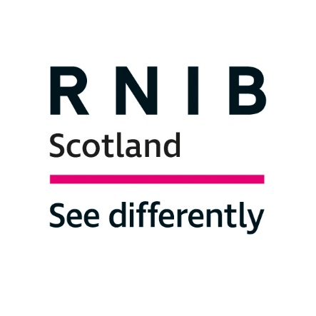
RNIB Scotland response to Avanti Rail Ticket Rail Station Ticket Office Closure (Glasgow Central Station)

Introduction
The Royal National Institute of Blind People (RNIB) Scotland is the country’s leading charity working with blind and partially sighted people. We support children and adults with sight loss and help them to live full and independent lives, campaigning for their rights.

The overall scale of ticket office closures in England will have a huge impact for travellers, not least for blind and partially sighted passengers and other disabled groups.

The proposals are to shut down most of the 1,007 remaining ticket offices in England, bar at the busiest stations, within three years. Among the proposed closures are all those run by Avanti West Coast, including the Avanti ticket office at Glasgow Central Station.

These changes would have a real impact on anyone in Scotland who travels to or via England.

We are writing to underline our opposition to the closure of ticket offices, to endorse the representations against the closures made by our RNIB colleagues and others in England and elsewhere, and to raise some specific questions about Glasgow Central Station.

Avanti West Coast consultation
On 5th July 2023 Avanti West Coast launched a consultation on the future of ticket retailing. The consultation is open for 21 days, closing on Wednesday 26 July. We would argue that a change of this scale requires a 12-week consultation.

We would also like to highlight that the online consultation itself is inaccessible and confusing. In addition, it is unsuitable for an organisational response; ergo, we are sending our response by email.

Why ticket offices matter
RNIB Scotland is very concerned that the closure of rail ticket offices will have a severe impact on blind and partially sighted people’s ability to purchase tickets, arrange assistance, and travel by rail. Reliable, consistent and clearly identifiable ticket offices, with staff who can offer a variety of services, are essential for many people with sight loss to use the railway.

Without ticket offices, rail passengers would be forced to purchase tickets online or using Ticket Vending Machines at the station, and neither of these options are accessible for many blind and partially sighted people.

RNIB research demonstrates the importance of ticket offices. According to our recent survey:
- Only 3 per cent of blind and partially sighted respondents said they could use a ticket vending machine without problems.
- 76 per cent said they would prefer to buy tickets from a person at a ticket office.

The benefit of ticket offices is not accurately captured in merely the number of tickets sold. 88 per cent of respondents to our survey said that a static point to meet rail staff was “important” or “very important”.

Ticket offices are a fixed location that blind and partially sighted people can rely on as the first point of contact for many kinds of staff assistance: staff can ensure the appropriate concession is applied to a ticket purchase, make sure passengers have the correct ticket, let passengers know when facilities like lifts are out of use, advise on any changes to their journey that may be required, and provide or arrange for sighted guidance through the station and safely on to the train.

Such multifaceted, flexible assistance cannot be replicated by apps or ticket machines. Already, 47 per cent of respondents to an RNIB survey reported having to make journeys around the availability of family members, friends or carers to assist them, and this number will only grow if staff support becomes less reliable.

Blind and partially sighted people, as well as other disabled people are more reliant on public transport, yet there seems to have been little regard for the full scale of how proposals could impact upon them.

Avanti has responsibilities towards its visually impaired passengers. Clarification is required on areas such as support available at unstaffed stations, particularly when there are travel disruptions, and concerns around companion discounts, as these cannot be purchased from automatic ticket machines.

Proposed closure of the Avanti ticket office at Glasgow Central Station
Regarding the proposed closure of the Avanti ticket office at Glasgow Central Station, the consultation document states:
“It is proposed that all ticket office windows at stations will close, with staff transitioning to multi-skilled Customer Ambassador roles where they would be available to give advice about the best and cheapest fares as well as supporting customers with accessibility needs.
“The changes would mean a visible and accessible staff presence in stations during staffed hours, on ticket concourses and on platforms.”
It is not clear what that means in terms of availability. A document relating to changes at Glasgow Central indicates that offices will close but “Ticketing Support” and “Staffed Hours” will remain. However, “Ticketing Support” will close earlier on all seven days of the week.

The document does not clarify what Ticketing Support and Staffed Hours means, that is, does this mean actual staff availability in Glasgow Central station and where will they be situated? Staff presence on platforms is mentioned but how will people with sight loss find them in what is Scotland’s busiest railway station?

Conclusion
In conclusion, we call on Avanti to halt the programme of railway ticket office closures, including the Avanti ticket office at Glasgow Central Station. We would be happy to discuss these matters further with you.

Yours sincerely

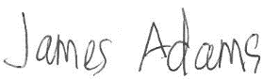

James Adams
Director RNIB Scotland

For further information please contact:
James Adams
Director RNIB Scotland
james.adams@rnib.org.uk

Dr Catriona Burness
Parliamentary and Policy Manager, RNIB Scotland
catriona.burness@rnib.org.uk

Kirstie Henderson
Policy Officer, RNIB Scotland
kirstie.henderson@rnib.org.uk

Erik Mathies
Policy Officer, RNIB
erik.mathies@rnib.org.uk

As widely reported – see for example - https://www.bbc.co.uk/news/business-66097850
Avanti West Coast launches consultation on the future of ticket retailing

