RNIB Centre for Accessible Information (CAI)

Research report # 11

Producing braille on swell paper
A study of braille legibility
Published by:
RNIB Centre for Accessible Information (CAI), 58-72 John Bright Street, Birmingham, B1 1BN, UK

Commissioned by:
As publisher
Authors:
Heather Cryer*, Claire Jones, Dave Gunn

* For correspondence
Tel: 0121 665 4211
Email: heather.cryer@rnib.org.uk

Date: 4 February 2011

Document reference: CAI-RR11 [02-2011]

Sensitivity: Internal and full public access

Copyright: RNIB 2011

Citation guidance:
Cryer, H. Jones, C., and Gunn, D. (2011) Producing braille on swell paper. A study of braille legibility. RNIB Centre for Accessible Information, Birmingham: Research report #11.

Acknowledgements:
Alan Waller and Martin Fuller for production of test materials and measuring in pilot, and the years of experience discussed using swell paper. Sarah Morley Wilkins and Sarah Home for input. Graeme Douglas for advice. The participants for taking part in
the study.

Contents
Introduction 3
Background 3
Pilot study 6
Rationale for legibility study 8
Legibility study 9
Method 9
Results 13
Discussion 17
Conclusion 18
References 20
Appendix 1 21
Appendix 2 22

Introduction

Background
Swell paper (also known as capsule paper or microcapsule paper) is commonly used for the production of tactile graphics. In an international survey, Rowell and Ungar (2003a) found swell paper to be the most popular production material used by producers of tactile graphics.
Swell paper has heat reactive microcapsules layered upon a paper backing. When black ink containing sufficient carbon is printed on the paper and passed through a heat fuser, the black ink absorbs the heat causing the microcapsule surface to swell. In this way, printed images or braille dots become raised and tactile.
Benefits of swell paper production include convenience and lower cost and speed of production when compared to other methods such as thermoform (Rowell et al, 2003a; Thompson and Chronicle, 2006). A key disadvantage of swell paper is that it is two dimensional (Thompson et al, 2006), and cannot offer the range of elevations that thermoform can (Rowell et al, 2003a). However, Jehoel, McCallum, Rowell and Ungar (2006) studied a range of substrates for producing tactile graphics including: aluminium; smooth and rough plastic; Braillon; smooth and rough paper, and swell paper. They found that rougher substrates – particularly rough paper and swell paper – were preferred by users, and were easiest to scan by touch based on time taken to locate a particular symbol. Together these findings suggest that despite some disadvantages, swell paper is widely used and appreciated by both designers and users of tactile graphics.

Tactile graphics often require identification labels such as titles, and scale information for maps. Rowell and Ungar (2003b) found that producers of tactile maps felt braille to be very important in labelling tactile maps. Braille can be produced on swell paper by printing dots onto the paper which are then raised by heating. There has been little research into best practice in how to produce consistent, legible braille on swell paper. The authors are aware of only one other paper investigating this subject (Watanabe and Oouchi, 2003).

Watanabe et al (2003) studied the legibility of a number of braille samples produced on swell paper. They manipulated printed dot diameters and spacing between dots to determine the effects on legibility. Overall, their findings showed that smaller printed dots and braille samples with inter-dot spacing wider than standard were easier to read, both in terms of reading time and legibility rating. Examination of the samples using laser measurement revealed that dots printed on swell paper swell laterally as well as vertically. This means that dots printed close together are likely to fuse when raised. Cross sections of the samples used by Watanabe and Oouchi reveal some dot fusion in most samples, but particularly where printed dots are large, and inter-dot spacing is small. These findings suggest that the fusion of dots is likely to affect the legibility of braille on swell paper.

Variables in the production process
Another issue regarding the production of braille on swell paper is that results can be very variable. Watanabe et al (2003) highlight a number of variables which may affect the degree of swelling, including type of swell paper used, heating time and fuser temperature.

Many years of experience in producing tactile graphics on swell paper shows variables at each stage of the production process which could account for the variation in raised height achieved
by swell paper. The following factors are suggested to have
an impact:

Creating and printing the design
- The same braille font can measure differently in different computer programs; therefore the raised output will vary depending on which computer program was used to create the image.
- The printer or photocopier the braille is printed on – whether it is laser or inkjet.
- The manufacturer of the printer or photocopier, as the composition of the ink/toner varies according to who it is produced by.
- The path the swell paper takes through a printer or photocopier as it can rise slightly in the process if the paper gets too hot.
- The amount of carbon in the ink/toner, as it is the carbon which responds to the heat causing the microcapsules to swell.
- The amount of ink/toner the printer/photocopier lays down on the swell paper at any given time, and how evenly it is distributed.
- The ink/toner can bleed when printed, affecting the shape of the raised dot.

Raising the swell paper design
- The model of fuser used: some are better suited to particular types of swell paper than others, due to the way paper is fed through.
- The temperature of the fuser: the fuser has to be brought to temperature and the quality of rising can depend on how many previous sheets of swell have been passed through.
- The period of time between sheets being passed through a fuser: If a sheet is passed through too soon after a previous sheet, the fuser can become too hot, over-raising the printed area, and if too long is left between sheets the fuser may cool down.
- The cleanliness of the fuser bulb, as hot or cool patches can cause the swell paper to rise unevenly.

Quality of swell paper
- The finished raised output on some paper types has been found to have risen well on one part of the page and not on another resulting in a tactually uneven surface.
- The way the paper has been stored: carefully wrapped paper which has not been exposed to the air for a long time tends to rise better.

Rationale
The initial aim of this study was to determine how braille should be printed onto swell paper so that when raised, it matched the specification for embossed Standard English Braille (Barker and Fraser, 2000) (see Table 3 for the relevant dimensions). This was carried out to determine how to produce appropriate braille labels on tactile diagrams. In pursuit of this goal, a pilot study was conducted to determine the correct diameter at which to print braille dots to achieve the UK standard braille height (0.46mm). Results of this pilot alongside findings from other relevant studies suggested that matching the UK braille specification was unlikely to be consistently achieved. However, as it is important that users can read braille labels on tactile diagrams, the rest of this study aimed to examine the legibility of braille for labelling tactile diagrams on swell paper.

Pilot study
Sample materials consisted of pages of swell paper featuring two columns of 21 printed dots ranging in diameter from 0.7–1.7mm (21 sizes, at 0.05mm intervals). Printed dot sizes were ascending in one column and descending in the other column, in order to investigate any variation in degree of rising across the page (for example, due to the direction in which the page entered the fuser).
Ten sample sheets were produced on each of three types of swell paper to determine any differences in performance between the papers. This resulted in sixty samples of each dot size. (see Appendix 1 for test sheet). The papers used were Capsule paper manufactured by Matsumoto Yashi-Sieyaku Co., Ltd (Japan),
Zy-Tex2 and a prototype swell paper both manufactured by Zychem Ltd (UK).

The heights achieved were measured using a Mitutoyo micrometer (No.2046F).

In terms of meeting the UK braille height of 0.46mm, none of the trialled dot sizes reached a mean height of 0.46mm across all papers tested (see Table 1).

Further analysis of the full dataset revealed a correlation between print diameter and dot height (r = 0.813, p< 0.0001), suggesting that the larger the diameter of the printed dot, the greater its height when raised. However, wide diameter dots rose less consistently than smaller dots, as evidenced by differences in range and standard deviations (see Table 1). When considering only data from dot diameters 1.40–1.70mm, the strength of correlation between print diameter and dot height was reduced to
r = 0.203, p< 0.0001).

Table 1: Pilot study results. Heights achieved by dots of different diameters
Diameter (mm) | Mean height  (mm) | Standard Deviation (SD) | Range
0.7 | .1450 | .053 | .34
0.75 | .1763 | .054 | .29
0.8 | .1990 | .072 | .40
0.85 | .2195 | .063 | .38
0.9 | .2247 | .058 | .31
0.95 | .2383 | .056 | .31
1.00 | .2488 | .058 | .29
1.05 | .2798 | .063 | .37
1.10 | .2927 | .060 | .31
1.15 | .3157 | .066 | .39
1.20 | .3252 | .069 | .32
1.25 | .3435 | .068 | .34
1.30 | .3557 | .065 | .37
1.35 | .3672 | .069 | .33
1.40 | .3855 | .075 | .36
1.45 | .3998 | .077 | .37
1.50 | .4115 | .079 | .34
1.55 | .4213 | .081 | .44
1.60 | .4345 | .097 | .50
1.65 | .4558 | .117 | .57
1.70 | .4433 | .119 | .56

Whilst the largest dots tested were approaching the required height of 0.46mm, this was not encouraging in terms of producing UK specification braille, as the diameters of these dots were too big to meet Standard English Braille specifications of 1.40mm (see Table 3). Furthermore, the findings of Watanabe et al (2003) suggest that swell paper braille tends to expand laterally as well as vertically; suggesting dots printed at wide diameters are likely to fuse, reducing the legibility of the braille.

In summary, findings of the pilot study showed that it was unlikely that UK specification braille could be consistently achieved on swell paper. This was due to the variability in performance of swell paper dots, and physical constraints of the UK braille specification.

Rationale for legibility study
Although it is unlikely that consistent UK specification braille can be achieved on swell paper, it is important that braille produced on swell paper is legible to readers. Therefore the second phase of this study focussed on the legibility of braille on swell paper.

The height of the braille dot is likely to be a factor in legibility. Whilst the findings of the pilot study suggest UK braille height cannot be consistently met on swell paper, previous research suggests that braille can be legible at heights well below the UK specification. Douglas, Weston, Whittaker, Morley Wilkins and Robinson (2008) found no significant difference in performance between a baseline reading task (standard braille) and reading of braille with a mean height of 0.18mm. Whilst these findings are not directly comparable to this study due to being tested on a different substrate, they do suggest that braille which does not reach UK specification height may still be legible. Many of the samples tested in the pilot study achieved heights above 0.18mm, suggesting swell paper braille may be high enough to be legible.

Due to a lack of UK standard or guidance on the production of braille on swell paper, producers use a variety of braille fonts. This could be a source of variability in the quality of braille on swell paper for end users. As consistency in this area would be beneficial, further study focussed on investigating the legibility of a variety of braille fonts used on swell paper.

Legibility study

Method

Participants
Twenty seven braille readers took part in this study. Participants were asked about their competence with braille, and experience with tactile graphics and swell paper, as shown in Table 2.

- Participants were aged between 9 and 84 years. Participants fell into three age groups, under 18 (N = 6), 18–59 (N = 16) and over 60 (N = 5).
- Participants were asked when they had learned to read braille. The vast majority learned as children (93%). Two participants learned braille as adults.
- In terms of braille competency, 18 participants (67%) reported their braille competency to be high. 7 (26%) felt their competency was medium, and 2 (7%) low.
- In terms of experience with tactile graphics, 10 participants (38%) reported having had a lot of experience, 14 (54%) reported having had some experience and 2 (8%) reported having had no experience (one participant did not answer this question).
- In terms of experience with swell paper, 9 participants (36%) reported having had a lot of experience, 11 (44%) had some experience and 5 (20%) reported having had no experience (two participants did not answer this question).
Table 2: Participant characteristics
 | < 18 | 18–59 | 60+ | Total
N | 6 | 16 | 5 | 27
Learned braille as child | 6 | 15 | 4 | 25
Learned braille as adult | n/a | 1 | 1 | 2
Competency – High | 4 | 11 | 3 | 18
Competency – Medium | 2 | 4 | 1 | 7
Competency – Low | 0 | 1 | 1 | 2
Tactile graphics experience – High | 3 | 6 | 1 | 10
Tactile graphics experience – medium | 3 | 9 | 2 | 14
Tactile graphics experience – Low | 0 | 1 | 1 | 2
Swell paper experience – High | 3 | 4 | 2 | 9
Swell paper experience – Medium | 0 | 10 | 1 | 11
Swell paper experience – Low | 2 | 2 | 1 | 5

Materials
Materials for the study consisted of swell paper samples featuring made-up words. The words were designed to sound like medicine names, as this study replicated the design of existing research (see Douglas et al, 2008). All words were produced in uncontracted braille.

Two existing braille fonts currently in use by RNIB for producing braille on swell paper were tested. These were Duxbury Swell Braille and RNIB Braille font. These two fonts differ as Duxbury Swell braille, based on the Duxbury Braille font, was specifically produced to be used on swell paper. Duxbury Braille font has a dot diameter of .059 inches (1.499mm); a measurement specified by the Americans with Disabilities Act (ADA, 1994). The Duxbury Swell Braille font has been produced to be 20% smaller than this font, to allow for swelling of the dots (Duxbury Systems Inc, 1999). Whilst the Duxbury fonts can be produced at different sizes, 24 point is recommended in order to match the dimensions of embossed braille (Duxbury Systems Inc, 1999). RNIB braille font is based upon the Standard English Braille measurements, in that the printed dots meet Standard English Braille specifications. Therefore RNIB braille font has larger dots and a larger space within the braille cell than Duxbury Swell Braille. See Table 3 for specific sizes of the printed dots.

To further investigate the effects of spacing and dot size, combinations of these two fonts were created. This resulted in one font with small dot sizes and wide spacing (Test font 3) and another with large dot sizes and tight spacing (Test font 4).

Figure 1 showing how the braille fonts have been measured with two full braille cells. Table 3 shows the specific measurements of each font.
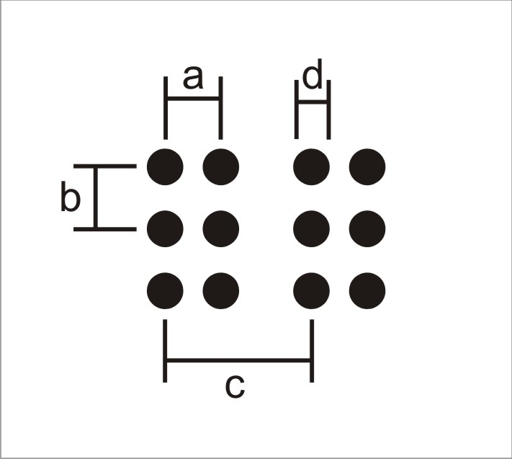

Table 3: Braille font specifications
 | a:  Horizontal dot to dot (mm) | b:  Vertical dot to dot  (mm) | c:  Horizontal cell to cell  (mm) | d:  Dot base diameter  (mm)
Standard English Braille | 2.29 | 2.54 | 6.00 | 1.40 – 1.50
Duxbury Swell Braille | 2.28 | 2.28 | 6.13 | 1.19
RNIB  Braille font | 2.29 | 2.54 | 6.00 | 1.50
Test font 3 | 2.29 | 2.54 | 6.00 | 1.19
Test font 4 | 2.28 | 2.28 | 6.13 | 1.50
A Konica Minolta C451 Series PCL was used to directly print braille samples onto swell paper, which was then raised through a Zy-Fuse fuser. Each font was tested with two different brands of swell paper which are currently used in the UK. These were Capsule paper manufactured by Matsumoto Yashi-Sieyaku Co., Ltd (Japan) and Zy-Tex2, manufactured by Zychem Ltd (UK). An embossed braille condition was also included to determine whether any issues reading braille on swell paper were due to the braille itself or simply the background texture. These combinations resulted in ten experimental conditions, as shown in Table 4.

Table 4: Testing conditions
Condition | Braille | Characteristics | Paper
1 | Embossed | Standard English Braille | Capsule
2 | Embossed | Standard English Braille | Zy-Tex2
3 | Duxbury font | Small dots, narrow spacing | Capsule
4 | Duxbury font | Small dots, narrow spacing | Zy-Tex2
5 | RNIB font | Large dots, wide spacing | Capsule
6 | RNIB font | Large dots, wide spacing | Zy-Tex2
7 | Test font 3 | Small dots, wide spacing | Capsule
8 | Test font 3 | Small dots, wide spacing | Zy-Tex2
9 | Test font 4 | Large dots, narrow spacing | Capsule
10 | Test font 4 | Large dots, narrow spacing | Zy-Tex2

Each participant was given fresh samples for testing. Made-up words were counterbalanced across conditions.

Procedure
Participant testing consisted of a short questionnaire followed by trials reading a variety of braille samples. Order of presentation was randomised to avoid order effects.

All participants were given a short practice passage to familiarise themselves with uncontracted braille, followed by two medicine names brailled on card to practice the procedure.

Participants were then asked to read aloud, letter by letter, two made-up words embossed in braille on card. This was taken as a measure of baseline braille reading performance, for means of comparison.

Following baseline testing, participants read two made-up words for each experimental condition. In each case, words were read aloud, letter by letter. Errors, hesitations and confusions were noted. After each word, participants were asked whether they thought they would be able to identify the label from the braille sample they had just read. Answer options were 'yes definitely, 'yes probably', 'probably not' and 'definitely not'.

Results

Performance measures
Participants reading performance was recorded in all conditions. Problem letters were recorded as errors (where a participant read a letter incorrectly), hesitations (where a participant paused or stumbled over a letter) and confusions (where a participant read a letter incorrectly, but then corrected their mistake).
Table 5: Reading performance: Errors, hesitations and confusions of all participants, by condition
Condition | Errors | Hesitations | Confusions | Total
Baseline | 2 | 2 | 0 | 4
1 | 2 | 4 | 4 | 10
2 | 3 | 3 | 5 | 11
3 | 7 | 11 | 1 | 19
4 | 5 | 3 | 3 | 11
5 | 4 | 4 | 2 | 10
6 | 5 | 4 | 2 | 11
7 | 0 | 3 | 3 | 6
8 | 11 | 5 | 2 | 18
9 | 3 | 3 | 1 | 7
10 | 3 | 5 | 1 | 9
Note: This table shows performance for all participants. Therefore for each condition, problem letters are out of a possible 6480
(2 x 12 letter words x 10 conditions x 27 participants)

It is clear from Table 5 that overall very few errors were made on all conditions. In considering performance compared to baseline, the criteria used for matching baseline were the same as those used by Douglas et al (2008): if the participant could not read the braille at all; or made 3 or more errors greater than in baseline testing, baseline performance was not reached. This threshold gives slight advantage to the experimental conditions in that participants can make 2 errors and be judged as meeting baseline, however, it was felt that errors can be sometimes be made in reading and these should not be incorrectly assumed to be due
to the braille presented.

Based on these criteria, 96% of all participants matched baseline performance in all conditions: only 1 participant performed poorer than baseline in one condition. The condition in which one participant failed to match baseline was condition 8 (test font 3 on Zychem paper).

Based on these findings, 9 conditions showed no difference in performance compared to baseline. Whilst there was one condition in which a difference in performance was found, this was the case for only one participant. Therefore, it is concluded that there is no significant difference in the legibility of the braille between baseline and any of the swell paper braille fonts tested.

Ability to identify
Overall, the vast majority of participants were very confident in their ability to identify the labels (See Table 6). This is reflected in the findings that nearly all participants matched baseline performance on all trials.

Table 6: Participant confidence in ability to identify the label from the braille presented
Condition | Definitely identify | Probably identify | Probably not identify | Definitely not identify
1 | 90 | 8 | 2 | 0
2 | 85 | 15 | 0 | 0
3 | 86 | 14 | 0 | 0
4 | 84 | 16 | 0 | 0
5 | 85 | 11 | 4 | 0
6 | 87 | 9 | 4 | 0
7 | 81 | 19 | 0 | 0
8 | 80 | 20 | 0 | 0
9 | 71 | 29 | 0 | 0
10 | 83 | 17 | 0 | 0

Subjective opinions
Whilst this study was primarily aimed at identifying a suitable braille font for use on swell paper, it was also an opportunity to collect qualitative data on users' experiences of reading braille on swell paper. Having taken part in the reading test, participants were asked to give their views on their experience of reading braille on swell paper. Responses fell into three broad categories: problems with the braille; texture of the paper and the reading experience.

Problems reading braille on swell paper
The most commonly reported problem with reading braille on swell paper was the tendency for dots to merge. Many participants commented on the importance of there being sufficient space between dots to keep them distinct. A number of participants remarked on braille fonts with tight spacing feeling like the shape of a braille character rather than being made up of distinct dots. Whilst no participants in this study had real trouble reading any of the braille fonts presented, a number hypothesised that some samples may be difficult to read for someone with a poor sense of touch (note: no participants reported having a poor sense of touch).

Another common problem reported was that dots felt flat or undefined. Many users compared the swell paper braille to conventional embossed braille and felt that swell braille was less distinct.

Another problem participants mentioned was the variability of braille on swell paper. For example, some felt the clarity of the dots seemed to vary in terms of how prominent or proud they were on the page. The range of fonts used in this study may have contributed to this perception. However, the researchers noted that participants also found variability within conditions (participants read two samples for each condition). For example, when reading the first sample in condition 6, one participant noted the dots felt firm, whereas the same participant thought the second sample of the same condition had dots which felt 'spongy'.

Texture of the paper
Many participants commented on the different texture of swell paper compared to typical braille reading paper. There was a range of opinion on this subject. Some users liked the texture of swell paper, describing it as soft, rubbery and warm to the touch. Others disliked the texture, describing it as sticky, rough and unpleasant. Some participants referred to how the texture affected their reading, including comments on the paper giving resistance and the finger not running so smoothly across the page.

The reading experience
There were a range of views regarding the reading experience with braille on swell paper. Some participants commented that they couldn't make a judgement from this study, and would have to read a longer passage to see whether they liked it. However, a number of participants commented that whilst they were happy reading labels in swell paper braille, they would prefer not to read longer passages. Some participants reported that reading braille on swell paper required extra concentration and was tiring, with some stating that they would eventually give up with the braille. Reasons for this included the unusual texture, discomfort and variations of dot heights which made reading challenging.

Despite this, many participants commented that overall, the braille samples within the study were all legible.

Discussion
Findings from the pilot study showed that achieving Standard English braille on swell paper was unlikely to be consistently achieved. To investigate the legibility of braille on swell paper, existing braille fonts with different dot sizes and inter cell spacing were tested for their legibility.

The variability in the production of swell paper became apparent both in pilot testing and when testing legibility, as participants' comments often differed between the two samples within a condition. These findings support the suggestion of Watanabe et al (2003) that the many variables involved in producing raised materials on swell paper are difficult to control. Though it is possible to produce good quality braille on swell paper, it can be difficult to maintain consistency of raising across many copies, highlighting the importance of consistently checking the final quality of production on swell paper.

In contrast to the findings of previous research (Watanabe et al, 2003), examination of performance measures showed no significant difference in the legibility of the braille between any of the fonts tested. It was found that all conditions could be read perfectly by almost all participants, indicating that braille readers are able to read braille at different sizes and of differing quality.

Whilst all braille samples tested were found to be legible the subjective comments made by participants gave interesting insight into users' perceptions of reading braille on swell paper. Braille dots merging on swell paper was a commonly reported problem. Larger braille dots tend to rise and swell out further than smaller dots and the space in between the dots becomes smaller so they feel closer together. This can make it harder to identify the braille character. This supports the findings of Watanabe et al (2003) in that braille reading becomes difficult as the dots are less defined. It is therefore essential for those producing braille on swell paper to ensure that raised dots are perceptibly clear and distinct.

A second reported problem was braille which was insufficiently raised, making it flat and undefined. Some participants believed that this could cause problems for those with a poor sense of touch or those learning braille. Some participants felt that extra concentration required to work out what the dots are could become tiring.

Potential improvements for further study may be to test braille reading on swell paper with real words or more realistic text passages, as some participants commented that reading nonsense words was not like real life. This study was specifically aimed at finding an appropriate braille font for labelling tactile diagrams, so only used short samples of text. However, these findings may have implications for the use of larger passages of braille text on swell paper, therefore this may be an area for further research. Caution should be taken against generalising the findings of this study beyond braille for labelling on swell paper.

The finding that there was no difference in reading performance between the samples tested may suggest that braille readers are flexible in their ability to read braille at different sizes. These findings support those of Douglas et al (2008), who found that braille readers could read braille much smaller than UK standard. However, it must be noted that Douglas et al (2008) found that older participants had more difficulty with lower raised braille; therefore these findings do not condone the production of lower than standard braille. Further research may be required into braille standards and what is an acceptable size for braille dots, including testing with older people, new braillists and people with poor tactile sensitivity. There may also be potential for developments in swell paper and the fusing process to improve consistency in performance.

Conclusion
The most significant finding was that the majority of braille readers could read all samples despite the variation in size and height of the braille dots. This suggests that braille readers are flexible in their ability to perceive braille of differing sizes and quality.

Despite issues such as merged or flat braille and the unusual texture of swell paper, none of the braille fonts stood out strongly enough in terms of legibility or ease of production to be recommended as the best braille font for use on swell paper.

Despite these findings, the researchers believe that there is benefit in a consistent approach in the use of braille fonts to produce swell paper braille. Achieving such consistency may benefit end users who would receive materials of a consistent quality, and would be useful for sharing of resources.

Of the fonts tested in this study, Duxbury Swell Braille is the only one which is freely available and already well supported. As this study has found no difference between the legibility of this font and baseline reading performance, the Duxbury Swell Braille font is suggested for use, at 24 point as directed in instructions from Duxbury (Duxbury Systems Inc, 1999). This font can be downloaded from http://bit.ly/gN0pkW.

The findings of this study highlight that output of materials on swell paper is extremely variable. Therefore it is vital that the quality of the raised braille output be checked for legibility, which is recommended for all those producing braille on swell paper.

References
Americans with Disabilities Act: Standards for Accessible Design 1994 (28 CFR Part 36). The U.S. Department of Justice.

Barker P and Fraser J, 2000. Sign Design Guide; a guide to inclusive signage. London: JMU and the Sign Design Society.

Douglas G, Weston A, Whittaker J, Morley Wilkins S, and Robinson D. 2008. Braille dot height research: Investigation of braille dot elevation on pharmaceutical products. Birmingham, UK: University of Birmingham.

Duxbury Systems Inc, 1999. Duxbury braille truetype set for windows: Background, installation, usage and limited freeware. [Online] (Updated 2008). Massachusetts: Duxbury Systems Inc. Available from:
http://bit.ly/gN0pkW [Accessed 3 February 2011 11:26].

Jehoel S, McCallum D, Rowell J, and Ungar S, 2006. An empirical approach on the design of tactile maps and diagrams: the cognitive tactualization approach. British Journal of Visual Impairment, 24 (2), 67–75.

Rowell J and Ungar S, 2003a. The world of touch: an international survey of tactile maps. Part 1: production. British Journal of Visual Impairment, 21 (3), 98–104.

Rowell J and Ungar S, 2003b. The world of touch: an international survey of tactile maps. Part 2: design. British Journal of Visual Impairment, 21 (3), 105–110.

Thompson L and Chronicle E, 2006. Beyond visual conventions: Rethinking the design of tactile designs. British Journal of Visual Impairment, 24 (2), 76–82.

Watanabe T and Oouchi S, 2003. A study of legible braille patterns of capsule paper: diameters of braille dots and their interspaces on original ink-printed paper. The Bulletin of the National Institute of Special Education, 30, 1–8.

Appendix 1

Figure 2: Test sheet for pilot study
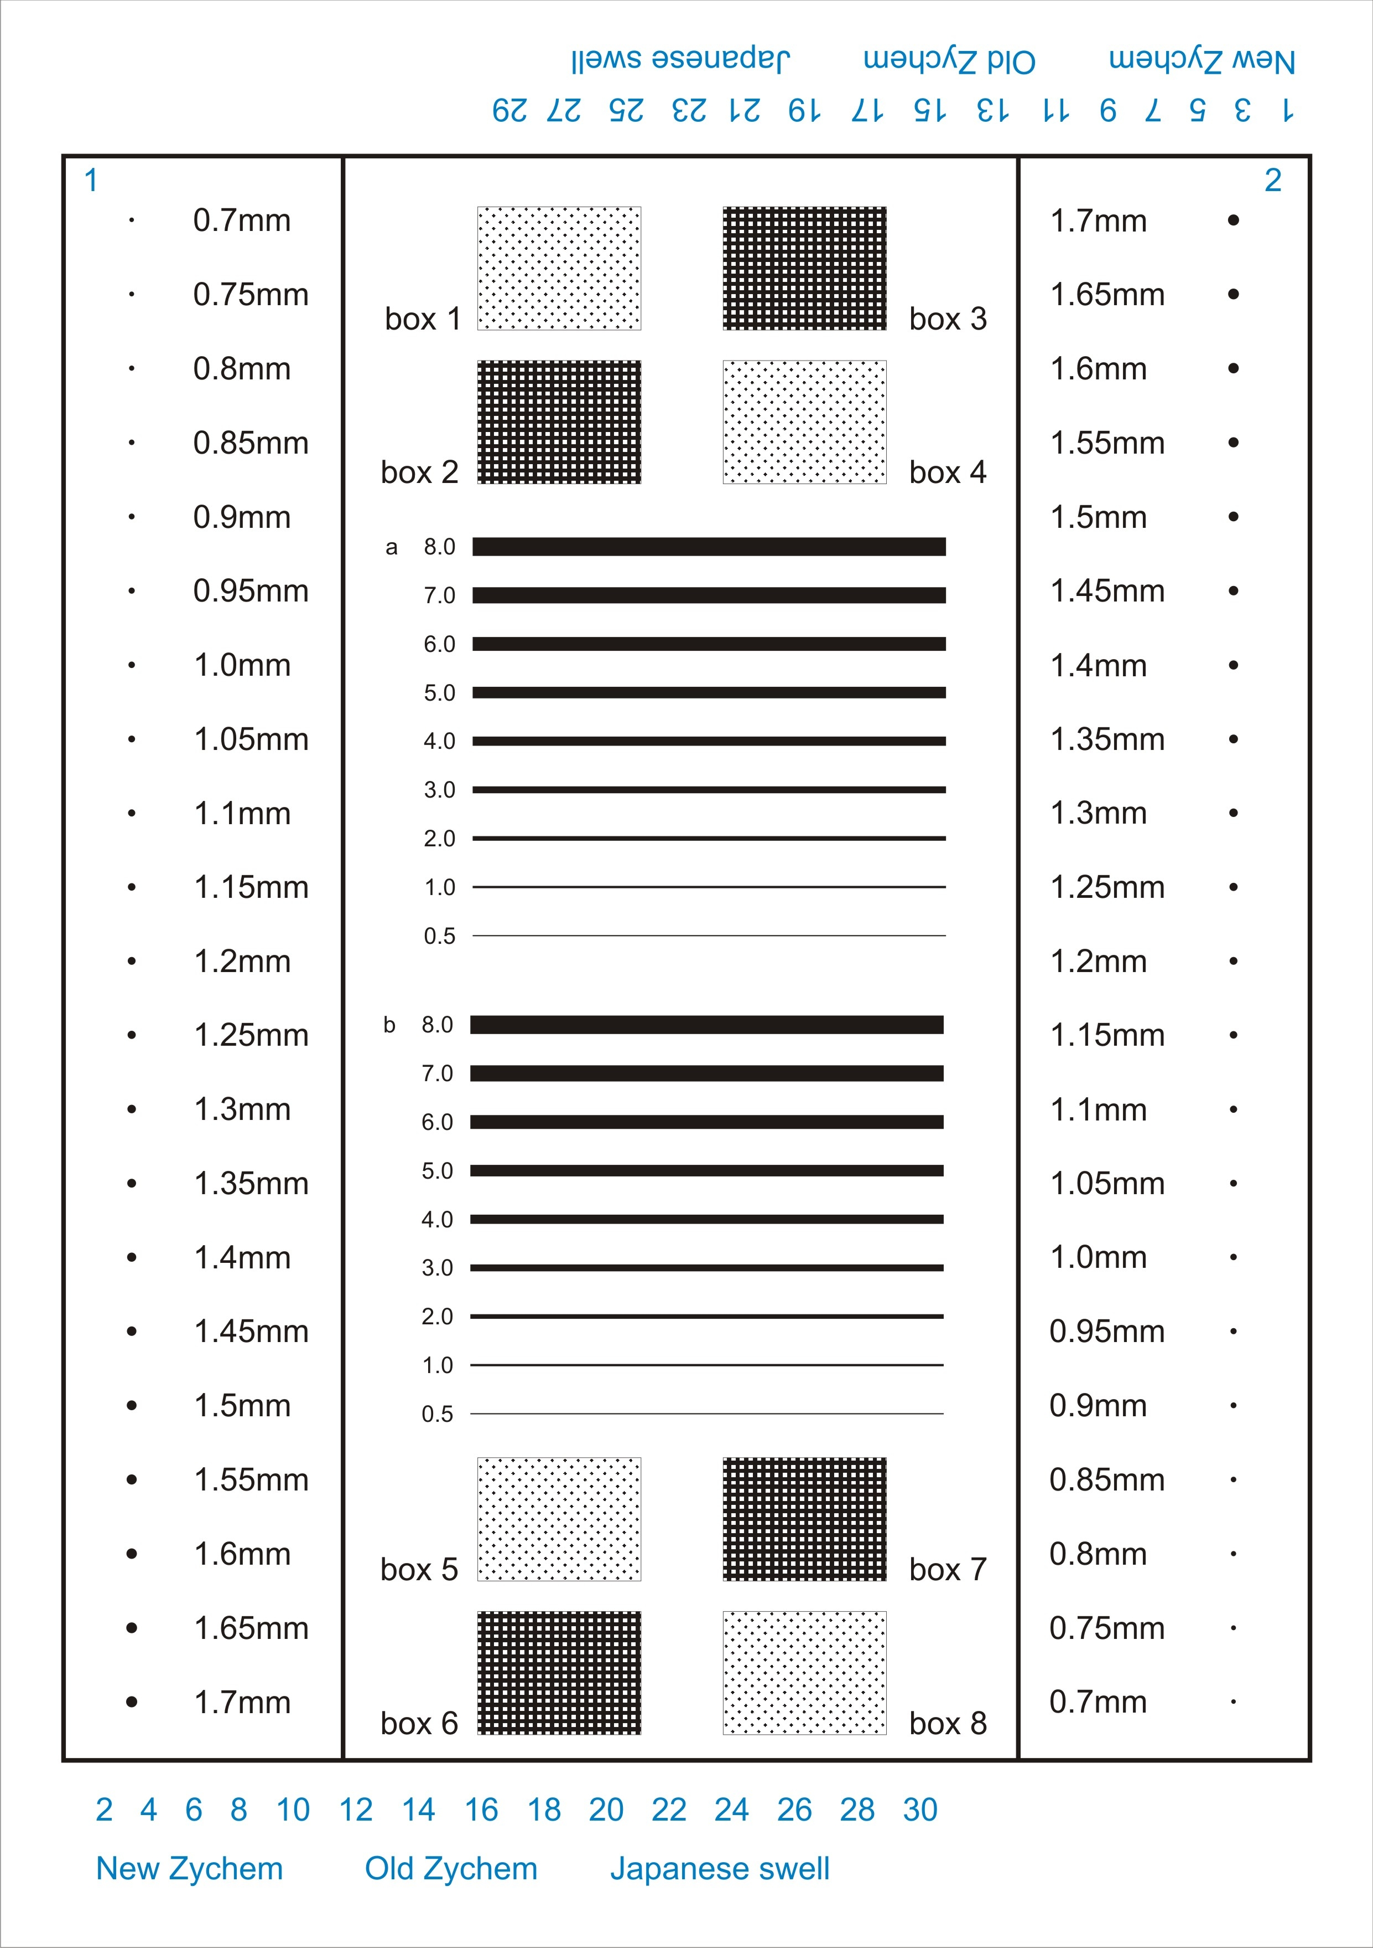

Appendix 2
Nonsense words used in legibility testing
- Zybrewstanol
- Monterioform
- Svenisotrope
- Isodietermos
- Cartagsandil
- Patraxarline
- Habdolcerene
- Thakulatease
- Mikytrexemol
- Larsidexocot
- Mutaryjanase
- Sedhuraldine
- Affaqstanten
- Marbutsanzyl
- Tridougonite
- Lionisinepic
- Jonhevitalip
- Tyleroxynate
- Cothowateaen
- Poldmotravil
- Duncrofixate
- Gosaraquikon

About RNIB’s research
RNIB is a leading source of information on sight loss and the issues affecting blind and partially sighted people. Our Research and Knowledge Hub contains key information and statistics about blind and partially sighted people including our Sight Loss Data Tool, which provides information about sight loss at a local level throughout the UK. You’ll also find research reports on a range of topics including employment, education, technology, accessibility and more. Visit our Knowledge and Research Hub at: rnib.org.uk/research or email research@rnib.org.uk.

