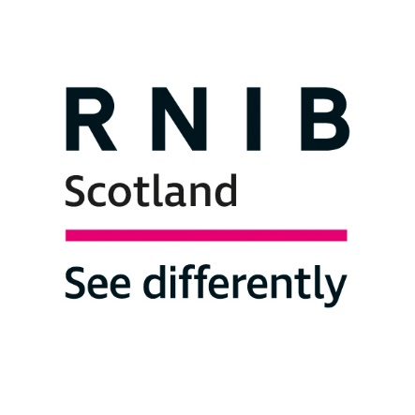

RNIB Scotland response to the Scottish Government - A Consultation on the provisions of the Education Bill

Questionnaire
The Royal National Institute of Blind People Scotland (RNIB Scotland) welcomes the opportunity to respond to this consultation. Please note that we have responded only to Questions 1, 2, 3, 5, 6, 7, and 8.

Question 1: What changes should we consider in terms of how qualifications are developed and delivered that you think would improve outcomes for Scotland’s pupils and students?

RNIB Scotland believes that accessibility is essential to improve outcomes for Scotland's pupils and students with Additional Support Needs, particularly those with vision impairment, a low incidence but high impact disability.

Access to information is one of the key barriers faced by students with vision impairment.

The successful development of qualifications depends on planning at the design stage to ensure that materials can be developed in Braille, Large print, accessible electronic formats (working with magnification and screen readers). This can be done by ensuring that qualifications bodies work with Local Authority Vision Impairment Teams made up of Qualified Teachers for children and young people with Vision Impairment (QTVIs).

RNIB Scotland also recommends that the Scottish Government considers the following:

- Developing qualifications that recognise progress in areas such as independent living skills and the use of assistive technology to give status to these key skill areas and so that learners with ASN can be more fully rewarded for their achievements.

- To allow for wider use of assistive technology in assessments for students who use this as their normal way of working.

- The Curriculum Framework for children and young people with Vision Impairment (CFVI) should be considered in the design of new qualification as it sets out key areas of specialist skills and services that children and young people with vision impairment need to meet their potential.
- Curriculum Framework for Children and Young People with Vision Impairment | RNIB | RNIB

Question 2: How best can we ensure that the views of our teaching professionals are taken into account appropriately within the new qualifications body, and do these proposals enable this?

RNIB Scotland recommends that the Scottish Government ensures that it seeks not only the views of teachers in schools and colleges but also those of specialist teachers such as QTVIs and strategic leads working for LA education support services.

Question 3: How best can we ensure that the views of pupils, students and other learners are appropriately represented within the new qualifications body, and do these proposals enable this?

RNIB Scotland recommends:

- The Involvement of organisations that advocate for different groups of learners, for example, RNIB Scotland, the Scottish Sensory Centre and Sight Scotland and youth groups who have contact with specific groups of young people.
- Ensuring that statutory support services, for example, ASN Teams including Vision Impairment teams, are consulted in the early planning stages so that young people with vision impairment can participate.

- Ensuring that any focus groups include adequate representation from learners with low incidence needs such as vision impairment and deaf learners as well as learners from higher incidence ASN groups.

- Ensuring that feedback from pupils, students and other learners is gathered in ways that are fully accessible to all.

Question 5: How do you think the qualifications body can best work with others across the education and skills system to deliver better outcomes for all?

It is essential that any new qualifications body forges strong links with Vision Impairment Services.

The qualifications body should:
- In consultation with employers, voluntary groups etc, develop qualifications that credit skills that can lead to employment/engagement with voluntary work/the ability to live an independent life for learners with ASN.

- Make information on how standard papers are adapted for large print or braille more widely available to schools and LA VI services so that classroom materials can be adapted along similar lines to better prepare students for external assessments.

- Deliver more training to teachers on the access arrangements available for students with ASN taking exams.

Question 6: Do you agree or disagree with the purposes set out? Is there anything in addition you would like to see included?

RNIB Scotland calls on the Scottish Government to:
- Ensure that both qualifications and inspection bodies take full account of all types of Additional Support Needs including low incidence disabilities such as sensory disabilities.

- Consider how effectively the needs of learners with ASN are being met.

- Consider the specific transitional requirements of VI pupils moving beyond schooling to either further education or work.

Question 7: Do you agree or disagree with the range of establishments to be inspected by HM Inspectors of Education? Is there anything you would add or change?

RNIB Scotland suggests making specific mention of services for students with Additional Support Needs.

Question 8: Do you have any specific comments on the role of the inspectorate of education in the inspection of publicly funded colleges, initial teacher education, early learning and childcare and / or modern apprenticeships?

It is imperative that the inspectorate has an understanding of low incidence disabilities like vision impairment in order to inspect the quality of support given to these students. Inspectors should receive good quality training and advice on vision impairment including the Curriculum Framework for children and young people with Vision Impairment (CFVI) - see
Curriculum Framework for Children and Young People with Vision Impairment | RNIB | RNIB.

