Christmas TV ads of 2020: accessibility for viewers with sight loss
Focus group evaluation report
Venue: Teams (online)
Date of Focus Group: 20 January 2021

Executive Summary 1
Why was this focus group conducted? 1
Participants 3
The stimuli 3
Key results from the discussion 4
Recommendations 4
Viewer feedback 5
Waitrose & John Lewis: Christmas 2020 Ad 5
Microsoft Holiday Commercial 2020 – Find Your Joy (A Dog’s Dream) 7
Aunt Bessie's - Caring is the hardest thing we do 8
Morrisons Making Christmas Special 10
M&S Christmas Food 11
Tesco No Naughty List 12
Viewer comments 12
Sainsbury’s Gravy Song 13
Discussion 14
Most enjoyable experiences: integrated descriptions 14
Biggest mistake: not naming the brand 14
Finer detail vs the complete story 15
Need for viewer feedback 15

Executive Summary

Why was this focus group conducted?
Christmas ads on TV have been heralding the start of the festive season for the past few years. Brands splurge on lavish productions for TV and online viewing platforms. Typically, these go live in the week following the Halloween weekend and are on-air until just after Christmas. With their complex storylines, and a lack of sufficient audio clues, voice over and audio description (AD), most ads are not accessible for viewers with sight loss. Following RNIB’s campaign in 2019, six brands added AD to their Christmas ads to make them accessible for people with sight loss. In 2020, the number grew to 12.

Six brands from 2019:
- Amazon
- eBay
- John Lewis
- Tesco
- Marks and Spencer
- Sky

11 brands that added AD in 2020
- John Lewis
- Morrisons
- ASDA
- Aldi
- O2
- Amazon
- eBay
- Microsoft
- Dunelm
- Very
- TKMaxx
- M&S integrated accessibility into the creative treatment so AD wasn’t needed.

In addition to M&S, few others also made their ads accessible by voicing graphics or producing audio-led ads eliminating the need for AD.

It was important, therefore, to evaluate if the measures taken so far have improved the viewing experience for people with sight loss. For this reason, a focus group was organised by RNIB. This was the first focus in a series of four that are planned for this year.

The first group assessed the ads released over Christmas 2020. The subsequent focus groups planned for 2021/22 will focus on the ads from specific sectors:
- Second focus group (Spring 2021): Banks, money and telecom
- Third focus group (Summer 2021): Supermarkets and consumables
- Fourth focus group (Autumn 2021): Charities

Participants
- 8 people attended the focus group
- 4 female and 4 male participants
- 1 partially sighted (sight impaired) and 7 registered blind (severely sight impaired)
- All participants had used AD for many years and continue to use it regularly on TV and catch-up TV.
- 3 of the 8 participants belonged to BAME groups

The stimuli
7 ads were shown at the focus group. Out of these:
- 4 ads were shown with AD
- 1 ad was shown with and without AD
- 2 ads were shown without AD

The following ads were shown with AD:
- Waitrose & John Lewis Christmas 2020 Ad #GiveALittleLove
- Microsoft Holiday Commercial 2020 Find Your Joy (A Dog’s Dream)
- Aunt Bessie's Caring is the hardest thing we do
- Morrisons Making Christmas Special

The following ads were shown without AD:
- M&S Christmas Food (no AD provided by M&S)
M&S confirmed that they had integrated accessibility into the creative treatment eliminating the need for AD.
- Sainsbury’s Gravy Song (no AD provided by Sainsbury’s)
Sainsbury’s ad was not audio described but expert evaluation prior to the focus group indicated that the ad was largely accessible and would not benefit much from AD.

The following ad was shown without AD and then with AD:
- Tesco No Naughty List
According to expert evaluation carried out prior to the focus group, this ad did not require AD. Therefore, both versions were tested to confirm the user preference.

Key results from the discussion
- AD was required to cover essential information
While in most cases, the AD track was used to set out important elements of the story, in some ads, the track was used to name the brand. The original ads without AD only had the names in an on-screen graphic rendering it inaccessible for people with sight loss.
Examples: Waitrose and John Lewis, Sainsbury

- Finer detail versus the complete story
Participants singled out experiences where they could picture the characters, scenes, or the general feel of the ad from the descriptions. These worked as visual memories that participants returned to through the discussion. Although it was agreed that understanding the plot was important in TV programmes, films and most other genres, in Christmas TV ads, translating the visual festive feel into audio took precedence.
Examples: Microsoft (with emphasis on plot), Morrisons (with emphasis on general feel of the ad)

- Integrating description into the ad makes the ad inclusive for all
According to the feedback, not all ads that were described would have needed AD had the requirements of people with sight loss and AD users been considered during the production stage. The details from AD could have been included in the voiceover, thereby eliminating the need for a special AD track.
Example: Aunt Bessie’s, Microsoft

- Taking feedback from people with sight loss through focus groups during production
Participants, AD users in this case, appreciated the opportunity to share feedback on the ads but felt that this needed to be done through the production process during the making of the ad and the AD track. This would help identify aspects that need further clarity. This is especially important as AD on ads is still a relatively new feature for all stakeholders including consumers of AD, creative industry and the AD Providers.

Recommendations
- Viewer consultation through focus groups of interviews: The intended viewer group, in this case, blind and partially sighted users of AD, be consulted during the production of the ad. This would help identify barriers. Even though it may not be possible to remove all barriers, discussions may result in some of them being addressed and resolved through consultation.
- Integrated experiences: Where possible, the creative process must consider integrating descriptions within the creative structure. This could be done by adding ambient sounds and enhancing the voiceover with audio clues.
- Name the brand: Essential information such as the brand name must be voiced in the original ad. Even when the ad is described, it is not broadcast with description on all channels. Additionally, the version of the ads on social media and other digital platforms often doesn’t carry the AD track. Viewers are signposted to a separate version on YouTube. In this case, the viewer is left uninformed on even the most basic information, such as the brand name.
- Same day release across all platforms: Viewing habits of blind and partially sighted viewers are similar to those of sighted viewers. They watch content across platforms and services. This includes social media channels. Therefore, where possible, the ads must be released with AD across the board on the same day. If the non-linear channel being used does not support the delivery of a secondary audio track, then YouTube is a good alternative.

Viewer feedback

Waitrose & John Lewis: Christmas 2020 Ad
#GiveALittleLove
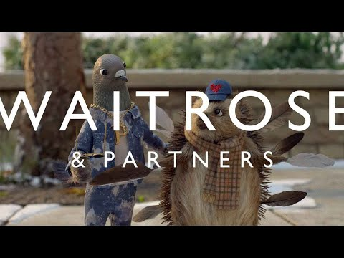
This ad was played with AD.

Viewer comments
Participants generally appreciated that the ad had been described and the AD was available on Linear TV and online on the day of the release. It meant not having to turn to family or friends asking them to describe the ad.

“If this was not audio described, I would not even know what shop this is for. Just by the music, I couldn't say that's John Lewis or that's ASDA or Morrisons and they don’t say John Lewis in the version without AD. Or do they? Did I miss it?”

It was evident to the participants that with so much happening in the ad, the describers had to prioritise what to describe and what to leave out.

“John Lewis obviously sets the benchmark for Christmas adverts, isn't it? It has to be busy. It has to be out there. Yeah, I'm always there for describers who have to strike a balance at some point where there are things, they can tell you, then there are things they can’t tell you because of the time constraints there. I think she [describer] got in to hang of a lot of info. It's probably the clearest John Lewis ad that I've heard with AD.”

“I don't understand the ad at all, but I think I understand it slightly more with audio description. There was a bit where I kept asking myself what's the bird got to do with, or the pigeon got to do with John Lewis? And the hedgehog and the boy with the ball. And you know you have to really work hard when you listen.”

There was a consensus that the voice worked well for the ad. The delivery was relaxed, clear and sufficiently festive which played well with the original content.

“I think it [the voice] was contextually appropriate. If it was like a scary ad, a creepy dark voice would have been better, but since this was obviously an upbeat Christmas ad, her voice was, you know, very relevant to the content. It matched the content very well, which I think we would all say is quite important in anything to do with AD.”

“I liked her, very Christmassy voice.”

Microsoft Holiday Commercial 2020 – Find Your Joy (A Dog’s Dream)
This ad was shown with AD

Viewer comments
This ad was not released by Microsoft on Linear TV in the UK and only distributed through social media and their channel on YouTube. The version with AD was available to watch on YouTube. The comments from AD users on Twitter were favourable and appreciative of the fact that the ad had been described. Similarly, in principle, the focus group responded positively to Microsoft describing its ad. The AD provided led to a discussion on whether it is the storyline that is important for description on ads or capturing the general feel and essence.

“In the John Lewis advert they described the girl with the blue glasses and yellow jacket. This one just went the boy, the woman, or the mum, the dog. I couldn’t picture it. However, they gave the story better because they didn’t go into finer detail so much. So, I know the story, but I can’t picture it. I don’t know what’s better.”

Most participants were able to summarise what happened in the ad but struggled to conjure up images of the characters, an aspect they felt the AD lacked.

“It reminds me of this thing that my husband does that drives me mad. So, we will be out somewhere, and he will say, oh, there's a dog because he knows I like dogs. Or there is a dog passing and I go, what kind of dog? What does it look like? Is it a big dog? Little dog? What colour is it? I can't get anything and that's how the ad made me feel. Couldn't picture the dog. Didn't know if he was cute, ugly, big small. Something like a Labrador with puppy dog eyes? The description did not bring up a picture. Was it Christmassy? Was there snow, a tree, lights? I got the story though.”

“Lonely dog begging for attention. Everybody is too busy with gadgets. But wasn't it dreaming as well? Is there a dream?”

“I think it was a typical day. Everyone was on their devices. Playing Minecraft on the TV, on the laptop. Mom was on the computer, and then maybe someone was playing a VR flight attendant thing and then Halo on the TV. Then he [the dog] was walking around seeing everyone playing and then he [the dog] went to his friend’s house across the street. The other dog. Later, both had a nap on the sofa, and they start dreaming pretending they were in the different games. Right? Yep – I know the story, but it didn’t feel Christmassy enough.”

Aunt Bessie's - Caring is the hardest thing we do
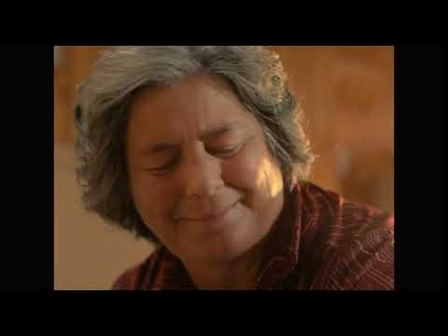
This ad was shown with AD

Viewer comments
The AD track was released a few days after the ad had been on-air on linear TV. The general response to the ad and description was positive but the group felt that had the creative team behind this production been aware of AD, they could have integrated elements of it into the creative structure. In the voiceover that ran through the ad, perhaps. This would have eliminated the need for additional description.

“Why did not just use the narrator to do the AD within the voiceover. I mean weave it [the descriptions] in. Why think of it afterwards? So, the AD should have been integrated. Makes it more inclusive too.”

Participants were able to understand most of the ad without any description but the most important aspect – reading of the Braille label- which makes it clear that the protagonist has sight loss had to be described in the AD track. Otherwise the group was divided on whether the ad benefitted from traditional description.

“It was clear enough for me, generally. Though I thought there were bits that didn't need to be described. They were crammed in very tightly. I could've got away with maybe about 3/4 of that advert without AD apart from the bit about the Braille label, stealing the Yorkshire pudding and pouring the gravy at the end. That for me would have been the only bits where I would have needed descriptions.”

“I loved the description of when she smiles at the end. Just when the family sits down for dinner.”

“It was sort of forced when it almost felt like something was added because the describer needed to describe something.

The ad uses a male voice for narration and so does the AD track. The group felt the two voices sounded so similar that in parts they were confused which was the main narration and which one was AD. This could have still worked but the change in audio drops every time the track switched from the original soundtrack to AD and vice versa, meant that viewers were able to achieve the immersion that was perhaps intended.

“I got confused between him (main voice over) speaking and the audio describer. Because it's so tightly packed and they sound quite similar. They should have used contrasting voices? Maybe that would have helped?”

Morrisons Making Christmas Special
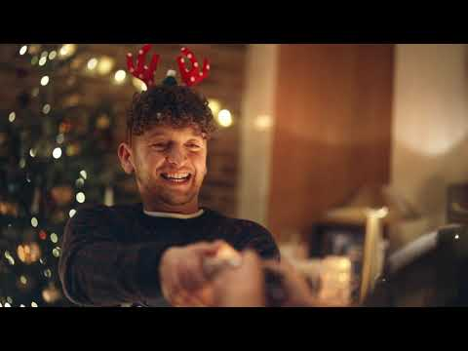
This ad was shown with AD

Viewer comments
This ad was released with AD on Linear TV and of the 4 ads with AD screened during this focus group, this was picked-out as the most satisfying, enjoyable, and inclusive for viewing experience. The group felt this was true for every aspect including the volume of description, the delivery and how it was described.

“I think this is my favourite one so far! In terms of the way it’s used [the AD] and just the right amount of AD.”

The lack of detail in the description of the visual storyline and characters did not bother the group. It was voice of the describer and the script that captured everyone’s attention.

“This didn’t sound like AD which was a good thing. The AD felt like it was the voiceover with music in the background. Maybe because the describer wasn’t plastered all over and listing all the things that were happening in the ad. Storytelling was spot on.”
“Just the right kind of details. I liked that “Morrisons making Christmas special” was in the original ad rather than the AD having to do it.”

“You got some sort of understanding of what’s going on. As long as you have that, even though it [AD] did not include everything, it was adequate. I didn't need anymore; it was perfect for me. I got the gist of what was going on.”

The aspect most enjoyed by the focus group was the voice of the describer and the feeling of festivity that it was able to communicate through the delivery.

“I thought the describer is actually really good. His intonation and the way he sounded upbeat but not hyper. An engaging voice you like and the way he delivered the AD and the description was just on point. I don’t think it was too much or too little actually on this.”

“Like the Microsoft ad, the pictures [imagery] were missing from this too, but the describer delivered that feeling of festivity and joy and that Christmassy feeling through his voice. That’s what I liked best about this one. Really good!

M&S Christmas Food
This ad was not audio described. M&S confirmed that the ad was designed as an inclusive asset and did not require AD.

Viewer comments
The feedback to this ad was overwhelmingly positive. The group felt that the creative team had considered their needs during the production and as such it represented best practice in terms of inclusion and accessibility.

“Sold out. Because it was done that way, it felt more inclusive. You could picture it. It was designed to draw people in and it did. It drew everyone in in exactly the same way. She [voice artist] sounded excited about it as well. I don’t think all ads could be done like this but if they can be then it would be great.”

“I like the fact that it didn’t have to made accessible for us. I can just watch the one that everyone else is watching.”

“This was gold standard in terms of accessibility.”

“Having watched this, could this way of delivery have worked on the Microsoft ad – voice of the dog – first person narrative? Or even Aunt Bessie’s? But they would have to plan it that way from the start.”

“Awesome voice! She didn’t rush. The pace was good.”

Tesco No Naughty List
This ad was shown twice. First without AD and then with AD.

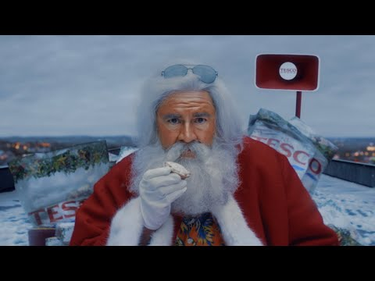
Tesco ad without AD
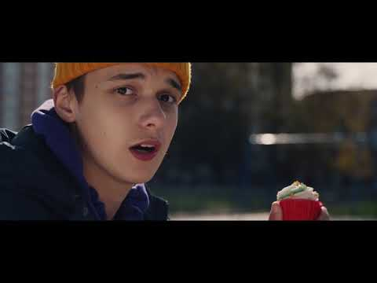
Tesco ad with AD

Viewer comments
The group agreed that the AD provided felt unnecessary and the original voiceover was sufficient for the understanding of the storyline. The humour, which was the main stay of the ad, came through clearly in the script and delivery by the different characters in the ad. There was discussion on describing diversity in the ad.

“No AD needed. Younger sounding Santa would have been great though (smile)!”

“I could tell it was a Christmas ad from the script and the way it is narrated.”

Prompt: After the ad was played, moderator briefly described the on-screen visuals that had not been covered in the AD track to the group.

When watching the ad visually, one of the aspects that stands out is the inclusion of people from diverse backgrounds and disabilities. Should this aspect have been described for viewers who rely on AD?

“There is no time to describe every character and you can’t just describe one. Also, I don't think it's relevant in this case. It does not impact the storyline or the feel of the ad. And there is no time. I don’t think it’s needed.”

“How could you possibly describe every character in this ad. Give me the gist and help me picture the general feel. If you described every character, I would miss the whole point anyway. This ad didn’t need AD.”

“It’s unlike Aunt Bessie’s where there is only one main character who could have been described.”

“I got the jokes. Voices communicated the feel of the ad. I didn’t need to know more.”

Sainsbury’s Gravy Song
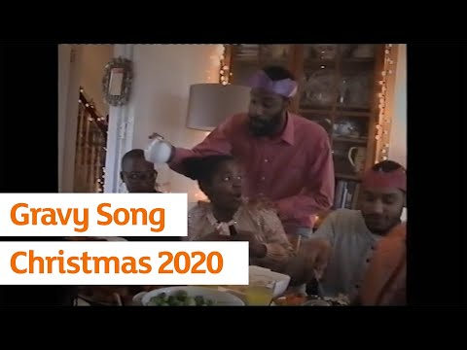
This ad was not audio described.

Viewer comments
This ad was chosen for the focus group because of its format. Whilst the footage of home videos is suitable material for description, it is the conversation between the two characters that communicates the central theme of the ad. Being home for Christmas. However, without any space for description, it was important to understand how the group responded to this content. The feedback was generally that the AD was not really needed but the brand name should have been voiced.

“The ad was good but if you hadn’t told me, I wouldn’t know what they were selling. They could have at least said Sainsbury’s at the end!”

“I don’t think we need AD here and if they put description into it, it would spoil the conversation. All they need to do is say who it is in the end. That’s all.”

Prompt: After the ad was played, moderator briefly described the on-screen visuals to the group.
This was followed by a question on the need for describing the visuals. In addition, as this ad had been in the news quite a lot over the Christmas season the focus group was asked whether the ethnicity of the cast should have been described?

“Maybe it’s just me, I got that it’s a black family. Not everyone will and I appreciate not everyone will. Maybe if description was needed and there was time to fit in, then it could be mentioned. But this doesn’t need description. It is fully accessible. So, it doesn’t seem necessary to add AD to just mention the ethnicity.”

“If you’re trying to create an image, then mention colour of skin. Don’t do it just to show how diverse the ad is. Also – if there is a need for description and here – there is no need or time for AD.”

“Yes- it would have helped me visualise the ad better but there was no space. I enjoyed the conversation. Glad no one tampered with it.”

Discussion
The group agreed that these ads were hard to describe but appreciated the effort of audio describers to describe as many aspects as possible and making them easier to understand.

Most enjoyable experiences: integrated descriptions
The ad that struck a chord with the group was the M&S Christmas Food ad. There was no need for additional AD as the voiceover, delivered by the British actress Olivia Coleman, described the visuals and the on-screen display. There was one voiceover for sighted viewers and viewers with sight loss. This made the experience inclusive.

It was interesting to note that after M&S, the next most enjoyable experience was that of watching the Morrisons ad with AD. Once again, the comments indicated the preference for an integrated experience. Although the AD was added retrospectively, the treatment including the script, voice and delivery made it feel like a single package.

Biggest mistake: not naming the brand
Out of the seven TV ads analysed in this focus group, two did not have the name of the brand in the original soundtrack – John Lewis and Sainsbury’s. As the John Lewis ad was audio described, the name was read out when it appeared on the screen at the end of the ad. However, on TV channels that still do not support AD on commercials, the brand name was not heard in the audio, leaving blind and partially viewers in the dark.

The other was Sainsbury’s. As the Sainsbury’s ad was not audio described, viewers who rely on AD were not aware that they had just watched the ad for Sainsbury’s. It must be noted that with the exception of the brand name, Sainsbury’s ad was otherwise considered fully accessible by the focus group.

Finer detail vs the complete story
Following on from the point made above about integrated accessible experiences, the group felt quite strongly that unless it was vital information such as the brand name, discounts and offers they would prefer a general understanding of the screenplay and being part of the emotional journey that the creative team had designed for the viewers rather than an objective coverage of the storyline and the various on-screen aspects.

One of the participants noted that in the TV version of the Waitrose and John Lewis ads, the music had been dipped so low that they could barely hear it during the broadcast. With music and lyrics setting the tone for the ad, it was an important aspect that was completely missed by blind and partially sighted viewers. This was in contrast to the Morrisons experience in which music could be clearly heard in addition to the AD and the original voiceover.

During the focus group, the version of the Waitrose and John Lewis ad used was the one from YouTube. Here, the audio mix allowed viewers to listen to the AD track with the song in the background.

“That’s strange! I have watched this ad – this version of the ad – not a different cut, but I don’t think I’ve ever heard this song in the background. It’s a beautiful song, why cut it. We enjoy music too.”

Need for viewer feedback
There was great excitement about the focus on making ads accessible through AD or without it and the group appreciated the efforts being made by all stakeholders, including the big brands, to bridge this gap. With all participants being regular users of AD and most admitting to not watching anything that was not described, they felt that AD on TV ads has led to a more inclusive and enjoyable TV experience.

“Even if I got up during the ad-break to make a cup of tea, like I often do, I can still hear the description and know more about the ad than my partner who is constantly on the phone. It sets you free! Everyone should try it once.”

There was, however, a strong feeling that more effort is needed to improve the quality of experience and make it truly inclusive. The group appreciated that AD on ads is still a new feature and recommended that the creative industry consult potential viewers on aspects of accessibility, particularly on prioritising what and how to describe. TV ads are designed to have an emotional pull and influence decisions. This is achieved through a powerful combination of music, lyrics, voiceover, and on-screen events packaged tightly mostly around 60 seconds. The AD needed to match the strength of this package to achieve the desired quality of experience.

The group agreed that consultation during the production stage would not necessarily lead to elimination of AD as not all formats are suitable for integrated description, but it could make the structure more conducive for adding AD retrospectively.

“Why aren’t we consulted when the ads are being planned? Like the way we have been consulted today, we should be consulted in the planning stuff. Engage with blind and partially sighted people at the production stage. Doesn’t the industry engage with focus groups. Just like ethnicity. Why are sighted people deciding how things should be described for blind people?”

If you would like to discuss accessibility of TV ads, drop us an email on audiodescription@rnib.org.uk

More information on Making TV ads accessible for people with sight loss

Date: 18 February 2021

