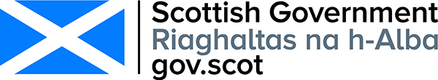
Patient safety commissioner role for scotland

RESPONDENT INFORMATION FORM

Please Note this form must be completed and returned with your response.
To find out how we handle your personal data, please see our privacy policy: https://www.gov.scot/privacy/
Are you responding as an individual or an organisation?
Individual
x Organisation
Full name or organisation’s name
Royal National Institute for Blind People (RNIB) Scotland

Phone number

Address
12-14 Hillside Crescent
Edinburgh

EH7 5EA

Postcode

catriona.burness@rnib.org.uk

Email
Information for organisations:
The option 'Publish response only (without name)’ is available for individual respondents only. If this option is selected, the organisation name will still be published.
If you choose the option 'Do not publish response', your organisation name may still be listed as having responded to the consultation in, for example, the analysis report.
The Scottish Government would like your
permission to publish your consultation
response. Please indicate your publishing
preference:

x Publish response with name
Publish response only (without name)
Do not publish response
We will share your response internally with other Scottish Government policy teams who may be addressing the issues you discuss. They may wish to contact you again in the future, but we require your permission to do so. Are you content for Scottish Government to contact you again in relation to this consultation exercise?
x Yes
No
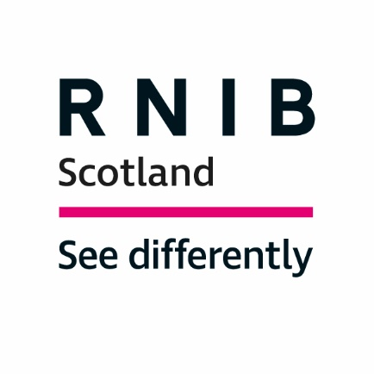

Royal National Institute of Blind People (RNIB) Scotland Response to the Scottish Government Consultation on "Patient Safety Commissioner role for Scotland"

Introduction

The Royal National Institute of Blind People (RNIB) Scotland is the country’s leading charity working with blind and partially sighted people. We support children and adults with sight loss and help them to live full and independent lives, campaigning for their rights.

In 2010, the date of the most recent figures published by the Scottish Government, the number of people registered as blind or partially sighted in Scotland was reported to be 34,492. Research suggests that around 10 per cent of eligible people do not register making the true figure closer to 40,000.

Around 178,000 people live with a significant degree of sight loss in Scotland, around 4,300 of which are children and young people.

This number could eventually double unless we act to prevent avoidable sight loss. The rise of sight threatening conditions such as diabetes and an aging population will increase the number of people affected by sight loss unless action is taken.

RNIB Scotland welcomes the opportunity to respond to this consultation as patient safety is incredibly important within the heath environment.

This includes providing accessible information for blind and partially sighted people so that they are aware of their rights and responsibilities. Without this, it could potentially lead to a lack of trust and understanding about, and during, their healthcare treatment and pathway.

The consultation poses a selection of questions; to highlight key points relating to sight loss we have replied to Question 7. The reply is based on previous RNIB/RNIB Scotland surveys, public consultation responses, literature review and specific consultation for this response.

RNIB Scotland Response - Question 7. In your view, despite the existing ways patients can make their voices heard (listed in table 1 of page 11 of the consultation document), why do you think people still feel that this is not happening?

Accessible health information is crucial.

Patients rely on good communication to ensure that they understand their health information and needs. For most people this is achieved through printed information, but for a person with sight loss, printed information is often inaccessible. Around 178,000 people live with a significant degree of sight loss in Scotland, so the need for accessibility is high.

People with sight loss should be informed about the accessible options available to them from the very beginning of their healthcare journey, giving them the opportunity to self-manage and control their own healthcare needs.

However, research for our “Communication Failure?” report found that blind and partially sighted people lacked confidence when considering requesting accessible formats from their health service. This was put down to feeling “a burden” or not wanting to be seen as “difficult”. They do not feel that they can enforce their rights to access information, as one respondent explained:

“No [I do not feel confident], because I worry I’m not worthy enough as I can just about manage with standard print for short lengths of time.”

Some respondents expressed a lack of trust in the health service and instead used their own supportive technology to make documents accessible at home, as one respondent explained:
“It’s easier to do it myself on a scanner so I don’t ask for information. If you’re ringing, they wouldn’t be there.”

Technology can reshape and improve services, support person-centred care, and improve outcomes. Furthermore, from 2019 - every public sector website and app including those of the Scottish health boards - will need to meet certain accessibility standards under new regulations.

Accessing information online can provide blind and partially sighted people with valuable healthcare advice and empower them to better manage their health and wellbeing while supporting independent living. As more of our public services move online, digital inclusion has become more necessary than ever before.

However, a digital divide exists in Scotland. This is partially due to geographic barriers with around 25 per cent of rural households experiencing poor broadband speed. Those who do not have internet access at home need to use a public service computer which requires pre-planning and may mean lack of privacy.

Levels of digital uptake can be significantly lower for people with disabilities. Accessing online information, for example, filling in forms online, can be very time consuming or completely inaccessible. Visual barriers such as inconsistent font sizes prevent blind and partially sighted people from accessing information with ease. One respondent explained:

“Websites are very complex to navigate in general so when you have sight loss of any degree it becomes harder. It would be good to have a button to press so that the website becomes less busy and shows simple text.”

Due to a lack of awareness and understanding of what accessible health information is available to them, some blind and partially sighted people were left feeling disengaged and disempowered. More work must be done to ensure that all accessible options are clearly stated, providing people with sight loss with the information they need to manage their healthcare needs.

The Patient Rights (Scotland) Act 2011 sets out the responsibility of the NHS to provide accessible information, including the requirement that “Communication about a patient’s health and wellbeing is clear accessible and understood”.

A Charter of Patient Rights and Responsibilities accompanied the Act. This summarised the existing rights and responsibilities of patients using the NHS in Scotland, setting out that “You have the right to be given information about your care and treatment in a format or language that meets your needs.”

At present, however, Health Boards are not dealing consistently with how information is sent to blind and partially sighted people. Requests for accessible formats are not being correctly managed or not logged centrally to enable consistency.

The effects of not receiving information in a preferred and accessible reading format should not be underestimated. This is leading to people with sight loss feeling unable to take control of their own health needs whilst their patient confidentiality can be compromised.

It is also worth noting that during the pandemic many blind and partially sighted people are currently receiving less support at home due to the risks posed by Coronavirus. This has led to individuals being home alone for a significant number of days during which health-related letters could be potentially left for weeks unread or put in the waste as junk mail.

Contact

For further information please contact either Dr Catriona Burness, Parliamentary and Policy Manager, RNIB Scotland on catriona.burness@rnib.org.uk or Laura Jones, Senior Policy Officer (Health and Social Care), RNIB Scotland, on laura.jones@rnib.org.uk.

A National Statistics Publication for Scotland: Registered Blind and Partially Sighted Persons, Scotland 2010, Scottish Government, 2010.
Communication Failure? A review of the accessibility of health information for blind and partially sighted people, RNIB Scotland, 2020 https://www.rnib.org.uk/scotland/reports-and-publications-rnib-scotland
Scotland’s Digital Health and Care Strategy: enabling, connecting and empowering https://www.gov.scot/publications/scotlands-digital-health-care-strategy-enabling-connecting-empowering/pages/3/
The Public Sector Bodies (Websites and Mobile Applications) (No. 2) Accessibility Regulations 2018 http://www.legislation.gov.uk/uksi/2018/852/contents/made
Spreading the benefits of digital participation, The Royal Society of Edinburgh, April 2014 http://www.rse.org.uk/wp-content/uploads/2016/09/Digital-Report-High-Res-EQ5.pdf
Superfast broadband for Scotland, Audit Scotland 2018 http://www.audit-scotland.gov.uk/uploads/docs/report/2018/nr_180920_broadband.pdf
Op cit, The Royal Society of Edinburgh.
Ibid.
Patient Rights (Scotland) Act 2011, Scottish Government https://www2.gov.scot/Topics/Health/Policy/Patients-Rights
Your health, your rights - The Charter of Patient Rights and Responsibilities, Scottish Government, 2012 https://www2.gov.scot/Resource/0040/00407723.pdf

