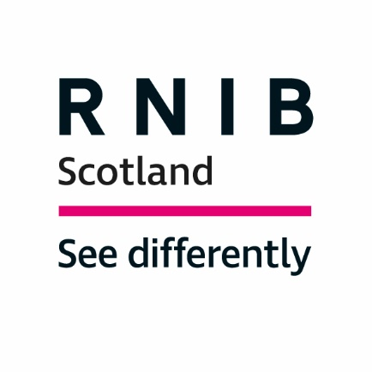

Royal National Institute for Blind People (RNIB) Scotland

Response to the Scottish Government Call for Evidence on "Review of Mental Health Law in Scotland"

Introduction

The Royal National Institute of Blind People (RNIB) Scotland is the country’s leading charity working with blind and partially sighted people. We support children and adults with sight loss and help them to live full and independent lives, campaigning for their rights.

In 2010, the date of the most recent figures published by the Scottish Government, the number of people registered as blind or partially sighted in Scotland was reported to be 34,492. Research suggests that around 10 per cent of eligible people do not register making the true figure closer to 40,000. A further 170,000 people in Scotland are estimated to have significant sight loss and this figure could almost double between now and 2030 due to increases in the elderly population and a variety of health factors.

RNIB Scotland welcomes the opportunity to respond to this consultation on the Review of Mental Health Law in Scotland. Providing accessible information about individuals rights under the Mental Health Law is essential for our customers whom use our social work and care services.

RNIB Scotland considers it important to ensure that people with sight loss, whom may also have a learning disability and/or complex needs, are considered when adapting services and/or the Mental Health Law about their individual rights.

Our response to the consultation is based on previous RNIB/RNIB Scotland surveys, public consultation responses, literature review and specific consultation for this response.

Question 1: The Mental Health (Care and Treatment) (Scotland) Act 2003 (“the Act”) came into force in 2005 – how well does it work at the moment?

Within the Review, it emphasises the importance of "how well the Act helps people to get the right care, treatment and support". RNIB Scotland has a social work and Visual Impairment and Learning Disability (VILD) service, working with blind and partially sight people who fall under the Adults with Incapacity (Scotland) Act 2000. In most cases, these individuals have dementia, a congenital or acquired brain injury and some may have a mental health disorder - however, it is important for us to raise the accessibility rights of people with sight loss who may require assistance under the Act.

Under the Patient Rights (Scotland) Act 2011 it states, "You have the right to be given information about your care and treatment in a format or language that meets your needs". With around 170,000 people in Scotland living with significant sight loss, the need for accessibility is high.

Our three VILD services, across the central belt of Scotland, work closely with Health and Social Care Partnerships (HSCPs) to adapt documents for people who have a learning disability and/or complex needs, including health passports which help if/when individuals are admitted to hospital.

We are pleased that a Human Rights based approach is being conducted throughout this Review. Accessible information allows people with a visual impairment to better manage their health and wellbeing while supporting independence. These apply to Human Rights legislation that no matter where you are from, what you believe or how you choose to live your life you have, "The right to live independently in the community", and "The right to private and family life".

In addition, the "Keys to Life Strategy" (Scottish Government and COSLA) is a key resource for our VILD service, ensuring that people with learning disabilities are treated with dignity, respect and understanding. VILD adheres to guidance from "Keys to Life" to consult and plan with customers and their families in order to support choice, control and positive mental health.

For further information please contact:

Dr Catriona Burness
Parliamentary and Policy Manager, RNIB Scotland
catriona.burness@rnib.org.uk

Laura Jones
Senior Policy Officer (Health and Social Care)
laura.jones@rnib.org.uk

A National Statistics Publication for Scotland: Registered Blind and Partially Sighted Persons, Scotland 2010, Scottish Government, 2010.
The Cost of Sight Loss Scotland: 2010-2020, RNIB Scotland, 2011. Community care and mental health services for adults with sensory impairment in Scotland; Scottish Executive 2006. The economic impact of partial sight and blindness in the UK adult population; Access Economics for RNIB, 2009.
Adults with Incapacity (Scotland) Act 2000, Scottish Government, https://www.gov.scot/publications/adults-with-incapacity-act-principles/
Patient Rights (Scotland) Act 2011, Scottish Government, http://www.legislation.gov.uk/asp/2011/5/contents
Keys to Life 2019-2021, Scottish Government and COSLA, https://keystolife.info/

