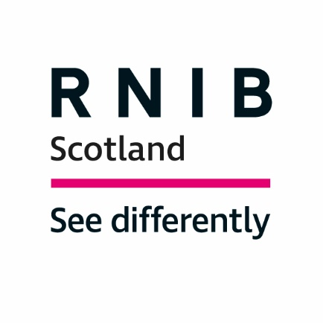

Observatory for Sport in Scotland
Brief for a Disability Sport Research Review - Draft, February 2020
Response from the Royal National Institute of Blind People (RNIB) Scotland

The Royal National Institute of Blind People (RNIB) Scotland is the country’s leading charity working with blind and partially sighted people. We support children, young people and adults with sight loss and help them to live independent lives.

RNIB Scotland welcome this research as we believe it is much needed. In a recent presentation to the Cross Party Group for Disability on Sport for All, RNIB Scotland highlighted Physical Education for children and young people with disability. This links well with the Government Active Scotland framework particularly in relation to the outcome – "We develop physical confidence and competence from an early age."

The presentation highlighted a paper produced by Scottish Disability Sport ("Included or Not?") carried out in one local authority which found only seven per cent of the mainstream pupils reach the recommended level of PE of two hours/week. The presentation went on to look at the reasons, impact and possible solutions. Following this meeting the CPG Convener undertook to write to the Scottish Government with several asks including the need for further research in this area.

The Disability Sport Research Review draft would benefit from considering Physical Education for children and young people with disability especially as a lack of involvement at an early stage will impact on the ability to access disability sport at community level. This is due to not having the opportunity to learn basic skills at the appropriate stage, feeling excluded and thinking sport is not for them.
RNIB have also asked that training for PE and Primary teachers is improved in relation to inclusive practice when teaching PE. This training is also required by coaches and instructors in all sports. Scottish Disability Sport are working with some governing bodies in sport to deliver such training although this requires government support to be expanded and increased.

Physical education can improve the physical and mental wellbeing of all children and young people, but it has added benefits for children and young people with a visual impairment. Through physical education children with sight loss can improve their mobility, gain self-confidence and awareness of their physicality and develop peer to peer support skills and communication skills. It is particularly important that children and young people with a visual impairment have the opportunity to develop these skills as their sight loss can create barriers which makes learning these skills naturally more difficult.

I would be interested in commenting on the draft report when it is available and would be happy to meet to discuss any issues raised in this response further.

Anne Marie Fleming
CYPF, Education and Transitions Lead, RNIB Scotland
E-mail: AnneMarie.Fleming@rnib.org.uk

