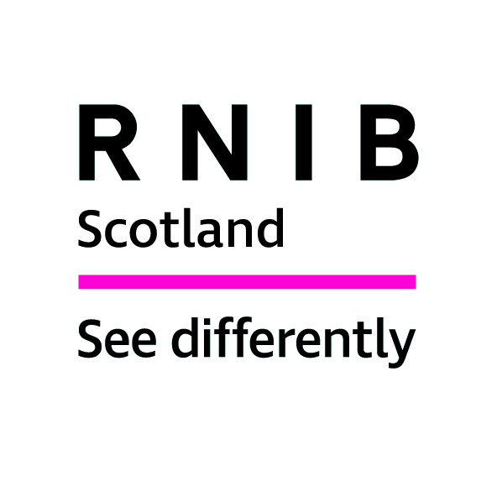

Royal National Institute of Blind People (RNIB) Scotland

Response to the Scottish Parliament Health & Sport Committee Call for Evidence on ‘COVID-19 Testing’

Introduction
The Royal National Institute of Blind People (RNIB) Scotland is the country’s leading charity working with blind and partially sighted people. We support children and adults with sight loss and help them to live full and independent lives, campaigning for their rights.

In 2010, the date of the most recent figures published by the Scottish Government, the number of people registered as blind or partially sighted in Scotland was reported to be 34,492. Research suggests that around 10 per cent of eligible people do not register making the true figure closer to 40,000. A further 170,000 people in Scotland are estimated to have significant sight loss and this figure could almost double between now and 2030 due to increases in the elderly population and a variety of health factors.

RNIB Scotland welcomes the opportunity to respond to this consultation on COVID-19 testing from the perspective of blind and partially sighted people. Access to accessible health information, not only provides essential advice, it also allows for informed and independent decision making.

RNIB Scotland considers it vital that people with a visual impairment have access to accessible COVID-19 testing information and kits.
The consultation poses two questions - we have focused on question two in our reply based on previous RNIB/RNIB Scotland surveys, public consultation responses, literature review and specific consultation for this response.

Question 2: What do we need to deliver this?
RNIB Scotland would like to make general comments relating to COVID-19 Testing under the following headings:

- Accessible information
- Self-referral portal
- Home testing

Accessible information
As UK and Scottish Government, health officials and businesses grapple with the spread of coronavirus, the outbreak highlights the importance of effective and accessible communication, so everyone knows how to keep themselves and the community safe.

There are 170,000 people with significant sight loss in Scotland. It is therefore essential that information and guidance about COVID-19 testing, is accessible, giving it the best chance of reaching those at high risk from the virus.

"Accessible health information is giving information in a way that is accessible to as many people as possible".

People rely on good communication to ensure that they understand their health information and needs, as well as being able to make informed choices and act independently. For most people this is achieved through printed information, but for a person with sight loss, printed information is often inaccessible.

Advancements in supportive technology now allow people with a visual impairment to scan text and use screen reading software to announce content using a synthesiser. This has allowed some independent access to information. However, access to supportive technology should not be taken for granted as not everyone has this support and equipment can be costly. For example, the current version of JAWS Home screen reading software for people with vision loss costs £699 and ZoomText screen magnifying software costs £575.

Self-referral portal
Accessing information online can provide blind and partially sighted people with valuable healthcare advice and empower them to better manage their health and wellbeing while supporting independent living. As more of our public services move online, digital inclusion has become more necessary than ever before.

However, a digital divide exists in Scotland. This is partially due to geographic barriers with around 25 per cent of rural households experiencing poor broadband speed. Levels of digital uptake can be significantly lower for people with disabilities. Accessing online information, for example, filling in forms online, can be very time consuming or completely inaccessible. Visual barriers such as inconsistent font sizes prevent blind and partially sighted people from accessing information with ease.

We welcome additional options in accessing the self-referral portal, and we could assist with ensuring these are produced in the most effective way, including working with the Scottish Government on solutions using smartphone apps and other assistive technology.

Home testing
Around 170,000 people in Scotland have significant sight loss. Being able to access and understand the guidance about testing is essential.

RNIB's Helpline and sight loss advice service is being approached by visually impaired people, who need to be tested and are facing barriers to getting a test. This includes concerns about not receiving the testing kit in a timely fashion and being told by their GP or local health provider that it is not possible for them to complete the test unaided. It is more important than ever that we find a way to remove barriers to testing for these and all people with sight loss.

Providing a choice of accessible instructions to complete the home testing kit is essential to allow for testing to be carried out independently and effectively. For example, Braille instructions could be a partial solution but there really should be other alternative formats available - an audio only version, large print and online instructions would also be needed.

In England, the Department of Health and Social Care may trial tests being administered at home by a health worker or GP. We would welcome making this option available in Scotland.

It is crucial that people with a visual impairment are considered when making tests available for key workers and those symptomatic within their households, as they may contain people who have sight loss.

As we approach the next phase of coming out of lockdown, providing accessible information and COVID-19 testing kits will play an important part in ensuring that the Scottish Government has an effective testing regime in place to combat this virus.

To sum up, we underline the need for accessible information and testing kits and hope that the option of trial tests administered at home by a health worker or GP will be made available in Scotland.

We would like to ask:

- What steps is the Scottish Government taking in ensuring that alternative self-referring options are available? For example, how do people request a test if they do not have access to a computer?
- Is there a phone line that individuals can call to request a test?
- What accessible formats are available for the home testing kit, including the step by step guide and online video?
- How are these accessible formats being publicised?
- If home tests are not available due to demand and you do not have access to a car to be taken to a drive-through testing centre by a household member, what options for testing are available for people with sight loss?

For further information please contact:
Dr Catriona Burness
Parliamentary and Policy Manager, RNIB Scotland
catriona.burness@rnib.org.uk

Laura Jones
Senior Policy Officer (Health and Social Care)
laura.jones@rnib.org.uk

A National Statistics Publication for Scotland: Registered Blind and Partially Sighted Persons, Scotland 2010, Scottish Government, 2010.
The Cost of Sight Loss Scotland: 2010-2020, RNIB Scotland, 2011. Community care and mental health services for adults with sensory impairment in Scotland; Scottish Executive 2006. The economic impact of partial sight and blindness in the UK adult population; Access Economics for RNIB, 2009.
Accessible Health Policy, NHS Health Scotland, 2018 http://www.healthscotland.scot/media/1606/accessible-information-policy-v30.pdf
Screen reading software, Technology resource hub, RNIB https://www.rnib.org.uk/practical-help/technology/resource-hub
Low Vision Software, Sight and Sound Technology
Spreading the benefits of digital participation, The Royal Society of Edinburgh, April 2014 http://www.rse.org.uk/wp-content/uploads/2016/09/Digital-Report-High-Res-EQ5.pdf
Superfast broadband for Scotland, Audit Scotland 2018 http://www.audit-scotland.gov.uk/uploads/docs/report/2018/nr_180920_broadband.pdf
Op cit, The Royal Society of Edinburgh.
Ibid.

