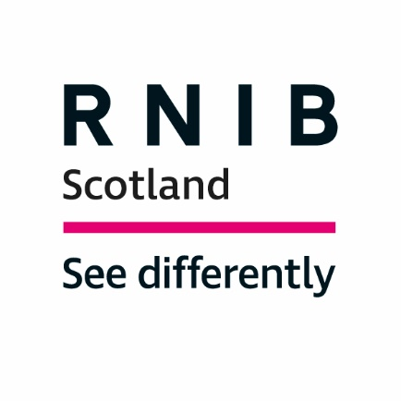

Dear Ms Lamont,

The Royal National Institute of Blind People (RNIB) Scotland is the country’s leading charity working with blind and partially sighted people. We support children, young people and adults with sight loss and help them to live independent lives.

Through our work with blind and partially sighted children and young people we are aware of the breadth of experiences children and young people can have moving on from school – both positive and negative - and fully understand the need to identify solutions to the problems children and young people with disabilities can face transitioning from secondary education.

As well as moving on from secondary education, there are other crucial transition points in a young person’s life that should also be considered under the umbrella of transitions. Namely the move from home to education and the move from primary to secondary education. We believe that a universal plan beginning when a child is moving into primary school, accompanying them as they transition to secondary school and then out of secondary school is vital and would have a wider benefit if applied to all pupils. We also believe that transitions should be looked at holistically evaluating the support which should be provided to the young person, parents and guardians, siblings and school, college and university staff involved in the transition. Most importantly any work in this area should build on existing work and good practice in order to avoid re-treading old ground.

Blind and partially sighted children and young people face a variety of challenges transitioning into adulthood including living independently, accessing information and communicating easily, developing self-confidence and settling into a new environment. Most of these challenges are faced by all young people transitioning into adulthood. However young people with a visual impairment require additional input to help build the skills needed to tackle these challenges. These skills are vital to a successful transition and should be developed throughout a child’s life. These skills can include:

- Braille literacy
- Mobility
- Communication skills
- Independent living

We believe therefore that a plan should be put in place much earlier than at 14 years old. A plan should be created for all children and young people when they are entering primary education. This would ensure that no child’s support needs were missed and would help normalise planning making it a standard part of a child’s education rather than an extra piece of work only for children with diagnosed additional support needs. We believe that linking the support needs of a child to a diagnosed condition risks missing out children who require support but who don’t have a diagnosis.

If a child is identified as needing more support than they are already receiving, extra input from a Qualified Teacher of children and young people with a Vision Impairment (QTVI) may be required. The earlier the child receives this input the easier it is to learn the independent living skills that are important for a successful transition out of secondary school. Any planned additional input into a child’s education should be formally recorded and available to be viewed by the young person and parents and guardians. This would make it clear to all parties what input they can expect in future.

As well as additional input to develop independent living skills children and young people also need support to access the curriculum and realise all the opportunities education has to offer. The attainment gap between students with sight loss and students with no additional support needs is stark. In 2017/18:

- Just under 1 in 50 pupils (1.8 per cent) with no additional support needs did not obtain at least one National 4 qualification. Just under 1 in 5 pupils (19.3 per cent) with a visual impairment did not achieve the same level.
- 92.2 per cent of pupils with no additional support needs achieved at least one National 5 qualification in 2017/18. 64 per cent of pupils with a visual impairment achieved at least one National 5 qualification. This is an attainment gap of 28.2.
- 71.3 per cent of pupils with no additional support needs achieved at least one Higher qualification. 40.2 per cent of pupils with a visual impairment achieved at least one Higher qualification. This is an attainment gap of 31.1.
- 24 per cent of pupils with no additional support needs left school with at least one Advanced Higher. This is almost double the percentage of pupils with a visual impairment who left school with at least one Advanced Higher (12.9 per cent).

There is no reason why, with adequate support, young people with sight loss shouldn’t be achieving at the same level as their peers with no additional support needs.

Lower attainment has a knock-on effect on employment prospects, narrowing the number of jobs and opportunities open to young people with sight loss. The employment rate for blind and partially sighted people is significantly lower than the employment rate for the general population at 26 per cent compared to the 81 per cent employment rate for the general population quoted in the consultation document.

Whilst we support the intention behind the proposal to make a transitions plan a statutory right, we think that it is unnecessary.

We support a universal plan for all children and young people in education which encompasses the three most crucial transition points in a young person’s life - entering primary school, entering secondary school and leaving secondary school. We support a plan being extended up until the age of 26 but acknowledge that the need for this will depend on the individual young person. Young people over the age of 18 should therefore be able to opt out of the plan if they no longer feel they require or want the support. All young people should have ownership over their plan, they should be aware of what is in it, when it is to be reviewed and the purpose of the plan. It should be reviewed annually but the child or young person should be able to have access to it on request at any time.

A National Transitions Strategy should consider existing work including:

- Work to reconsider sections 4 and 5 of the Children and Young People (Scotland) Act 2014
- Establishing a strategic leads network on transitions
- Identification of data gaps in transitions
- Raising awareness amongst parents and guardians of support available and positive destinations for their child on leaving school
- Work by ARC Scotland to embed the seven Principles of Good Transitions

It should be created in partnership with children and young people and their parents and guardians. It should also approach transitions holistically, looking at how all individuals and organisations involved in a transition can be supported to achieve the best result for the child.

We support the intention behind creating a Minister for transitions and recognise the benefits it would bring in putting transitions on the agenda and giving it a governmental focus. However, we suggest that this is broadened out into a Minister for Disability (Children, Young People and Adults) role which would include a remit over transitions as well as factors that can affect transitions.

We would be delighted to talk with you further about any issues raised in this response.

Yours,

Anne Marie Fleming
Education, CYPF and Transitions Lead
AnneMarie.Fleming@rnib.org.uk

Cate Vallis
Policy and Campaigns Officer
cate.vallis@rnib.org.uk

