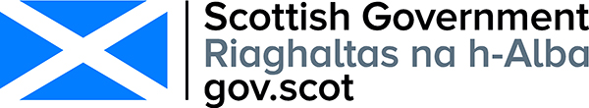
Respondent Information Form

Consultation on the new national public health body ‘Public Health Scotland’
Please Note this form must be completed and returned with your response.
Are you responding as an individual or an organisation?
Individual
x Organisation
Full name or organisation’s name
Royal National Institute of Blind People (RNIB) Scotland
Phone number
0131 652 3140
Address
RNIB Scotland, 12 - 14 Hillside Crescent, Edinburgh

Postcode
EH7 5EA

Email
catriona.burness@rnib.org.uk
Information for organisations:
The option 'Publish response only (without name)’ is available for individual respondents only. If this option is selected, the organisation name will still be published.
If you choose the option 'Do not publish response', your organisation name may still be listed as having responded to the consultation in, fr example, the analysis report.

The Scottish Government would like your
permission to publish your consultation
response. Please indicate your publishing
preference:

x Publish response with name
Publish response only (without name)
Do not publish response
We will share your response internally with other Scottish Government policy teams who may be addressing the issues you discuss. They may wish to contact you again in the future, but we require your permission to do so. Are you content for Scottish Government to contact you again in relation to this consultation exercise?
x Yes
No
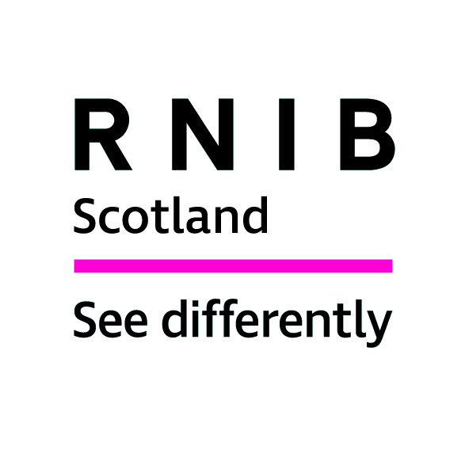
Royal National Institute of Blind People (RNIB) Scotland Response to the Scottish Government Consultation on ‘A new National Public Health body: ‘Public Health Scotland’’

Introduction

The Royal National Institute of Blind People (RNIB) Scotland is the country’s leading charity working with blind and partially sighted people. We support children and adults with sight loss and help them to live full and independent lives, campaigning for their rights.

In 2010, the date of the most recent figures published by the Scottish Government, the number of people registered as blind or partially sighted in Scotland was estimated to be 34,492. Research suggests that around 10 per cent of eligible people do not register making the true figure closer to 40,000. A further 130,000 people in Scotland are estimated to have significant sight loss and this figure could almost double between now and 2030 due to increases in the elderly population and a variety of health factors.

RNIB Scotland welcomes the opportunity to respond to this consultation as public health is integral to the lives of blind and partially sighted people.

The public health landscape is ever-changing, so clear, accessible health information is needed to allow people with sight loss to take control of their eye health.

RNIB Scotland wants to ensure that people feel empowered and enabled to make their own decisions that impact on their lives. Yet blind and partially sighted people face barriers every day, as we demonstrate in this consultation response, so it is even more important for the Scottish Government to aspire to create a new National Public Health body that can ensure sufficient information and awareness of healthcare for blind and partially sighted people.

The consultation poses wide-ranging questions; to highlight key points relating to sight loss we have replied to Question 15, under Chapter 9: Data science and innovation. The replies are based on previous RNIB/RNIB Scotland surveys, public consultation responses, literature review and specific consultation for this response.

RNIB Scotland responses

Chapter 9: Data science and innovation

Question 15: ‘What are your views on the arrangements for data science and innovation?’

Accessible Health Information

Patients rely on good communication to ensure that they understand their health information and needs. For most people this is achieved through printed information, but for a person with sight loss, printed information is often inaccessible.

Managing blind and partially sighted people’s requests for accessible formats, in a timely and consistent manner, creates clear communication and understanding between the individual and the health service. It can also prevent any unnecessary delays that could lead to a greater risk of sight deterioration for patients.

The Patient Rights (Scotland) Act 2011 and its accompanying Charter of Patient Rights and Responsibilities set out that, ‘You have the right to be given information about your care and treatment in a format or language that meets your needs.’

This requires each Health Board to be responsible for ensuring that ‘all NHS Health Scotland staff is aware of the level of accessibility [to] … adhere to when producing information products'.

Today, people with sight loss are still misinformed about accessible options available to them, not giving them the opportunity to say which accessible format they require from the very beginning of their healthcare journey.

Unless a robust central patient information system logs patients’ requirements and requests, blind and partially sighted people will continue to receive inaccessible documents, leading to devastating consequences, for example, missing important eyecare appointments or information about eye conditions that are irreversible and potentially life threatening.

Eye condition statistics

In 2010, the date of the most recent figures published by the Scottish Government, the number of people registered as blind or partially sighted in Scotland was estimated to be 34,492. Research suggests that around 10 per cent of eligible people do not register making the true figure closer to 40,000. A further 130,000 people in Scotland are estimated to have significant sight loss and this figure could almost double between now and 2030 due to increases in the elderly population and a variety of health factors.

As of 1 April 2018, sight loss registration in Scotland changed with the introduction of the new Certificate of Vision Impairment (CVI) Scotland form. This replaced the BP1 form. The CVI form does not include children and young people under the age of 16 years. Instead, arrangements for supporting them follow the Visual Impairment Network for Children and Young People (VINCYP) Pathway.

As ISD Scotland becomes a core element of the new National Public Health Body ‘Public Health Scotland’, RNIB Scotland would like to see further advances in collating data and statistics about eye conditions and ophthalmology demands on NHS Scotland.
This should include annual publication by ISD Scotland of:

- The numbers of those registered as blind and partially sighted under the previous registration system;
- Those over-16 registered under the new system from April 2018; and
- Those under-16 recorded on the VINCYP pathway.

This will overcome the current data shortfall and enable local service provision and the health sector to plan ahead of potential increasing demands.

Digital adaptations

It should be noted that like other public sector bodies, Public Health Scotland will be subject to new legislation on web accessibility.

The Public Sector Bodies (Websites and Mobile Applications) (No. 2) Accessibility Regulations 2018 implemented the EU directive on the accessibility of the websites and mobile applications of public sector bodies into UK law. There are three future compliance deadlines:

- September 23 2019 – all new websites and apps published after this date will become subject to the directive;
- September 23 2020 – all websites published before 23 September 2018 will become subject to the directive;
- September 23 2021 – all mobile apps will become subject to the directive.

Listening to people’s experiences of accessible websites is a simple and inclusive way of identifying changes needed to ensure online information is accessible to all. It is important to carry out testing with end-users who use health services. Checking for potential accessibility issues during web-building ensures that accessibility issues have been considered.

Digital adaptations to healthcare are advancing in Scotland. In the future this could reduce the need to attend physical appointments. There is an opportunity for blind and partially sighted people to be involved in future discussions about creating a fully accessible digital healthcare service.

For further information contact Catriona Burness, Parliamentary and Policy Manager, RNIB Scotland on catriona.burness@rnib.org.uk

A National Statistics Publication for Scotland: Registered Blind and Partially Sighted Persons, Scotland 2010, Scottish Government, 2010.
The Cost of Blindness Scotland: 2010-2020, RNIB Scotland, 2011. Community care and mental health services for adults with sensory impairment in Scotland; Scottish Executive 2006. The economic impact of partial sight and blindness in the UK adult population; Access Economics for RNIB, 2009.
A National Statistics Publication for Scotland: Registered Blind and Partially Sighted Persons, Scotland 2010, Scottish Government, 2010.
The Cost of Blindness Scotland: 2010-2020, RNIB Scotland, 2011. Community care and mental health services for adults with sensory impairment in Scotland; Scottish Executive 2006. The economic impact of partial sight and blindness in the UK adult population; Access Economics for RNIB, 2009.
See https://www.rnib.org.uk/scotland-how-we-can-help/helping-children-and-young-people
https://www.gov.uk/guidance/accessibility-requirements-for-public-sector-websites-and-apps
Website accessibility, RNIB https://www.rnib.org.uk/rnib-business/website-and-apps/website-accessibility
Scotland’s Digital Health and Care Strategy: enabling, connecting and empowering https://www.gov.scot/publications/scotlands-digital-health-care-strategy-enabling-connecting-empowering/pages/3/

