Working with the RNIB Careers site

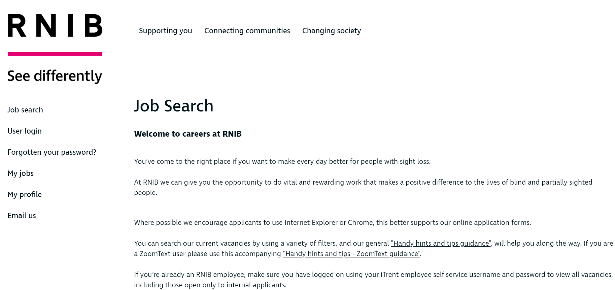
Figure 1: Job Search Page

General information

The hints and tips guides contains information we feel will help you to complete the application form. This includes advice for the use of assistive technologies e.g. screens readers and magnification. The completing the Application Forms section is primarily designed for applicants using screenreaders(i.e JAWS). Zoomtext users may wish to go straight to page 6.

If you have any queries regarding the Application form please contact us using the details below:

The Resourcing Team
resourcing@rnib.org.uk

The Starting point

Logging in and out

- Login by using your provided login details i.e. username and password. TAB to USER LOGIN and activate. Then TAB down to Username and Password and fill these in. TAB to and Activate Login.

Searching for roles
The system allows you to search for full or part-time roles across different pay grades and locations. After you have logged in, do the following:

1. Activate the Job Search link.
2. The page contains different headed sections. The type of search you need to perform will determine what choices you need across the three sections:
TAB to each section and use up/down arrows to navigate.

- Job Title: If you know the type of role or even the title of a role, you can use the edit field in this section to input that search information. Salary Band: You can move into the list of different salary bands here and choose one, or block out several lines, to run a search across multiple ranges.
- Region: Use the list here to select one, or several, regions.
- Job category/type: You can set the options in this list to display roles under certain categories such as ‘fundraising’ and ‘Education’.

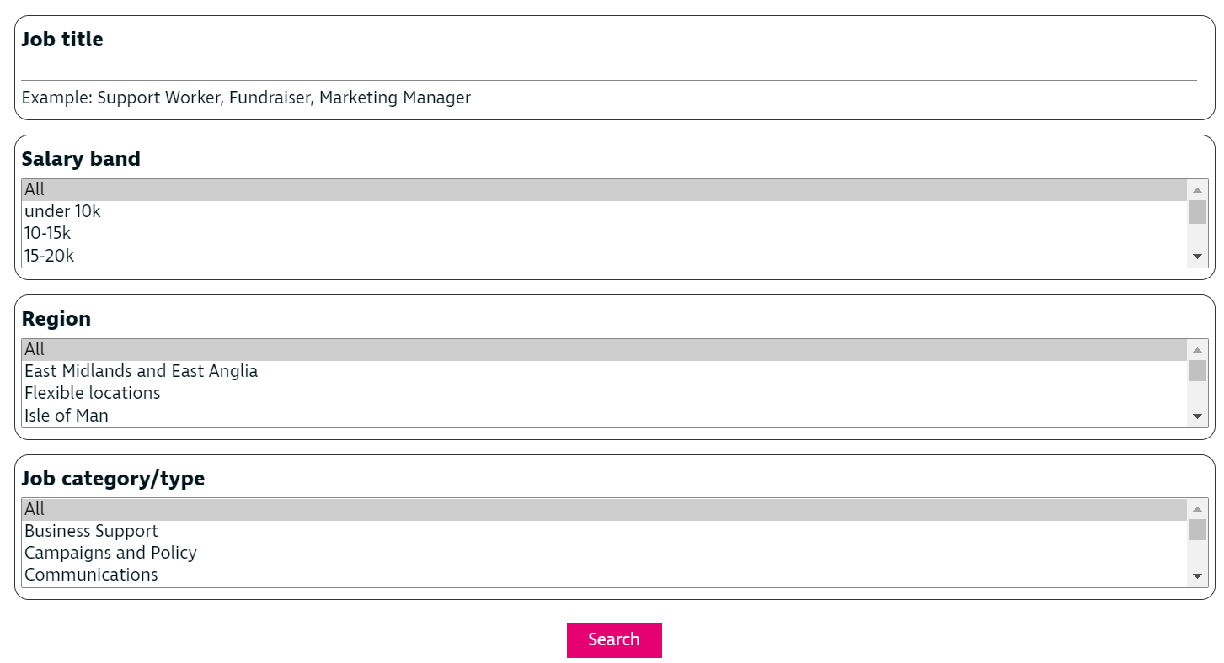
Figure 2: Jobs search Menus

3. When you have set all the options you require, move to the Search button and activate it.
4. A results page will appear with each role in its own headed section. Activate Apply online in the headed section of the job you wish to apply for.

Screening Questions

On the Screening questions page, TAB to the relevant radio button and SPACE to activate it. Then activate CONTINUE.

Application Summary Page

On this page is the sections you will need to complete, followed by the submit button you will activate once you have completed all sections and return to this page. TAB to and activate the Personal Details link.

Depending on requirements, online applications may differ due to the relevant safeguarding and compliance regulations specific to that role. While there may be small variances in terms of questions, the forms generally require the same pages completed. The list of main section areas is as follows:

- Personal Details
- Qualifications and Professional Memberships
- Current Employment and Career History
- References
- Supporting Information
- Additional Information
- Equality Information
- Disclaimer and Declaration

You must make sure that you complete all the fields in each section before selecting next. Mandatory fields in the application form are marked visually with a blue dot and, if you are using a screen reader such as JAWS, “required field” will be announced on focus. You cannot move on to the next stage if certain required fields have not been completed.

Each section of the form can be completed in stages and stored – you are able to save and edit your application at any point prior to submission.

After completing each section you will need to activate the icon. (Described as “Next” in screenreaders. ) Once you have reached the end of all sections you no longer have a next button. You will have the options Previous and Summary. Activate Summary, and then once back in the summary page TAB down and activate SUBMIT.

Tips for completing the application form
Here are a few useful tips to remember when you are working in RNIB Careers system:

- You can complete each section of the form in stages.
- You can save and edit your application at any point before submission.
- You can cut and paste content from other documents into the sections of the form or type information straight in.
- If you’re typing directly into the form please make sure you save your work at regular intervals to avoid any “time-outs” or PC crashes.
- When you activate the Next option at the bottom of each section your work will be saved.
- Use the Next and Previous buttons in the pages to move through the whole form.
- You can review your overall progress by activating the Summary button.
- You can preview your application and save a copy before you submit it to check for any errors or omissions.

While you can type everything in to each of the pages directly and in order, a more effective strategy is to create your text elsewhere (in MS Word for example) then copy and paste it in to the application form when it is ready.

When preparing to complete your application, make sure you have the key information to hand before you start. Information that is required as part of the application process includes:

- Qualifications: You need to enter Dates and grades. RNIB does not require your place of learning for GCSE’s or ‘A’ Levels.
- Employment History: Details of previous employment, including job title, duties etc.
- Referees: Typically, two referees are required. You need to include their contact details - email and postal address.

General information for applicants using assistive technology
The RNIB Careers site has been thoroughly tested with different speech and magnification tools. This section covers a few general approaches and strategies that someone using speech and magnification software can apply.

Screen readers

JAWS
In the RNIB Careers pages you will mainly be using the typical keyboard approaches using the Tab and arrow keys as necessary. Some additional controls are:

Next item – Tab
Previous item - Shift+Tab
Select item – Enter
Space - Select Radio Button/tick box.
Expand drop down list - Enter
Select next/previous drop down list item - Down Arrow/Up Arrow
Collapse filter drop down list - s
Go Back to previous Page/Section - Delete/Backspace

If you are using JAWS, this will mean using forms mode when required to input text or change options. By default, JAWS runs in auto-forms mode so when focus is on an input field (edit or combo box for example) you will hear a popping sound indicating that virtual cursor mode is off and forms mode is on. Always bear in mind that you can only type text into a field in a web page if the default virtual cursor mode is off.

Using Zoomtext
With Zoomtext (or any other mainstream magnification tool) always take a few moments to orientate yourself in each page – the layout of our application forms is very consistent. As mentioned previously, make sure the browser window is maximised so that all the left-hand options appear on screen then pass over the page content a few times so that you understand the layout.

You should find that any Zoomtext focus highlighting or cursor enhancements are displayed as you would expect in and around any fields in focus. These techniques are especially useful if you are using the keyboard only to move through the content of each page. Zoomtext hotkeys to toggle these features on and off are as follows:

Zoomtext V10 focus/cursor
- Focus enhancements on and off: Control Shift O
- Cursor enhancements on and off: Control Shift R

Zoomtext V11/2020+ focus/cursor
- Focus enhancements on and off: Capslock F
- Cursor enhancements on and off: Capslock R

If you are moving in the pages using the keyboard only, your main Windows keystrokes you will be Tab and Shift Tab keys as usual. To activate options such as links, buttons and checkboxes when necessary you will also use the standard Enter and Spacebar keys.

If you are using the mouse to move around, you will generally be following a pattern of slowly working down the screen. Remember that you can get an overall sense of the page by zooming in and out quickly in Zoomtext by holding down the Control key and scrolling your mouse wheel up and down. Alternatively, you can zoom in and out with the keyboard in the following way:

Zoomtext V10 mag level
- Increase magnification level: Alt Numberpad Plus key
- Decrease magnification level: Alt Numberpad Minus key

Zoomtext V11/2020+ mag level
- Increase magnification level: Capslock Up Arrow
- Decrease magnification level: Capslock Down Arrow

Near the bottom of each page you will find important buttons: Previous, Next and Summary. Remember that when you activate the Next button, your work is saved. The Summary button returns you to the main home page which contains a list of links to skip to each page of the application specifically. It is also where you can monitor your overall progress towards the completion of the form. Using the Summary page in this way is useful - you may not be completing the form sections in order.

Narrator, Zoom options, high contrast.
If you are working in Windows 10 with Narrator, RNIB Careers is approached in the same fashion as other websites. In Narrator you can turn the scan mode on and off as required (Capslock Spacebar) and use the TAB and Shift Tab keys to move between fields. As with any other assistive technology, take time to explore the page first and build up a bigger picture.

If you are using built-in program zoom options (instead of, or in addition to, magnification software) please bear in mind that when you increase the program zoom the left-hand vertical task pane (which contains the main system links such as Job Search, User Login and so on) will disappear. Instead, you will need to activate the button icon with three lines, located near the top left of the page:

Figure 3: Menu Button

If you are using the keyboard, Tab to the button and activate using the Spacebar. Doing this will allow you to Tab through the Job Search, User Login, Forgotten Your Password, My Jobs etc. fields and activate as necessary.

1. If you use a high/reverse contrast mode these settings will be reflected across the system. However, if you do experience specific issues concerning colour (or any other usability issues across the system) then please email using the addresses provided.

Figure 4: High Contrast Mode

Filling in the application form
As mentioned earlier, there may be small variations in questions, but the general information required in the form is the same. The main sections in general are as follows:

Right to work in the UK
Contains the ‘What is your right to work status?’ drop down option. You must complete this before starting your application.

Depending on the Application, you may also need to state if you an existing RNIB Employee.

Personal details

Address details
Note that you can supply more than one address using this form however you must tick the Mailing Address checkbox to indicate the current/main address that needs to be used for any correspondence relating to your application. You do not need to use the save button in this section – it will save when you select next.

The Application form can experience issues when you have an address saved in the menu but not the main section which is mandatory. Where this is the case the address details will read as blank.

When this is the case, please TAB to the three dots(described by Screenreaders as “Address Main Menu”) use spacebar to ACTIVATE, TAB once and Activate edit.

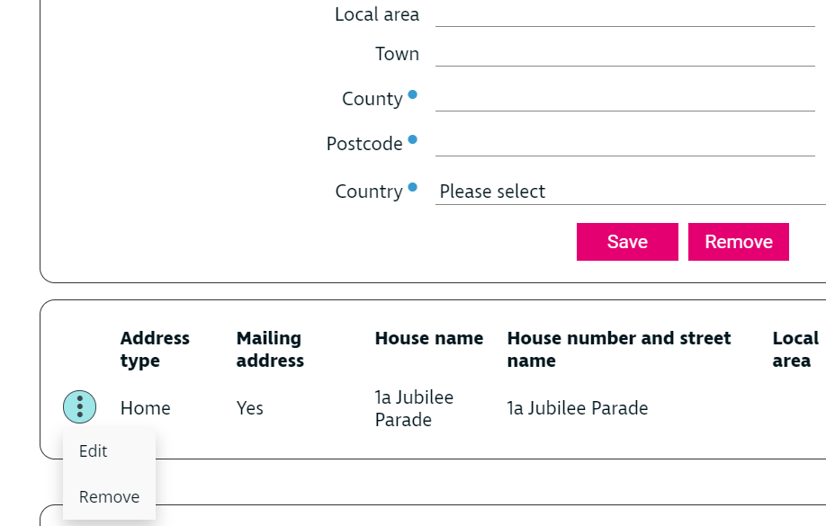
Figure 5: Edit Address

This will bring your address into the main section. Check that all fields have been completed. Then click Save. This will ensure that you do not have duplicate Addresses on the Application form, causing the form to bring back an error message. It will be necessary to do this for other sections where you already have details saved in the Menu but they do not appear in the main section.

Screen reader tip
When using a screen reader, complete the fields in order and save the entry in the page. You then need to navigate through what you have just saved to move on to the next area. If you have made a mistake with any previous details stored, there is an associated edit button next to the already stored details that you can access.

Qualifications and Professional Memberships
Note that the place of learning field should only be completed for third level education - place of learning is not required for GCSEs or A levels. Also, if you are unsure of any of the exact study dates, use the 1st of the month instead. Finally, if your grade is not available to select, choose the Qualification Level Other.

The qualifications page operates in the same way as the address fields on the personal details screen. Complete the fields per qualification, saving each time.
NOTE - Once you have saved the information you will be presented with a screen to enter further qualifications. The previous information you have entered has been saved. You will be informed of this when the screen is re-presented to you. The previous information entered is displayed at the bottom of the screen. Dependant of the type of device and screen resolution you use you may not be able to see the information until you move down the page. When you do this if you need to correct the information activate the corresponding Edit button.

Screen reader tip
When using a screen reader, complete the fields in order and save the entry in the page. You then need to navigate through what you have just saved to move on to the next area. If you have made a mistake with any previous details stored, there is an associated edit button next to the already stored details that you can access.

Current Employment and Career History
Once you have saved the information you have input will be presented with a screen to enter further qualifications. The previous information you have entered has been saved. You will be informed of this when the screen is re-presented to you. The previous information entered is displayed at the bottom of the screen. Dependant of the type of device and screen resolution you use you may not be able to see the information until you move down the page. When you do this if you need to correct the information activate the corresponding Edit button.

Employment Start Date
If you enter employment history you must enter the start date. If it is your current position you do not need to enter the end date. The system does not validate if start and end dates overlap with other employment details. Please check your information before you submit. If you cannot remember the day you started your employment, current or previous enter the first day of the month you started.

Supporting Information page
This is an important section. It is your opportunity to secure an interview by demonstrating that you have the specialist skills, knowledge or experience for the role. Hiring managers will be making their decision on whether to interview you based on this section. You must attach a supporting statement to show how you meet the specialist knowledge, skills and experience selection criteria section (See section 1 of the person specification).

It is important that you describe how you meet each criteria in Section 1 by giving specific examples. It can be helpful to use the STAR method for your examples:

- S for situation (describe the situation)
- T for task (what was your task or role)
- A for action (what action(s) did you take and why)
- R for result (what was the outcome)

Additional details
Dependant on the role you are applying for we will ask you for additional information about your personal circumstances. Some of this will be relevant to you personally, i.e. do we need to make any personal adjustments to allow you to present yourself in the best way when you are interviewed.

Other information requested will be dependent on the role you have applied for e.g. in a care environment and will be critical to your application being taking forward to the next stage.

Equality Information
The information you supply will be used for monitoring purposes and only relevant information will be forwarded to line managers when a reasonable adjustment is required to allow us to support you through the recruitment process.

Disclaimers and declarations
This screen asks you to confirm you are willing for the information you have submitted to be used to assess your applicability to be interviewed for the vacancy. Use Space to select the tick boxes/radio buttons.

It also asks you to confirm the information you have submitted is accurate.

Closing dates and submitting
When your application is complete remember to use the Submit button. If your application is only saved and not submitted, the hiring managers will not have any visibility of your application.
After you submit your application a screen will confirm it has been successfully submitted, this message will also include your reference number. Note that once you submit your application you are no longer able to change it.

All job opportunities have a fixed closing date for applications to be submitted. You will be able to submit your application up until 11.59 pm on the published closing date. Once this date has passed, the role will not appear in the jobs page and you will not be able to submit an online application or see the job details. With the latter, make sure you download a copy of the job description to refer to later on if required.

Only the recruiting manager will see the final submitted form.
To request a copy of your application, use the ‘My jobs’ option on the left-hand side menu. Once in the ‘My jobs’ section, select the corresponding tick box and select 'Send'. A PDF attachment will be automatically emailed to your registered email address.

If you are shortlisted for interview, you will receive an email from RNIB taking you through the next steps.

These will be repeated in the workflow, but are also summarised below:

Login to the RNIB website as per the earlier instructions in the guide.
TAB to My Jobs

TAB to skip to Interviews
TAB to view and “book an interview date button”
Activate by pressing spacebar

Screenreaders reads "Click to select Date and Time, to activate press spacebar"
Tab and Alt-TAB to go through different times and dates
To activate a time and date Press Spacebar
You have now booked your interview, and will receive a further email confirming the time and date.

End of Document

