Stargardt disease
Stargardt disease is an inherited eye condition that affects your macula which is the tiny central part of your retina, the light-sensitive layer at the back of your eye. It causes a reduction in your central detailed vision, which is the vision you use when looking directly at something. For the majority of people with Stargardt, it doesn't usually affect your peripheral or side vision, so you don’t lose all your sight. Being diagnosed with Stargardt disease can cause great worry but with the correct information and support, people manage very well. Stargardt disease is also known as Stargardt macular dystrophy, juvenile macular dystrophy and fundus flavimaculatus.

What is the macula?
The macula is the small central area of your retina where the light entering your eye is focused. The retina is made up of cells called photoreceptors which are cells that are sensitive to light.

The macula is a specialised area that contains a high concentration of photoreceptor cells called cone cells. Cone cells work best in bright light and allow you to see fine detail for activities such as reading and watching television, as well as seeing colour. Therefore, the macula is very important and is responsible for:

- what you see straight in front of you
- the vision you need for detailed activities such as reading and writing, and
- your ability to appreciate colour.

Away from the central macula is the peripheral retina, made up of mostly the other type of photoreceptor called rod cells and some cone cells as well. Rod cells enable us to see in dim conditions and provide peripheral (side) vision outside of the main line of sight. The cone cells in the peripheral retina give peripheral vision in normal daylight conditions.

How does Stargardt disease affect your sight?
Stargardt disease is sometimes called a juvenile macular dystrophy as it can first appear in childhood. However, Startgardt disease can also begin in young adults and late adulthood.

At first, Stargardt disease can make your vision unclear or blurry. Things may sometimes appear distorted or wavy. You can have problems with your central, detailed vision which can make activities such as reading and recognising faces difficult. Your colour perception may also be affected. If you’ve had Stargardt disease for a number of years, then you may have a blank patch in the centre of your vision. This blank patch will not move and will always be in the very centre of your field of vision.

There are some forms of Stargardt that can affect your side or peripheral vision but for most people with the condition, it is the central vision that is affected. Since you use your peripheral vision when you’re moving around, most people with Stargardt disease can manage to continue getting out and about on their own.

Stargardt disease can also cause problems with light, such as glare and difficulties adapting to changing light conditions.

Some people who have lost a significant amount of vision because of Stargardt or another eye condition may experience visual hallucinations – they may see shapes, colours or figures that aren’t really there. This condition is known as Charles Bonnet Syndrome (CBS). You can find more information on CBS on our website www.rnib.org.uk/eyehealth, or by calling our Helpline on 0303 123 9999 to ask for a leaflet.

A diagnosis of Stargardt usually means that you will not be able to obtain a driver’s license to drive a car and it may affect some career choices that require a certain level of vision to be reached such as being a pilot, some areas of the forces, air traffic controllers, etc. However, people with sight loss are still able to have careers in a wide range of occupations and settings. Keeping this in mind can help you or your child plan any career choices for the future. You can ask your optometrist (optician) for more information about certain jobs and whether your child may be affected by this.

What causes Stargardt disease?
Stargardt disease is an inherited condition that is caused by a change or variation in one of our genes. In Stargardt, this variation in the gene leads to a build-up of a waste product, lipofuscin, and can eventually damage the cone cells in the macula.

When genes are identified they are given names usually made up of numbers and letters. The genes associated with Stargardt are ABCA4, ELOVL4 and PROM1. The gene responsible for most cases of Stargardt disease is ABCA4.

How are genes inherited?
All genes come in pairs and you inherit one of each pair from your mother and one of each pair from your father. Your genes determine the many things which make you an individual such as hair or eye colour.

There are a number of ways a genetic condition can be passed through genes. If Stargardt disease is caused by a variation in the ABCA4 gene, then it is inherited in an autosomal recessive pattern. If a variation in the ELOVL4 gene is responsible, then Stargardt disease is inherited in an autosomal dominant pattern.

Autosomal recessive
Most cases of Stargardt are inherited in a recessive pattern. A recessive condition can only be inherited when you get two variant genes, one from each parent. Therefore, both parents have to carry a variant gene. If your parents have one normal gene and one variant gene, they are carriers of Stargardt and their sight won’t be affected. This is because the “normal” gene compensates for the “variant” gene. If both your parents pass on their variant ABCA4 gene, then you have two of these variant genes, and will inherit Stargardt disease.

The diagram below shows the four possible ways in which a child can inherit the ABCA4 gene when their parents are both carriers of the gene. For each child these parents have:
- there is a 25% (one in four) chance that a child will inherit two “variant” genes, one from each parent, and they will be affected by Stargardt disease
- there is a 50% (two out of four) chance that a child will inherit one “normal” gene from one parent and one “variant” gene from the other; they will be a carrier of the condition
- there is a 25% (one in four) chance that a child will inherit two completely “normal” genes.

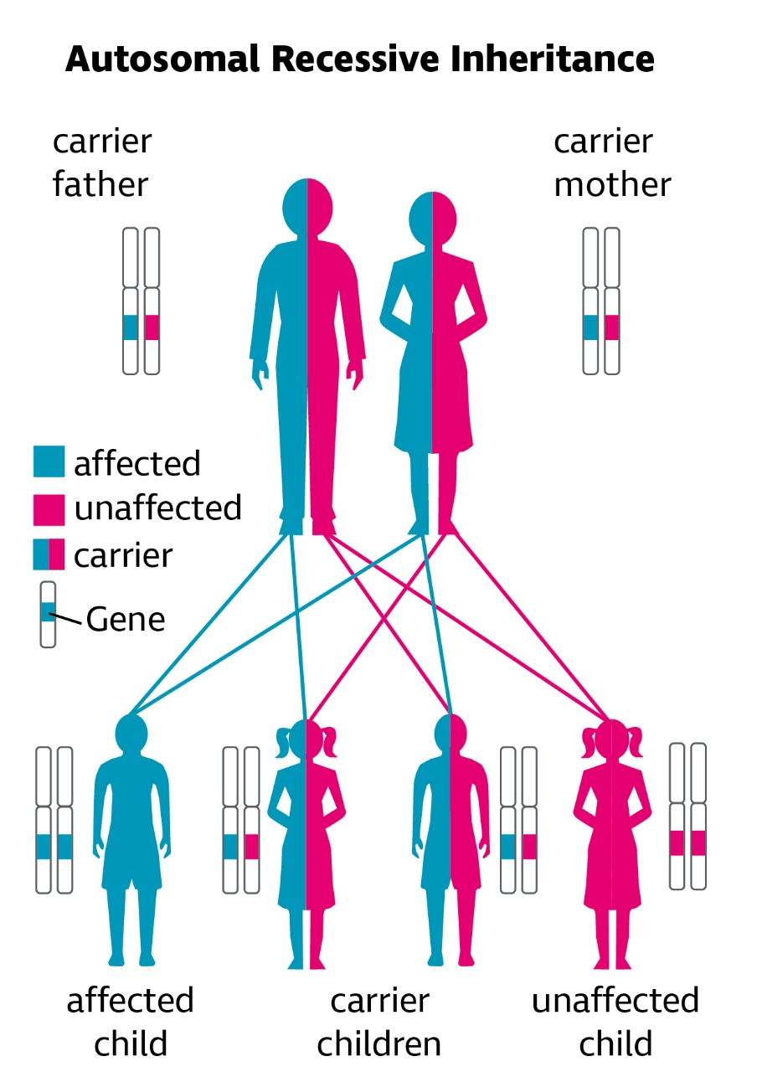

Autosomal dominant
Dominant inheritance means that you inherit a disease from only one of your parents. The “variant” gene that you inherit from one parent is the dominant one and over-rides the “normal” gene from your other parent. Usually the parent who has passed on the “variant” gene will also have Stargardt disease.

When a parent with the dominant ELOVL4 Stargardt gene has a child with someone who does not carry the Stargardt gene, there is a 50 per cent chance that the “variant” gene will be passed to a child. If a child does not inherit the “variant” gene, the child cannot pass it on to their own children.

A small number of cases of Stargardt disease are inherited in a dominant pattern.

The diagram below shows the four possible ways in which a child can inherit the ELOVL4 gene when either one of their parents has the condition. For each child these parents have, there is a 50% (two out of four) chance that they will inherit the “variant” gene and be affected by the condition. Equally, there is a 50% chance that a child inherits two “normal” genes and be unaffected.

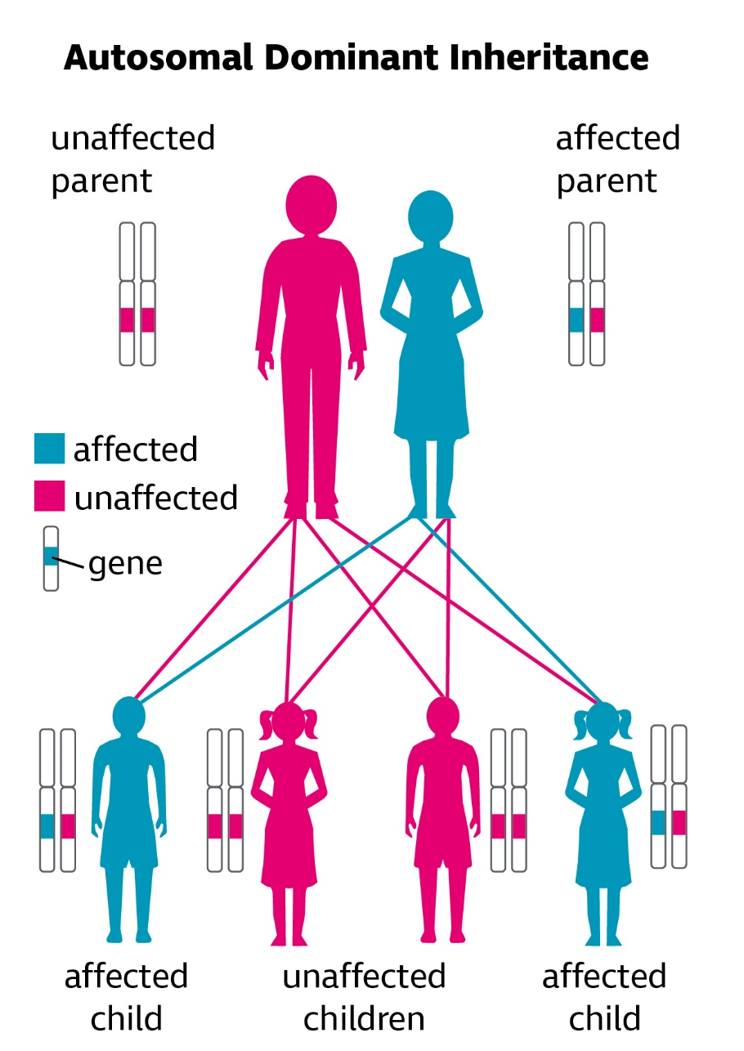

Most people who have Stargardt disease have parents who don't have the condition. This means that Stargardt often occurs in families that have no history of the disease in the past.

For more information on how Stargardt disease may be passed through your family, you may want to speak to your GP about a referral to a clinical geneticist (a doctor who specialises in genetic conditions). They can discuss your situation with you and your family in more detail. You may also wish to contact the Genetic Alliance for more information on genetics; their contact details are listed at the end of this information.

How does Stargardt disease affect your eye?
Stargardt disease causes changes to the appearance of the macula area of your retina. It affects the vision by causing the photoreceptor cells of the macula to be lost over time. When the ophthalmologist (hospital eye doctor) looks into your eye to examine your retina they may notice differences which can help them to diagnose the condition:

- Yellowish flecks which surround your macula are very characteristic of Stargardt disease. These yellow flecks are lipofuscin which is a by-product of cell activity.
- As the disease progresses, an oval lesion can be seen which is often referred to as “beaten bronze” in appearance within your macular area.

The ophthalmologist may request certain specialised images of the retina to be taken as these give more information about the condition than can be seen when simply looking into the eye. Also, during the visit, you will usually be given eye drops that increase the size of the pupils, so that the retina can be seen more clearly. These drops usually blur the vision for a few hours afterwards.

Sometimes people have just the flecks without the macular lesion, and in the past, these people may have been diagnosed with an eye condition called fundus flavimaculatus. However, researchers now believe that these two problems, the macular lesion and the yellow flecks, are part of the same genetic problem, but are just expressed in different ways.

Are there any treatments for Stargardt disease?
Although there is no treatment for Stargardt disease at the moment, there is much that can be done to make the most of the vision you have. This may mean making things bigger, using brighter lighting, or using colour and contrast to make things easier to see. Further information on this can be found below in our section, ‘Help to see things better’

It is hoped that current research and developments into drug and gene therapies will lead to treatments in the near future for those that are in the early stages of Stargardt, while stem cell therapy can give hope to those who have had the condition for a while.

An active area of research is looking at medications that can reduce the amount of vitamin A by-product that builds up in the eyes of those with Stargardt disease. If you have Stargardt disease you aren’t able to clear vitamin A by-product in your eye due to the variant gene. These by-products collect in the macula and this affects how well the cells work, leading to your sight being affected. If you are diagnosed with Stargardt, you should avoid taking supplements containing vitamin A. There is further information on the role of Vitamin A on Stargardt’s Connected website at the following link: Vitamin A and Stargardt's Disease - Stargardt's Connected

Gene therapy aims to replace the “variant” gene such as ABCA4 within the affected retinal cells with a new gene that works properly. The “normal” gene is injected into the eye of the person with Stargardt disease. The hope is that the affected cells then begin to work correctly thereby stopping the progression of the disease.

Stem cells are cells that can divide many times and can replace damaged or missing cells in different organs and tissues of the body. If stem cells can be turned into the specialised retinal cells, it may be possible to replace the cells that have been damaged in Stargardt disease.

Researchers have reported that exposure to ultraviolet (UV) light may theoretically cause further toxic by-products leading to retinal damage. Therefore, protecting your eyes from UV and blue light with sunglasses that have 100 per cent UV filtering might be helpful. Wraparound styles provide protection from light coming in from the sides and tops. Further information on choosing sunglasses can be found on our website at the following link: Five steps to getting the right glasses for light sensitivity - RNIB - See differently You can also call us at 0303 123 9999 and we can send the information out to you in your preferred format.

There is much that can be done to help make the most of your sight. This includes visual aids and adaptations around the home, adaptations and specialised software for computers and at work, and training from social services. Our Sight Loss Advice service can help provide information about all the different practical support available. They can be contacted via our Helpline on 0303 123 9999.

Coping

Being diagnosed with an eye condition can be very upsetting. You may find that you’re worried about the future and how you will manage with a change in your vision. All these feelings are natural.

Some people may want to talk over some of these feelings with someone outside their circle of friends or family. RNIB can help with our telephone Helpline and our Counselling and Wellbeing team. Your GP or social worker may also be able to help you find a counsellor if you think this would help you.

The Macular Society has local groups which meet throughout the country and also offer a telephone counselling service. Sometimes it can help to talk about your feelings or share your experience with people who may have had similar experiences. The Macular Society contact details can be found at the end of this information.

For children who have sight loss from Stargardt, having the right support at an early age can make a big difference. Your local authority (LA) should have at least one qualified teacher of children and young people with vision impairment (QTVI) to work with you and your child both at home and at school. A QTVI is a qualified teacher who can provide support with development, play, learning and education. At an early stage, ask your local authority to put you in contact with a QTVI. They will support you and your child as soon as a visual impairment is suspected or diagnosed. If you have difficulty getting help or need the details of the specialist teacher in your area, contact RNIB Helpline on 0303 123 9999.

Your eye clinic may also have an ECLO (Eye Clinic Liaison Officer) who can be on hand to provide you with further practical and emotional support about your eye condition.

Help to see things better
Stargardt disease can cause severe problems with your central vision. However, most people with the condition retain their peripheral vision, so won’t lose their sight completely.

There are lots of things that you can do to make the most of the vision you have. This may mean making things bigger, using brighter lighting or using colour to make things easier to see.

A low vision assessment gives people a chance to discuss any practical problems they are having with their vision with a low vision specialist. The specialist can explore things like magnifiers, lighting, colour contrast and other adaptations that may help. Assistive technology can also be very useful to help you with your work, hobbies and activities. You can ask for a referral to a low vision clinic from your ophthalmologist, optometrist or GP. We have a series of leaflets with helpful information on living with sight loss, including how to make the most of your sight. You can find out more about our range of titles by calling our Helpline on 0303 123 9999.

When you have sight changes, you may be worried about finding work, or staying in your job. Our Employment team can provide specialist support and advice about employment for people with sight loss. You can contact this team via our Helpline on 0303 123 9999.

Local social services should also be able to offer you information on staying safe in your home and getting out and about safely. They should also be able to offer you some practical mobility training to give you more confidence when you are out.

Depending on how much of a person’s sight is affected by Stargardt, they may be eligible to be registered as sight impaired (partially sighted) or severely sight impaired (blind). An ophthalmologist would be able to tell you whether you are eligible. Registration can act as a passport to help and sometimes to financial concessions, but a lot of this support is still available to people who aren’t registered.

You can find more information about all the support available to people with sight problems on our website www.rnib.org.uk or by calling our Helpline on 0303 123 9999.

Sources of support
Whether you have just been diagnosed with Stargardt disease or have been living with it for a while, at RNIB, we are here to help and support you at every step.

RNIB
105 Judd Street
London
WC1H 9NE

The RNIB Helpline is your direct line to the support, advice and products you need. We'll help you to find out what's available in your area and beyond, both from RNIB and other organisations.

Whether you want to know more about your eye condition, buy a product from our shop, join our library, find out about possible benefit entitlements, be put in touch with a trained counsellor, or make a general enquiry, we're only a call away.

Give us a call today to find out how we can help you.

RNIB Helpline
0303 123 9999
helpline@rnib.org.uk

We’re ready to answer your call Monday to Friday 8am to 8pm and Saturday 9.30am to 1pm.

You can also get in touch by post or by visiting our website:

RNIB
105 Judd Street
London WC1H 9NE
rnib.org.uk

Other useful contacts

Stargardt’s Connected
Stargardt's Connected is a UK Charity which aims to raise awareness of Stargardt, give support and raise funds for support and a potential treatment/cure. More details can be found on the website where you can find relevant information and join their mailing list:

Website: stargardtsconnected.org.uk
Email: stargardts183@gmail.com

Macular Society
Macular Society provide free information and support to those with macular disease, along with their family and friends, to help people keep their independence.

PO Box 1870
Andover SP10 9AD
0300 3030 111
macularsociety.org

Genetic Alliance UK
The Genetic Alliance is a national alliance of patient organisations with a membership of over 130 charities which support children, families and individuals affected by genetic disorders.

Level 3, Barclay House
37 Queen Square
London
WC1N 3BH
020 7831 0883
contactus@geneticalliance.org.uk
geneticalliance.org.uk

We value your feedback
You can help us improve our information by letting us know what you think about it. Is this factsheet useful, easy to read and detailed enough – or could we improve it?

Send your comments to us by emailing us at eyehealth@rnib.org.uk or by writing to the Eye Health Information Service, RNIB, 105 Judd Street, London, WC1H 9NE.

This factsheet has been written by the RNIB Eye Health Information service. Our factsheets have been produced with the assistance of patient and carer input and up-to-date reliable sources of evidence. The accuracy of medical information has been checked by medical specialists. If you would like a list of references for any of our factsheets, please contact us at eyehealth@rnib.org.uk

All of our factsheets are available in a range of formats including print, audio and braille.

Last updated: May 2021
Next review: May 2024

