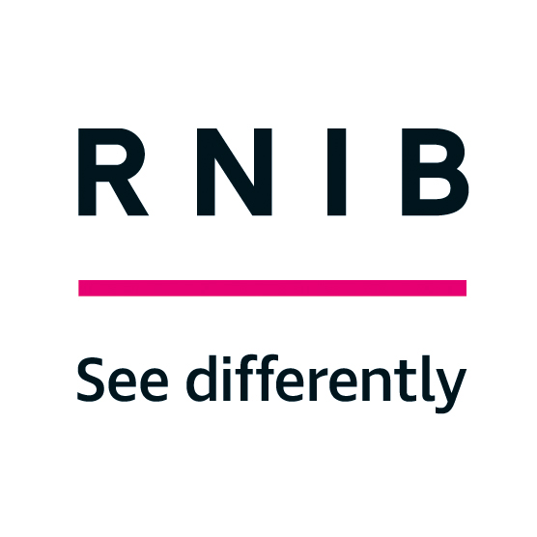
RNIB See differently Logo

Dat

Factsheet for employers

RNIB work-based assessment services

About this factsheet
This factsheet has been designed to give employers information about our work-based assessment services. It explains when an assessment might be relevant, details the objectives of an assessment, the benefits of assistive technology, and what you can expect from us.

This factsheet does not provide any specific guidance on work-based assessments or reasonable adjustments. If you wish for RNIB to provide further guidance on work-based assessments, then you should instruct the RNIB employment team to undertake a work-based assessment.

Introduction
RNIB works with individuals with sight loss and employers, giving advice and guidance to help people stay at work. Many people need straight forward, or no adjustments to achieve this.

If an employer or individual has a particular question about support in the workplace, our Helpline or Sight Loss Advisers can usually answer this right away. Sometimes, we need to work with individuals and their employers for a longer period, and our specialist employment advisors can provide further advice.

Additionally, some employers ask us to arrange a work-based assessment. This could include:

- an unbiased assessment acting upon referral from employer or occupational health provider
- advice on the installation and configuration of assistive technology
- advice on reasonable adjustments

While most of the employment advice you get from RNIB is delivered without charge, work-based assessments involve a considerable time commitment, including arranging the assessment, carrying it out and compiling a report that is quality controlled. We therefore charge a service fee for any work-based assessment.

Work-based assessments
A work-based assessment from one of our employment specialists can have any of the following objectives:

- to identify the issues that an employee is facing as a result of their sight loss, and suggest potential solutions
- to identify any assistive software and equipment an employee requires to carry out their range of duties effectively
- to identify any training needs relating to equipment or software
- to identify the environmental factors in the workplace that impact on the employee such as lighting, workstation ergonomics or signage
- to identify any factors affecting an employee’s mobility to, from and within work
- to identify any additional services that are necessary for the adjustments to be effective: for example, scripting of assistive technology software
- to identify any additional services that may be beneficial: for example, a functional low vision assessment
- to identify any requirement for a support worker, where all other adjustments have been considered
- to identify adjustments to working practices to meet employee needs
- to identify any other rehabilitation or work-related training needs if required
- to identify an employee's preferred format for communication

The assessment results in a detailed assessment report, which identifies the work-related issues that the employee is facing as a result of their sight loss, with suggested solutions. Our assessments take around a month to complete.

Access to Work
Access to Work, delivered by the Department for Work and Pensions, can provide grants to help pay for practical support in the workplace. Some of the recommendations we make can be eligible for Access to Work grant funding, although this is subject to their eligibility rules. For example, at the time of printing, government departments are not covered by Access to Work.

Although our work-based assessments can help to inform decisions with Access to Work applications, they do not replace Access to Work’s own assessments.

Quality assurance
RNIB follows rigorous, internal quality assurance procedures to ensure that we maintain a high standard so that the employer, employee and occupational health providers receive the most effective and efficient service possible.

Sources of help and further information

Employment factsheets
We currently produce the following factsheets for employers and employment professionals:
- Access to Work
- RNIB work-based assessment services
- Blind and partially sighted people at work - Guidance and good practice for Risk Assessors
- Testing the compatibility of access software and IT applications
- Guidelines on meeting the needs of partially sighted delegates on training courses

RNIB Helpline

The RNIB Helpline can offer further advice and guidance. RNIB Helpline can also help you by providing information and advice on a range of topics, such as eye health, the latest products, leisure opportunities, benefits advice and emotional support.

Call the Helpline team on 0303 123 9999 or email: helpline@rnib.org.uk

November 2023

End of Document

